Foundational Elements Workbook Introduction

Introduction

The Foundational Elements are a blended approach to learning that have been developed to provide both the flexibility of individual online learning and the opportunity to discuss the learning and build connections and community with cohort colleagues.

In each element of the training, you will engage with a variety of content types: lectures, scenarios, videos, interactive exercises, knowledge checks, reflections, and discussions.
- You will do some of the work asynchronously, which means that you will access and complete the instructional content online on your own schedule, within a certain timeframe. You will access the instructional content through the online learning packets that will be available to you in PDS Online.
- You will do some of the work synchronously, which means that you will come together with a facilitator and fellow learners on specific dates and times virtually via Zoom. We refer to this class time as a Community Huddle.
- In order to help you to participate in the synchronous Community Huddle discussions, you will complete asynchronous online learning packets prior to attendance at a Community Huddle.

Your Workbook

The purpose of the Foundational Elements Workbook (hereafter referred to as “Workbook”) is to serve as a map to you, the learner, and your supervisor, through each of your Foundational Elements. The Workbook pages are structured to support you through the online learning packets and Community Huddles in each foundational element.

Within each element’s Workbook pages, you will find the element’s learning objectives, sections (with time approximations, order, and type of learning for each section), supporting materials, and handouts as well as worksheets to record the activities and discussions that you complete in the online learning packets to bring to your Community Huddles. Your Workbook is a companion that goes hand-in-hand with the online learning packets and Community Huddles.

The Workbook for each element is available in two formats on the WCWPDS website at: https://yj.wcwpds.wisc.edu/wilearn-youth-justice-yj-program/ . Exactly the same information is in each version.
- One version can be used entirely electronically, allowing the child welfare professional the ability to capture their notes, reflections, and assignments directly into the pages from their device.
- The second version is meant to be printed and has additional space for capturing handwritten notes, reflections, and assignments.
What is a Community Huddle?

Community Huddles are live synchronous sessions that you attend at designated points during each course with a cohort of approximately 20 other learners. Each Community Huddle is an interactive, facilitated conversation lead by one of the WCWPDS trainers. Some elements may contain more than one Community Huddle, and they will vary in length from about 60 – 120 minutes. Community Huddles are held virtually via Zoom.

Community Huddles are an active learning debrief rather than a passive, lecture-based event. Much of the content shared in the online learning packets is brought into the Community Huddles for further exploration, discussion, and sharing as well as practice in applying the skills and tools you learned. Therefore, it is important for you to complete the online learning packets before attending the next scheduled Community Huddle and come prepared to reflect, discuss and share.

You will find the date, time, and Zoom link for all 11 Community Huddles within an email that you receive from WCWPDS. Please see that email for details about logging in to the Community Huddle and contact information should you have any questions about the Community Huddle.

You are expected to attend all scheduled Community Huddles. If an emergency arises, please reach out WCWPDS at the contact information included in the email you received.

Community Huddle Expectations

In order to successfully participate in a Community Huddle, you need to have completed all your online learning packets, have your workbook and other needed supplies, keep your camera on and be present for the entire Community Huddle, and be in a private, quiet space without interruptions (such as an office or another enclosed room where other people are not present; you cannot be driving in your car or occupied in another manner while participating in a Community Huddle).

Community Huddles are designed to promote and encourage discussion in a safe and judgment-free environment. Therefore, each cohort will develop their own detailed group agreements and other ground rules.

Zoom Information

In order to assure that you are prepared for the Community Huddles, 7 days prior to your first Community Huddle review the VILT checklist that is posted as a separate handout on the WCWPDS website in the same area that you downloaded these workbook pages. The handout is entitled: “VILT Checklist”.
Online Learning Packets

You will complete online learning packets prior to attendance at Community Huddles. The Workbook for each element includes time approximations for every online learning packet to allow you sufficient time to complete this required work prior to the next scheduled Community Huddle.

You will complete the online learning packets at your own speed. Find a quiet place, free of distractions and take breaks as needed. Take time to reflect on important content and return to sections you feel need extra review.

You will encounter the following types of learning activities within the online learning packets:
- Packets contain important and practical content for your work. Information in packets is presented through varied methods such as matching, sorting, flash cards, quizzes, short lecturettes, and other activities to engage every learning style.
- Grounding Activities build background knowledge and may ask you to examine personal experiences, beliefs, or assumptions that you bring to the learning journey.
- Culminating Activities provide the learner the opportunity to weave together multiple ideas from elements.
- Independent Studies allow learners to apply what they have discovered by engaging in discussion and activities with their colleagues and supervisors in their agency.

You are expected to come prepared to Community Huddles having finished the preceding packets, grounding activities, culminating activities, and independent studies so you can best share your reflections and ask questions.

- Where do I find the Online Learning Packets for my Foundational Element?

You will find the Online Learning Packets on your PDS Online Transcript. For each Foundational Element, you will see a curriculum and a session on your transcript.

The session includes a list of all Community Huddles. Select View Training Details for a list of dates and times for your Community Huddles in the Foundational Element. Remember: the Zoom links for each of the Community Huddles was sent to you via an email from WCWPDS. NOTE: You do not need to do anything with the session as it is only for reference.

The curriculum contains the online learning packets.
Select Open Curriculum

Once you open the curriculum, you will see each of the online learning packets in the table of contents on the left side, listed in the sequence you complete them and including the Community Huddles.

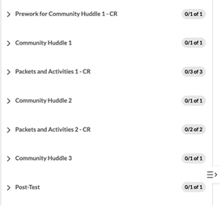

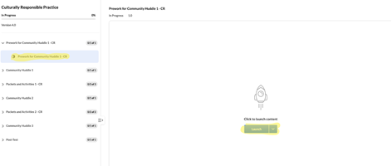
Select the online learning packet from the table of contents on the left side of the screen. Then, select Launch to begin the online learning packet.

Close the window when you have completed the online learning packet. You will be returned to the curriculum’s table of contents and will see the packet marked completed. If you do not see the online learning packet marked completed, return to the packet and make sure that you have accessed and listened to the complete audio on every slide/page in the packet so it will be marked “completed” on your PDS Online transcript.

Use your Workbook as you complete each online learning packet.

- How do I know which Online Learning Packets need to be completed before my next Community Huddle?

The Workbook contains a detailed list of all Online Learning Packets and Community Huddles in seqence of completion under the heading Element Sections. You will need to complete all of the Online Learning Packets that preceed the Community Huddle on the list.

In the example below, the Prework for Community Huddle 1 indicated by the blue dot must be completed prior to the start of Community Huddle 1. After Community Huddle 1 is complete, the next set of Online Learning Packets will be acessible to you, and must be completed prior to Community Huddle 2. This includes Packet 1, Packet 2, and Prework for Community Huddle 2 as depicted by the blue line.
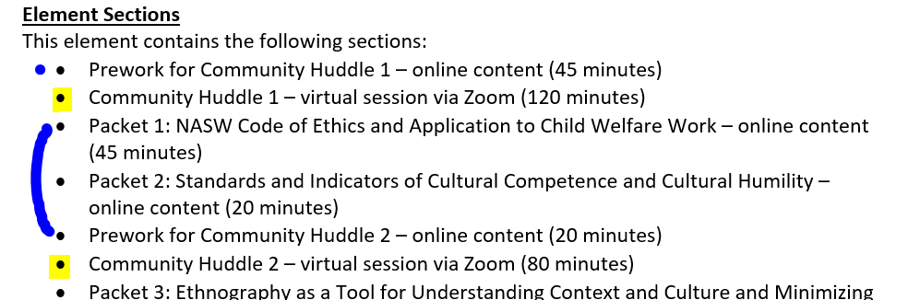
Online learning packets are sequenced to assist learners in navigating the curriculum in order. You must complete one packet before launching the next packet. When a Community Huddle is next in the sequence, it is a stopping point. Upon completion of the Community Huddle, the next online learning packet will be accessible.

