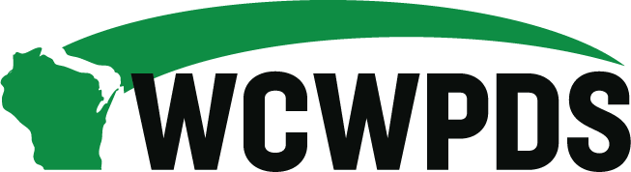

WCWPDS Steering Committee Meeting Notes
Tuesday, July 21, 2026, from 1:00pm-3:30pm

Attendees:

Dan Williams (Green County), Serena Peloza (La Crosse County), Sandy Hoefert (Washington County), Greg Rewolinski (Waukesha County), Mandy Stanley (Marquette County), Wendy Knauf (Wood County), Madeline Prange (Dane County) Alebra Metoxen (Oneida Nation), Amanda Jaeger (Brown County), Jeffrey Jazgar (Menominee Tribe), Emily Erickson (DSP), Nicole Fischer (DMCW), Shannon Braden (DSP), Shelby McCulley (DSP), Tania Cornelius (DSP), Angi Krueger (DSP), Dana Johnson (DSP), Darin Smith (WCWPDS-Madison), Jennifer Heil (WCWPDS-Madison), David Harkins (WCWPDS-Madison), Julie Brown (WCWPDS-Milwaukee), Stephanie Reilly (WCWPDS-Madison), Ellen Smith (UW-Madison), Heather Halonie (WCWPDS-Madison)

Welcome & Introductions – Shelby McCulley & Darin Smith
- Overview of Agenda: See “WCWPDS Steering Committee Agenda 7-21-26” document Darin sent via email

MI Project Update – Angi Krueger
- Angi Krueger provided the following update while screen sharing a PowerPoint slide deck:
- Motivational Interviewing Summit was held on July 16, 2026, where plans for the implementation of motivational interviewing in Wisconsin were discussed. More tha 130 partners participated in the event.
- During the Summit, an overview of MI was provided and a panel of WI experts discussed MI. What MI training in WI will look like was also shared.
- Given the feedback from the External MI Workgroup members as well as what the evidence about MI training and implementation tells us, the following training format has been developed: 5 hours of asynchronous training that focuses on foundational MI knowledge + 6 hours instructor-led virtual training via Zoom that allows for practice through role plays and feedback.
- Fidelity Monitoring is critical to supporting effective MI practice skills, so a component of the MI project will include fidelity monitoring.
- What’s been decided to support fidelity:
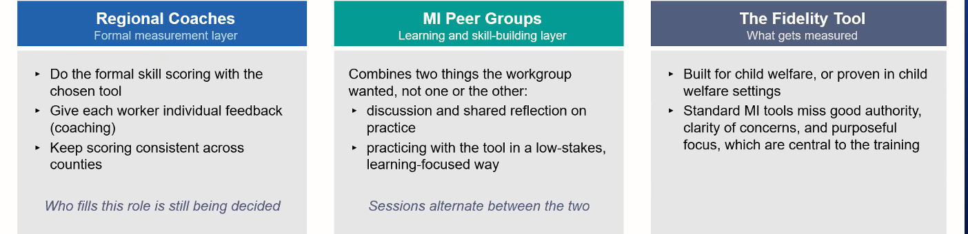
- Decisions still in process:
- Who are the regional coaches?
- How will MI Peer Groups be structured?
- How will the tool be used?
- Pilot logistics and selection
- Next steps:
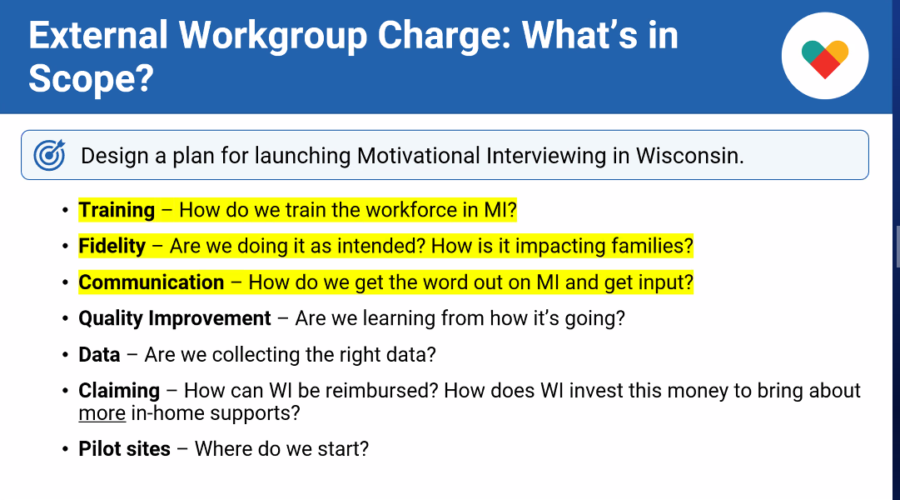
- Questions from the Steering Committee included:
- Wendy Knauf: Wondering about the WHY and sharing that with folks around the state – how is this being presented to folks? Answer: Background was shared at the Summit. CW leaders did say that the WHY hasn’t made it to the direct practice workforce yet. There needs to be an intentional workforce communication strategy.
- Darin Smith: What’s the long term roll out thinking? Answer: not fully landed on a time frame. Working with the external workgroup to make decisions about model as that will impact long term roll out.

YJ Auto Enrollment – Jen Heil
- We’ve been increasing our auto enrollments of new staff into training to best support them getting into the right training courses in a timely manner.
- Focused on primary YJ and CPS professionals who have YJ case responsibilities.
- What’s staying – currently happening and will continue:
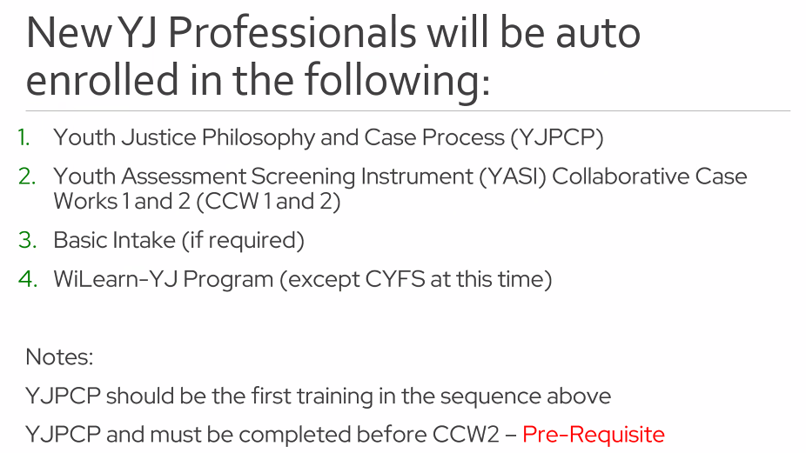
- What’s changing: enrollment for new YJ secondary professionals (usually CPS professionals) into a YASI session to support training sequencing. The YASI training will follow their WiLearn completion so as not to overwhelm them with training in their first 6 months.
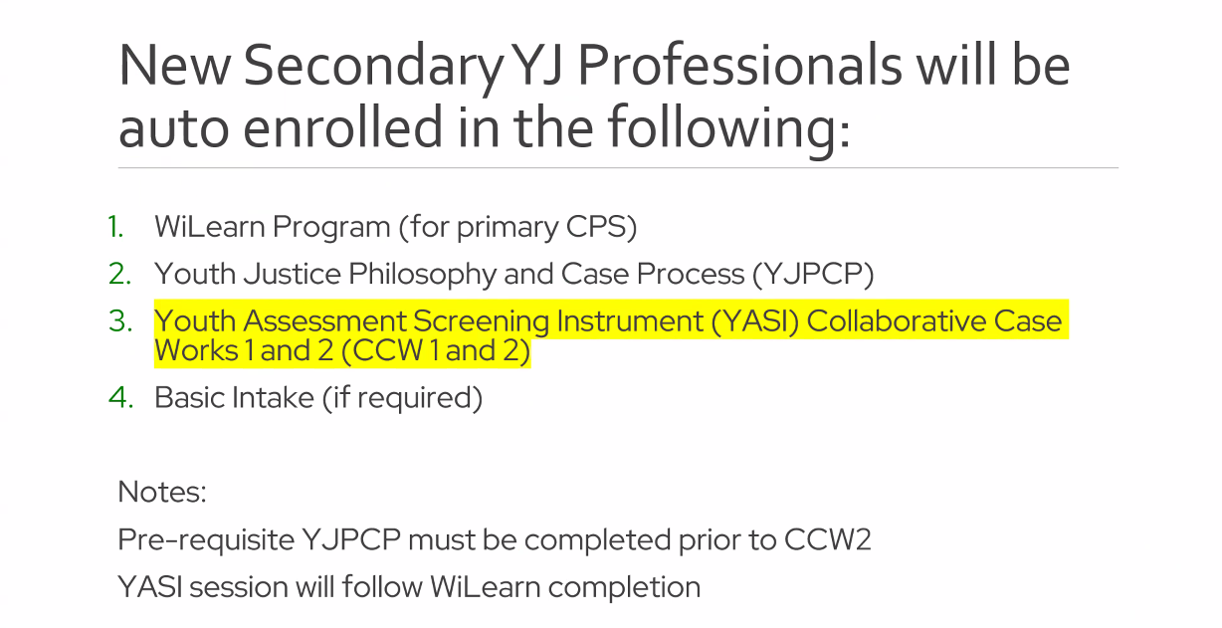
- New YJ supervisors are not auto enrolled. WCWPDS staff will work with new YJ supervisors to understand what they previously completed and what they still need to complete.
- Key Takeaways:
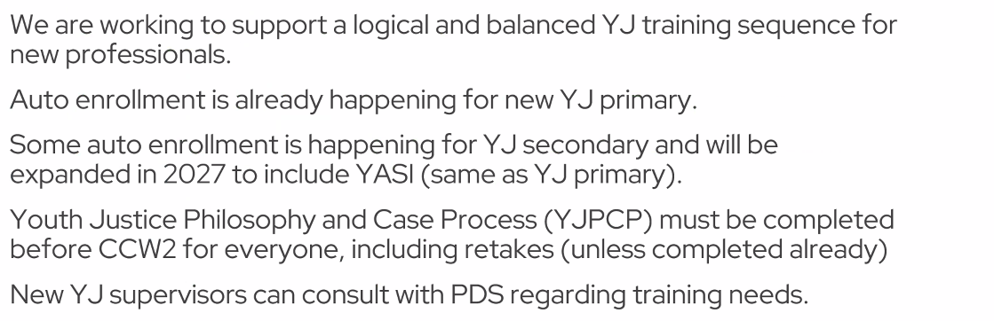
- Feedback:
- Greg Rewolinski – process has been working great in terms of managing JCI department; some staff have been JCI trained and wondering about BI refreshers in the future (Response from Jen: none are planned but can connect with Nicki to discuss individual staff needs)
- Darin Smith asked: Is auto enrollment advantageous from a county perspective? Lots of heads shaking “yes”.

Joint Meeting with ICW Directors – Heather Halonie & Shelby McCulley
- Meeting will be held on August 20, 2026, from 10-2 at The Waters in Minocqua.
- Update on priority items from 2025 meeting (Heather) – for supervisors who need refresher on WICWA there is already a web-based course included in our WICWA Resource; develop guide for supervisors in supervising WICWA cases – initial draft has been developed with feedback from ICW directors forthcoming and finalization and distribution in fall 2026; will also get feedback at joint August ICW-PDS Steering Committees Meeting
- Agenda items for meeting (Shelby):
- Updates since 2025 meeting
- How to make resources that are already available more prominent
- MI project
- Training and how to support the workforce with ICWA practice: pain points/knowledge gaps of county CW professionals – Sandy commented that the learning from last year’s is that we need to continue to ask our families if there is a Indian heritage, concerned that this gets lost – how can we enforce the continual asking about Indian heritage?
- Tribal input on 2027 priorities

2027 Priority Setting – Jen Heil, Shannon Braden & Darin Smith
- 2026 Priority Updates:
- Jen Heil & Julie Brown provided an update on the status of the 2026 priorities that WCWPDS is engaged in.
- Jen Heil highlighted the following priorities:
- 2025-2027 E&B training focused on defining and setting boundaries continues through early December 2026 for this licensing period
- YJ new learning opportunities: one is a YASI Hybrid Booster following a youth named Wes with most of it self-paced web-based with a 90-minute huddle – will be advertising further as had no one enroll for the first session (there are two remaining sessions for the year)
- 2026 Safety Collaboration: Building Confidence in In-Home Planning for supervisors and CW professionals
- ALCs: Collaborative Family Case Planning and Teaming
- Develop New Training:
- Access Response Time (materials developed and posted to support launch)
- Access Fundamentals training will be piloted in August
- Access Supervisor Training – planning meeting just kicked off
- Family Case Planning – new sessions will be launched in 2028
- Lived Experience Supervisor Training – being developed this year
- YASI Booster 4: YASI-Informed Court Reports – will launch in 2027
- Training for New Foster Care Coordinators – 4 web-based modules to be available in late August and a VILT training that will be available in early 2027
- WICWA web-based training (Heather previously spoke about this)
- Supporting Youth Transition to Adulthood – web-based training completed in June
- Training updates to:
- Mandated Reporter Training (updating in 2026 with a Spanish version to begin to be developed in 2027)
- YASI Collaborative Case Works
- Understanding Child Sex Trafficking in WI
- Other projects:
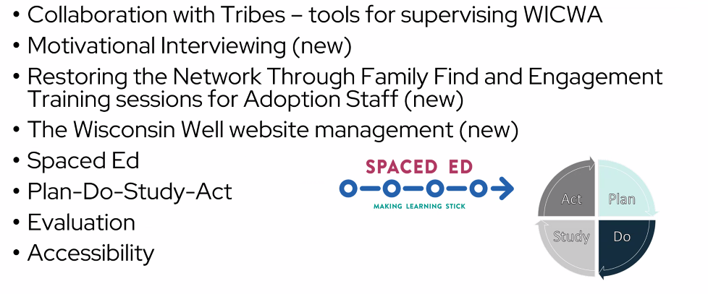
- Julie reviewed the Milwaukee CW Priorities:
- Crucial Conversations – Mastering Dialogue and Accountability
- Court Practice and Practicum training expansion
- Mental Health
- DMCW-identified priorities
- Caregiver training: revamping the Foster Parent Pre-Placement training which will feature voices of youth and those with lived experience; continuing to offer Nurturing Connections and ongoing training

- 2027 Items on Horizon:
- Shannon Braden provided a high level overview of some of the items that could make their way to the 2027 priorities list.
- No big surprises or shiny new things – continue preparing for MI; continuations of current projects - BSWB: PDSA and MR training; BYS: auto enrollment expanded, YASI Boosters; BPOC: Foster Care Licensing training
- Shelby spoke about CFSR timeline and impact: in preliminary stages right now (state led review); PIP will be developed in summer 2027 so will roll into 2028 training priority development

- 2027 Process:
- Darin Smith outlined the 2027 priority setting process and reviewed the activities and deadlines associated with collecting and submitting county feedback about items to be considered in the 2027 priority setting process.
- Talking points will be developed and shared with Steering Committee by end of July; Steering Committee reps will collect feedback from their regions and share with Darin by end of September; we will discuss at October Steering Committee Meeting

Updates
- Public Child Welfare Conference – Dana Johnson
- See “DCF_WCWPDS Conference Exhibitor Guidelines July 2026 document Darin sent via email
- Registration announcement will be shared by end of July; tracks are system and skill focused

Next Steps
- Key Messages to share with WCHSA or CYF PAC – none identified

