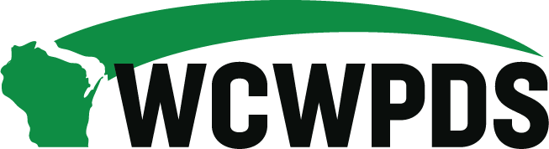

WCWPDS Steering Committee Meeting Notes
Tuesday July 15, 2025, from 1:00pm-3:30pm

Attendees:

Darin Smith (WCWPDS-Madison), Emily Erickson (DSP), Nicole Fischer (DMCPS), Ellen Smith, Jennifer Heil (WCWPDS-Madison), David Harkins (WCWPDS-Madison), Dan Williams (Green County), Heather Halonie (WCWPDS-Madison), Wendy Hendrickson (Wood County), Mandy Stanley (Marquette County), Penny Nevicosi (Waukesha County), Serena Peloza (LaCrosse County), Amanda Jaeger (Brown County), Tania Cornelius (DSP), Jeffrey Jazgar (Menominee Tribe), Julie Brown (WCWPDS-Milwaukee), Stephanie Reilly (WCWPDS-Madison), Sandy Hoefert (Washington County), Shannon Braden (DSP), Therese (Tess) Brodsky (DSP)

Welcome & Introductions – Darin Smith
- Overview of Agenda: See “WCWPDS Steering Committee Agenda 7-15-25” document Darin sent for the meeting; Darin walked through today’s agenda
- New Member Introduction: Nicole Fischer is taking Mika Makarovich’s place on the Steering Committee as Mika is not the Deputy Administrator in DMCPS

August Meeting Agenda Recommendations – Emily Erickson
- Joint meeting with ICW Steering Committee in Minocqua on August 21
- Emily- DSP’s hopes for the meeting: start to think through the different aspects of the convo will have about training needs that impact how counties interact with tribes and how counties proceed with OCW cases; identified two years ago the need for some specific supervisor training begin working with tribes – will revisit in August; other areas that needs continue training; questions on or about training needs from ICW directors; (Tania) also other items this committee wants on the agenda
- Heather update on the identified training for supervisors: have some sort of training in supporting supervisors in better collaborating with tribes; HH put together charter and then went out to gather information from sups (tribe and county) – received no feedback in these discussions; reached out to other states to gather information but wasn’t what we were talking about related to collaboration; in August what do supervisors really need and what would they find valuable to attend; how do supervisors support your case managers that have ICWA cases vs those who don’t have ICWA cases
- Jeff- what do the counties need from the tribes to assist the collaboration, what are some of the barriers, communication gaps, where is the base line of collaboration vs resource needs vs tribal burden for active efforts – can we develop a mental model to support this?
- Mandy – practical stance: if work in a county with a small tribal presence / rarely have ICWA cases, then need practical information, i.e., checklist of what need to do, who to go to, to do the work right when do get a case; Dan – if work in a county with a larger tribal presence, direct communication when regularly working with tribes; if have tribe in area or the tribe is not close so don’t have regular communication or a relationship then don’t know who to reach out to – who should we reach out to since don’t always have contact information for tribes or website information is out of date; what to do when families don’t want the tribe involved and how to support the worker in this dynamic since involving the tribe is a requirement of the county agency; Wendy Hendrickson – new “tribal collaboration” eW tickler (when open for ongoing but have a new IA) that can’t click on and doesn’t go away, it’s about documenting ICWA engagement and stays on the screen even though staff are entering what they think is the right thing in the right place
- Need: General process information that will vary from tribe to tribe (for those who infrequently work with tribes) AND regular communication/collaboration opportunities (for those who frequently work with tribes or one tribe in their area)
- Tania: told everyone she can be a resource if need assistance in connecting with or reaching out to tribes
- Soft skills - best practices on how to engage a tribe, practices that lead to collaboration, practical information, how kick off a relationship with the tribe and how to keep it going, how should I supervise a staff member who has a tribal case, include tribal reps in team meetings; Nicole request from DMCPS Sups: training for supervisors on ICWA specific trainings (compliant and technical components, especially the more advanced areas); as a county supervisor how do I support and coach staff in meeting compliance requirements?; collaboration from the beginning, not as an afterthought or after county made the decision; the Model for Practice and structured decision making is not a relational model so we need to help staff figure out how to integrate collaboration into these models that are not relational; cultural shift to approach tribes how we approach our families – how to promote a different way to join with tribes; (Serena) how state supports compliance/implementing the law AND state supervised, county administered – directors set the conversation/enforce the expectations at the local/county agency level so need to have something more than just training for supervisors

PDS Budget & Cost Allocation - David Harkins & Darin Smith
- See “Steering Presentation” excel document sent with the agenda
- David walked through each of the tabs in the document
- Big 5 cost areas (all around $500,000 each): Conferences, WiLearn, YJ, Ongoing, and Foster Parent
- Questions: Dan – are there opportunities as a state we are leaving on the table related to training that other entities are providing, if we run it through PDS would we be able to draw down IV-E funds? is it even feasible for PDS to support? David shared that DCF is claiming IV-E for training hits to the RMTS that PDS isn’t offering (offered by other entities)

eWiSACWIS Module Discussion - Jen Heil
- See “WiLearn eWiSACWIS Modules with Timing” document sent with the agenda
- Are the original 8 modules the right modules? What to do with the additional developed modules?
- Jen reviewed the modules being assigned to CPS (Access, IA and ongoing) professionals and the modules that will be assigned to YJ professionals; public adoption staff and tribal staff also complete CPS WiLearn
- Jen: Does it seem like we are requiring the right 8 modules for new CPS and YJ professionals? What could be our next steps?
- Penny: frequency of use of the non-required modules – from January 2025 data, usage ranges from 69 (Perm Plan) to 2 (SYNC Application); kinship care is new
- Dan: surprised the Perm Plan is not used more; would like more of a “how to” guide rather than a web-based module format; disconnect in KnowledgeWeb – the training links are on the bottom of the page and I would have gone to the videos not the web-based training modules – can this be better labeled?; not a fan of requiring training that isn’t necessary (Mandy, Serena, Penny and Wendy concurred)
- Mandy: more experienced staff do the out-of-home care related tasks so maybe that’s why they’re not utilized
- Penny: new staff are getting coaching from experienced staff rather than be directed to web-based modules
- Think about how new staff are learning their eW work – what do they need either in WiLearn or shortly after WiLearn (Amanda Jaeger would like to gather info from sups)
- Penny: Is the declined usage related to decreased placements statewide so the training isn’t as needed? As a new worker, not likely going to do this training unless required or if need it because I have a placement

2025 Priority Updates - Jen Heil & Shannon Braden
- Individual Priority Area Updates
From Jen and Shannon:
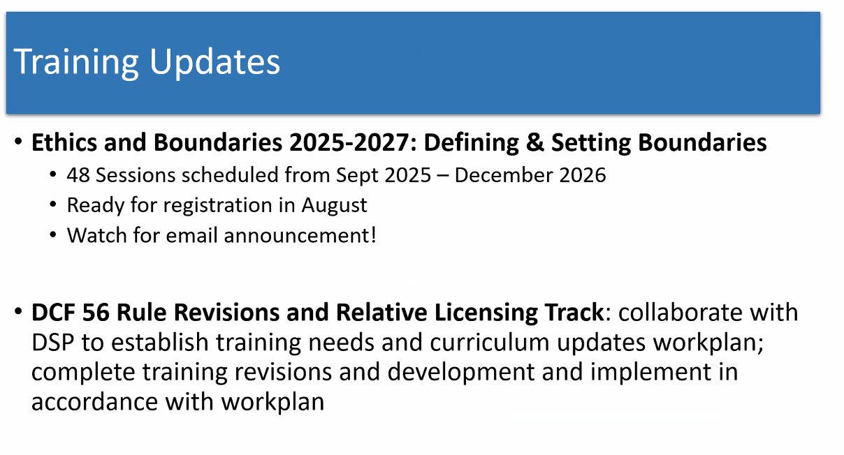
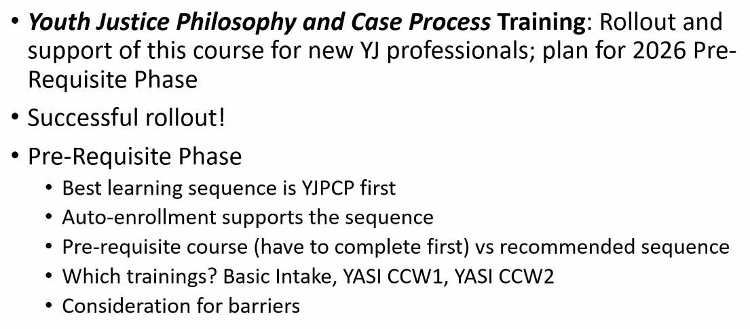
- Discussion: What impact do we need to consider for pre-reqs and sequencing? Sick or emergency to date/course missed – how strongly should we hold to the pre-req?
- Penny: endorse a continuing auto enrollment; this is foundation work and want it to mirror the CPS structure as closely as possible; we have a successful CPS product and should apply it to the YJ structure we develop

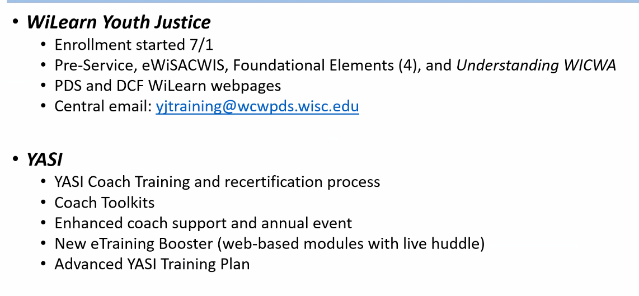
From Julie:
- Nurturing Connections starts August 1, registration opened in mid-June 2025; more info on WCWPDS website at: https://care.wcwpds.wisc.edu/
- Crucial Conversations training for child welfare professionals – sessions open and available for registration; looking at an Accountability focused training in 2026
- Mental Health First Aid- national curriculum with one that focuses on adults and the other on youth: how to identify and respond to people with MH crisis, structured for those who are not MH professionals
- Expanding a mock court session to a statewide audience- have been piloting it so can make adjustments to it to assure that meet the needs of counties outside of MKE

- What Will Continue in 2026
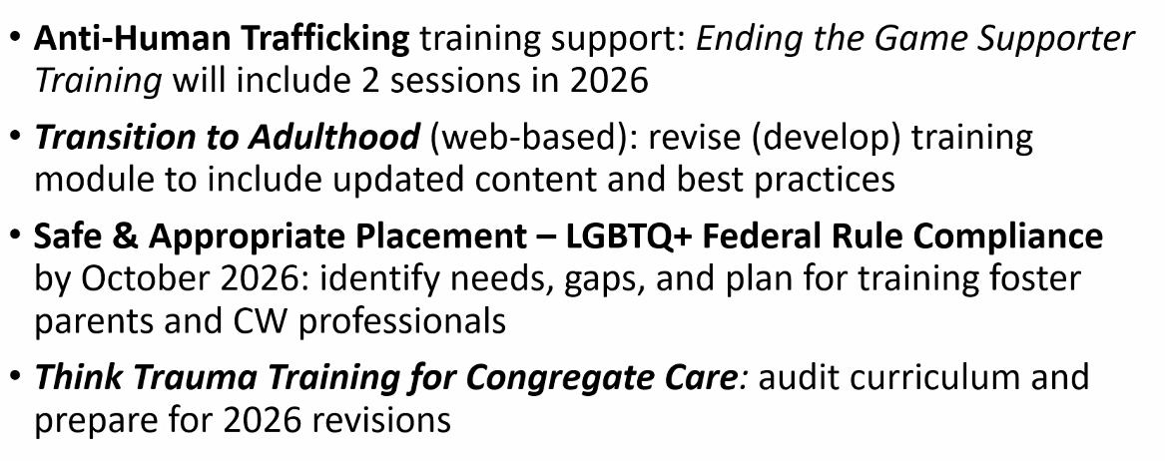

2026 Priority Setting – Shannon Braden & Darin Smith
- Priority Items on Horizon - Shannon
- In early days of identifying what will be carried over to 2026
- Exec Order scrutiny will need to be considered
- Process – DSP: meets with each bureau to discuss priorities; review strategic initiatives including case planning, safety and access; DCF 56
- Talking Points for Regional Meetings – see “WCWPDS Feedback Template”
- County and tribal reps to take templated to monthly meetings with your counterparts and discuss:
- What do more of; what do less of?
- Catch all – anything related to training that we could be doing, other efforts, function more effectively
- What are unmet training needs – topic areas not being addressed sufficiently
- Return template by late September 2025 so Darin can compile and prepare for October Steering Committee Meeting; Looking for 2 templates per region – 1 from Director conversation and 1 from Supervisor conversation

Next Steps - Darin Smith
- Key Messages
- Priority setting process overview – Steering Committee reps will be asking questions at the regional director and supervisor meetings

- Other:
- CW and the Courts Conference registration is open
- Joint Meeting with the ICW Steering Committee is on August 21 at The Waters in Minocqua from 10-2 with lunch provided – let Darin know if you are coming if didn’t chat “yes” during this meeting

