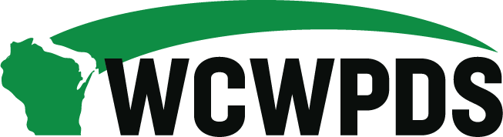

WCWPDS Steering Committee Meeting Notes
Tuesday, April 21, 2026, from 1:00pm-3:30pm

Attendees:

Darin Smith (WCWPDS-Madison), Emily Erickson (DSP), Nicole Fischer (DMCPS), Jennifer Heil (WCWPDS-Madison), David Harkins (WCWPDS-Madison), Dan Williams (Green County), Serena Peloza (La Crosse County), Julie Brown (WCWPDS-Milwaukee), Stephanie Reilly (WCWPDS-Madison), Sandy Hoefert (Washington County), Shannon Braden (DSP), Greg Rewolinski (Waukesha County), Shelby McCulley (DSP), Evelyn Coker (DSP), Penny Nevicosi (DSP), Mandy Stanley (Marquette County), Wendy Knauf (Wood County), Dana Johnson (DSP), Jenny Fahy (WCWPDS-Madison), John Tuohy (WCHSA), Ellen Smith (UW-Madison), Wade Flavion (WCWPDS-Madison), Madeline Prange (Dane County), Angi Krueger (DSP), Ann Price (Florence County), Heather Halonie (WCWPDS-Madison), Alebra Metoxen (Oneida Nation), Amanda Jaeger (Brown County), Kim Eithun (WCWPDS-Madison)

Welcome & Introductions – Shelby McCulley & Darin Smith
- Overview of Agenda: See “WCWPDS Steering Committee Agenda 4-21-26” document Darin sent via email
- New Member Introduction: Welcome to Madeline (Maddie) Prange (Dane County) who is replacing Jada Hrubes on the Steering Committee. Committee members introduced themselves to Maddie.

MI Project Overview – Angi Krueger
- Angi Krueger provided background on the Motivational Interviewing (MI) Project that is underway, including opportunities and challenges. Angi walked through a slide deck that will be provided to Darin to be shared with the Steering Committee. The Save the Date will also be shared to be distributed.
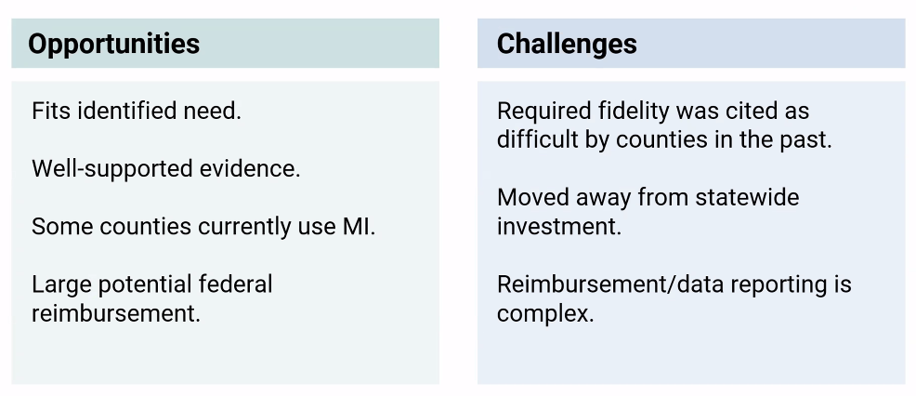
- A large component of the project is training, with the launch of a pilot in 2027. Planning for between 100-120 workers to be trained during the pilot phase. The MI Workgroup is focused on the following:
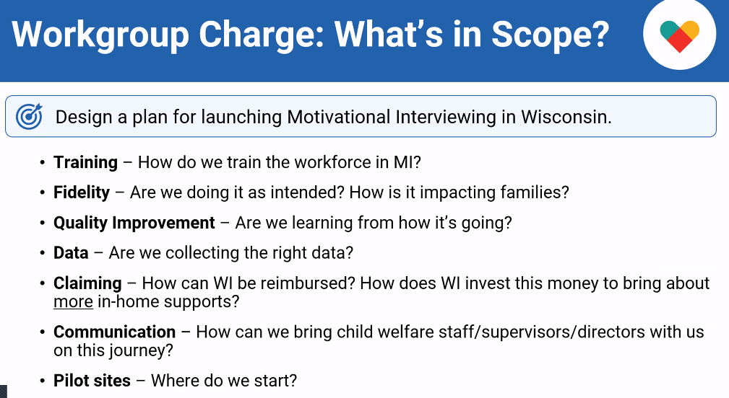
- Questions from the Steering Committee included:
- Amanda Jaeger: Will there be an opportunity to review what the plan for fidelity is longer term? In process of developing. Will be discussed at the MI Summit on July 16, 2026. Encourage attendance to be part of the discussion.
- Dan Williams: Are we looking at how this is going to be integrated into all training and not a separate initiative? This has been talked about within the workgroup, including talking about exposing WCWPDS trainers to MI language and practice so it can be reinforced in the training room before we get to revising all of our curriculums.
- Madeline Prange: Will there be markers or data points to measure the impact? Yes, we will need to identify the data markers and then report on them periodically to the feds. There will be other statewide data points we want to identify and measure.

PDS Annual Reports – Jen Heil, Julie Brown, Darin Smith, Stephanie Reilly, David Harkins, Heather Halonie & Jenny Fahy
- Overall Annual Report – See the “2025 WCWPDS Annual Report” document that Darin shared via email with meeting agenda and materials
- WCWPDS staff verbally shared key components of the report
- Steering Committee members had no questions
- WiLearn Report – See the “WiLearn Annual Report 2024-2025” document that Darin shared via email with meeting agenda and materials
- Jenny Fahy verbally shared key components of the 2nd annual report
- Question (Darin Smith): Can you have a pre-test score too high? Yes, but in looking at the test questions, believe that the questions were too easy/general. The questions have been revised to tie them closer to the learning objectives and specific content in the training vs more general content. Jenny will look at the results next year to see if there have been changes and if not there will be conversations with the Evaluation Committee about other considerations, including curriculum edits.
- Question (Madeline Prange): Curious about impact of not having or having a social work degree on the pre-test scores
- Budget and Cost Allocation – See the “Steering Fiscal Review” document that Darin shared via email with meeting agenda and mate
- David Harkins reviewed WCWPDS staff time by programmatic area and the WCWPDS training costs/spending

Connecting Conferences with WCWPDS Training – Dana Johnson
- DSP and WCWPDS jointly plan conferences. Dana Johnson facilitated a conversation with Steering Committee members about:
- Skill Building Curriculum and Conference Sessions – what could conference sessions look like with a skill building focus? Are there soft skills we could be offering at conferences vs the typical informative focused sessions? Is there space for more in-depth training on topics PDS already trains as part of the conference? Thinking about having 25% of the sessions focused on skill building.
- Comments:
- Amanda Jaeger: Tremendous amount of room for revisiting content that have been part of ALCs, PDSAs and other training. Plus these topics: Developmentally centered interviewing of children and how to document, and Behaviorally specific / focused documentation.
- Wendy Knauf: In-home family cases will increase the need for training on facilitating family team meetings.
- Julie Brown: Crucial Conversations
- Madeline Prange: Absolutely agree with what’s been said (defensible writing, working with adults and children with developmental delays, having difficult conversations). Also, group facilitation and how to balance judgement/bias in the work (use of supervision, team).
- Jen Heil: Approach from an annual priority planning perspective so we can plan for PDS staff to do this as part of their planned workload and not an add on.
- Nicole Fischer: How trauma can impact child interviews (lack of linear narrative, etc.)
- Penny: Is there a need for training on collaborative training across system partners? Madeline and Amanda – understanding who the professionals are is important for especially new staff + a place for child welfare staff to come together to understand how to center family voice when collaborating with partners.
- Tribe and County Input on Conferences, Call for Proposals for Conferences – Dana: how should we gather input from these staff? Responses included: Steering Committee members could be the liaison to the surveys sent out.
- Survey Responses on Current Trends or Needs for Training Topics – Dana: can the Conference Planning Committee get this information from WCWPDS from the Level 1 surveys completed by trainees? Darin: Yes, and PDS can also share annual survey responses that Steering Committee members gather from their regions.
- Reminders:
- Youth Services Conference is on April 29-May 1, 2026
- Public Child Welfare Conference is on Oct 21-23, 2026 – focus: family is the main ingredient with a recipe/cooking theme
- Adoption Conference is on September 29-30, 2026
- All conferences are being held at the Wilderness in Wisconsin Dells

Updates
- Evaluation – Jenny Fahy
- See slide deck entitled “WCWPDSEval_Update_04.2026” Darin shared via email with meeting agenda and materials
- Jenny reviewed purpose of the WCWPDS vision for evaluation, WCWPDS’s overall goals for the next 2-4 years, and WCWPDS’s 2026 evaluation priorities

- ICW Meeting Location – Darin Smith
- Meeting will be held on August 20, 2026, from 10-2 at The Waters in Minocqua.
- Darin will be sending an email invite, please respond whether you will attend or not as need numbers for meal count.

