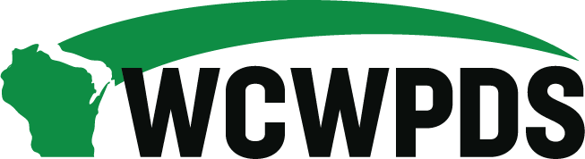

WCWPDS Steering Committee Meeting Notes
Tuesday, October 21, 2025, from 1:00pm-3:30pm

Attendees:

Darin Smith (WCWPDS-Madison), Emily Erickson (DSP), Nicole Fischer (DMCPS), Jennifer Heil (WCWPDS-Madison), David Harkins (WCWPDS-Madison), Dan Williams (Green County), Heather Halonie (WCWPDS-Madison), Serena Peloza (LaCrosse County), Amanda Jaeger (Brown County), Julie Brown (WCWPDS-Milwaukee), Stephanie Reilly (WCWPDS-Madison), Sandy Hoefert (Washington County), Shannon Braden (DSP), Nicki Laufolff (WCWPDS-Madison), Greg Rewolinski (Waukesha County), Paula Winter (Dunn County), Jenny Fahy (WCWPDS-Madison), Becky Albricht (Dunn County); Shelby McCulley (DSP), Dion Racks (WCWPDS-Milwaukee), Jada Hrubes (Crawford County), Ann Price (Florence County), Alebra Metoxen (Oneida Nation), Evelyn Coker (DSP), John Tuohy (WCHSA), Jamie Gennrich (DSP), Penny Nevicosi (DSP), Mandy Stanley (Marquette County), Ellen Smith (UW-Madison), Jeffrey Jazgar (Menominee Tribe)

Welcome & Introductions – Darin Smith
- Overview of Agenda: See “WCWPDS Steering Committee Agenda 10-21-25” document Darin sent with the agenda; Darin walked through today’s agenda
- New Member Introduction: Greg Rewolinski is taking Penny Nevicosi’s place on the Steering Committee as Penny is the new BSWB Bureau Director at DCF; Greg currently supervises Juvenile Court Intake in Waukesha County

Basic Intake Curriculum Feedback
- Ann emailed Darin about feedback on Basic Intake Worker Training that she received from a regional director meeting. Directors were wondering about how to support new staff and expressed concern that more time spent was being spent on the softer skills than on statute, possibly making it redundant with other training and not providing enough information about statutes. They had questions such as: Is there a curriculum that can be shared? How much time is really being spent on statutes?
- Nicki Laudolff provided a brief presentation on Basic Intake Worker Training format, goals and components and reviewed the core competencies which are focused on: What Can I do? What Should I do? How should I do it? Additionally, Nicki shared that the concepts are connected across multiple training but not trained the same in every training – there is repetitiveness of key concepts vs redundancy in content.
- Conversation by Steering Committee members:
- Shannon Braden noted that the training does not teach learners everything in statue (but even the older version did not) and learners are told throughout the training that they need to regularly review statute and have discussions with their supervisors throughout their careers
- Most directors took the old version of the training and may not know how best to support their new staff
- Ann thought it would be helpful for Nicki to present at her regional director meeting, walking through the slide deck Nicki presented at today’s meeting would answer their questions

Mental Health First Aid Update – Dion Racks and Julie Brown
- Julie – several years ago WCWPDS-Milwaukee was reflecting that mental health learning needs always come up as a need on the annual training survey, so they decided to think about what MH means and how to develop training at a measured pace that best supports child welfare practitioners understanding of MH
- For this first year (2025), a decision was made to use the Mental Health First Aid national curriculum
- Youth Mental Health First Aid training is a comprehensive training course designed to equip participants with the skills necessary to assist youth experiencing a mental health crisis. The course covers common mental health disorders, crisis intervention techniques, and how to connect youth with appropriate professional help. Participants will learn to recognize the signs and symptoms of mental health issues and will practice using a five-step action plan to support youth in distress.
- Adult Mental Health First Aid training is a comprehensive training designed to equip participants with the skills necessary to assist individuals experiencing a mental health crisis. The course covers common mental health disorders, crisis intervention techniques, and how to connect people with appropriate professional help. Participants will learn to recognize the signs and symptoms of mental health issues and will practice using a five-step action plan to support someone in distress.
- 6 sessions of the Adult Mental Health First Aid training and 4 sessions of the Youth Mental Health First Aid training were offered in 2025; for 2026 the same amount will be offered; if participants do follow up work they can get certified
- Additionally, a decision to focus self-care and secondary traumatic stress to support the workforce was determined as a priority focus
- The Self-Care learning collaboratives are a 6 month journey that focuses on self-care tools to use in individual practice; information available at: https://wcwpds.wisc.edu/learning-collaboratives-home-page/mental-health-ambassadors/
- No registration required for the learning collaborative; just attend whichever sessions you want; CEHs are available for the sessions you attended
- Alebra Metoxen: Is there a plan to update content in the learning collaboratives and provide support to agencies, if requested? Dion: Yes, interested in feedback and will update based on feedback received.

2026 Priority Setting – Jen Heil and Shannon Braden
- County Feedback – Jen Heil
- See “Key Themes & Priorities for 2026 Training” doc that Darin shared with Steering Committee as a handout
- Jen reviewed the feedback covered on the document on what was working well/should continue, areas for adjustment/scale back, system supports and structural improvements, and unmet/emerging training needs
- Jen noted that the classroom trainings don’t fill up but the virtual trainings do
- Overview of 2026 priorities that connect with the themes identified by the county feedback – Shannon Braden
- Some of the priorities planned for 2026 include: access and access supports for supervisors, supports for supervisors on working with employees in the PSP program who have lived experience, safety and danger threats with additional supports to supervisors (cohort and booster versions), supervisory support for collaboration with tribes, supporting the case planning process, foster parent curriculum changed so will be offering Train the Trainer sessions for CPAs, bolstering the YASI training sequence, finessing the auto enrollment for new YJ professionals
- New: Motivational Interviewing, leadership development for Human Service leaders (directors, managers), eagerly awaiting publication of new DCF 56 admin rule which will mean foster parent pre-placement revisions

Joint ICW Directors Meeting Review – Heather Halonie
- Focus of meeting: supervisor support re WICWA cases and building collaborative relationships with tribes
- Heather reported on the meeting and the brainstorming and discussions on whether training was the best solution.
- The next step take-aways included: development of tools to support supervisors, i.e., desk guide that supervisors can use as they staff WICWA cases with their staff; supervisors felt that a training at a set time is not the most helpful - rather an on-demand refresher would be more helpful for supervisors to get info they needed when they need it; adding a section for supervisors to the online WICWA guide; looking at utilizing ALCs as a way to support collaboration between counties and tribes in the future
- Shelby McCulley also spoke about the needs being broader than just training – supervisors and child welfare professionals needing quick access to resources was a key theme. DCF will look at updating desk guides, making sure everyone knows where all the documents live (CCIP, WCWPDS, DCF), more consistent messages to staff where these resources live. Shelby also noted that there is a process that CCIP and DCF work together to conduct WICWA case reviews – DCF is looking at how they could extract the lessons learned and share them with others across the state as well as share information with supervisors on how to find WICWA practice in their county via eW reports. Finally, there is a need to continue to tend to county-tribal relationships.
- Sandy – enjoyed the meeting, good communication, heard we need to ask over and over again about Indian heritage as families may not volunteer this at first
- Darin – follow up question on status of getting the OE project from 2021 going again (counties were going to take to WCHSA and Jeff to tribes). Mandy Stanley reported that she reached out to Matt Strittmater and John Tuohy – Mandy will follow up but needs to know a contact; Heather will touch base with Tania and get back to Mandy; Jeff also happy to be the contact.
- Darin – Next year’s meeting will take place in August 2026 (either the 20th or 27th); will also need to decide where to hold the meeting; Darin will send out a doodle poll to select date that works for those who are planning to attend.

Updates
- Evaluation Program – Jenny Fahy
- Hired an eval coordinator in late 2025 (Jenny Fahy)
- Jenny summarized our evaluation vision
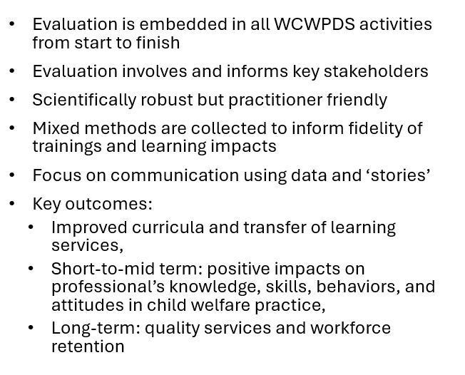
- Jenny reviewed the goals for the two evaluation areas that we worked on in 2025: WiLearn Youth Justice (YJ) and Nurturing Connections Training for Foster and Adoptive Parents

- Member Terms – Darin Smith
- 3 members whose term is up on 12/31/2025: Ann Price, Paula Winter, and Jada Hrubes
- Darin will reach out to each to see who is interested in continuing for another term

- Foundation Compliance – David Harkins
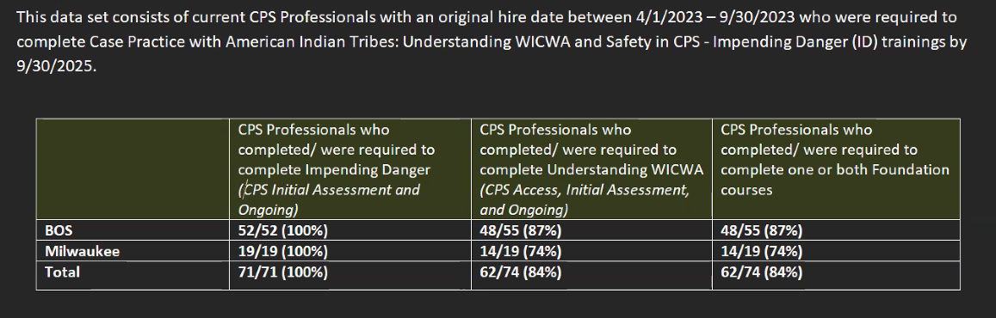

- WiLearn Compliance
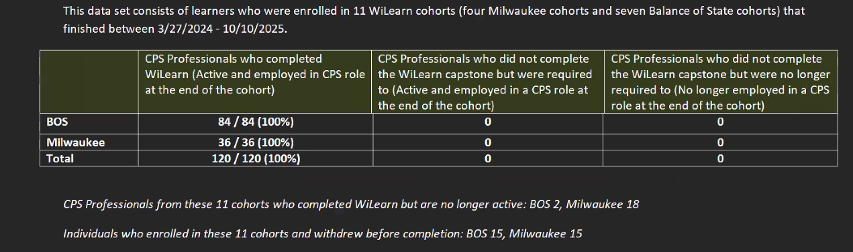

Next Steps - Darin Smith
- Key Messages
- Basic Intake Worker Training – outreach by Nicki to provide an overview at Regional Meetings to those regions who are interested
- Ongoing Collaboration with the tribes
- PR on the self-care learning collaboratives

