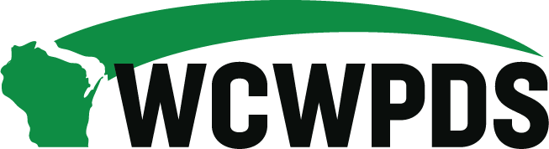

WCWPDS Steering Committee Meeting Notes
Tuesday, January 11, 2022, from 1:00pm-4:30pm

Discussion/Decision Items

- Welcome & Introductions
Meeting Attendees: Mika Makarovich (DMCPS), Fred Naatz (Grant County), Vicki Tylka (Marathon County), Mandy Stanley (Marquette County), Diane Cable (Eau Claire County), Lisa Roberts (Waukesha County), Jeff Jazgar (Menominee Tribe), John Elliott (DCF), Becky Yang (DCF), Emily Erickson (DCF), Michelle Rawlings (DCF), Darin Smith (WCWPDS-Madison), Stephanie Reilly (WCWPDS-Madison), Heather Halonie (WCWPDS-Madison), Julie Brown (WCWPDS-Milwaukee), and Ellen Smith (UW-Madison). Kris Korpela (Dunn County), Tania Cornelius (DCF), Jamie Keehn (DCF), Teresa Kovach (Portage County), Nancy Ortegon-Johnson (Dane County), Shelby McCulley
Guests: Colin Holden, Amy Smith, Jerry Hagen (CGI)

Overview of Agenda

Updates

Staffing: WCWPDS-Milwaukee has had two new staff begin last week to replace Mike Kluesner who retired and Dion Racks who stepped into Mike’s position: Renee Spielbauer and David Foley as training staff.

WCWPDS-Madison has hired a new Instructional Design Manager as DoIT on campus will no longer be able to work with WCWPDS. Jennifer Filz started in this position on January 2.

Face-to-face switch to virtual: We have several foundations that were designated to begin in a face-to-face format. However, with rising cases of COVID it was decided that each training would be staffed 6 weeks ahead of time to decide whether to hold it face-to-face or move to a virtual format based on the current pandemic numbers. Currently all training through February will be held virtually.

- New Worker Training Update

WCWPDS has been working with Knowledge Launch out of Tennessee. They were initially asked to work on our Initial Assessment foundation training and developed an end-to-end virtual training delivery model. They have been working on all the different elements of the NWTP and developed them into one comprehensive training model. It has been reviewed and feedback has been provided back to Knowledge Launch. The vast majority of content will be delivered in an asynchronous format. It will begin with a face-to-face community kick-off, then workers will do work in an asynchronous format, and then come back together in community huddles to discuss what they’ve learned.

Question: Critical thinking was mentioned as one of the elements—how is that being presented? This content comes from the Information Collection course offered through Milwaukee and will be presented while learning about safety decision making.

WCWPDS put an RFP out on January 10th. There are 8 elements to the NWTP. The RFP are asking for vendors to propose an activity-based detail design for these elements as well as complete the development work for all components of the design. The RFP is looking at the cost and experience of the responding agencies with this type of work. We are not interested in purchasing an existing program—we want them to be flexible in looking at different ways that content can be delivered.

Responses are due January 31 with the vendor selected by end of February and the contract signed and ready for work on March 1. Some of the development work will be completed by WCWPDS, but we will not know how much until the RFP comes in.

Communication: DCF has created a menu of communication tools. They have developed a list of what they want to communicate with key groups along with a menu of how that information will be shared. These include the website, events like lunch and learns, and social media. We are shifting to more outward-facing communication methods including information through the Family First website and newsletter.

DCF is now focusing on agency readiness to shift to the new program which is currently being referred to as Initial Child Welfare Professional Training. There is a communication timeline:
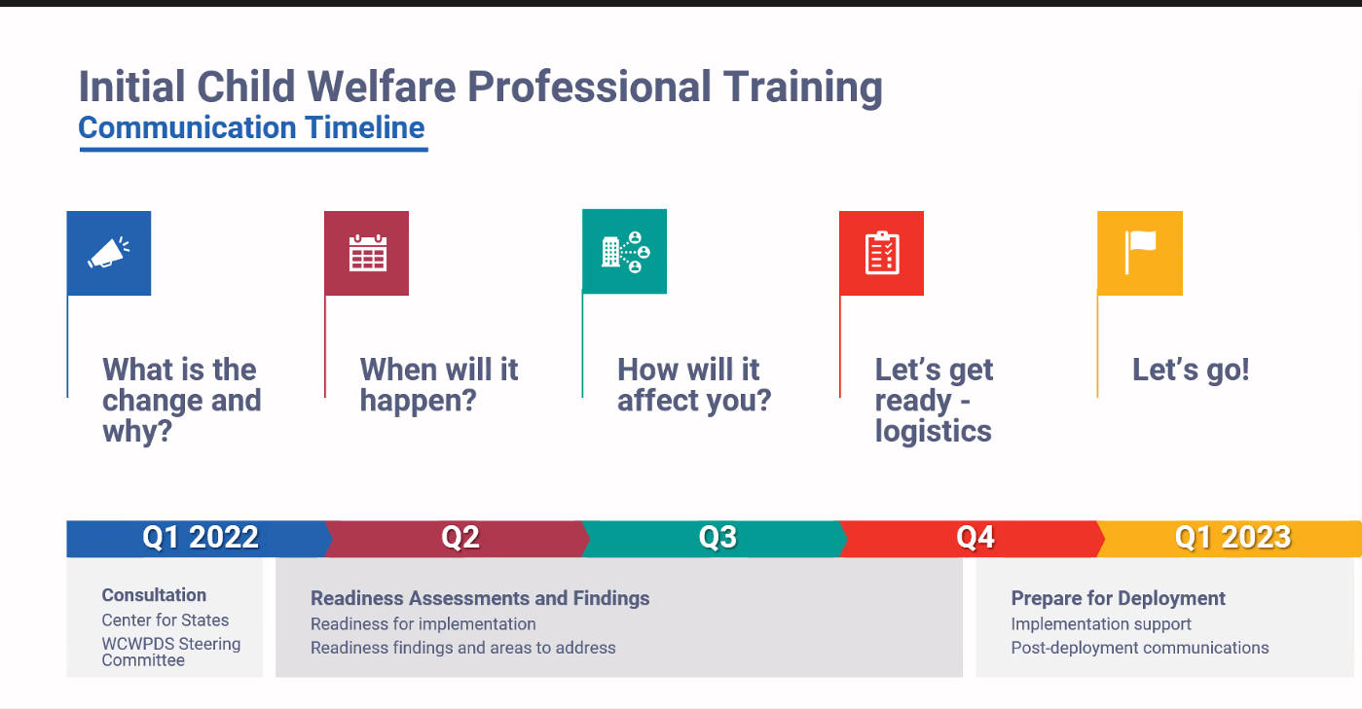

Vicki shared that she thought Directors have been well-informed about the upcoming changes and wondered how much time will be spent on communicating the “what” and “why” versus getting the workforce ready. Becky shared that much of this information is being provided to the new child welfare professionals, but want to hear from Directors where else they need to communicate this information. Diane shared that the most important audience is the CW supervisors as they’ll be the one working with the new workers. Kris stated that it will be essential to help supervisors navigate the new program when there are issues—such as being short-staffed.

Jeff expressed concern with the name Initial Child Welfare Professional Training since the acronym ICWPT could be confused with the acronym for Indian Child Welfare (ICW).

Question: What about the people in transition (ie. Already taking Foundation when the program rolls out)? WCWPDS has been discussing this and will make it part of the communication plan as we begin to talk about how agencies will be affected and logistics. It is felt that the best audience for this information is at regional supervisor meetings. Mika can help plan communication to DMCPS and tribes can be included through the ICW Director meetings.

Kris stated that she likes the town hall format as you can reach people from various levels within organizations at the same time and have been a helpful way to receive information in the past.

- Learning Strategies Unit Proposal Option

This concept was presented at our last Steering committee meeting with the commitment to come back this month with more information. Julie presented a PowerPoint that was included in the meeting materials—see Learning Strategies Steering Committee presentation. The general idea is to create a program that reflects needs and the best practice strategies for addressing them. We would begin by building regional coaching capacity that supports another key priority and allows for flexible support. Over time a cadre of coaches that are able to support key aspects of agency practice will be developed.

Question: Will these coaches be existing staff? They could be. There are many talented people around Wisconsin who could be WCWPDS staff and/or agency staff.

Question: Could we develop regions where there are panels regularly held to discuss certain questions/topics? We should have some concept of what we are aiming this toward before choosing what format we are going to use.

A regional approach could be helpful in helping staff implement the concepts they learn in training through coaching and mentoring. This could be very individualized in that we could be doing regional forums, agency-based coaching, or a variety of other ways.

Suggestion in chat: Look to Gallup StrengthFinders for a conceptual model. They have a formal coaching training program on individual and group application of the StrengthFinders tool.

Income maintenance consortiums have developed this over time. Supervisors began having discussions around needs and then began breaking down responsibilities based on the strengths within the groups. Breaking the state into regional groups may be a helpful starting point to help organize and figure out what the needs are and where the strengths exist. Instead of starting with concepts and finding the people, start with the people and develop the concepts.

For a possible name of this “program” Vicki suggested Maximizing Learning Concepts (MaxLearning for short).

- eWiSACWIS Training Update

WCWPDS approached CGI last year and work on the training began in 2021. We were going to develop web-based modules. Jerry from CGI overviewed the 8 modules that were developed and will be launched very soon.
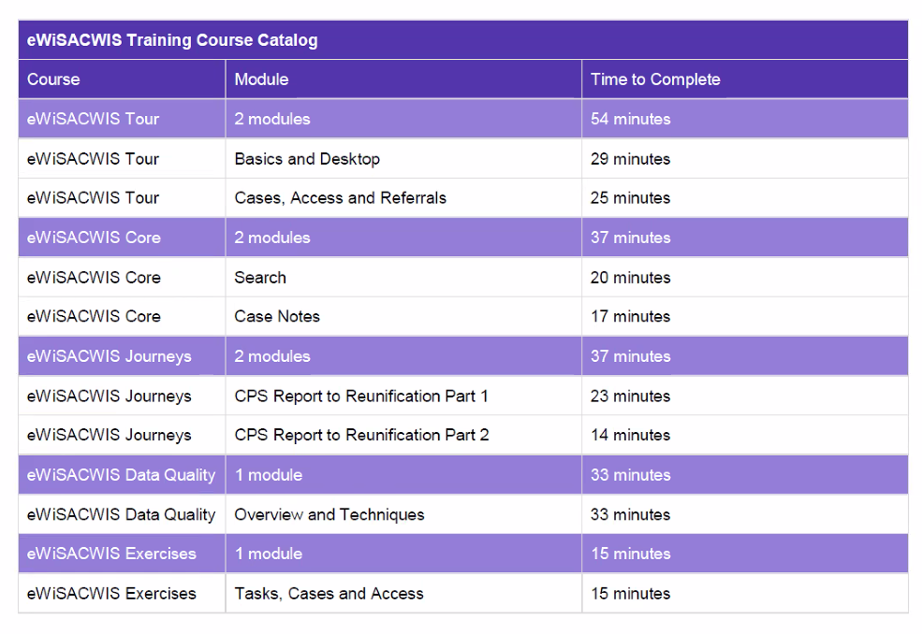
Colin gave a demonstration of the “Search” module. The table of content is more extensive than most web-based modules to make it easier for learners to go back and find pieces of information when they need them. Each module has some type of interactive component to them—including quizzes and exercises. Directors were appreciative of the extensive table of content and the time that it will save them in training new workers.

The training will be housed both in PDS Online and on the WCWPDS website. CGI is done with development and WCWPDS Instructional Designers are working on getting them ready to go. Stephanie Reilly will send an email out directing people to the new training. The anticipated date is by January 31. As we move forward, we can assess what those who have completed the training feel would be helpful in developing future modules.

- Priorities 2022

Stephanie shared a PowerPoint presentation—see 2022 Training & Development Priorities Preview for 1-11-2022 Steering Committee Meeting FINAL. The focus for 2022 will be:

- continued development of the New Worker Training Program
- preparation for the 2023 roll-out of the New Worker Training Program
- expanded offerings of safety-related training topics
- continued support of new and ongoing DCF special projects

Preservice Development priorities:
- revisions to the Court Pre-Service module
- revisions to the Domestic Violence and Child Maltreatment section of the Co-Occurring Considerations Pre-Service module
- minor revisions to the eWiSACWIS section of the Introduction to Child Protective Services module to bring in reference to the new eWiSACWIS web-based training
- revisions needed to pre-service (1) related to Ethan’s Law, (2) based upon changes to the Safety Intervention Standards, and (3) based upon changes to the permanency plan, as the training needs to stay current with policy

We reviewed priorities for: Worker Foundation Training, Worker Foundation Development, Ongoing Worker Training, Youth Justice Training & Development, ICW Training & Development, Supervisor Training & Development, Web-based Development, Foster/Adoptive Parent Training & Development, Congregate Care Training & Development, Ongoing DCF Special Projects, and New DCF Special Projects.

Additional professional development opportunities to support in-home safety-related training will be provided, including:

- ALC focus for 2022 will be around safety-decision making at Access
- Present Danger and Protective Planning: Safety Salon Blog (monthly video blogs) & Office Hours (March-December)
- Impending Danger Initial Assessment topics
- Impending Danger Ongoing topics

County Identified Priorities

A web-based training focused on “Civil Rights for CPS and YJ Professionals” will be developed. The sections are introduction, laws, and agency responsibility with a knowledge test at the end which workers must complete with at least an 80%. Darin demonstrated the existing training which is an “Introduction of Civil Rights for DCF Programs” to give people an idea of what it will look like. WCWPDS is exploring ways we can document that people have completed the training.

Secondary Traumatic Stress – WCWPDS is wondering what people are wanting from this training as attendance has been dropping for this training for the past several years. Milwaukee just offered this training in November and only 5 people registered. Stephanie is taking this to the CYF PAC meeting to pull together a limited-time workgroup to look at what has been done historically, and what should be done in the future. Stephanie is looking for feedback about what the hopes/thoughts for this training are as it was identified in the different regions.

Vicki shared that in the Northern region it came up as a worker retention issue—especially with the pandemic and our current political climate. There was also the practical issue of how to put the information into practice once workers get back to their agencies. Lastly, there were thoughts that it may be helpful to offer this in a regional or agency-based format to help workers create support systems.

Diane thought people need to be aware that they can go to this training as a reoccurring training. The training is not just about understanding STS, but that we are experiencing things differently and this training may be a place they can go to have discussions about dealing with current issues.

Safety Booster & Offerings – Amy Smith presented on what additional safety offerings will be provided based on the county priority item and the formats that will be utilized to hopefully meet the identified need. The 2022 offerings will include a Present Danger at Access booster through the ALC program, a Present Danger and Protective Planning Safety Salon offered monthly with synchronous feedback opportunity and Impending Danger IA & Ongoing boosters delivered in a hybrid manner with asynchronous and synchronous components. Initial offerings of these items will begin in Q1/2 2022.

- Member Terms – OE Project Item

We ran short of time so will move this onto the next agenda, but Darin asked people to consider how long we think terms for this committee should be and how to stagger them.

- Next Steps

Key Messages from the 1/11/2022 Steering Committee Meeting:

- Communication plan for the new worker training program
- eWiSACWIS web-based training is coming soon and the details will be communicated to counties by the end of the month.
- Face-to face trainings may be switched to virtual training depending on the risk posed by COVID—this will be reviewed by WCWPDS six weeks prior to each training.

