 | Spaced Education 2025  Topic: Child Welfare and Domestic Violence | 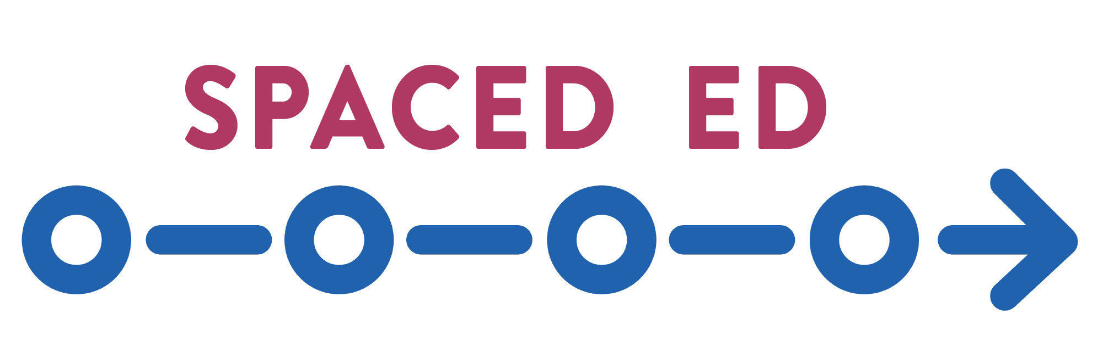

2025 Executive Summary
Background
Spaced Education is a simple, efficient learning modality based on two key adult learning principles: the “spacing effect”, when important information is presented and repeated over time, and the “testing effect”, when we use a testing format to solidify learning. DCF in collaboration with WCWPDS utilizes Spaced Education to support topics identified by CQI and DCF priorities. Participants in Spaced Education are either proxy/automatically enrolled or self-enrolled based on their role in child welfare.

Spaced Ed 2025: Child Welfare and Domestic Violence
One cohort of the 2025 Spaced Education curriculum “Child Welfare and Domestic Violence” was offered (10/21/25 – 12/12/25). The curriculum consisted of 7 multiple choice or true/false questions sent to participants on a weekly basis pertaining to child welfare practice when domestic violence is present. Information for the curriculum and discussion guides was drawn from: Child Protective Services Access and Initial Assessment Standards, Ongoing Services Standards and the Domestic Violence Handbook.

Spaced Education 2025 Child Welfare and Domestic Violence Participation
Total Registrants: 1568
Registrants who participated: 956 (61%)
Registrants who did not participate: 612 (39%)

Participation Rate of Those Enrolled
 | Total Count | Completed 1+ questions | Completed all 7 questions
All Self-Enrolled | 84 | 76 / 90.5% | 47 / 56%
All Proxy-Enrolled | 1482 | 880 / 59.4% | 486 / 32.8%
All Child Welfare Professional | 1308 | 799 / 61.1% | 444 /33.9%
All Child Welfare Supervisor | 248 | 157 / 63.3% | 89 / 35.9%

2025 Evaluation Results
The evaluation survey was sent on 12/17/2025 with 316 participants responding. The graphs represent a response rate of 33.1% of participants who answered at least one question (956) in the curriculum.

Question 3.1: Question scenarios were realistic and relatable to my practice:

Question 3.2: I was able to complete each Spaced Education question in 5 minutes or less:

Question 3.3: The feedback provided after answering each question was relevant and helpful to my learning:

Question 3.4: I discussed Spaced Education Domestic Violence questions/answers with colleagues and/or my supervisor as part of a unit, team or individual discussion:

Summary
Spaced Ed 2025 had a 61% participation rate. Self-enrolled participants had a higher rate of completing all 7 questions (56%) compared to those who were proxy/automatically enrolled (32.8%). Participants agreed or strongly agreed (90+%) that question scenarios were realistic and relatable to their practice, the feedback provided after answering each question was relevant and helpful to their learning and the learning was “quick”.

