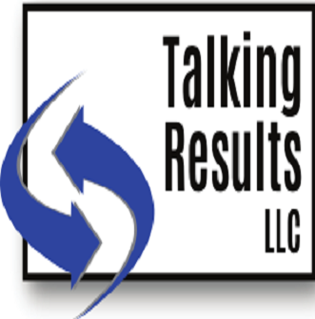

**Service Offerings**

Talking Results, LLC is a consulting business that specializes in facilitating and conducting Organizational Effectiveness (OE) projects for counties and governmental agencies.

Tammy is the founder of Talking Results, LLC, a company that partners with county agencies to help them gain clarity on their vision, design their organizational culture standards and develop strategies to achieve their organizational goals. This is done using the Organizational Effectiveness process.

Tammy has over twenty years of county government experience in various roles including being a Social Services Director and a Human Services Director and over five years of experience facilitating Organizational Effective projects. Tammy has an MBA, a Bachelor of Science Degree in Human Services and a Bachelor of Arts in Business Administration.

Services that Talking Results, LLC provides, however is not limited to include:

* Organizational Effectiveness (OE)
* Facilitating Organizational Change
* Mentoring/Coaching/Training for Directors, Supervisors and Managers
* Strategic Planning for Counties, Organizations, Agencies and Departments

Checkout Talking Results, LLC:

* [www.talkingresultsllc.com](http://www.talkingresultsllc.com)
* https://www.facebook.com/talkingresultsllc
* www.linkedin.com/in/tammy-tom-steinmetz