#### DAPIM™ Process Work Products Guide

This guide is designed to assist a facilitator in developing an understanding of the types of work products that should result from each phase of the DAPIMTM process as well as the types of things the facilitator should be thinking about to ensure a quality product. The facilitator can use this guide for an at-a-glance review to ensure that appropriate task and team activities have been facilitated and the necessary products developed prior to moving to the next phase of a continuous improvement effort using the DAPIMTM approach.

The DAPIMTM model, when applied in a learning by doing format, provides a framework for systematically improving or innovating something within the organization. DAPIMTM is the following step-by-step approach:

**Step One: Define** priority improvements in operational terms.

**Step Two: Assess** observable, measurable strengths and gaps. Identify root causes and general remedies for priority gaps.

**Step Three: Plan** quick wins, mid-term, and longer-term improvements.

**Step Four: Implement** action plans while managing communication and capacity.

**Step Five: Monitor** progress, impact, and lessons learned impact for accountability and on-going adjustments.

At each phase of a DAPIMTM process, the facilitator should ensure that work products and related team-building experiences that prepare participants to move on to the next phase are completed. The following illustrates the work products to be completed; beginning on the next page are reflective thinking questions the facilitator should consider when developing the products.

Step One: Defining what you seek to improve in operational terms means facilitating discussion that identifies in specific, behavioral terms a meaningful real life issue that the participants are interesting in improving.

**Define**

Work products – baseline surveys and measures, alignment notes, initial feelings, ground rules, defined areas for improvement

**Assess**

Work products – findings: strengths and gaps, root causes and general remedies

**Plan**

Work products – quick wins, mid- and long- term improvement plans, communication and capacity plans

**Implement**

Work products – team activities, action plans, charters for working teams, communication efforts

**Monitor**

Work products – monitoring quick wins, and other changes, evaluations and measures of progress and impact

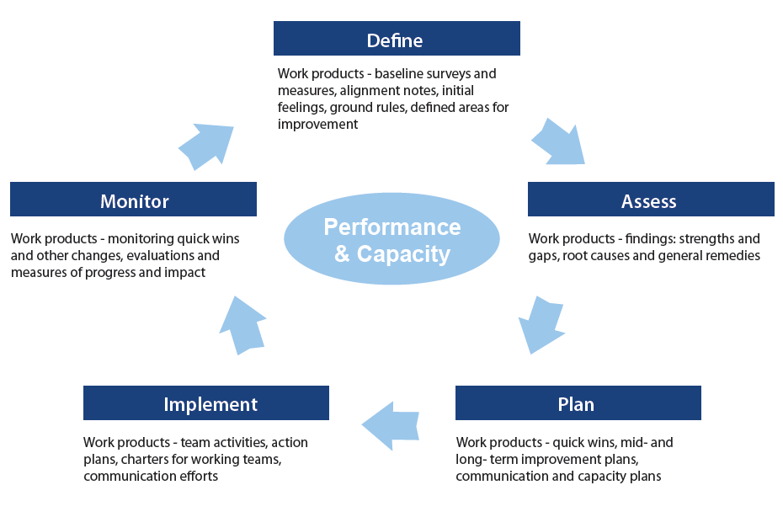

Specific work products that the team should complete include:

* Baseline surveys and measures
* Alignment notes
* Initial thoughts and feelings
* Ground rules
* Defined areas for improvement

To assist the team, the facilitator should consider the following:

* Have participants been introduced to learning by doing principles, the DAPIMTM flywheel and the purpose of continuous improvement?
* Have participants reviewed and discussed data about the organization currently available to them as it applies to the selected area for improvement? (e.g., turnover rates for retention issues or annual reports for casework specific concerns)
* Have initial thoughts and feelings of participants been explored with regard to the continuous improvement effort in general and the selected area for improvement?
* Has the readiness of participants been assessed to determine the kind of pace and scope of the overall continuous improvement process the group is ready for?
* Have ground rules been established for how participants will participate in the DAPIMTM continuous improvement process?
* Have participants clearly articulated in behavioral terms what it is they want to improve?
* Have all the step one work products (operations definition of the area to be improved, thoughts and feelings, ground rules) been recorded and reviewed by participants for accuracy and agreement?

**Step Two:** Assessing the current and desired state or situation requires the facilitator to engage participants in a reflective thinking process and facilitated dialogue around the current strengths and gaps the participants have as a team and as an organization in reaching their desired state. It then requires the facilitator to help participants build a bridge to planning by prioritizing identified gaps and identifying root causes and remedies for the highest priority gaps.

Specific work products that the facilitator should walk away with include:

* Findings: identified and prioritized strengths and gaps
* Initial quick wins
* Root causes and general remedies

To help the team identify findings and quick wins, the facilitator should consider the following:

* Have participants developed and/or been introduced to markers of effectiveness that will allow them to reflect on the issue at hand? (e.g., markers of effective meeting management, leadership or follow through)
* Have participants been introduced to models or tools that allow them to reflect on the issue at hand? (e.g., trust model, decision making model, or time management matrix)
* Have participants utilized reflective thinking guides that will allow them to reflect on the issue at hand?
* Have all participants openly shared what they see as the strengths and gaps in themselves, team members, and the organization?
* Have the participants reflected in immediate improvements they can make with minimal investments of time and energy (quick wins)?
* Have the quick wins, strengths and gaps been recorded and reviewed by participants for accuracy and agreement?

To help the team build a bridge to planning by prioritizing gaps and identifying root causes and remedies for the highest priority gaps, the facilitator should consider the following:

* Have participants identified the highest priority gaps to target for root cause and remedy analysis?
* Have participants been introduced to root cause and remedy analysis utilizing the Root Causes and Remedies slides?
* Have participants identified a range of root causes? Did they drill down deep enough? Are they balanced between structural and relational root causes?
* Have participants been introduced to the three types of general remedies?
* Have participants identified concrete remedies for their identified root causes? Are the remedies recommendations, decisions and commitments, and/or team activities?
* Have the priority gaps, root causes, and general remedies been recorded and reviewed by participants for accuracy and agreement?

**Step Three:** Planningfor both rapid and longer-term improvements requires the facilitator to engage participants in the development of commitments and plans that result in the desired improvements.

Specific work products that the facilitator should walk away with include:

* Additional quick wins
* Mid-term improvement plans
* Longer-term improvement plans
* Communication plans
* Capacity plans

To assist participants, the facilitator should consider the following when helping them make commitments and develop plans:

* Have participants been introduced to the types of improvement: quick wins, mid-term, and long-term?
* Have participants been introduced to the elements to consider with planning for improvement using the continuous improvement planning template?
* Have participants agreed on changes to implement (quick wins, mid-term, and longer-term)?
* Have participants thought through how improvement efforts will be communicated?
* Have participants been introduced to the elements to consider when planning communication using the communication template?
* Have communication plans been developed and implemented for all staff, clients, and other stakeholders impacted by the improvement work?
* Have participants thought through how improvement efforts will impact staff capacity?
* Have participants been introduced to the elements to consider when managing capacity using the capacity management guide?
* Have work capacity plans been developed and implemented for all staff impacted by the improvement work?
* Has the continuous improvement, communication, and capacity plans been recorded and reviewed by participants for accuracy and agreement?

**Step Four:** Implementingimprovement plans in detail require the facilitator to guide participants in the development of action plans and charters as well as engage them in team activities to support effective implementation of quick wins and plans.

Specific work products that the facilitator should walk away with include:

* Action plans and charters
* Communication efforts
* Team activities (if applicable)

To assist participants, the facilitator should consider the following:

* Have participants been introduced to the action planning/tracking quick wins tool and chartering template to assist them in implementing the improvement effort?
* Have participants developed action plans for work that needs to be completed and charters for work teams (if applicable)?
* Have action plans and team charters (if applicable) been put into writing and reviewed by participants for accuracy and agreement?
* Have communication and capacity plans from the planning phase been implemented?
* Have participants been introduced to the data collecting template to define measures of success and how they will be assessed?
* Have action plans, charters, and measures of success been recorded and reviewed by participants for accuracy and agreement?

**Step Five:** Monitoring plan progress and impact for accountability and on-going adjustments helps participants determine the impact of the improvement effort and apply lessons from the effort for ongoing adjustment and further continuous improvement. During this phase, the facilitator should be guiding the team through monitoring activities that allow for evaluation and measurement of progress, impact, and lessons learned. Re-adjustments of actions and plans can be developed as needed.

Specific work products that the facilitator should walk away with include:

* Monitoring of initial thoughts and feelings, ground rules, quick wins, and other changes
* Evaluation and measures of progress and impact
* Adjusted plans and lessons learned for further continuous improvement

To assist participants, the facilitator should consider the following:

* Have techniques for monitoring and evaluating team dynamics and their improvement efforts been introduced to the participants?
* Is the team monitoring plan progress, impact, and lessons learned, both with the facilitator and on their own?
* Has data been collected based on the measures of success?
* What does the data indicate, and have adjustments been made to actions and plans if needed?
* Have the adjustments to actions and plans been recorded and reviewed by participants for accuracy and agreement?
* Have successes been celebrated and shared internally and externally?
* Have successes been recorded and reviewed by participants for accuracy and agreement?