# The DAPIM™ Process: Balancing Safety and Accountability

Establishing a safe and trusting environment up front is critical to the success of a continuous improvement effort. When teams feel unsafe, they tend to experience a great deal of anxiety (“should I really stick my neck out here?”) or apathy (“how do I manage these people so they’ll leave me alone?”). Creating and maintaining trusting relationships establishes the safety needed for open and honest communication throughout a continuous improvement effort.

The facilitator must be familiar with the following elements of trust and engage in activities that reinforce these elements:

* Benevolence - kindness, caring;
* Integrity - no hidden agendas; honesty;
* Openness - vulnerability with information and authority;
* Reliability - what is committed to is done; and,
* Competence - capabilities expected for one’s role.

Trust and safety-building can be initiated prior to a continuous improvement effort using a variety of methods, such as the following:

* One-on-one interviews, focus groups and surveys;
* Sharing the agenda with participants prior to the session; and,
* Sharing information about the facilitator prior to the session.

Trust and safety can continue to be developed during a continuous improvement effort using methods such as the following:

* Sharing information early in the process about the facilitator’s background and familiarity with DAPIMTM tools and techniques – if the facilitator is new to the DAPIMTM process, this fact should be shared openly as a way to be transparent with the participants;
* Establishing ground rules for how participants and the facilitator will interact during the sessions, and holding participants accountable to these ground rules, especially ones concerning respectful treatment;
* Pointing out to the group when it appears there is an “elephant in the room,” encouraging them to be open and honest with one another and with the facilitator
* Being open to the ideas of the group and making related changes;
* Using the language of participants when recording their discussion, checking-in to ensure thoughts have been captured as the participants intended, and always working from their points of view;
* Following through with commitments made to the participants during the session in the timeframes agreed upon; and,
* Thanking participants for their time at the start and end of each session.

Once teams feel safe with the facilitator and each other, the emphasis of facilitation should evolve to building a shared sense of accountability for meeting demanding goals and following through on commitments made. Teams that feel safe but not accountable tend to go into a comfort zone where relationships are strong but challenges and hard work are avoided. The DAPIMTM process itself, mini-DAPIMTMs related to follow through and motivation (see chapter four) and reinforcing the task-based elements of trust-building -- reliability and competence -- all help facilitators build a shared sense of accountability on a foundation of team safety. Once teams are in this learning zone, they can improve their performance and capacity steadily over time.

Harvard’s Amy Edmondson has done some excellent work on learning organizations, and the Safety and Accountability Performance Matrix below is derived from her work. The matrix is also in the appendix of this chapter.

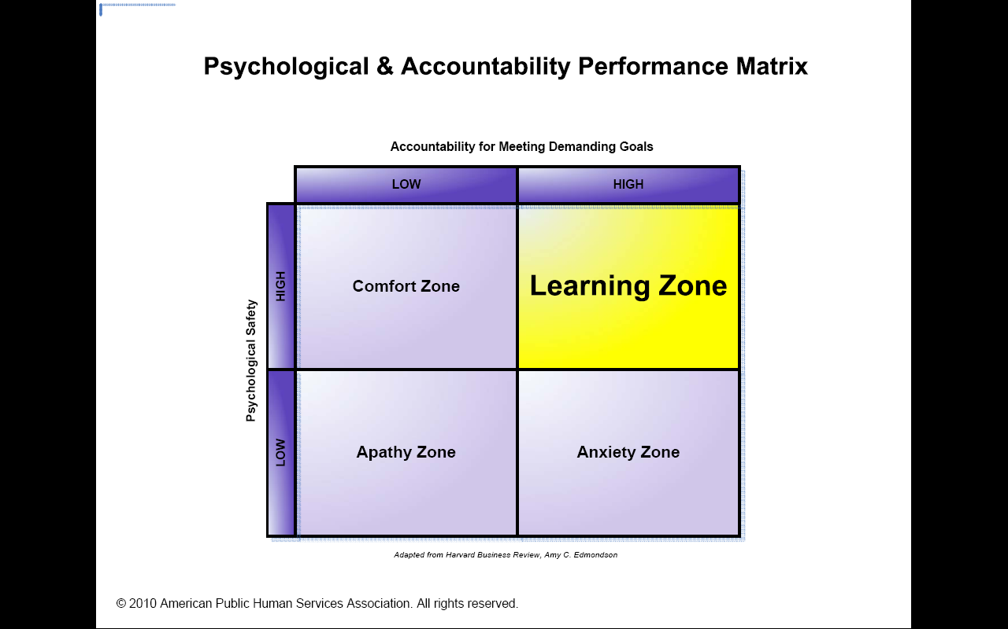

Edmondson’s research focuses on the role leaders must play to create learning organizations. She suggests that in order to create a learning organization, team leaders must continually clarify the meaning and importance of the team’s goals, make sure the goal is supporting the organization’s aim, and remain open to input from team members about ways to modify the team’s goal to implement new changes and overcome challenges the team faces in the organization. Leaders must set challenging goals and specific direction but still allow team members to be innovative within the provided structure for learning. This requires leaders to provide enough structure to ensure teamwork and engagement of team members without restricting their creativity, keeping the team in the learning zone. In effective learning environments, participants feel both safe enough to be open and collaborative as well as accountable for making improvements to their performance and capacity.

As continuous improvement teams begin to take accountability for their work, the OE facilitator must work closely with sponsor team members to ensure they are setting direction, linking goals to the organization’s aim and providing a structure that is safe and allows for risk taking.