Culturally Responsible Practice – Hybrid Course Workbook

Welcome to the Culturally Responsible Practice - Hybrid course. In this course we review the cultural competence standards that guide our practice, explore ways that cultural differences and biases can impact our practice, and discuss strategies to work with families in a culturally responsible manner.

These workbook pages will support your learning through this course and aid your supervisor in understanding the purpose of the course (see the Course Learning Objectives below), its sections (see Course Sections below), and how they can support you in your learning.

Throughout the workbook, you will find space to capture your responses to activities within the online modules – some of your responses will be brought to Community Huddles, while others may be shared with your supervisor or colleague for on-the-job application activities.

Course Learning Objectives
Upon completion of this course, child welfare professionals will be able to:
- Identify and manage personal cultural identity, preferences, and biases as they arise in child welfare practice and services.
- Review and discuss what the National Association of Social Workers (NASW) cites as the ethical responsibility in providing culturally competent services.
- Apply the four tenets of Cultural Humility for child welfare practice and child welfare professionals.
- Identify ethnographic interviewing techniques to engage with culturally diverse families.
- Practice preparing to interview for the family story.
- Adopt an intersectional approach to the diversity of cultural groups and their history in Wisconsin when providing child welfare services to children and families in Wisconsin.

Course Sections
This course contains the following sections:
- Prework for Community Huddle 1 – online content (45 minutes)
- Community Huddle 1 – virtual session via Zoom (120 minutes)
- Packet 1: NASW Code of Ethics and Application to Child Welfare Work – online content (45 minutes)
- Packet 2: Standards and Indicators of Cultural Competence and Cultural Humility – online content (20 minutes)
- Prework for Community Huddle 2 – online content (20 minutes)
- Community Huddle 2 – virtual session via Zoom (80 minutes)
- Packet 3: Ethnography as a Tool for Understanding Context and Culture and Minimizing Bias – online content (90 minutes)
- Packet 4: Application Activity – online module (35 minutes)
- Community Huddle 3 – virtual session via Zoom (70 minutes)
Prework for Community Huddle 1

Culture Defined

The word “culture” implies the integrated pattern of human behavior that includes thoughts, communications, actions, customs, beliefs, values, and institutions of a racial, ethnic, religious, or social group. Culture is often referred to as the totality of ways being passed on from generation to generation. Culture includes, but is not limited to, history, traditions, values, family systems, and artistic expressions of groups served in the different cultures related to race and ethnicity, immigration and refugee status, tribal status, religion and spirituality, sexual orientation, gender identity and expression, social class, and abilities. (From NASW Standards and Indicators for Cultural Competence in Social Work Practice.)

How do we practice cultural responsibility?

We seek to reduce bias and disproportionality at the individual, agency, and systemic level through a deep commitment to personal accountability and a genuine respect for embracing the similarities and differences of others.

Life Journey Map Activity

Cultural competence starts with an understanding of your own cultural identities before attempting to understand others who are culturally different from yourself.

To support this personal understanding of how culture has influenced your life, you are asked in your Prework to Community Huddle 1 packet to create a life journey map and bring it with you to the first Community Huddle. Complete the online Prework to Community Huddle 1 packet first and then return to this page for instructions on capturing your life journey map.

- Create your Life Journey Map

In this activity, you will create a picture of some big moments in your life. You will identify key moments, people, situations, or actions in your life that have had a significant impact. This reﬂective exercise supports thinking introspectively about those impactful moments. It also provides an opportunity to consider how behaviors and motivators in your life have inﬂuenced and shaped your cultural identify.

Map out your life journey from childhood to present. Make note of 6-12 events, people, decision points or life changes that shaped who you are today, focusing on important or significant “inﬂection points''. Others have included things like moving in grade school, their parents’ divorce, a first job, receiving a college acceptance letter, their first apartment, the beginning of a significant relationship, and accepting a position as a child welfare professional. Think of memorable decisions, incidents, and people who have inﬂuenced who you have become. Be expansive and creative! This is a ﬁrst look at how culture shapes human behavior.

You can do this activity in one of two ways. You can use the Life Journey Map page later in your Workbook (on the blank page following the instructions below), or you can create the map using a PowerPoint slide.

Instructions to complete your Life Journey Map:

Step 1: Create a road winding from the lower left corner to the upper right corner. Label the lower left “Birth” and the upper right “The Present.” (See picture below.)

Step 2: Be creative. You may include bridges, forked roads, roundabouts, exit ramps, construction, rest stops, or anything that symbolically represents how you make decisions about your life (e.g., traveled to a different country, lost a job, been fired, had a parent who struggled with substance abuse, etc.).

Step 3: Draw pin markers in the highway, each to represent places you’ve lived, key people you’ve known or who have inﬂuenced your life, and any other “landmarks” along the journey of your life (e.g., jobs, projects, relationships, accomplishments, failures, etc.).

Step 4: Along each side of the road, add billboards that make note of challenging and afﬁrming moments from your life. Think of those events, decisions, and turning points that taught you something that made a lasting impact on who you are.

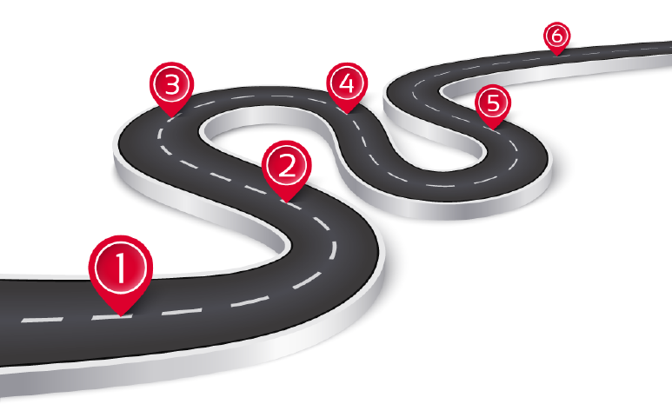

Sample of a Journey Map that captures significant moments, people, situations, or actions – in order from birth to present

- (Pinned landmark Item) Birth
- Family moves to Wisconsin from Illinois
- Attended Hardin Valley High Elementary School
- Begin playing soccer
- Mother falls ill with rare disease
- Graduates high school with honors
- Best friend dies in car crash
- Goes to college at UW-Madison
- Join intramural soccer team and meet best friend
- Get first apartment with friends
- Start dating Drew
- Change major to Social Work
- Do field placement at child welfare agency
- Break up with Drew
- Graduated from college
- Get 2 job offers and accept position at current agency
- (Pinned landmark item) Present

- When your Life Journey Map is completed, reflect on the following questions:

- What life lessons have you learned from your upbringing that have most influenced choices you have made as an adult?

- How do lessons from your childhood affect your perceptions of the world around you today?

- What cultural aspects of your identity must you be aware of to avoid bias in your professional role?

Be prepared to discuss these reﬂection questions and one insight that you gained from developing your life journey map during our Community Huddle.

My Life Journey Map
Community Huddle 1

Community Huddles are a way to discuss learning and build connections and community with your colleagues.

Community Huddles are held virtually via Zoom. You will find the date, time, and Zoom link for this Community Huddle within the Pre-Training email that you received from WCWPDS.

Please see that email for details about logging in to the Community Huddle and contact information should you have any questions about the Community Huddle.

During this Community Huddle, we will:
- Discuss the purpose and general expectations of Community Huddles
- Develop the cohort’s group agreement
- Define culture and discuss its role and importance in child welfare practice
- Experience how cultural differences can impact communication
- Discuss the dimensions of culture
- Preview course content

In this Community Huddle, we spend time:
- exploring how culture has impacted your behaviors, actions, and decisions by using the life journey map that you developed during Prework.
- exploring the impact of cultural differences on communication via an activity.
- developing an understanding of the dimensions of culture and their impact on your interactions with others.

Within this Community Huddle, there is one short reading that your facilitator will ask you to read during the Community Huddle: High and Low Context Cultures. You will find it beginning on the next page.

High and Low Context Cultures

Cultural context is a concept developed by cultural anthropologist Edward T. Hall who applied his field to the understanding of cultures and intercultural communications. He developed a useful way to understand culture by identifying their social framework as low or high context.

High-Context Cultures
In high-context cultures (such as those in Japan, China, Korea, and Arab countries), communication relies heavily on non-verbal, contextual, and shared cultural meanings and are more likely to be intuitive, contemplative, and concerned with the collective. In other words, high-context communicators attach great importance to everything that surrounds the explicit message, including interpersonal relationships, non-verbal cues, and physical and social settings. Information is transmitted not through words alone but also through non-verbal cues such as gestures, voice inflection, and facial expression, which can have different meanings in different cultures. Eye contact, for example, which is encouraged in North America, may have ambiguous meaning or be considered disrespectful in certain high-context cultures. Meaning is determined not by what is said but by how it is said and by how social implications such as the communicator’s status and position come into play.

Communicators in high-context cultures pay attention to more than the words spoken – they also pay attention to interpersonal relationships, nonverbal expressions, physical settings, and social settings. In high-context cultures, communication cues are transmitted by posture, voice inflection, gestures, and facial expression. Establishing relationships is an important part of communicating and interacting. Unlike the linear communication style preferred in low-context cultures, high-context communicators may use spiral logic, circling around a topic indirectly and looking at it from many tangential or divergent viewpoints. A conclusion may be implied but not argued directly.

Because directness may be thought of as disrespectful, discussions in high-context cultures can be circuitous, circling key issues rather than addressing them head-on.

Low-Context Cultures
Communicators in low-context cultures (such as those in North America, Scandinavia, and Germany) depend little on the context of a situation to convey their meaning. They assume that listeners know very little and must be told practically everything. Meaning depends on what is said- the literal content of the message- rather than how it is said. Information has to be explicit and detailed for the message to be conveyed without distortion. Low-context cultures tend to be logical, analytical, action-oriented, and concerned with the individual.

Low-context communicators don’t need to be provided with much background information, but they do expect messages to be professional, efficient, and linear in their logic. Conclusions are explicitly stated. Effectively communicating within this culture, therefore, requires messaging that is perceived as objective, professional, and efficient.
Communicating with high-context cultures can require those from a low-context culture to focus on politeness strategies that demonstrate your respect for readers and listeners.

[The Above information is adapted from: Intercultural Business Communication by Confederation College (https://ecampusontario.pressbooks.pub/communications/front-matter/adaptation-statement/), licensed under a Creative Commons Attribution-NonCommercial-ShareAlike 4.0 International License (https://creativecommons.org/licenses/by-nc-sa/4.0/).]

To Summarize:

A person from a High-Context Culture (HCC) usually:
- Relies on implicit communication - People of high context culture have been thought from early childhood to look for implied meaning. They believe that what is implied takes precedence over what he said. They will recognize discrepancies between actual words and intending meaning.
- Emphasizes nonverbal communication - Although non-verbal communication conveys meaning in every culture, people from HCC rely more heavily on non-verbal communication than people from LCC. The non-verbal communication provides “the context” for the conversation and therefore must be carefully observed for effective communication to take place.

In a high-context culture, there are many contextual elements that help people to understand the rules. As a result, much is taken for granted. This can be very confusing for person who does not understand the 'unwritten rules' of the culture.

A person from a Low-Context Culture (LCC) usually:
- Relies on explicit or lateral communication - LCC prefer that message be explicitly stated rather than simply understood by the parties involved.
- Emphasizes verbal communication over non-verbal communication - The phrases “what you mean” and “what you say” is often repeated to children from LCC as they are growing up. Parents pay far less emphasis on communicating indirectly or non-verbally and ask their children to “speak up”. So, by the time they enter business, people from LCC have learnt to rely on words to convey exactly what they mean.

In a low-context culture, very little is taken for granted. While this means that more explanation is needed, it also means there is less chance of misunderstanding particularly when visitors are present.

Dimensions of Culture

Factor | High-Context Culture | Low-Context Culture
Overtness of messages | Many covert and implicit messages, with use of metaphor and reading between the lines | Many over and explicit messages that are simple and clear
Use of non-verbal communication | Much nonverbal communication | More focus on verbal communication than body language
Expression of reaction | Reserved, inward reactions | Visible, external, outward reaction
Cohesion and separation of groups | Strong distinction between in-group and outgroup. Strong sense of family | Flexible and open grouping patterns, changing as needed
People bonds | Strong people bonds with affiliation to family and community | Fragile bonds between people and little sense of loyalty
Level of commitment to relationships | High commitment to long-term relationships. Relationship more important than task | Low commitment to relationships. Task more important than relationship
Flexibility of time | Time is open and flexible. Process is more important than product | Time is highly organized. Product is more important than process

Course Content Preview: What’s Next

- Packet 1: NASW Code of Ethics and Application to Child Welfare Work – Child welfare work requires compliance with numerous standards and practices. Above all, our work must be ethical. We’ll examine the National Association of Social Worker (NASW) Code of Ethics, which outlines the core values, ethical principles, and standards that should guide our child welfare practice.
- Packet 2: Standards and Indicators of Cultural Competence and Cultural Humility – Child welfare professionals should be able to respond respectfully and effectively to a diverse variety of people in a manner that recognizes, affirms, protects, and preserves the dignity of each person they interact with. We’ll explore cultural competence and humility as these standards are particularly important since children of color are overrepresented in almost every part of the welfare system.
- Prework for Community Huddle 2 – To better understand cultural competence and cultural humility, you will be asked to create a short story based on personal life events.
- Community Huddle 2 – One aspect of cultural humility involves critical self-reflection, or objectively evaluating your own personal preferences and/or biases. This Community Huddle will allow you to practice interacting with and listening to personal “stories.” The exercise allows you to develop empathy as you will feel what it is like to be vulnerable with others, and you will begin to uncover the mindsets and skillsets needed for your work with families.
- Packet 3: Ethnography as a Tool for Understanding Context and Culture and Minimizing Bias – Ethnography is a practice that relies on careful observation and considerate conversation to understand the “lived experience” of individuals. Another goal of ethnography is to recognize and minimize potential biases, like microaggressions. You will learn to understand cultural norms and practices by examining the individual’s content (environment) and activities and by listening to both verbal and nonverbal cues in conversations.
- Packet 4: Application Activity – To demonstrate your understanding of cultural competence and cultural humility, you’ll be asked to apply the skills of ethnography to a case scenario. You will read the scenario and prepare interview questions as if you were a child welfare professional working with the family.
- Community Huddle 3 – In this Community Huddle, you will discuss with fellow learners how you applied the concepts learned in this element to the approach you took in the case scenario application activity. We’ll explore remaining questions and share any particularly enlightening messages.

Use the space below to jot down any personal take-aways from Community Huddle 1.

Packet 1: NASW Code of Ethics and Application to Child Welfare Work

In the NASW Code of Ethics and Application to Child Welfare Work packet, you are asked to (1) write three specific, practical actions that you can take in your role as a child welfare professional based on the NASW core value “Dignity and Worth of the Person” at the conclusion of the first video, (2) write three specific, practical actions that you can take in your role as a child welfare professional based on the NASW core value “Importance of Human Relationships” at the conclusion of the second video, and (3) write a personal reflection. Use the sections starting below to record your activities as you complete the online packet.

In the box below, write three specific, practical actions that you can take in your role as a child welfare professional based on the NASW core value “Dignity and Worth of the Person” at the conclusion of the first video. (Link to the NASW Code: https://www.socialworkers.org/About/Ethics/Code-of-Ethics/Code-of-Ethics-English).

In the box below, write three specific, practical actions that you can take in your role as a child welfare professional based on the NASW core value “Importance of Human Relationships” at the conclusion of the first video. (Link to the NASW Code: https://www.socialworkers.org/About/Ethics/Code-of-Ethics/Code-of-Ethics-English).

Personal Reflection: Reflect on the other values and principles, and think about how they might apply to your work as a child welfare professional. Which are you most interested in exploring?

Space for any additional notes or questions about the NASW Code of Ethics and application to your child welfare practice that you’d like to capture for discussion with your agency supervisor.

Packet 2: Standards and Indicators of Cultural Competence and Cultural Humility

Understanding the cultural context is critical to our work in child welfare. Our actions as a child welfare professional can be impacted by how we adapt to a family’s culture. In this packet we examine the NASW Code of Ethics and the Standards and Indicators for Cultural Competence in Social Work Practice, and explore cultural competence, cultural humility, and privilege.

The full text of the Code of Ethics is available at: https://www.socialworkers.org/About/Ethics/Code-of-Ethics/Code-of-Ethics-English

While there are no activities within this packet that ask you to record anything within the workbook, space has been made available on this page should you wish to capture any notes or reflections for discussion with your agency supervisor.

Prework for Community Huddle 2

Share Your Story Activity

In preparation for Community Huddle 2, you are asked to create an outline of a story from one point in your life journey map or from another impactful circumstance.

The story should be about one of the following three topics:
- Your childhood
- Your first experience as the “only one” like you
- Your experience in a foreign country or unfamiliar environment

Below, make an outline of some of the key points you will share with a partner during Community Huddle 2. Also, make note of your feelings and emotions in the space below.

Please be ready to share your outline at the Community Huddle.
Outline of the key points in my story

Make note of your feelings and emotions in the box below.

Community Huddle 2

Community Huddles are a way to discuss learning and build connections and community with your colleagues.

Community Huddles are held virtually via Zoom. You will find the date, time, and Zoom link for this Community Huddle within the Pre-Training email that you received from WCWPDS.

Please see that email for details about logging in to the Community Huddle and contact information should you have any questions about the Community Huddle.

During this Community Huddle, we will:
- Share your stories from the Share Your Story activity in Prework to Community Huddle 2
- Learn more about the demographics of the families we serve
- Preview course content

In this Community Huddle, we spend time:
- reflecting on the impact of the NASW standards, values, and principles and privilege on your practice as a child welfare professional.
- debriefing the Share Your Story activity and considering how it applies to the families with whom you work.
- reviewing racial and ethnic disproportionality in Wisconsin’s Child Welfare System and discussing its implications for your work with families.

Within this Community Huddle, there is one short reading that your facilitator will ask you to read during the Community Huddle: Racial and Ethnic Disproportionality in Wisconsin’s Child Welfare System. You will find it beginning on the next page.

Racial and Ethnic Disproportionality in
Wisconsin’s Child Welfare System

As you learned in Packet 2, children and families of color are overrepresented in the child welfare system and are more likely to experience negative outcomes compared to white families.

- Families of color are:
- investigated more frequently
- their children are more often found to be “victims” of abuse, neglect, or maltreatment
- experience a higher percentage of child removals from family homes.

- Children of color are:
- more likely to experience multiple placements
- less likely to be reunited with their birth families
- more likely to experience group care
- less likely to establish a permanent placement
- more likely to experience poor social, behavioral and educational outcomes.

The overrepresentation or underrepresentation of a racial or ethnic group compared to its percentage of the total population is called disproportionality.

(From: https://www.ncsl.org/research/human-services/disproportionality-and-race-equity-in-child-welfare.aspx)

Children of color in Wisconsin are also overrepresented in the child welfare system, including the number of children reported, investigated, substantiated, entering and in out-of-home care, and in congregate care, as summarized in the table on the next page. (Table from Wisconsin Department of Children and Families, 2022.)

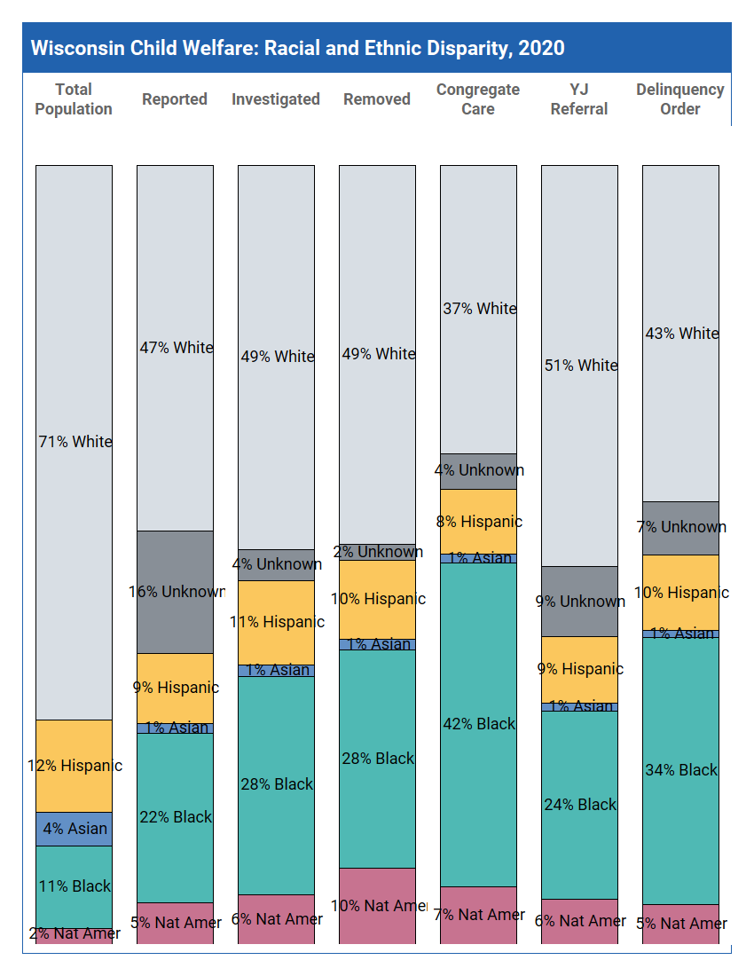

Course Content Preview: What’s Next

- Packet 3: Ethnography as a Tool for Understanding Context and Culture and Minimizing Bias – Ethnography is a practice that relies on careful observation and considerate conversation to understand the “lived experience” of individuals. Another goal of ethnography is to recognize and minimize potential biases, like microaggressions. You will learn to understand cultural norms and practices by examining the individual’s content (environment) and activities and by listening to both verbal and nonverbal cues in conversations.
- Packet 4: Application Activity – To demonstrate your understanding of cultural competence and cultural humility, you’ll be asked to apply the skills of ethnography to a case scenario. You will read the scenario and prepare interview questions as if you were a child welfare professional working with the family.
- Community Huddle 3 – In this Community Huddle, you will discuss with fellow learners how you applied the concepts learned in this element to the approach you took in the case scenario application activity. We’ll explore remaining questions and share any particularly enlightening messages

Use the space below to jot down any personal take-aways from Community Huddle 2.

Packet 3: Ethnography as a Tool for Understanding Context and Culture and Minimizing Bias

In the Ethnography as a Tool for Understanding Context and Culture and Minimizing Bias packet, you are asked to (1) write about a time when you committed a microaggression or were the recipient of a microaggression, (2) read the Thao Family Scenario, and (3) complete an ecosystem map for the Thao family. Use the sections starting below to record your activities as you complete the online packet.

In the box below, write about a time when you committed a microaggression or were the recipient of a microaggression.

Family Ecosystem Map Network Components

The chronosystem may include a change in family structure, address, parents’ employment status, as well as immense society changes such as economic cycles and war.

The macrosystem is the largest and most distant collection of people and places to the children that still have significant influences on them. This ecological system us composted of the children’s cultural patterns and values, specifically their dominant beliefs and ideas, as well as political and economic systems.

The exosystem pertains to the linkages that may exist between two or more settings, one of which may not contain the developing children but affect the indirectly, nonetheless. Such places and people may include the parents’ workplaces, extended family members, and the neighborhood the children live in.

The mesosystem encompasses the interaction of the different microsystems which children find themselves in. It is, in essence, a system of microsystems and as such, involves linkages between home and school, between peer group and family, and between family & community.

The microsystem is the smallest and most immediate environment in which children live. As such, the microsystem comprises the daily home, school or childcare, peer group and community environment of the children.

Adapted from https://www.simplypsychology.org/Bronfenbrenner.html
Scenario: The Thao Family

Chee Thao is a 20-year-old, second generation Hmong American, and mother of two small children. She lives in a duplex on the westside of Milwaukee with her roommate and the Xiong Family. The Xiong Family occupies both floors of the duplex. Chee moved to Milwaukee with her husband, Kim, three years ago. Her extended family lives in Chicago, IL.

Chee reports that her husband travelled out of state to work on a disaster clean-up crew in the Mississippi gulf. She felt that it would not be wise to travel with two small children. Because of this, Chee made the difficult decision to remain in Milwaukee with their children. The distance has been challenging for the couple’s relationship. The clean-up crew travels a lot, so Kim does not have a fixed address. Kim sends money, when possible, although there is not a set schedule for when he can do so. They have not lived together as a family in six months.

Chee moved in with the Xiong Family after her children were removed three months ago.

Ling and Melissa are 2 years and 13 months old respectively. The children were placed in out-of-home care because the medical regime set for Melissa by her doctors was not being performed in home despite several attempts at safety intervention. Melissa has severe asthma and dermatitis caused by allergies. She also has food and environment restrictions because of her allergies. Her pediatrician and nurse practitioner have made CPS referrals because the specifically prescribed care for Melissa was not performed, and Melissa was treated at Children’s Hospital’s emergency room for asthma attacks five times in one month.

Chee has been very communicative with her family’s child welfare professionals and the foster family her children are placed with. Chee has never missed a visit with her children, any of their doctor’s appointments or any other expectation given to her by the courts.

-------------------------------------------------------------------------------------------------------------------------------

Print off the Ecosystem Map on the next page and complete it for the Thao family.

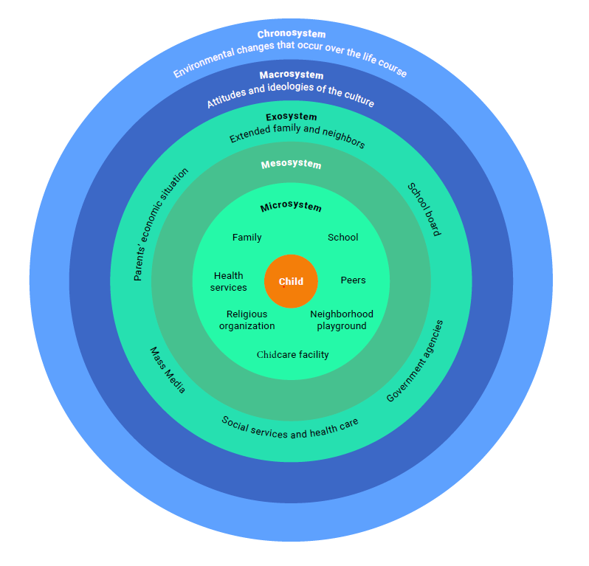
Adapted from https://www.simplypsychology.org/Bronfenbrenner.html
THAO FAMILY ECOSYSTEM MAP
Mesosystem
Exosystem
Macrosystem
Chronosystem
Microsystem

Packet 4: Application Activity

In the Application Activity packet, you are asked to (1) review the Thao Family Scenario (located previously in this workbook), (2) answer a series of questions related to the scenario, (3) write a brief summary of your approach to remaining culturally responsible, and (4) complete a self-reflection. Use the sections starting below to record your activities as you complete the online packet.

Review the Thao Family Scenario (located previously in this workbook), then answer the series of questions in the boxes and lines below.

Who would you interview?

Record the 5 interview questions would you ask? (Hint: review the awareness, understand, and do/skill questions in the online packet on slide 1 for considerations.)

After you have watched the video of the child welfare professional explaining their approach to remaining culturally responsible within their practice in child welfare, write a brief summary in the box below of the approach you will take to remain culturally responsible in your practice with families. Bring it to our next Community Huddle.

Self-Reflection

In the packet, you are asked to think over all we have learned in the Culturally Responsible Practice element: self-awareness, culture, the NASW standards and practices, storytelling, ethnography, and application. Record your answers to the questions in the boxes below.

What more do you need to feel confident that you can engage with families to learn about their cultural identity ad tailor your way of working with them based on that information?

What was the most challenging part of the content and why?

Be prepared to discuss these reﬂection questions during our Community Huddle.

Space for any additional notes or questions you’d like to capture for discussion with your agency supervisor.

Community Huddle 3

Community Huddles are a way to discuss learning and build connections and community with your colleagues.

Community Huddles are held virtually via Zoom. You will find the date, time, and Zoom link for this Community Huddle within the Pre-Training email that you received from WCWPDS.

Please see that email for details about logging in to the Community Huddle and contact information should you have any questions about the Community Huddle.

During this Community Huddle, we will:
- Reflect on your learning in this course
- Share lingering questions and concerns around practicing in a culturally responsible manner
- Create final reflections and commitments

In this Community Huddle, we spend time:
- reflecting on the impact of an ethnographic perspective, intersectionality, PIE, and your personal biases in your practice as a child welfare professional.
- applying the concepts/practices to the Thao Family scenario via a small group discussion.
- exploring lingering questions.
- developing an Action Plan to apply what you have learned in this course.

Action Plan

Culturally Responsible Practice - Hybrid

Please list three important concepts, ideas, or skills which you plan to take from the training and implement in your work.
1.
2.
3.
Identify a plan to implement these concepts upon return to your agency.

Identify resources that will help you to implement this plan.

Identify any barriers to the implementation of this plan.

Please share and discuss your Action Plan with your supervisor.

