**Present Danger and Protective Planning Learning Collaborative: Topics**

Below is a general outline of the topic areas that will be addressed; however, this list is flexible, and topics identified by the group may be added.

**Topics include:**

**Engagement to Collect Information**

**Sept**

**August**

**May**

**April**

**March**

**June**

**July**

**October**

**Who to Consider**

**Present Danger Threats**

**Observable Conditions and Significance**

**Immediate**

**Severe Harm**

**Protective Action Options**

**Strategies for Protective Plans**

**Nov**

**Protective Planning Roles**

**Creating & Managing Protective Plans**

**Dec**

The Present Danger and Protective Planning Learning Collaborative is an opportunity to improve your analysis and decision-making in identifying present danger threats and creating protective plans to address them. It will reinforce what you already know and provide new ways of viewing the work.



Outreach and Safety Coaching Specialist:

Erin Nasgovitz

[safety@wcwpds.wisc.edu](mailto:safety@wcwpds.wisc.edu)

(414) 339-2239

**Present** **Danger & Protective Planning Learning Collaborative**

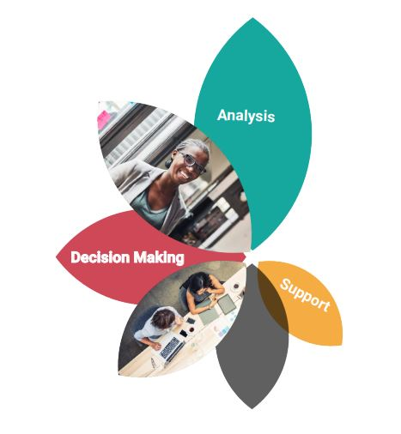

If you cannot see where you are going, ask someone who has been there before.

-J Loren Norris

**Present Danger and Protective Planning Learning Collaborative: Target Audience**

The Present Danger and Protective Planning Learning Collaborative is for CPS professionals; Access, Initial Assessment, and Ongoing workers; who have completed the Pre-Service Safety Module and Safety in Child Protective Services – Present Danger. Supervisors and directors may also join the learning collaborative.



“Continuously learning helps fully develop natural abilities, and creates a curious, innovative mind.”

Dr. Amil Kr Sinha

**Present Danger and Protective Planning Learning Collaborative: How It Works**

Each month (March 2022 – December 2022), a video blog with present danger and protective planning elements will be introduced. The video will be posted on the Wisconsin Child Welfare Professional Development System website by the first Wednesday of each month. CPS professionals can watch the video at a time that is convenient for them. The video blogs will be archived on the WCWPDS website.

A short worksheet with prompts to guide reflection and analysis and application to practice will be posted with the video.

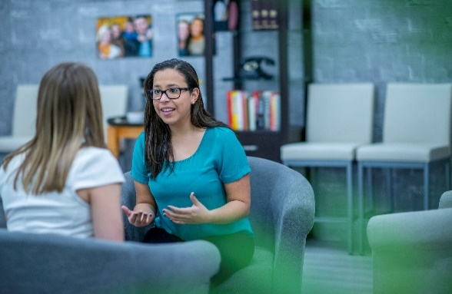

CPS professionals will apply the safety concept throughout the month in their daily practice. They will take note of the successes and challenges and questions on the concepts. Comments and questions will be gathered on the website (after each video blog) to guide group live discussion.

**Present Danger and Protective Planning Learning Collaborative: Coming Together**

A live facilitated discussion will be held via Zoom on the **last Tuesday (3:00 pm – 4:00 pm and Wednesday (8:30 am – 9:30 am) of each month.** Please watch the video blog for the current month before choosing the discussion to attend. *A flyer with all 2022 dates and times is located on the website.

The session will be a deeper look at practice implications when thinking about and using the safety concepts. The group will gather insights and ideas from their peers.

It will only be necessary to attend one of the discussion sessions. There is no need to register; you may use the following link to join the discussion sessions: <https://uwmadison.zoom.us/j/96597115996?pwd=Y1dLYUpWMHJjRGFueE55VnJDcGVUdz09&from=addon>

Meeting ID: 965 9711 5996

Passcode: 249193