Culturally Responsible Practice

**Explorations**

Transfer of Learning Activity

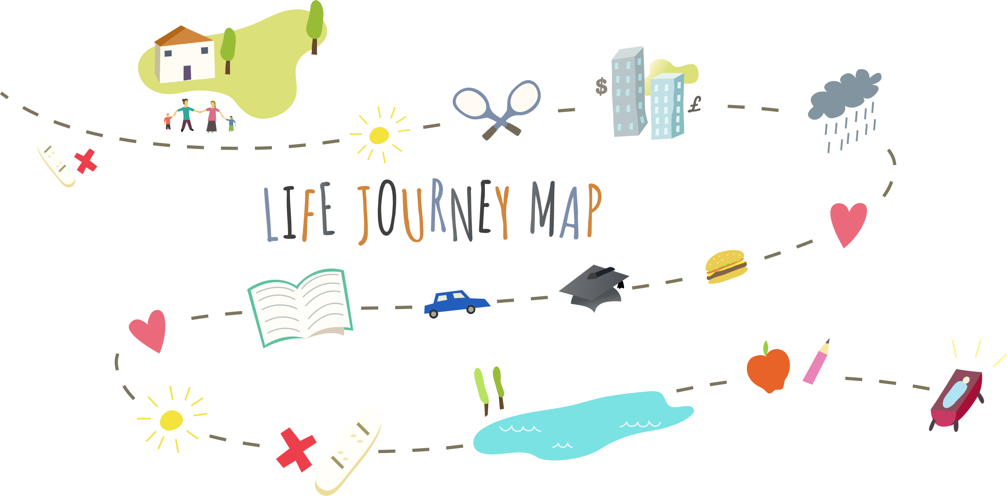

**Set-Up Instructions**

During the Community Huddles, learners completed a life journey map, to picture big moments. Included were identifying key moments, people, situations, or actions that have had a significant impact. This reﬂective exercise supports thinking introspectively about those impactful moments. It also provides an opportunity to consider how behaviors and motivators in life influence and shape cultural identity.

The following explorations can be used with staff to coach them through possible situations where their past lived experience may shape engagement with families. This is an opportunity for you to coach them through these interactions. The idea is to help staff consider different types of people and cultures they may encounter in their interactions with families. We want them to think about cultures different than their own and begin to consider how they may react in situations where they may not understand the cultural context of that particular family. Remember that culture encompasses factors beyond just race and ethnicity and can include such factors as socioeconomic status, rural vs urban settings, religious beliefs, and sexuality – among many other characteristics.

**Exploration 1**

*(Questions to be asked by Supervisor in conversation with a child welfare professional):*

Imagine yourself on the job in the future, interacting with someone on your own, without a supervisor present. Now imagine a challenging, uncomfortable, but nonviolent interaction with someone. This could be a reporter, a family member, a child, someone who you will interact with on the job. It’s the challenging interaction you’ve dreaded since you took on the role of child welfare professional. This interaction is one you have wondered how you will react when confronted with it and try to imagine how to handle it as a professional. First imagine that interaction. Then flesh it out for me. Who are you interacting with? Why? What is their background, life situation, and attitude? Be honest and be specific.

*(****Note****: the child welfare professional may begin describing an interaction that is challenging because the subject matter is challenging (i.e. “I dread getting an access call about. . . “). Make it clear that you are exploring a situation where it is about something specific about the person you are interacting with rather than being uncomfortable with an angry or aggressive individual.*

Think of the person you’re interacting with. Are they similar to you? How? Are they different from you? How? Do those differences or similarities make the imagined interaction more challenging? Are there life experiences in your history that make the interaction more challenging? How? Identify at least two things (differences, similarities or life experiences) that drive your concerns about that this interaction will affect you.

**Exploration 2**

*(Questions to be asked by Supervisor in conversation with a child welfare professional):*

You’ve identified an interaction that may be challenging and hopefully identified what makes that interaction so potentially challenging for you. Your unique life journey has prepared you for many challenges by giving you tools. And it may make you feel less prepared for others. How do lessons or experiences from your life your perception of the situation? How does your cultural or family background affect your perception of the situation?

**Learning Objectives:**

* Child welfare professionals will describe challenging interactions with families, including verbal and/or emotional reactions from those families, that they know will be very challenging for them.
* Child welfare professionals will explore how their background and history, including class cultural ethnic family and trauma history, influences their perceptions of what interactions will be most challenging.
* Child welfare professionals will begin a dialogue with their supervisor about the interactions with families they are concerned about what they will find most challenging and draw on their supervisor’s experience and expertise.
* Child welfare professionals will practice using the Life Journey Map as cultural information gathering tool.