Module 6 Caregiver Self-Care

1. Module 6: Caregiver Self-Care

1.1 Foster Care Overview

Notes:
This module, called Caregiver Self-Care, will help to show you how being a foster parent can affect your family, and about the stress that comes with fostering, grief and loss felt by the caregiving family, the importance of taking time for yourselves, and about reaching out for support and assistance. You have learned about how children and birth families feel about being in foster care, and in this module you will learn how children entering and leaving your home may affect you and your family.

If you are related to the child or are a like-kin caregiver, your family may be affected in ways different from foster parents who did not know the child or their family prior to them being placed in their home. You may feel a sense of grief and loss in a different way from other foster parents, and you might have different support systems.

2. Voices of Foster Parents

2.1 Voices of Foster Parents
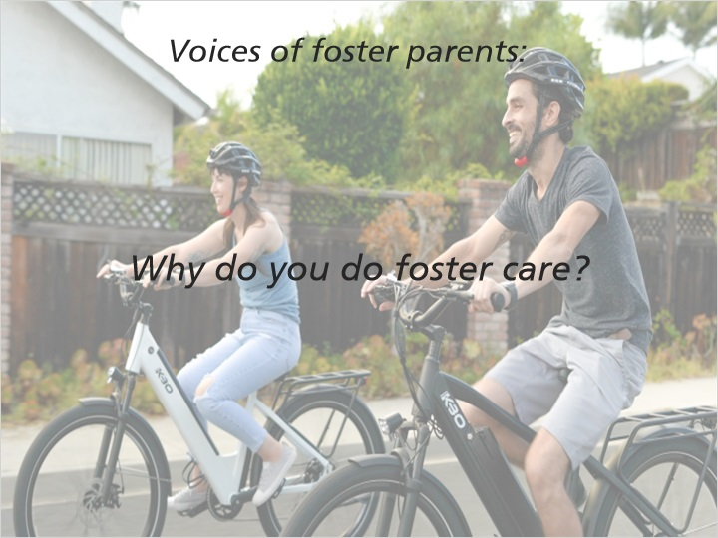
Notes:
“I kind of stumbled upon it by accident actually I had a friend at work who was doing foster care and he really encouraged me and I found that most people start that way, that someone encouraged them.”

“I do foster care because I think that the richness in human life can be measured in our connections to other people.”

“There's a lot of reasons and the most important one, I've been asked that question many times and if I can make a difference, if that one day in our home can show a child that there's a different way to do things that brings them a little bit more peace or happiness then it was worth it.”

2.2 Voices of Relative Caregivers
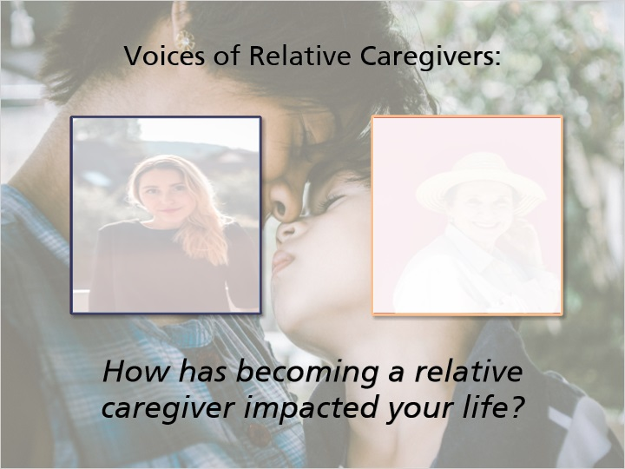
Notes:
“The adjustment for me as a caregiver were gigantic. You know, it was really a choice when social workers said, you know this tiny baby needs a place to live for a short time or for a super long time, we’re really not sure. As time went on it was apparent to me that if I was going to make this decision and this commitment, I was going to need to change my life dramatically. And so, there was, I think, a lot more adjustment for me than for anybody else, except obviously the parents who no longer had that child with them every day. So, you know, I changed my job, I changed so much of what I do and that was, I’m very grateful that I had the opportunity to make those kinds of changes to be able to support her in my life. It’s an ongoing process.”

“How has it overall been an impact on our life? Well, you start thinking of financials. You start thinking of ‘when do I retire,’ ‘What do I have for affordability for things?’”

“As a relative caregiver, relationships in my family have changed quite a bit. I think there is a lot of, you really, I think what makes it easier for me is knowing what my priority is. You know when a baby or a child is placed with you and you are responsible for that child’s safety, that is, that’s all I need to know and base all of my decisions relative to that. You know my child, who had a child is now an adult, and I’m no less committed to my child who has made me a grandparent. But my decision for that child, I’m really, I’m now the sole caregiver for this baby and I need to base all decisions I’m making in relation to that, so that makes those decisions a lot easier when I know who I’m making those decisions for. I have heard a lot of relatives talk about how challenging that can be during the holidays, especially if you are the person who hosts those, and you want all the people you love under one roof. I don’t know how to make that easier. That can really be a challenge. But what I would say is you really need to focus on you and the commitment that you’ve made to that child and, you know, and everybody else in the family is going to make their own decisions. You know, I rely and can lean on other relative caregivers who are going through the same thing. It’s a unique situation and I think only relative caregivers understand how joyous and how painful that can be. So, my advice would be to rely on the support of other relative caregivers who are very uniquely equipped to support and help you.”

3. Effects of Fostering on the Family

3.1 Effects of Fostering on the Family
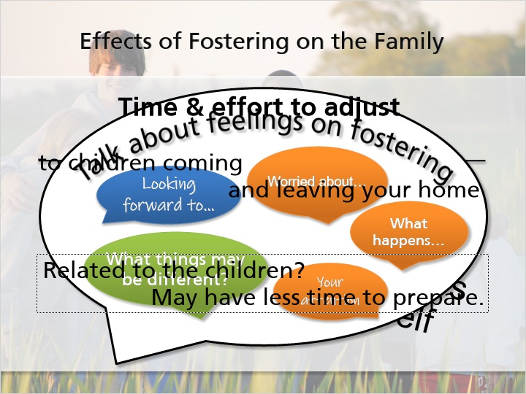
Notes:
When you decided to become a foster parent, was it a decision that you made by yourself, or was it something that you talked through with your spouse, partner, children, or extended family? Regardless of who in your family made the final decision to foster, the decision will affect your entire family. As a foster parent, you have a responsibility to meet the needs of the foster children in your home, but as a member of your family, you also have a responsibility to meet the needs of your spouse, partner, children, and yourself.

It is a great idea for families who are considering fostering to talk about their feelings about fostering, including things that they look forward to as well as any concerns they might have. Talking about these things, especially with the children in the home, will help to prepare the family for fostering. Your children may be worried that they won’t get as much of your attention or about what happens to the foster children when they leave your home.

You have likely prepared for quite some time for children to come into your home, but no matter how much preparation you do, it will still take some time and effort to adjust to having a child in your home. This will be true not just for the first child that you foster, but for each and every child that you welcome into your home. As you gain experience in fostering, you will learn how to help your family adjust to children coming into your home, and you will also learn how to help your family to adjust to children leaving your home.

If you are a relative or like-kin caregiver to the children in your home, you probably did not have the same preparation time that other foster parents do. You may have been asked to provide care and may have had short notice before accepting placement of a child. Foster parents who are not related to the children in their homes usually plan to become foster parents long before they bring children into their homes, and you might not have had that same length of time to prepare for the changes in your home.

3.2 Voices of Foster Parents and Relative Caregivers
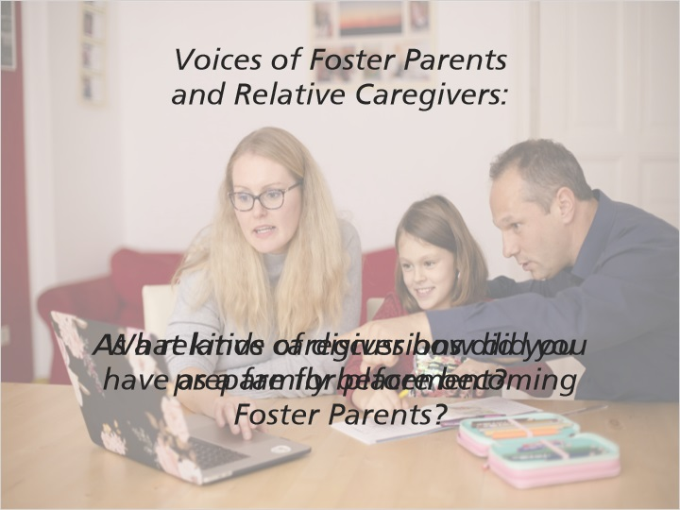
Notes:
“We talked about becoming foster parents for quite a while, my husband and I we only had one little one at the time so it really was a decision for us and we just thought that it was really important to be able to help somebody besides ourselves. Later on we started fostering again when our children were older and then we had a family discussion about it, talked to the children and just told them that we wanted to hear their input, but ultimately it would be dad and I's decision whether or not we did it but we wanted to hear how they felt and how it would effect their lives.”

“I think pretty typical discussions, we were worried about whether we had the room to do it like physically had the room, we were worried about the space in our life, we already seemed like we were... we had a busy life and we were full and tired at the end of every day and we didn't have kids to take care of, just how are we going to make it all work if we have another person in our house and then how are we going to make it all work if we have two more people in the house. And then how are we going to make it all work if we have three more people in the house.”

“You don’t get much information ahead of time you don’t even know what’s going to happen. It’s not like going into foster care because I want to help these children, whoever they may be, or I’m hoping to adopt these children, whoever they may be. Most pre-placements for relative caregiver occur because there is an existing problem. And you don’t know that you’re going to have placement until somebody’s standing at your door. We had to acquire a crib and we had to acquire a lot of things and literally…. the groups that are out there for fostering can help so well that I think relative caregivers need to know that information. It’s kind of hard because you, like I said, ours was like ‘ok you’ve got an hour’s notice and we’re bringing you a child’, or you have to come pick up a child, but you don’t expect that but believe it or not, you sit down and you go, in afterthought you realize that all existed.”

“I did not prepare for this placement. I think for many of us, you know, it’s a, it’s a sad surprise that our grandchild, our niece, our nephew, our brother or sister needs ongoing daily, all-encompassing love and support because their parents can’t care for them anymore. I, so, I absolutely did not prepare for that. And once I was asked to make that decision though, it was pretty easy. You know, I threw my heart and all of my resources 100% into that and number one made sure anybody else living in my home was on board with our mission, and at this point we all were behind that, and the rest of that was pretty easy. Once I had those discussions with everybody under my roof and we were we were ready to go, then we were ready to go, you know. And I think the conversations that have to happen are, you know, no matter how hard this gets, we are in this. I want to know how everybody feels about it, but if we make the decision to make this commitment, then we’re sticking with it.”

3.3 Grief & Loss for Foster Families
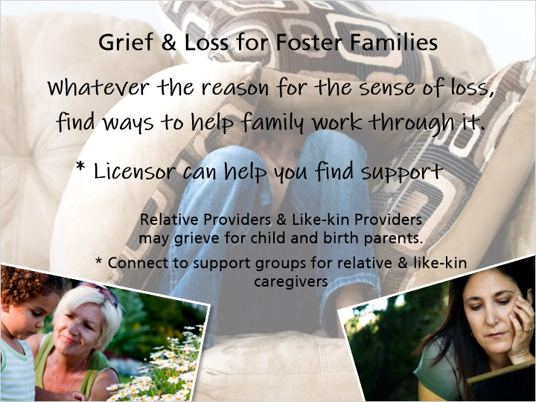
Notes:
In other modules, you have learned about the grief and loss that children and birth parents experience, but now think about the grief and loss that you and your family might experience when children leave your home. While you might support the decision to move the child, or maybe you requested the change, you may still feel a sense of loss when they leave. Sometimes this loss is a feeling of sadness that you miss the child and care for them, and sometimes the sadness is because you felt you couldn’t support their needs. Whatever the reason for the sense of loss, it is important to find ways to help your family to work through it. This sense of grief and loss may be shared by your children as well, and it is important to process these feelings as a family.

Your licensor can help you to find support during this time of grief. You’ll learn later in this module about ways to find assistance through respite and support groups.

For relative and like-kin providers, your sense of grief and loss may feel very different from that of foster parents who are not related to the children in their homes. You may also be grieving for the child and the birth parents because the child had to go into foster care. You might feel a sense of loss or embarrassment for your family to be involved with the child welfare system, and you will also probably feel a sense of loss like any other foster parent when the child leaves your home. You’ll probably have similar fears about what will happen to the child and if the move was a positive one. Talk with your licensor about getting connected to caregiver support groups that address the grief and loss of relative and like-kin caregivers.

4. Voices of Foster Care Licensors

4.1 Voices of Foster Care Licensors
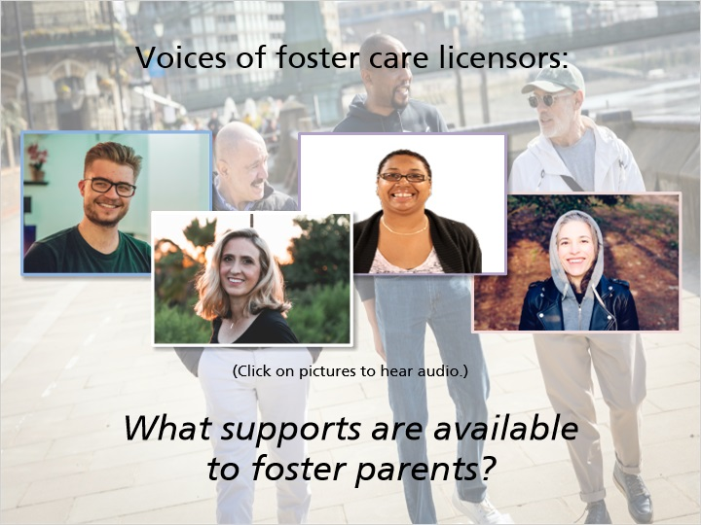
Notes:
“There's a lot of support available to foster parents, the county or agency involved with their license and the case situation. There are community resources involved depending on the needs of the child in the family, the court system, the school system, therapist, all kinds of other professionals are there to help support the placement, help meets the child's needs and the foster parents also can benefit from getting involved with foster parent support groups, and looking at the website or going to additional foster parent educational opportunities, there is a statewide organization and there are also local associations for foster parents. There's a lot out there.”

“It helps to have foster parent associations, I think foster parents are the biggest support for each other, the Foster Care and Adoption Resource Center has some really good information as does the Department of Children and Families web site so the more connected foster parents can be with each other and workers and therapists... those are the best supports they can get.”

“I think foster parents should really use their worker whenever they can because they're a wealth of knowledge but there's also foster parent organizations, local organizations, support groups for foster parents to get connected with other foster parents which I've really heard to be the most beneficial when foster parents can interact and learn from other people doing the work that they are doing and post strategies and ideas from them, there's also national foster parent organizations that have great web sites and great conferences, not to mention all of the community resources out there that are available to parents, you know I think sometimes foster parents think that they're not eligible or they don't fit in those types of groups but any of the parent support groups, the parenting network or anything like that's available to regular parents, foster parents can access.”

“There are a lot of supports that are available to foster parents depending on the county or the agency that they are working with, some counties and agencies have periodic foster parent meetings where foster parents gather and share stories and support each other. Some agencies and counties have regular trainings and that's another place where you can get to know other foster parents, learn some more about the kids that are in your care and further your own skill level. Each family has a social worker that is assigned to the child and that social worker can be a source of support, education, encouragement, I think probably most importantly is foster parents supporting each other because this is a really tough job and nobody knows the work better than other foster parents, so my experience has been that foster parents supporting each other is a really good thing.”

5. Support Network

5.1 Support Network
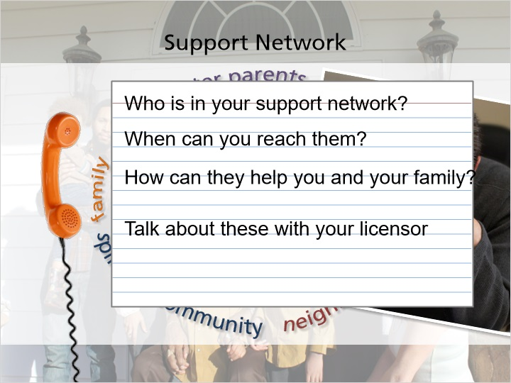
Notes:
As you foster, remember that in order for you to fully take care of the children in your home, you must also take care of yourself. In order to take care of yourself, think about how you can be supported by those around you. You and your family might feel supported by family members, neighbors, friends, coworkers, members of your spiritual community, or by other foster parents. These people who can and will support you and your family are your “support network,” and they will be really important people to lean on as you foster.

Imagine that you’ve had a really stressful day and you’re not feeling well. Who can you call to vent to or to talk to? Who can you call that you know will listen and will offer their support? Who are the people in your life that you know that you can count on, no matter what?

Use your notepad document or other paper to write down who is included in your support network. Then write down when you could reach out to those people when you need them. A person doesn’t really need to be available to you 24 hours a day to be part of your support network. You might have a friend who doesn’t live nearby but you can call her anytime for support. She would be a great help to you to talk things through, but it wouldn’t be realistic to think that she could help you by grocery shopping or running errands for you. Think about and write down the ways that each person in your support network can help you and your family as you foster, and then talk about these with your licensor.

5.2 Refueling Yourself and Your Family
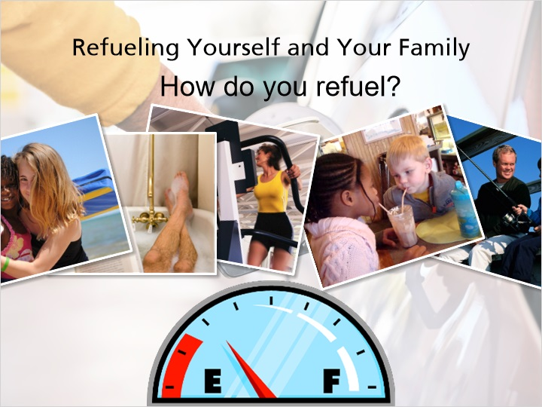
Notes:
Being a foster parent can be fun and rewarding, but it can also be exhausting. In order to effectively care for the children in your home, you’ll need to think about how you and your family “refuel” – how do you take time for yourself and get energized? Think about stressful times that you have gone through and that your family has experienced – how did you recover? Some examples of refueling could be…

Taking a family vacation after stressful holidays to spend time together and have fun
Taking a long bath or spending time alone reading
Working out or exercising after a stressful day
Taking your kids out for ice cream
Going fishing

How do you refuel? How can you help your family to refuel? Refueling can include taking 10 minutes to yourself every day, or it could be taking that family vacation. You can refuel every day, but sometimes you’ll need more than that. Think about different ways that you and your family can feel refreshed, and write down your ideas to share with your licensor.

5.3 Voices of Foster Parents
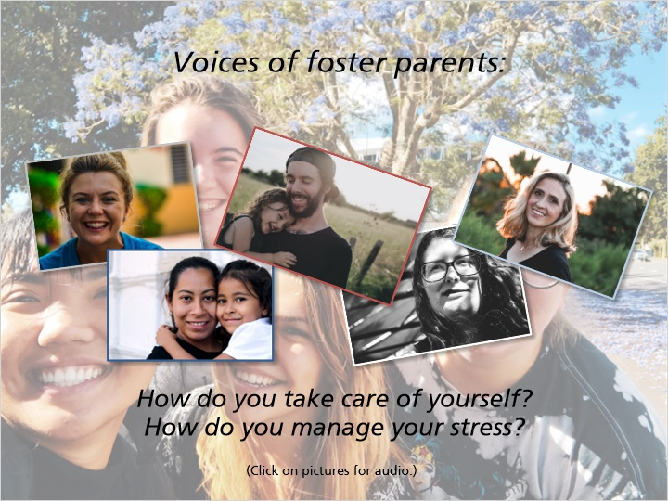
Notes:
“Things that I do to take care of myself and my stress, that's really grown in the 15 years I've been fostering, that was a real weakness when I first started, respite or babysitting of any kind is great and I'm much more involved in the community than I ever was when I started and some of that is just because once you have foster kids you get involved in school and plays and sports and church and...”

“Ways that we take care of our own family is being aware of what's going on for our children. Knowing are they... how are they reacting to a placement or a child leaving our home and trying to help them go through that by either pictures or talking about it, we like to... it's like children aren't gone forever and we still have things that remind us of them so that it's not such a great loss, it's not like... because you're already packing their clothes and you're packing things when you leave or resetting up rooms when children are coming so we try to keep that continuity so the children see that they're... they're still there, they're just not with us anymore.”

“I think making sure that you make time for yourself and that you leave yourself time for respite so that you can't... you can't sprint being a foster parent, you have to be in it for the long haul. We forget that we really need to take care of ourselves especially in these complicated emotionally stressful situations that we've just chosen to put ourselves into being foster parents. That we have to make self-care first.”

“My husband and I have a great sense of humor after all these years of fostering and it helps us refuel ourselves. We just be able to chuckle together at the end of the day and make sure that we connect every day, that we talk to each other each day, we do some fun things like go out to a movie, have a movie night, um go out to dinner together, see some friends, it's very, very important to keep connected with your partner through fostering because it takes a lot of energy.”

“It's really important to take care of ourselves because if we don't take care of ourselves we can't take care of the children. I try to find little things each day that the children are doing that bring joy instead of frustration, don't look at it as a frustrating thing. I like to take walks as a family, as myself we do a lot of... just try to make fun and have fun with it because that takes the stress away…”

5.4 When to Ask for Help
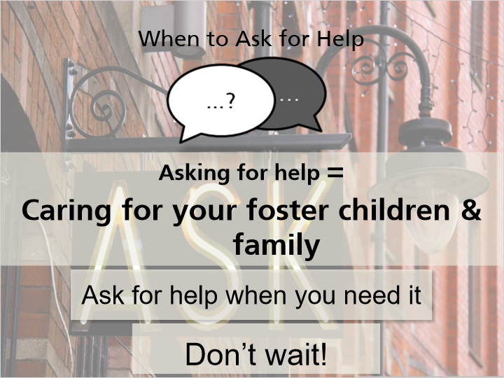
Notes:
Throughout this training, you’ve probably heard 100 times to turn to your licensor when you need help – don’t be afraid to ask for help when you need it! By asking for help, you will be caring for the foster children in your home and for your family the best way that you can. If you ignore warning signs of stress or frustration, you won’t be able to care for your foster children, your family, or yourself effectively.

It’s important to ask for help when you need it. Don’t wait! When you’re feeling stressed or overwhelmed, talk with your licensor about how you can handle the stress in the most productive way.

5.5 Voices of Foster Parents
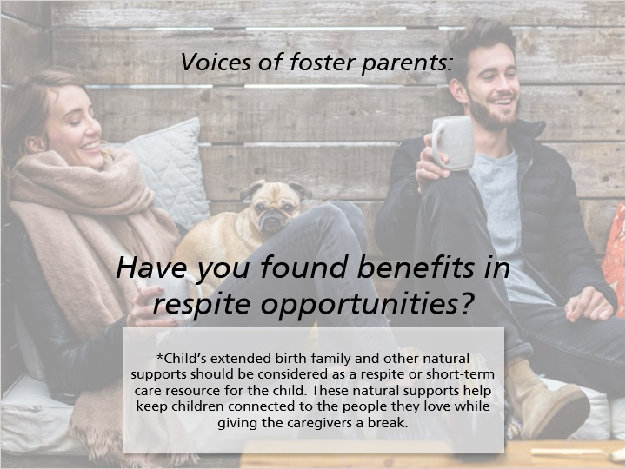
Notes:
“For our family we usually use each other so in terms of respite for our family we have adult children at this point and they would step in for us so we don't use formal respite but I do think it's really important that foster parents take those opportunities and take care of themselves and use respite if that's what they need to do.”

“You can arrange play dates for your kids after school and so you're getting the time that you need while they're off playing with friends, that in itself, that one night a week can be just amazingly healing having that time to just be a couple again with our large family and our dog.”

5.6 Support Groups and
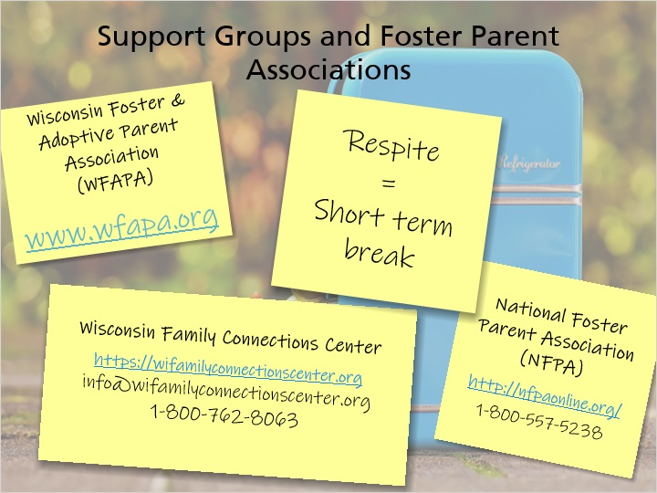
Notes:
As you heard earlier in this module, your licensor can connect you with foster parent, relative, and like-kin support groups. You learned in Module 2 about the Wisconsin Foster and Adoptive Parent Association (WFAPA), a statewide support network for foster and adoptive parents. You can find out more about WFAPA on their website listed on the slide. Your community may also have local support groups; talk with your licensor about this. There is also a National Foster Parent Association (NFPA) that can offer you support and assistance (see slide for contact information.)

In Wisconsin there is a statewide organization that supports all out of home caregivers and children, the Wisconsin Family Connections Center. You can find contact information on this slide. The organization provides a free lending library, ongoing training, and other opportunities to connect with other families like yours. Please take a moment to jot down their contact information.

In addition to attending caregiver support groups, another way to deal with grief and loss is to use respite, which is a short-term break for both you and the children in your home. This is not used as a punishment for children, but is used to give you and the child some time and space. Respite can be for a few hours or a couple of days. Respite can also be an opportunity for the child to deepen their kin and familial connections and to build their individual support network. If you do not have children in your home as you’re dealing with grief and loss, you can take a short break from accepting children into your home. As you learned earlier in this training, it is better to take the time that you need and be prepared for bringing children into your home than to accept children you do not feel that you can care for appropriately. If you are dealing with grief and loss associated with a child leaving your home, it may be best to give yourself and your family.

5.7 Voices of Foster Parents
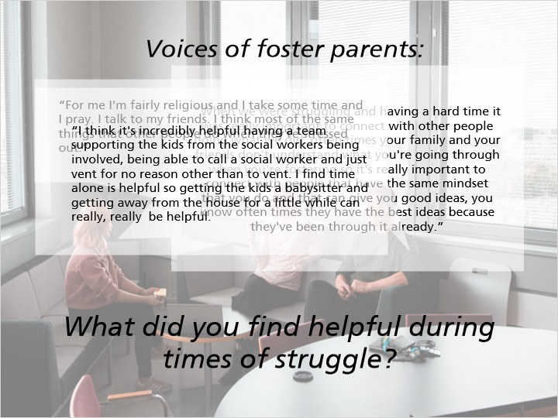
Notes:
“When we were struggling and having a hard time it was really important to connect with other people doing what we did, often times your family and your friends don't understand what you're going through when you're fostering so it's really important to connect with people that have the same mindset that you do and that can give you good ideas, you know often times they have the best ideas because they've been through it already.”

“For me I'm fairly religious and I take some time and I pray. I talk to my friends. I think most of the same things that other people do when they're stressed out.”

“I think it's incredibly helpful having a team supporting the kids from the social workers being involved, being able to call a social worker and just vent for no reason other than to vent. I find time alone is helpful so getting the kids a babysitter and getting away from the house for a little while can really, really be helpful.”

6. Knowledge is Power

6.1 Knowledge Is Power
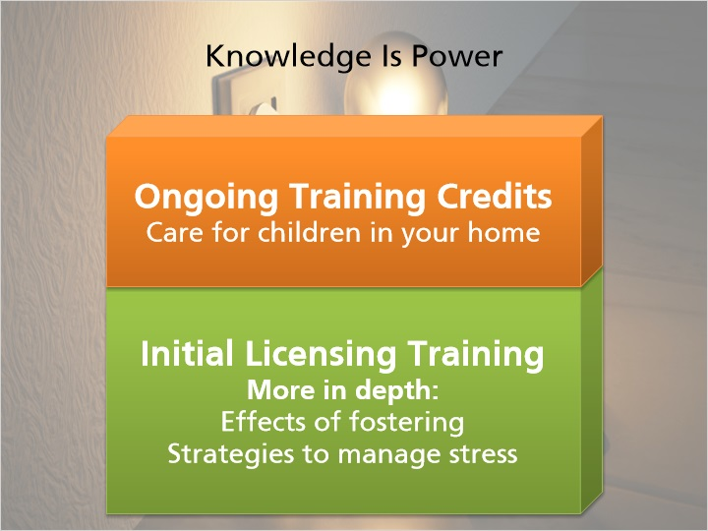
Notes:
Your support network will be incredibly valuable to you as a foster parent. In addition to having people to turn to, additional training will help you to be prepared to care for the children in your home as well as for the stress that comes with fostering. The training that you will complete in your first licensing period will go into more depth about the effects of fostering on your family, and will give you even more strategies to manage the stress that you might experience. Your licensor can also inform you of other training opportunities that would help you to better care for the children in your home. The Wisconsin Child Welfare Professional Development System (WCWPDS), the Wisconsin Foster Care and Adoption Resource Center (FCARC), and the Wisconsin Adoption and Permanency Support programs offer statewide ongoing training opportunities for all caregivers. These other training opportunities could count for your Ongoing Training requirements. Again, because you haven’t heard it enough already, talk with your licensor about this!

6.2 You Made It!
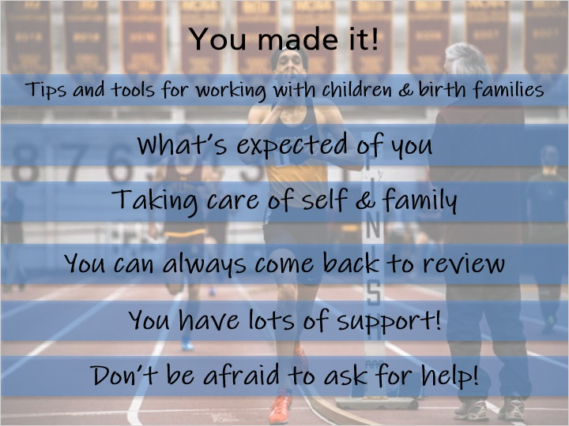
Notes:
You made it! In just a few more slides, you will have completed the Pre-Placement Training and you’re well on your way to becoming a great foster parent! You’ve been given lots of tips and tools for working with children and birth families, and you’ve learned about what is expected of you as a foster parent. You’ve heard about what you can do to take care of yourself and your family and about how things might be different if you are related to the children in your care. Don’t feel like you have to have all of this memorized – it’s all here for you when you need to come back to it. You have lots of people behind you, supporting you, and willing to help you when you need it. Don’t be afraid to ask for help. Say it with me now, when in doubt, talk with your licensor!

7. Voices of Foster Care Licensors

7.1 Voices of Foster Care Licensors and Caregivers
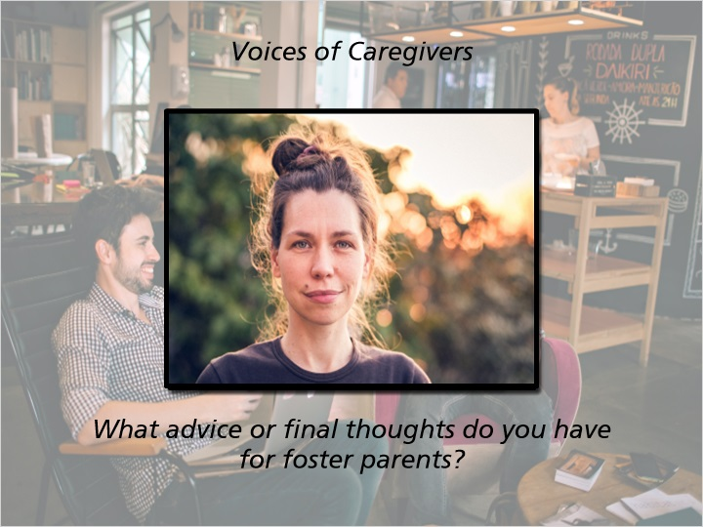
Notes:
“The work and job and effort that foster parents do and put forth is extremely difficult and wonderful all at the same time and for every challenge that there is, there's a bright moment that makes it all worth while. So when it seems like it's getting tough, hang in there because there's a bright moment around the corner.”

“Stick in there with them, hang in there with them because these kids are very confused, they've seen a lot, heard a lot, some have been moved around a lot and they just want someone to understand them and some kids make it harder than others to do it and if foster parents can be patient, show them that they care and that they love them no matter what they have to do for discipline that is the key for these kids to make it.”

Voices of Caregivers:

“Foster parenting is amazing work, it's the hardest thing I've ever done and also the most rewarding, it's hard to realize how much another person counting on you can matter in your life.”

“You know when you become a relative caregiver, you…a whole new part of yourself is born. When you are a relative caregiver, you’re bringing...you need to use different coping skills, different gifts, new support systems. That’s part of the gift of being a relative caregiver and part of the challenge. Whatever’s working in your life you may have to develop new resources, new skills, new supports, and they are all there. You know, the social workers, the support people, the trainings, it’s all there for the taking. There are lots of resources there to support you and help you, but you have to reach out for them. You have to let the team know what you need, what you want, what’s working and what’s not working, and help is there. If you keep your doors open and you keep your heart open, everything’s going to be ok.”

“When I think about all of the things that I didn’t know when I started fostering it’s amazing to realize all of the resources, I’ve been connected up with over the years. And what I would want you to know is that when you discover that your like, oh, I don’t know anything about that or I had no idea there were 25 different ways to make macaroni and cheese, you know, to just, be able to laugh at yourself a little bit and recognize that all of us are on a journey to figure all of these pieces out together. And it’s not that you’re doing something wrong because you didn’t know, it’s just that there’s always more for all of us to know about being human and doing life together.”

8. Thinking Back on

8.1 Thinking Back on the Module…
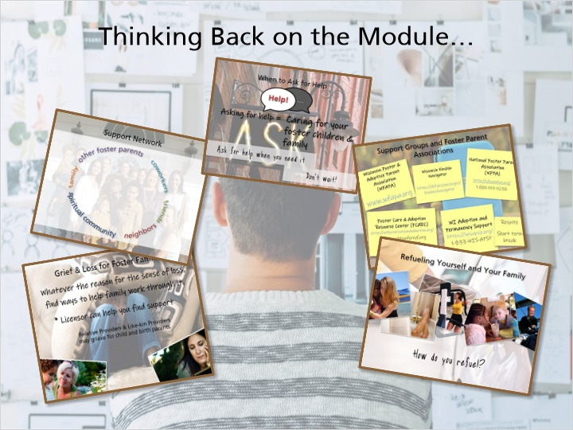
Notes:
Take a deep breath and take a minute to think back on this module. You’ve heard how important it is to take care of yourself and your family in order to take care of the children in your home. You’ve thought about who is in your support network or your child’s support network and how you can lean on them when you need them, and you’ve heard how important it is to ask for help. You have information on support groups and ways to take breaks as you foster. You’ve learned how important it is to refuel and to take time for yourself.

9. Voices of Thanks

9.1 Voices of Thanks

Notes:
Thanks foster parents. We appreciate you, and we need you. Thank you. Thank you.
Thanks for your caring.

Thanks. Thank you. Thanks.

Thank you for making a positive difference in the life of a child.

Thank you.

9.2 Results Slide
(Results Slide, 0 points, 1 attempt permitted)


Notes:

