Module 4 Medication Management

1. Medication Management Introduction

1.1 Welcome
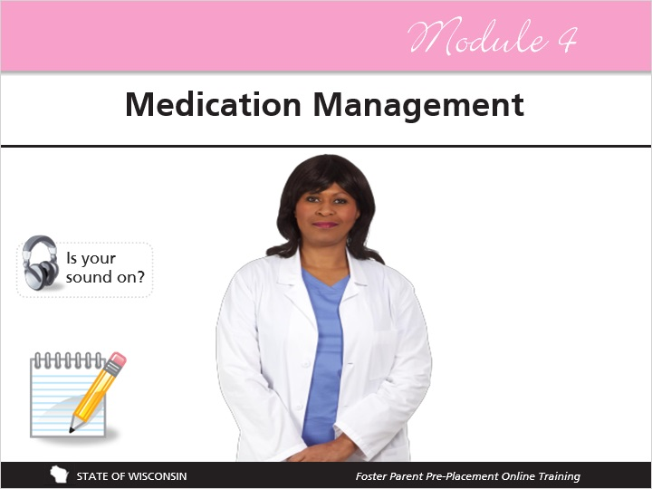
Notes:
Welcome to Module 4 of Foster Parent Pre-Placement - Medication Management. In this module, you will be given information on the following topics:

Proper medication administration
Psychotropic medication administration
Safe medication storage
Secure medication disposal
And
The correct response to medication errors

Before you continue, please remember that you have the notepad document to jot notes in as you go!

2. Eight Rights

2.1 The Eights Rights
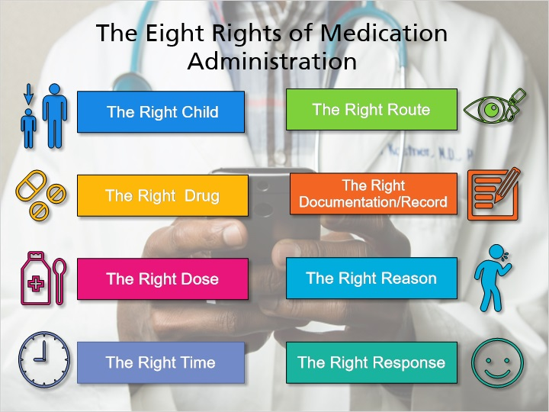
Notes:
When preparing to administer any medication to a child, consider The Eight Rights of Medication Administration. They are:
The Right Child
The Right Drug
The Right Dose
The Right Time
The Right Route
The Right Documentation or Record
The Right Reason
And
The Right Response
Over the next several slides, we will go into detail about these rights.

Based off material from: Wisconsin Department of Health Services and Oregon Department of Health Services

2.2 The Right Child
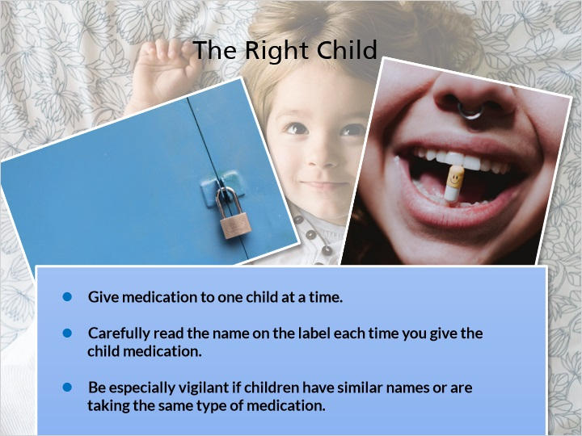
Notes:
Always make sure that you are giving medication to the correct child. One precaution you should take to ensure that the right child receives the correct drug is to give medication to one child at a time. After you have finished giving all required medications to one child, you should then put those medications away before giving medication to the next child.

Carefully read the name on the label each time you give the child medication. You should do this whether this is the first time or the 100th time you have administered the medication to the child.

Be especially vigilant if children in your home have similar names, the same last name, or are taking the same medication.

2.3 The Right Drug
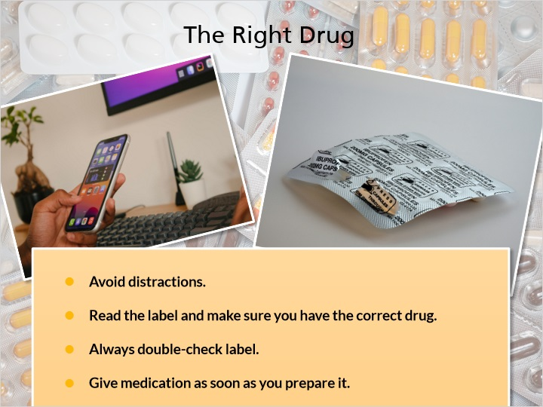
Notes:
Make sure that you are giving the child the correct medication. Avoid distractions. You should be focusing only on the medication and the child that is receiving it. Do not talk to others and ask others not to talk to you. Do not talk on the phone, text, or watch TV while giving out medication. Do not stop to do something else in the middle of administering medication. You might need to go to a quiet room or find an activity to occupy other children in your home.

Reading the label is the most important step you can take to ensure that you are giving the correct medication to the child it is prescribed for. Read the label every time. Always double check - once when you take it out of the medicine cabinet and once right before giving it to the child. Give the medication as soon as you prepare it to avoid it becoming contaminated or taken accidentally by someone other than the child for whom the medication is prescribed.

2.4 Medication Labels
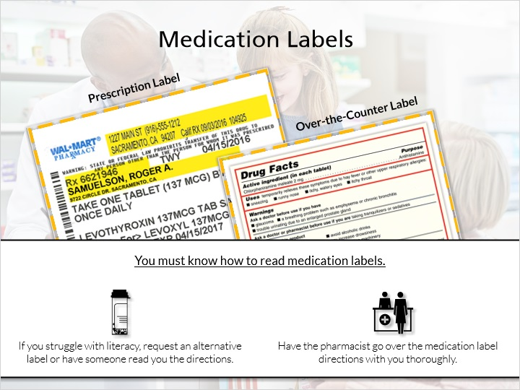
Notes:
Proper medication administration requires knowing how to read medication labels. If you struggle with literacy, request an alternative label or have someone read you the directions. You should also make sure to have the pharmacist go over the medication label directions with you thoroughly before you leave the pharmacy so that you feel comfortable administering it on your own at home.

There are two types of medication labels: Prescription labels and over-the-counter labels.

A prescription label is used for prescription-only drugs. These are drugs that are only available with a valid prescription from a prescriber such as a doctor or other qualified healthcare practitioner. These drugs usually require a visit to the prescriber followed by a diagnosis and then monitoring to ensure that the drug is working correctly. Prescription-only drugs are intended to treat a specific individual for a specific condition.
Over the counter drugs do not require a prescription from a prescriber and may be purchased right off the shelves at a pharmacy, drugstore, or supermarket. Examples include pain relievers like Tylenol and Advil and antihistamines like Claritin.

Information from: https://www.drugs.com/otc/

2.5 Prescription Label
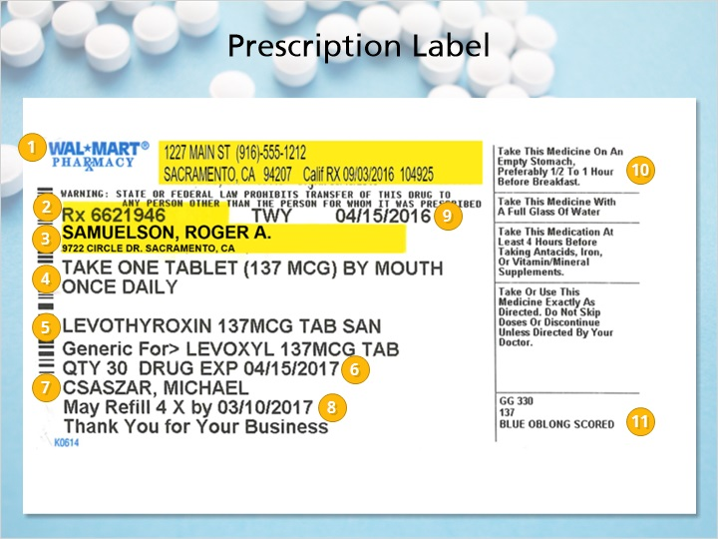
Notes:
Here is an example of a pharmacy prescription label. Take a few minutes to look over the information on this label. Click on the numbered circles to learn more about each section of the label.

2.6 Over-the-Counter Label
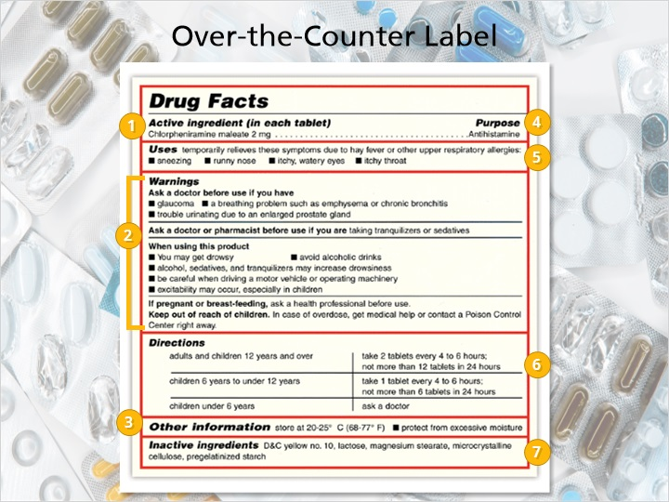
Notes:
Now that you have looked at the various sections of a prescription label, take a moment to look over the information on an over the counter medication label. Click on the numbered circles to learn more about each section of this label.

2.7 The Right Dose
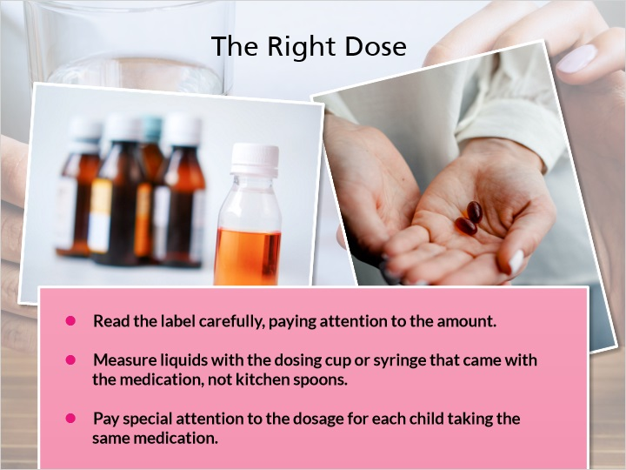
Notes:
The right dose is how much of a medication you are to give at one time. This information is located on the medication label. Read the label carefully. For pills and tablets, pay attention to the number of tablets in a dose. Some dosages may even be for half a pill.
If the drug is in a liquid form, use the dosing cup or syringe that came with the medication. Do not use spoons from your kitchen as these can vary in size and are not calibrated measurements.
If more than one child in your home is taking the same medication, pay special attention to the dosage for each child. Children may be prescribed different dosages based on a wide range of factors including weight, age, and medical history.

2.8 The Right Time
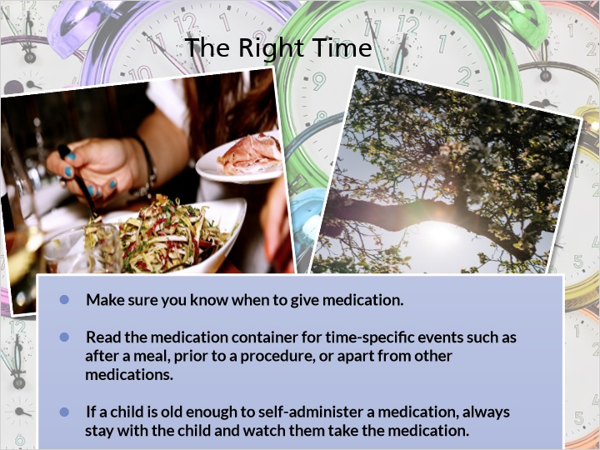
Notes:
Always give medication at the required time. When you are first given a new medication to administer, make sure that you know when it needs to be given to the child. Some medications need to be taken at a specific time of day or more than once a day. Other medication may need to be taken around a specific event such as after a meal, prior to a procedure, or apart from other medications. In addition, medications may need to be taken with food or on an empty stomach. Always check the label.

If no specific time is listed on the label, ask the prescriber or pharmacist about the best time of day to give the medication.

Finally, if a child is old enough to self-administer a medication, always stay with the child and watch them take the medication. This is to ensure that the correct child takes the medicine at the correct time.

2.9 PRN Medication
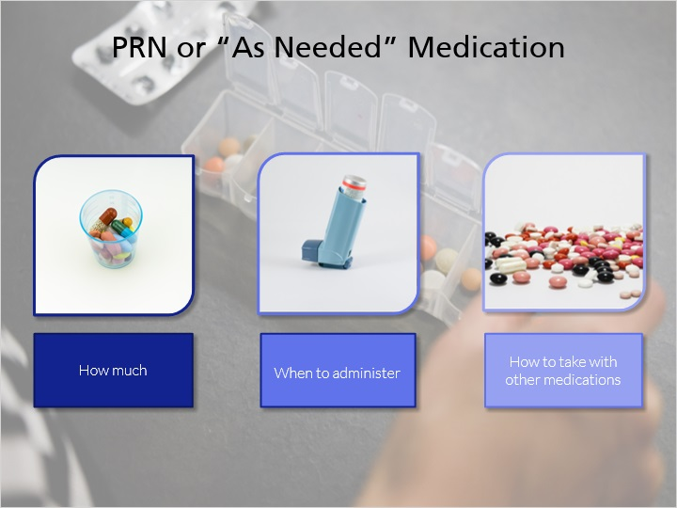
Notes:
For PRN or medicines that are taken only “as needed,” make sure you are given clear directions from the medication prescriber on the following information:

· How much medicine you can administer in a set period of time. This will help you prevent giving too much medication. In addition, you should be given information on what steps to take if the medication appears to not be working.
· When to administer the medicine. For example, medication that is needed for pain after surgery should only be administered if the child is feeling pain.
· How to take PRN medication in conjunction with other prescribed medications. Make sure to inform the medication prescriber of all the other medication the child is currently taking.

Ask if there are any rules you should follow such as a specific order in which medication should be taken and how long to wait between doses of different medications.

Information from: https://www.safemedication.com/pharmacist-insights/2021/04/26/using-prn-or-as-needed-medicines-safely

2.10 The Right Route
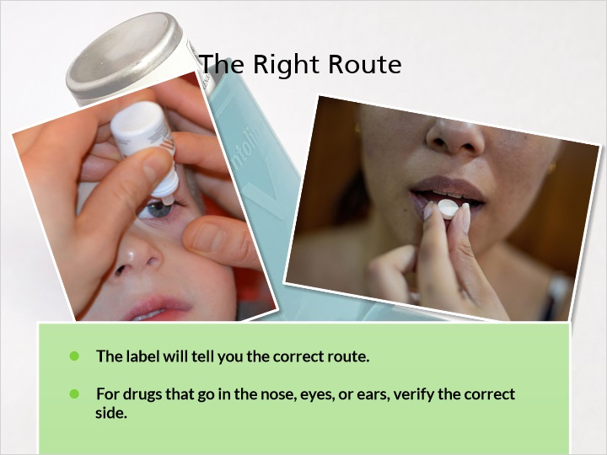
Notes:
Be sure the correct route is used. The route is how and where the medication goes into the body. The label will tell you the correct route. The most common route is through the mouth, but medications can be prescribed to enter the body in different ways such as the eye, nose, lungs, and skin.

For drugs that must go in the nose, eyes, and ears, double check the prescription instructions to ensure that it is going into the correct location, such as the right eye, or both nostrils.
Next, we will go over the various medication forms and their routes.

2.11 Forms of Medication
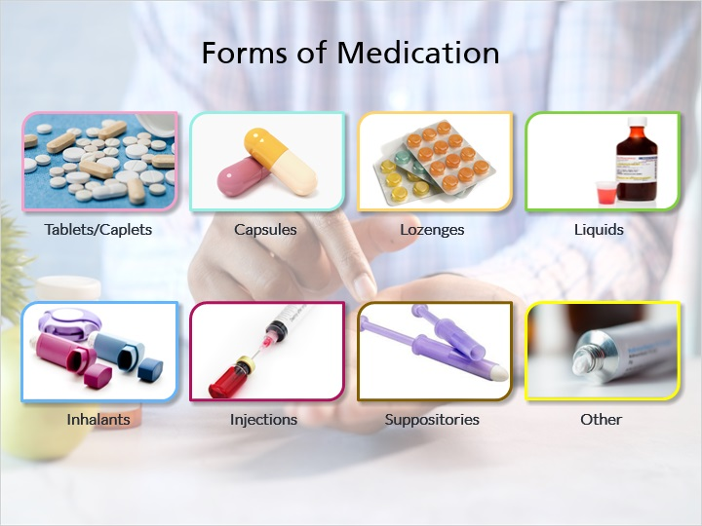
Notes:
Medication comes in many forms. Knowing a little about each type is helpful in ensuring that you are giving the right drug and using the right route. Here are several of the most common types of medication.
· Tablets or caplets come in different sizes, shapes and colors. These are administered orally and swallowed or chewed depending on the label directions.
· Capsules have a gel coating on the outside, which is used to encapsulate the medicine. They come in two forms: soft gel which contains oil and hard gel which are the capsules pictured on this slide. These are also administered orally and swallowed.
· Lozenges are different from tablets or capsules in that they are usually meant to be sucked on and dissolved in the mouth, instead of being swallowed whole or chewed.
· Liquid medicine, also called suspensions, syrups and elixirs must be carefully measured before use. Some must be well-shaken before consumption. As with the previous forms of medication mentioned, liquid medicine is given orally.
· Inhalants are designed to inhale into lungs. They are often prescribed for children with asthma. When properly used, they should take effect immediately.
· Injections involve putting a liquid form of medication into the body using a needle. An example would be administering insulin to a child with diabetes.
· Suppositories are designed for absorption from the rectum or vagina.
· Other forms of medication include creams, ointments, sprays, powders, patches, lotions, and medicated shampoos.

2.12 The Right Documentation
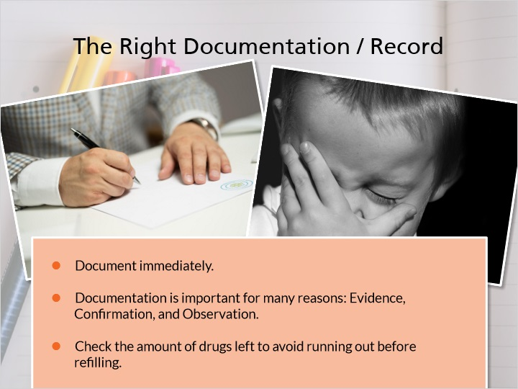
Notes:
Each time a medication is administered to the child, it must be documented. Documentation should be done right after giving a medication and always before giving medication to another child.
Documentation is important for many reasons. It provides evidence that the medication was administered. It confirms when you last gave a medication, which is useful in preventing accidental overdoses or missed doses. It also allows you to keep track of the child’s responses to medication which is helpful during follow-up visits to the doctor and for catching any adverse effects to medications.

After you have documented your medication administration, you should also check the amount of medication remaining. This will help you to avoid running out before refilling a prescription.

2.13 Documentation Sheets
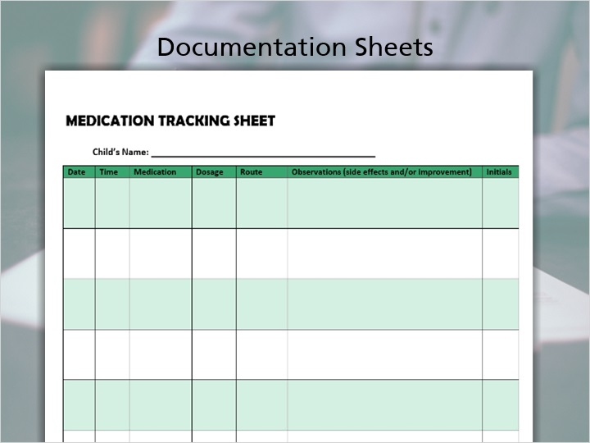
Notes:
Here are two useful documentation resources you may want to use to record medication administration. The first document is called the “Medication Log.” This log can be used to keep track of all the medication the child is taking. It includes space to write the following:

· Medication Name,
· The date the medication started,
· The date the medication was stopped. Daily medications may be stopped after consulting with a doctor. Other medication may be time-limited such as an antibiotic used to clear an infection.
· Dosage and time or times of day you must administer the drug,
· Special instructions such as taking the medication with food,
· Purpose of medication,
· Possible side effects from the medication,
· Prescriber name and phone number, and
· Pharmacy phone number.

The second document is the “Medication Tracking Sheet.” This should be used every time you administer medication to the child. You should have one sheet for every child taking medication. Do not use the same sheet to log more than one child’s medication. This document requires you to track the following information each time you administer medication:

· Date,
· Time,
· Medication Name,
· Dosage given,
· Route of medication - as an example you might write “Left Eye” for eye drops that you administered into a child’s left eye,
· Observations - This is the space to track any side effects the child is experiencing as well as your observations about if the medication is working. Using the eye drop example, you could write, “Left eye is less red today and seems to be clearing up,” and
· Finally, the initials of the person who administered the medication to the child.

Keep in mind, that if your child attends day care or school, you should communicate with them about the needed medications and tracking methods. Day cares and schools often have tracking and communication mechanisms already in place.

2.14 ABCs of Documentation
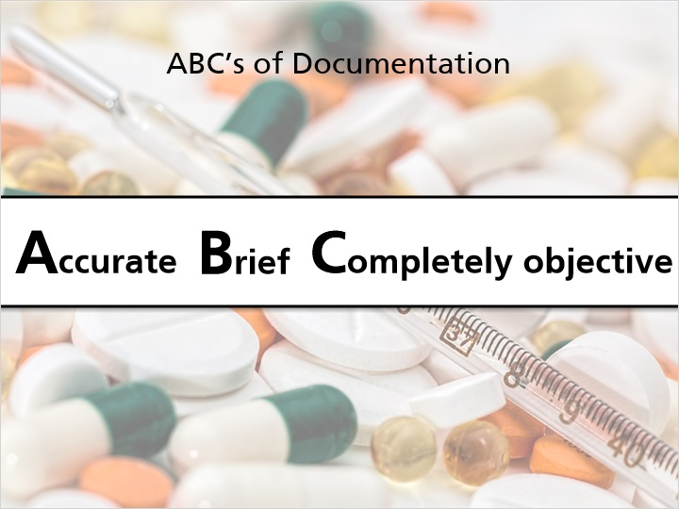
Notes:
When filling out these documents, it can be helpful to follow the ABC’s:

· Be Accurate - this entails writing your documentation immediately after you administer medication, when it is still fresh in your mind. Being accurate also means double-checking your documentation. Reread it once you have written it, to catch any mistakes.
It also means being honest. If you were a little bit early or late giving a medication, always write down the correct time.
· Be Brief - Write clearly and concisely. Only write what you believe is important and related to the administration of that medication. Also, write legibly so that others will be able to read your documentation.
· And Be Completely Objective - Don’t write your opinions. An example would be writing, “It’s not working.” This is vague and needs more concrete evidence. Instead, write observations that you can see, hear, feel, and smell. For example, “The left eye is as red as it was when I gave drops yesterday,” is a more objective observation.

Information from: https://dphhs.mt.gov/assets/dsd/DDP/MedicalDirector/TheMARhowtofilloutanduse.pdf

2.15 The Right Reason
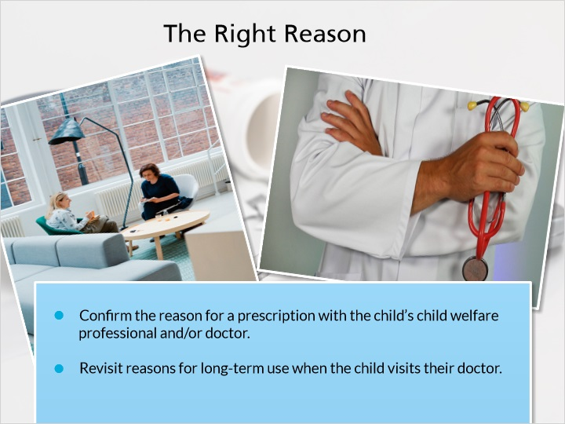
Notes:
It is important for a caregiver to understand the reason medication is being prescribed to the child. Before you administer a new medication to the child, confirm with their child welfare professional and/or doctor the reason for the prescription.

While pharmacists have a legal duty to counsel patients when they pick up their medication, some medications can be used for multiple conditions, so it is best to discuss the reason for a medication with the child’s doctor.

After the child has been taking the medication for awhile, it is helpful to revisit the reason for the long-term use with a doctor. A child’s physical and mental health may change over time as can the effectiveness of a medication.

Knowing the reason for the child taking a specific medication also helps you better undertake the final right - the right response.

Information from: https://www.pharmacytimes.com/view/pharmacists-neglecting-their-duty-to-counsel

2.16 The Right Response
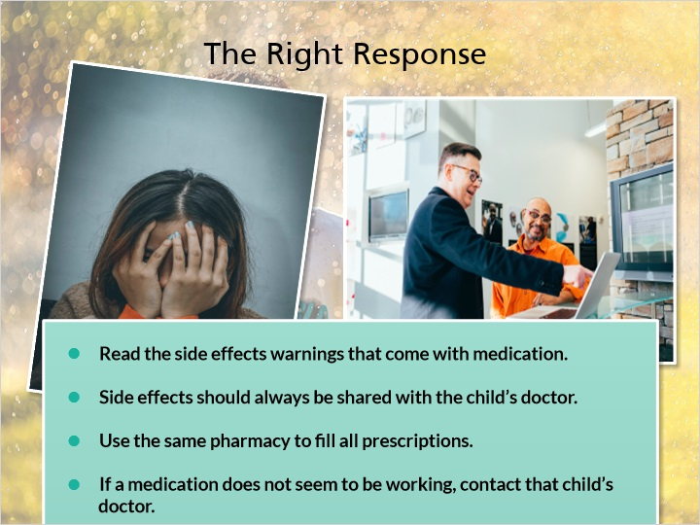
Notes:
Be sure to monitor that the medication the child is taking is having the desired effect. Read the side effect warnings on the medication label. Common side effects may include rash, upset stomach, constipation, diarrhea, or fatigue.

The prescriber and pharmacist are also useful resources for this information. When completing medication documentation, note typical side effects for the medication and write down any side effects you notice in the child or that are described by the child. These side effects should always be shared with the child’s doctor. If a side effect is severe, stop administering the medication and call the child’s doctor.

Another type of harmful effect is a drug interaction. Some medications may be harmful when taken together. This is why you should use the same pharmacy to fill all prescriptions. They are trained to know how drugs may interact with one another. It would also be helpful to bring your Medication Log and Tracking Sheets to doctor visits so that the doctor is aware of all the medications the child is taking.

If a medication does not seem to be working, contact that child’s doctor.

You should also be documenting the child’s response to a medication, so that you can accurately report whether a medication is working correctly during any follow-up doctor visits.

2.17 Eight Rights Printout
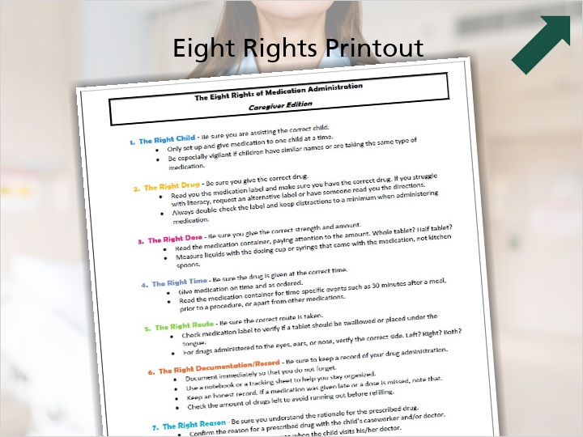
Notes:
The Eight Rights of Medication Administration is an important resource for helping you be consistent and thorough while administering medication. A summary of all this information can be found by clicking on the Resources tab. Print out a copy and keep it with your medication as a reminder of these Eight Rights.

2.18 Dietary Supplements
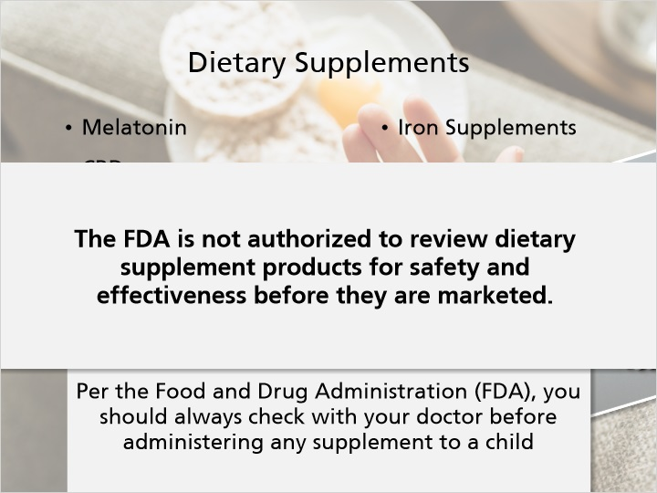
Notes:
Dietary supplements such as Melatonin, CBD, St. John’s Wort, iron supplements, fish oil among many others have become increasingly popular to use and are readily available at pharmacies and online. However, they are different than over-the-counter medications and could have side effects or could interact with another medication that a child is taking whether it is a prescribed medication or an over-the-counter medication. Per the Food and Drug Administration (FDA), you should always check with your doctor before administering any supplement to a child. Also, check with your licensing agency about any policies they may have about providing dietary supplements to a child in out of home care.

Dietary Supplements are regulated differently than prescription and over-the-counter medications, the FDA is not authorized to review dietary supplement products for safety and effectiveness before they are marketed.

https://www.fda.gov/consumers/consumer-updates/mixing-medications-and-dietary-supplements-can-endanger-your-health

https://www.fda.gov/food/dietary-supplements/information-consumers-using-dietary-supplements

2.19 Question 1
(Drag and Drop, 10 points, 5 attempts permitted)
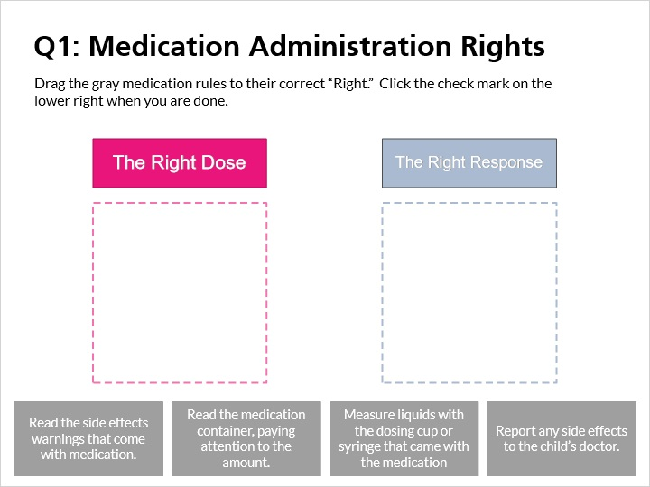
Drag Item | Drop Target
Report any side effects to the child’s doctor. | Response Drop
Read the side effects warnings that come with medication. | Response Drop
Read the medication container, paying attention to the amount. | Dose Drop
Measure liquids with the dosing cup or syringe that came with the medication | Dose Drop

Drag and drop properties
Snap dropped items to drop target (Free)
Delay item drop states until interaction is submitted

Feedback when correct:
That's right! For the “Right Dose” be sure you give the correct strength and amount. For the “Right Response” be sure to monitor that the drug is having the desired effect.
Feedback when incorrect:
You did not select the correct response.

Notes:
Drag the gray medication rules to their correct ”Right.” Click the check mark on the lower right when you are done.

2.20 Question 2
(Multiple Response, 10 points, unlimited attempts permitted)
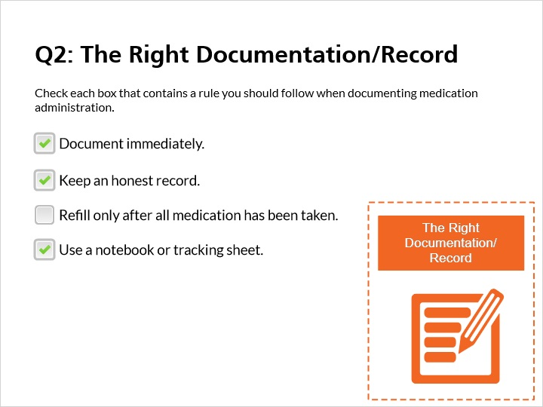
Correct | Choice
X | Document immediately.
X | Keep an honest record.
 | Refill only after all medication has been taken.
X | Use a notebook or tracking sheet.

Feedback when correct:
That's right! It is important to document immediately, keep an honest record, and use a notebook or tracking sheet to stay organized. Do not wait until all medication is gone to call in a refill. There may be a delay in refilling such as needing prescriber approval or insurance issues.
Feedback when incorrect:
You did not select the correct response.

Notes:
Check each box that contains a rule you should following when documenting medication administration.

2.21 Question 3
(Drag and Drop, 10 points, 5 attempts permitted)
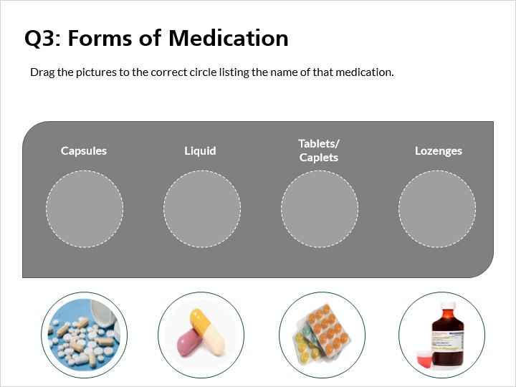
Drag Item | Drop Target
liquid | Drop Target Oval 2
loz | Drop Target Oval 4
caps | Drop Target Oval 1
tab | Drop Target Oval 3

Drag and drop properties
Snap dropped items to drop target (Stack random)
Delay item drop states until interaction is submitted

Feedback when correct:
That's right! You selected the correct pictures for each form of medication.
Feedback when incorrect:
You did not select the correct response.

Notes:
Drag the pictures to the correct circle listing the name of that medication.

3. Psychotropic Medications

3.1 About
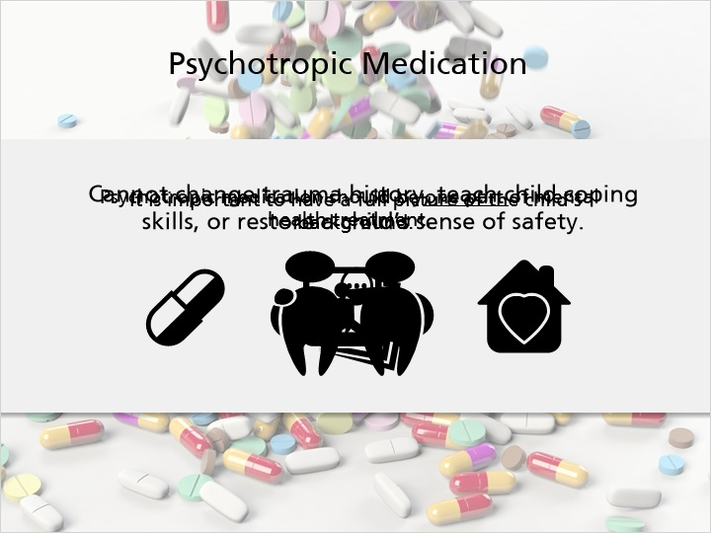
Notes:
Psychotropic medications affect the chemical makeup of the brain and nervous system and require a prescription. Psychotropic medications can decrease hyperactivity, anxiety, and depression but cannot change the child’s past life experiences or teach the child coping skills and restore their sense of safety. Some behaviors that present as a significant mental health issue may be due to a child’s trauma history. It is important to have a full picture of the child’s background and to make the prescribing doctor aware of any trauma history so the prescriber can make an informed decision regarding the most appropriate plan of treatment. If a psychotropic medication is included in the treatment plan, it should be one part of mental health treatment that may also include other therapies to support emotional well-being.

Often, these prescriptions play important roles in helping a child function. However, they can cause side effects, especially when too much or too many are taken by young children. Caregivers should be especially vigilant when administering and monitoring psychotropic medications

3.2 Types of Psychotropic Medication
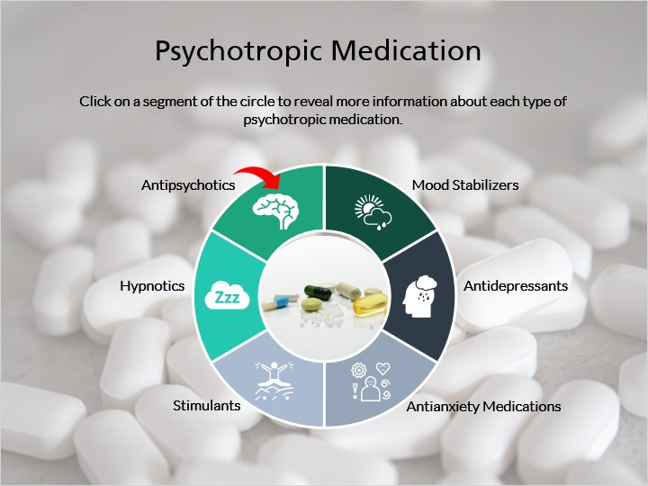
Notes:
Psychotropic medications can affect the mind, emotions, and/or behavior of a child and are prescribed for a variety of behavioral health conditions. Click on a segment of the circle to reveal more information about each type of psychotropic medication.

o Antipsychotics are used to control psychotic symptoms such as hallucinations, delusions, and mania. They may be used to treat Schizophrenia, Bipolar Disorder, or severe depression or anxiety. Examples include Abilify, Clozaril, Geodon, Risperdal, Seroquel, and Zyprexa.
o Mood Stabilizers are used to treat dramatic mood swings and treat mood disorders. They may be used to treat Bipolar Disorder. Examples include Lithium, Lithobid, and Eskalith.
o Antidepressants are used to treat symptoms of depression and elevate patient mood. They may be used to treat depression. Examples include Paxil, Prozac, Zoloft, Celexa, and Wellbutrin.
o Antianxiety Medications are used to relieve anxiety and nervousness. They may be used to treat generalized anxiety disorder, panic disorder, or PTSD. Examples include Xanax, Klonopin, Valium, Ativan, and Buspar.
o Stimulants are used to manage attention span, impulsivity, and hyperactivity. They may be used to treat ADHD or ADD. Examples include Adderall, Ritalin, Concerta, Focalin, and Vyvanse.
o Hypnotics are used to induce or support sleep. Examples include Ambien, Lunesta, Sonata, and Unisom.

3.3 Documentation
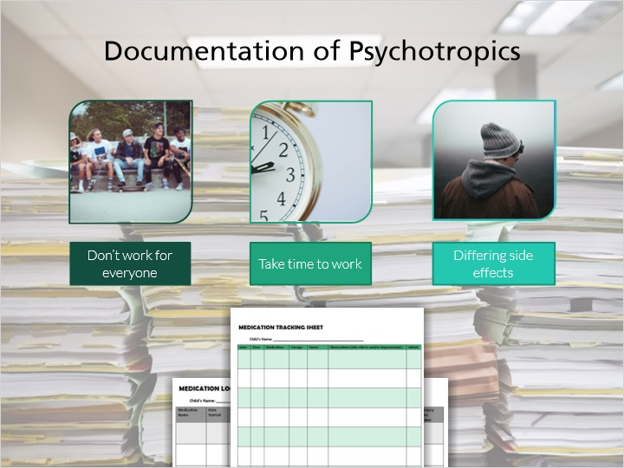
Notes:
Documentation is very important when administering psychotropics for three key reasons.

· Like any medication, not all psychotropic medications will work with all individuals. You may need to try two or more medication options before finding the right fit.
· They are often not designed to work instantly. Many require 4-6 weeks before the desired effect becomes apparent.
· Depending on the behavioral issue of the child, these medications can have different types of side effects including possible adverse side effects. You should talk to the prescriber about possible side effects and pay attention to changes in the child’s behavior, activity, and well-being.

Taking accurate and timely notes on the Medication Log and Medication Tracking Sheet you learned about earlier will help you keep track of these issues. Report any changes to the child’s team, including their prescriber.

3.4 Question 4
(Drag and Drop, 10 points, 5 attempts permitted)
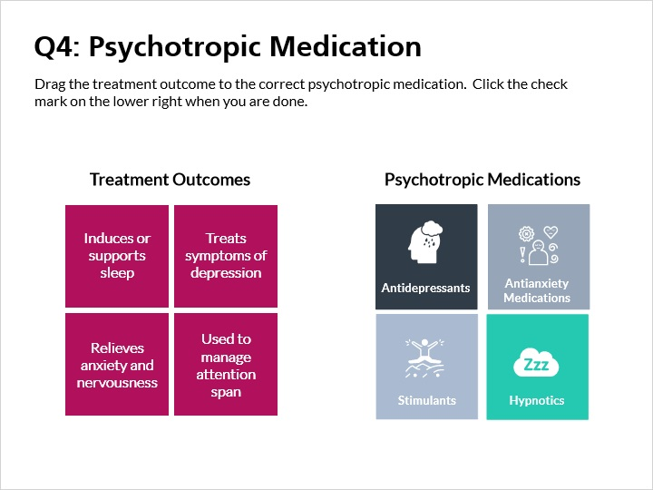
Drag Item | Drop Target
Used to manage attention span | stim 1
Relieves anxiety and nervousness | anx 1
Treats symptoms of depression | dep 1
Induces or supports sleep | hyp 1

Drag and drop properties
Snap dropped items to drop target (Free)
Delay item drop states until interaction is submitted

Feedback when correct:
That's right! You matched the potential outcomes with the correct psychotropic medication.
Feedback when incorrect:
You did not select the correct response. Please look back on the “Types of Psychotropic Medications” slide and review.

Notes:
Drag the treatment outcome to the correct psychotropic medication. Click the check mark on the lower right when you are done.

4. Medication Storage and Disposal

4.1 Storage & Small Children
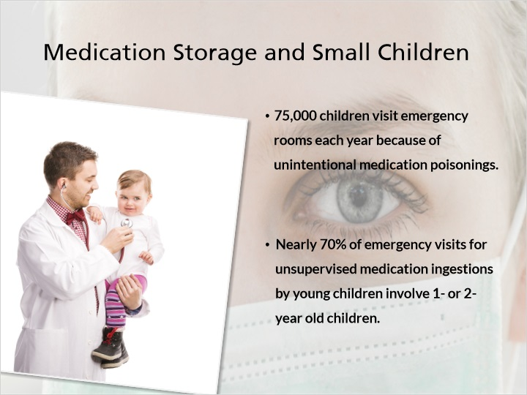
Notes:
Safe medication storage is incredibly important when you have children living in your home. An estimated 75,000 children visit emergency rooms each year because of unintentional medication poisonings. Those under 5 years old are especially vulnerable. In fact, the younger the child, the more vulnerable they are. Nearly 70% of emergency department visits for unsupervised medication ingestions by young children involve 1- or 2- year old children.

A few tips for keeping medication away from small children include:

- Store medications in a locked and childproof place that is too high for young children to reach or see.
- Do not leave medications out after using them.
- Never tell children that medicine is candy in order to get them to take it.
- Make sure child-resistant caps are securely on each time you finish using a medication.

And remember, Chapter DCF 56 requires the medications and other materials that might be hazardous to children be stored in areas not readily accessible to foster children. While storing medication in a high and locked cabinet may be appropriate for younger children, an alternative might be necessary when children reach adolescence. Locking up medication is recommended and considered best practice for medication storage, especially opioid and antipsychotic medications. This better ensures that children cannot access them. Check with your licensing agency about any policies they may have about medication storage.

4.2 Storage & Teens
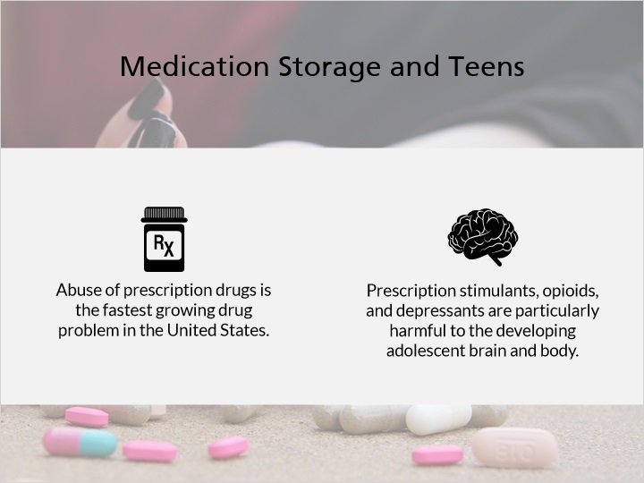
Notes:

For older children you will need to take a different approach. Abuse of prescription drugs is the fastest growing drug problem in the United States. A common misperception is that prescription drugs are safer or less harmful to the body than other kinds of drugs. Prescription stimulants, opioids, and depressants are particularly harmful to the developing adolescent brain and body. You can minimize misuse by doing the following:

- Educate the teen on the dangers of prescription drug misuse. The National Institute on Drug Abuse for Teens website has useful information for you and your teen. This website specifically discusses prescription drugs. Go over the information together.

- Monitor prescription drug use. This means following the suggestions given in the Eight Rights of Medication Administration, including watching the child take their medication, documenting medication administration, knowing the reason the child is receiving the medication, and paying attention to potential side effects.

- Safely store and dispose of medication. Two-thirds of teens who misused pain relievers say that they got them from family and friends, including their home’s medicine cabinets. Best practice is to lock- up prescription stimulants, opioids, and depressants. There is a variety of options on the market. They include locked bags, boxes, and cabinets. You may already have a locked space in your home such as a drawer with a lock or a safe. Those could be used as a safe medication storage space as well.

- Locking up medication is recommended and considered best practice for medication storage. This better ensures that children cannot gain access to them. Check with your licensing agency about any policies they may have about medication storage.

Information from: https://www.samhsa.gov/homelessness-programs-resources/hpr-resources/rise-prescription-drug-misuse-abuse-impacting-teens

4.3 General Storage Tips
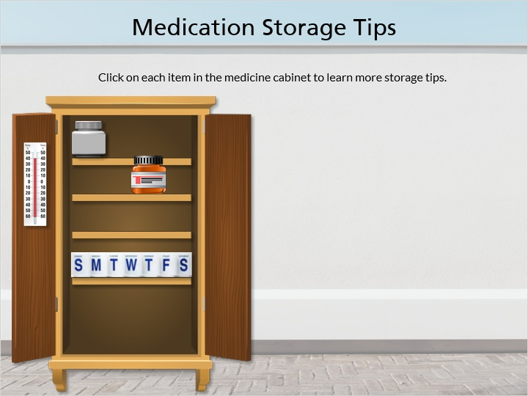
Notes:
There are also general tips for medication storage that apply to children of all ages. Click on each item in the medicine cabinet to learn more.
· Medication is best kept in a cool, dry place. A bathroom cabinet that gets hot and steamy is not the ideal location for medication storage.
· Always check the label to see if there is a specific storage requirement. Some medications need to be refrigerated.
· Always store medication in the container that was given to you by the pharmacist.
· Do not remove the label from a medication container until the medication is finished.

4.4 Medication Disposal
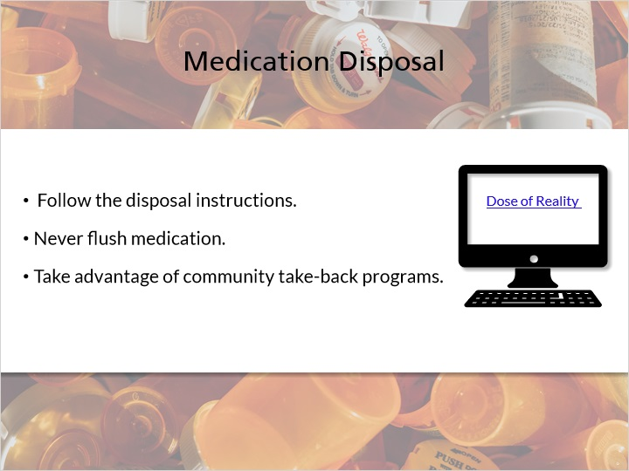
Notes:
Properly disposing of unused, unwanted, or old medications helps prevent prescription medication from being taken by others and protects the environment.
Follow any disposal instructions that are on the medication label.
Never flush medication down the sink or toilet unless you are instructed to do so.
Take advantage of community take-back programs. You can find a location near you using the Wisconsin Dose of Reality website.

Information from: https://doseofrealitywi.gov/drug-takeback/

4.5 Question 5
(True/False, 10 points, 5 attempts permitted)
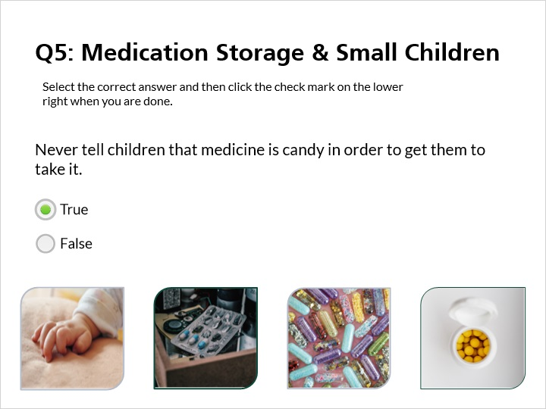
Correct | Choice
X | True
 | False

Feedback when correct:
That's right! Never tell children that medicine is candy in order to get them to take it.
Feedback when incorrect:
You did not select the correct response.

Notes:
Select the correct answer and then click the check mark on the lower right when you are done.

4.6 Question 6
(Fill-in-the-Blank, 10 points, 5 attempts permitted)
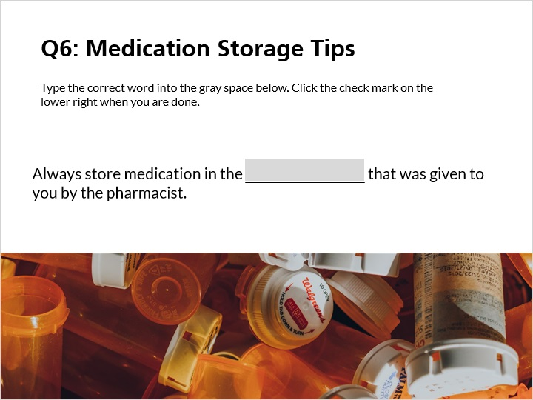

Choice
container
bottle
bag
box
continar
containor
bottle
containers
bottles
container

Feedback when correct:
That's right! Always leave medication in the container or bottle it came in.
Feedback when incorrect:
You did not select the correct response.

Notes:
Type the correct missing word into the gray space below.

5. Errors and Ending

5.1 Medication Errors
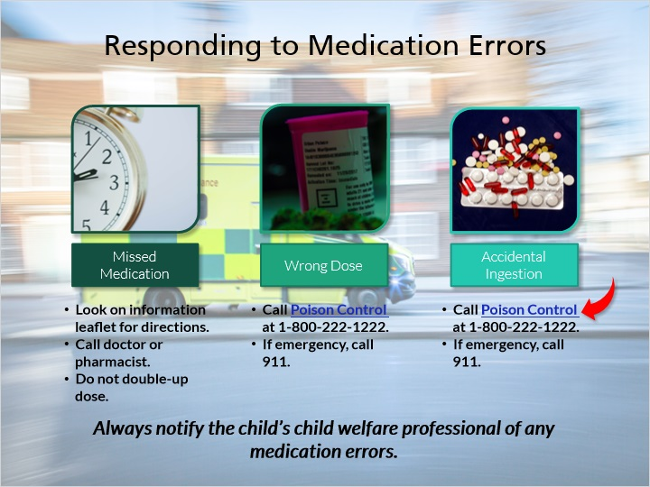
Notes:
Medication errors may happen. Some errors may be minor while others can be life-threatening. It is important to know what to do. Common errors include:
- Missed medication
- Wrong dose of medication
- Accidental ingestion of medication

If you missed a dose of medication, your first action should be to look at the drug information leaflet that comes with the medicine for directions. If there is no information there, call your doctor or pharmacist. Do not double-up on medication if you missed a dose. This can lead to an overdose.

Giving the wrong dose of medication is the most common error people make when giving medication. Documenting when you give medication is the best way to prevent this error. If a wrong dose is given, call Poison control at 1-800-222-1222. If the child collapses, has a seizure, has trouble breathing, or is difficult to wake, this is considered a medical emergency and you should call 911.

If a child accidentally ingests a medication that is not theirs, follow the same suggestions that were given for “wrong dose.” Call Poison control at 1-800-222-1222 or use their online tool POISONCONTROL. If the child is having a medical emergency you should call 911.

You should also notify the child’s child welfare professional of any medication errors. DCF 56.06(1)(d) states that foster parents shall immediately notify the supervising agency and, if not the same, the licensing agency of an error in administering medication to a foster child. This is required under serious incident reporting.

Information from:

https://www.phttps://www.phttps://www.phttps://www.phttps://www.phttps://www.phttps://www.phttps://www.phttps://www.phttps://www.phttps://www.phttps://www.phttps://www.phttps://www.phttps://www.phttps://www.phttps://www.phttps://www.phttps://www.phttps://www.phttps://www.phttps://www.phttps://www.phttps://www.phttps://www.phttps://www.phttps://www.phttps://www.phttps://www.phttps://www.phttps://www.phttps://www.phttps://www.phttps://www.phttps://www.phttps://www.poison.org

5.2 Question 7
(Drag and Drop, 10 points, 2 attempts permitted)
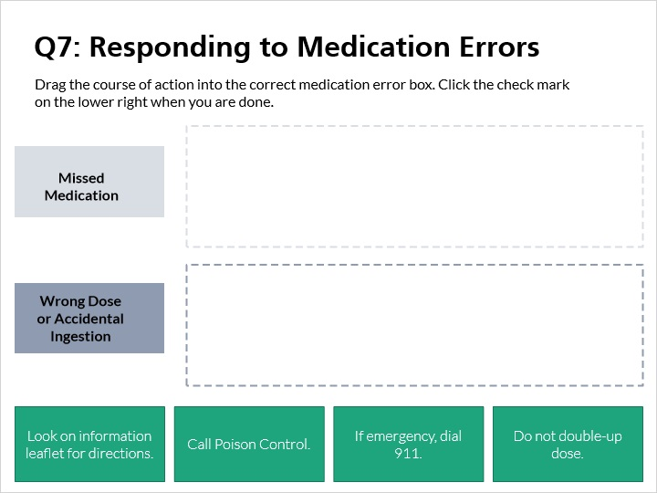
Drag Item | Drop Target
Do not double-up dose. | Dose Drop
Look on information leaflet for directions. | Dose Drop
Call Poison Control. | Response Drop
If emergency, dial 911. | Response Drop

Drag and drop properties
Snap dropped items to drop target (Free)
Delay item drop states until interaction is submitted

Feedback when correct:
That's right! You may now continue to the final slide of this online training.
Feedback when incorrect:
You did not select the correct response.

Notes:
Drag the course of action into the correct medication error box. Click the check mark on the lower right when you are done.

5.3 Review
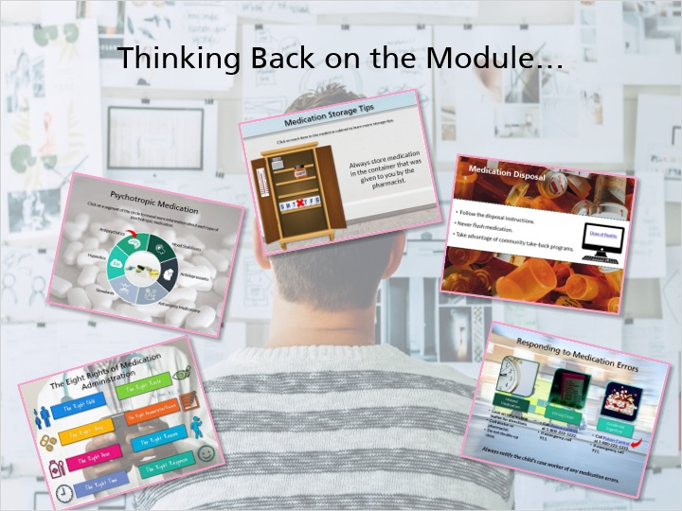
Notes:
Please think back over the information you have learned in this module and make some notes about what you feel are the most important points.

· When preparing to administer any drug to a child, consider The Eight Rights of Medication Administration. They are:
o The Right Child
o The Right Drug
o The Right Dose
o The Right Time
o The Right Route
o The Right Documentation or Record
o The Right Reason and,
o The Right Response

· Psychotropic medications can affect the mind, emotions, and/or behavior of a child and are prescribed for a variety of behavioral health conditions. Caretakers need to be especially vigilant when administering and monitoring these medications.
· Store medication safely. For young children this means keeping it in a high and locked place. For teens you need to educate them on prescription drug abuse and keep drugs like opiates locked up.
· Never dispose of medication by flushing it. Instead, seek out community take-back programs.
· Medication errors can happen. Depending on the severity of the situation, call your doctor, pharmacists, Poison Control, or 911.

This concludes the Medication Management module. As always, remember that if you need clarification or have additional questions, ask your licensor.

5.4 Results Slide
(Results Slide, 0 points, 1 attempt permitted)


Results for
5.2 Question 7

Result slide properties | Passing Score
100%

Notes:

