Module 3b

1. Module 3 - Part 2: Caring for the Children in Foster Care

1.1 Foster Care Overview
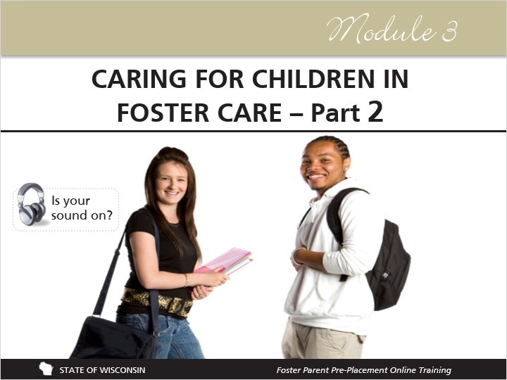
Notes:
In this module, you'll learn about nurturing care and discipline, the daily needs of children in foster care, fostering teens, culture, identity and transitions that children in care face at different times in their lives. Remember to jot down notes as you go.

2. Qualities of a Good Foster Parent Part 1

2.1 Qualities of a Good Foster Parent: Part 1
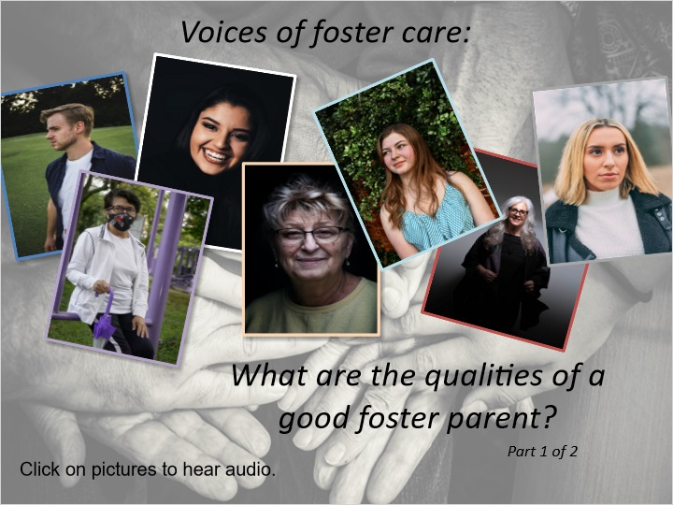
Notes:
“Qualities and characteristics of good foster parents include being flexible, having a good sense of humor, being patient, being able to understand and display empathy, being a good listener, being able to think on your feet and having a positive attitude and really it's about enjoying children, you need to be able to effectively say no, you need to be able to withstand a lot of pressure. You also need to be a good team member and recognize that it's about the children and not necessarily about you.”

“I think the qualities of a good foster parent, not that I always have these, are flexibility and humor come to mind, it's hard to be rigid and it's really the qualities of any parent I think. Compassion, compassion for the birth family, empathy to see, you know to try to put yourself in where they've been and that it helps to be somebody who's curious and who wants to learn more because you learn a lot about everything when you're a foster parent.”

“The qualities of a good foster parent is someone that treats the child like one of their own, doesn't show any discrimination between biological children and foster children.”

“Someone who's caring, patient, loving, supportive of the strengths of the child and being able to see those as well as encouragement for the challenges or the difficulties they may have, it's really important for a foster parent to also consider older youth and helping prepare them for independent living and teaching them the life skills that will enable them in the real world to be out there and be self-sufficient when they're adults.”

“A good foster parent is somebody that is doing foster care for the children and for their well-being.”

“Well foster parents have to have the same magical qualities that parents have but they need to be amplified because parenting your own children is somewhat natural to you but parenting someone else's children and children you don't have that history with, that's really tough so some of the qualities are patience and acceptance and some understanding, a quality of a good foster parent is to accept the child and their family and their situation without feeling the need to question it and being in it whole heartily, 100 percent. Kids deserve that from a foster parent that they're in 100 percent.”

“The warmth and the caring and the love that they show these kids, even though they take them in as complete strangers and then they learn to have them be part of their families and as the child feels more and more secure in these homes it's just wonderful to watch the children blossom and the foster parents give them structure and routine which some of these kids may not have had for a long time and they do it in such a loving and nurturing way. They have to learn unique discipline skills for these children as well as unique ways to help them with their emotional and mental health and the foster parents go out and do that for these kids and the families.”

3. Advice from Foster Youth

3.1 Advice from Foster Youth
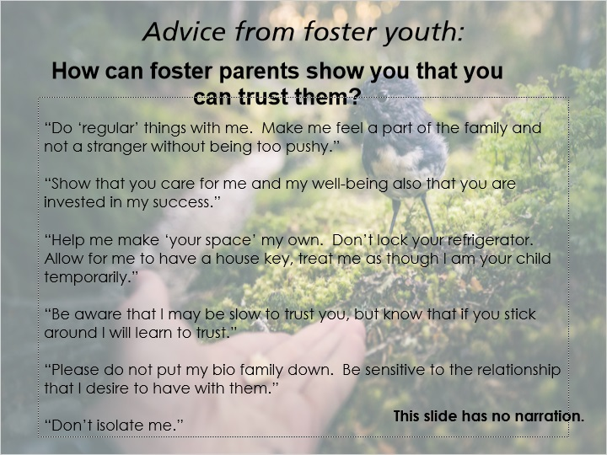
Notes:
This slide contains no narration. Please read the statements on the slide.

3.2 Best Interest of the Child
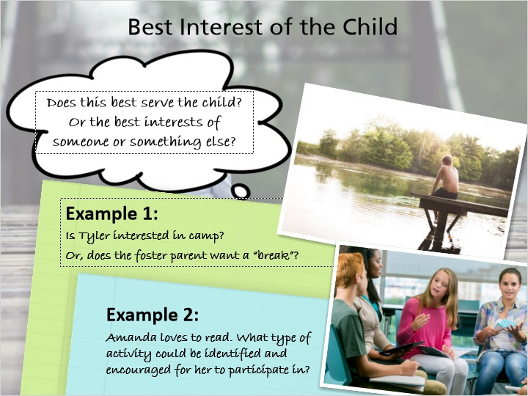
Notes:
Building trust involves considering what is in the best interest of the child that is in your care. What is in the best interest of the child involves giving primary consideration to the child through a thoughtful assessment and is part of the Reasonable and Prudent Parenting Standard.

A good question to ask is, “Does this best serve the child? Or the best interests of someone or something else?” We want to view situations through the eyes of the child.

Consider an example of whether to send a child, Tyler, to an overnight camp. Are you sending Tyler because he is interested in the camp and will benefit from it, or, do you only have the motive of giving yourself a “break”?

Here’s another scenario to think about: Amanda is not interested in sports, but loves to read. What type of activity could be identified and encouraged for her to participate in?

As a foster parent, it’s important to remember to encourage children to voice their opinions and thoughts to ensure their best interests are being served.

4. Nurturing Care & Discipline

4.1 Nurturing Care & Discipline
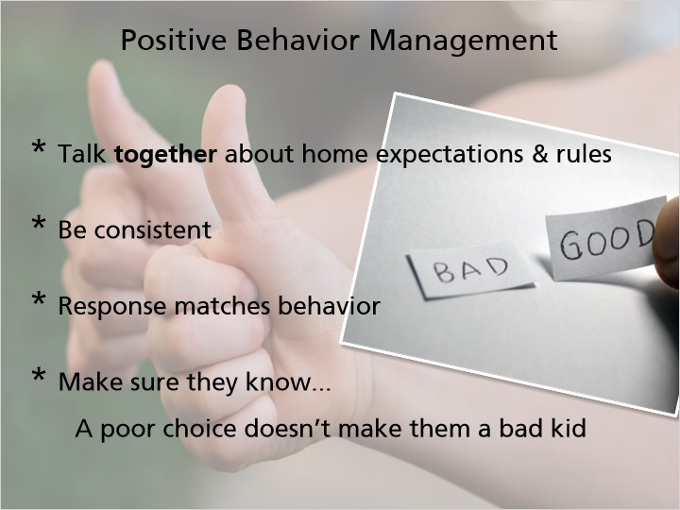
Notes:
In parenting, discipline is a fact of life, and foster parenting is no different. The reality is that you will have to provide some discipline to the children in your home. The main thing to remember when disciplining children is that discipline is meant to teach, not punish. Providing discipline is not a way for you to get out your anger or frustrations, it is a way for the children in your home to learn about how their actions affect themselves and others. You will be best able to manage children’s behavior and to teach them how to better manage their behaviors if you first have a relationship with them. When children have a trusting relationship with you, they will care about your reactions to their behaviors and will care about how their actions affect those around them. However, if children do not have a trusting relationship with you, your reactions to their behaviors will have little effect on them.

Foster care licensing code explains specific restrictions on disciplinary approaches. The code will give you a lot of information about what you cannot do in disciplining children, but doesn’t give you many ideas of what you can do. Some ideas for positive behavior management include:

- When a child is placed in your home, talk with the child (not to the child) about the expectations and rules in your home. Explain the reasons behind the rules in your home and give the child an opportunity to ask questions. Children are more likely to respect the rules and expectations when they understand the reasons behind them.

- Be consistent in your expectations and follow through! If you say you’re going to do something, do it!

- Have the response match the behavior. For example, if a child didn’t clean his room, it would be more appropriate to tell the child that he cannot go play at the park before he cleans his room than to simply prohibit the child from playing at the park. In this case, your response is connected to the child’s behavior and will make more sense to the child.

- Make sure that you communicate that while the child may have made a poor choice, this doesn’t make them a bad kid!

4.2 Managing Behavior
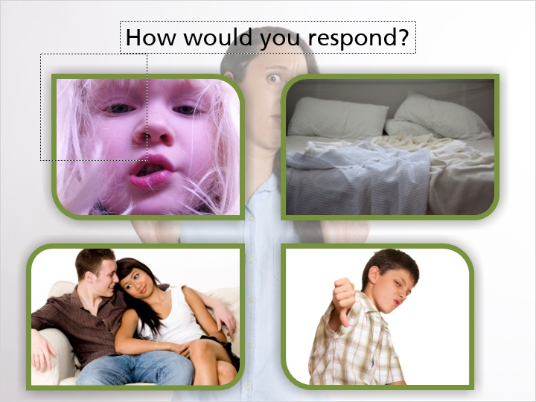
Notes:
Please listen to the following scenarios and think about how you would handle these situations. How could you respond to these situations in order to manage the child’s behavior in a productive way? Write down your ideas and discuss these with your licensor.

- You are on the phone with a friend who you haven’t spoken to in months. Your 3-year-old foster daughter wants you to put her favorite DVD in for her. She asks you repeatedly while you’re on the phone to start her movie and to watch it with her. When you ask her to wait, she asks you “Why?” over and over.
- One of your house rules is that everyone makes their beds in the morning before they go to school. Your 12-year-old foster son regularly leaves his bed unmade despite your reminders about the house rule.
- Your 16-year-old foster daughter asked if she could invite her boyfriend over after school. You told her that she could invite him over once her homework was finished, but she came home after school with him.
- A 9-year-old boy is removed from his father’s home due to neglect and placed in your home. When you sit down with him to talk about your house rules, he tells you that he didn’t have to follow any rules like that at home and doesn’t have to at your house either, because you’re not his parent.

All of these scenarios are potentially frustrating situations and probably resulted in some stressful reactions. Talk with your licensor about your ideas and any concerns you have about dealing with situations like these.

Now listen to other foster parents as they share creative ideas for managing behaviors…

4.3 Voices of Foster Care: Managing Behavior
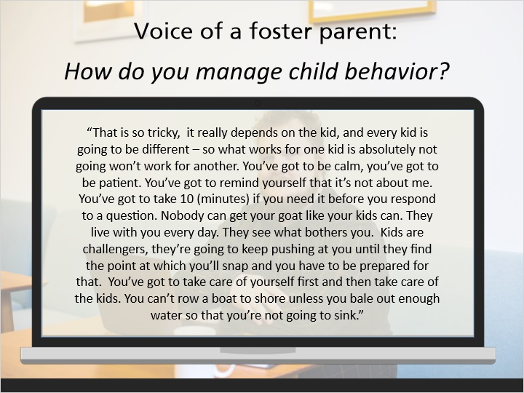
Notes:
Voice of a foster parent:

“That is so tricky, it really depends on the kid, and every kid is going to be different – so what works for one kid is absolutely not going won’t work for another.
You’ve got to be calm, you’ve got to be patient. You’ve got to remind yourself that it’s not about me. You’ve got to take 10 (minutes) if you need it before you respond to a question. Nobody can get your goat like your kids can. They live with you every day. They see what bothers you. Kids are challengers, they’re going to keep pushing at you until they find the point at which you’ll snap and you have to be prepared for that. You’ve got to take care of yourself first and then take care of the kids. You can’t row a boat to shore unless you bale out enough water so that you’re not going to sink.”

4.4 Child’s Behavioral History
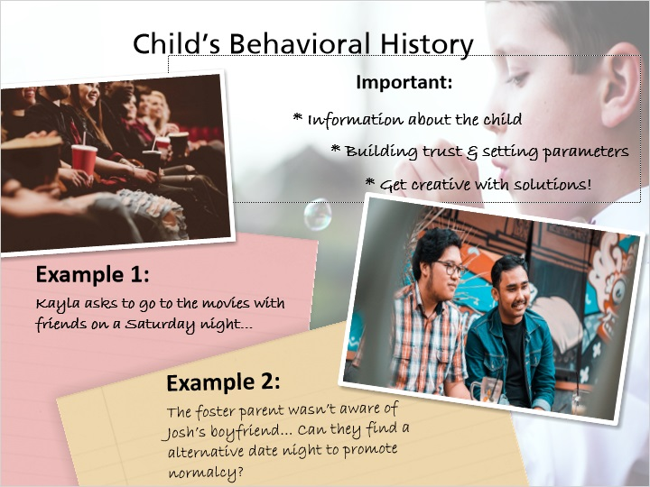
Notes:
Taking into account a child’s behavioral history is another factor to consider when it comes to the Reasonable and Prudent Parenting standards. This consideration stresses the importance for you as a foster parent to be given as much information about the child as possible to help you better make informed parenting decisions when it comes to a child in your care.

Every child makes mistakes and their past should not eliminate the opportunity for a second chance. You should keep in mind the importance of building trust and setting parameters with the children in your care. Conversations with the child must also occur when their behavioral history has a great impact on the decision being made.

Try to get creative if a child’s behavioral history is swaying you to say “no” to a normalcy activity.

For instance: Kayla asks to go to the movies with friends on a Saturday night. Staying out past curfew has been an issue for her lately. Your first reaction may be to say “no” based on her previous behavior. Yet, you need to be creative to promote normalcy activities. Therefore, you agree to let Kayla go to the movies with friends, as long as you drive them.

Here’s another example relating to how a child’s behavioral history influences a reasonable and prudent parenting decision.

Late on a Thursday, you receive placement of Josh, a 15‐year‐old male. Shortly after the child welfare professional left, Josh explains to you that he has a date with his boyfriend tomorrow night.

You received information about Josh through the Information for Out‐of‐Home Providers Part A & B forms, but neither Josh nor his mother mentioned anything to the child welfare professional about a boyfriend.

How does the lack of information affect your reasonable and prudent parenting decision?

Due to the timing, lack of information, and to ensure safety, you can still promote normalcy for Josh by allowing his boyfriend to come over for pizza in your home rather than go out to dinner, as originally planned. You should supervise and establish boundaries for the date.

4.5 Disciplinary Principles
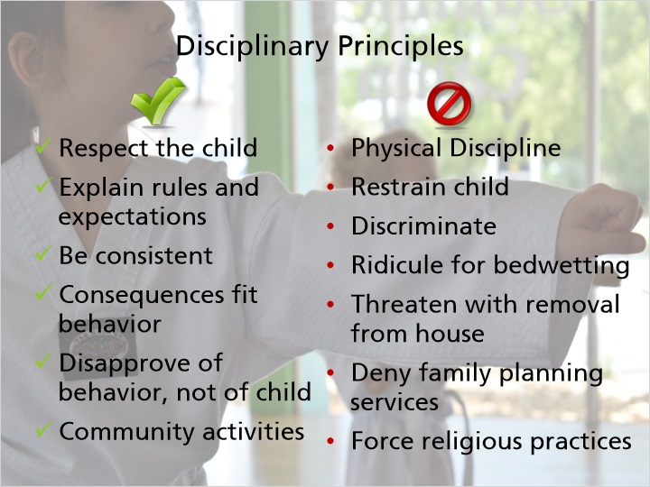
Notes:
As a foster parent, there are many things you can do and many things you cannot do when disciplining children in your home.

You can:

- Respect the child as a person
- Explain the rules and expectations of your home ahead of time
- Be consistent in your expectations and in enforcing rules in your home
- Give consequences that fit the behavior, and the age and developmental level of the child
- Ensure that the child knows that you disapprove of the behavior, not of the child
- Let the child participate in community activities

You cannot:

- Use any physical discipline, which includes spanking
- Restrain a child
- Discriminate against the child
- Ridicule any foster child for any bedwetting or lapses in toilet training
- Threaten a child with removal from your home
- Deny a child access to confidential family planning services
- Force a child to participate in religious practices

Please see Ch. DCF 56.09, Care of Foster Children, for additional information about principles for nurturing care of foster children.

4.6 Check Your Understanding - Behavior & Discipline
(True/False, 10 points, 2 attempts permitted)
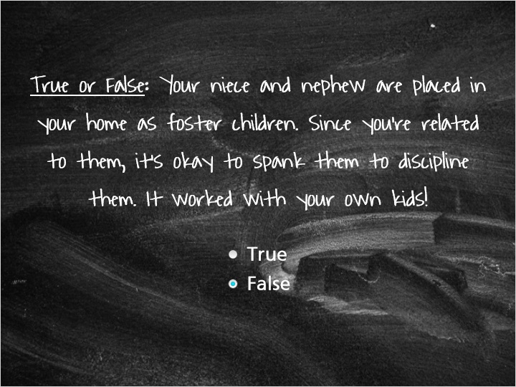
Correct | Choice
 | True
X | False

Feedback when correct:
You're correct, you cannot use any type of physical discipline with any foster child.
Feedback when incorrect:
This is false. As a licensed foster home, you cannot use any physical discipline with foster children, which includes spanking, even if you are related to the child.

4.7 Voices of Foster Youth: Open Communication
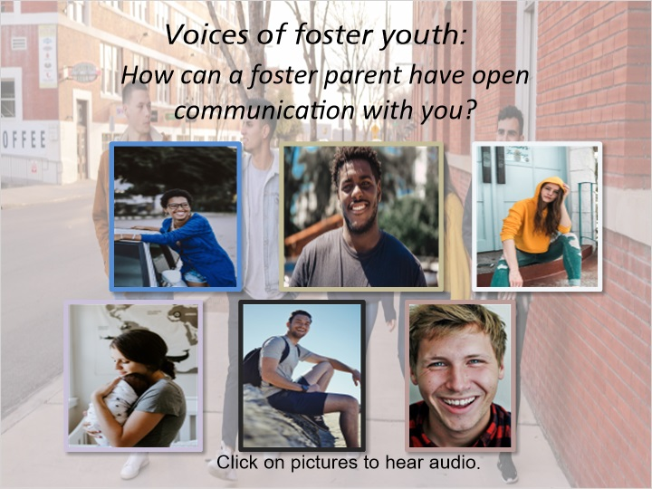
Notes:
Voices of foster youth:

“I would like to see a relationship where I can come to you and communicate with any situation, and on any given day where you wouldn't judge me about anything that I'm coming to you about. Not necessarily if it is negative or positive, if I can come to you and talk to you about anything that I'm going through, a problem you can give me a solution and we can come to a conclusion and solve it. Sit us down, talk to us, guide us in the right direction, basically love us like they would love someone as his child or their own child. It's basically listen to our problems because we're already going through enough.”

“Asking me how I feel, caring about what I think is important, caring about my future, caring about what I think is important in life, caring about you know reunification, trying to get me back with my birth parents, I think that is a very important one and just caring about my overall well-being, I mean don't look at me like I'm just in your home and in the way, you know actually look at my situation and want to do right by me, help me succeed and get past it.”

“Letting us come to them, not pushing us right when we enter their home, it's going to be a scary environment, something new and we never knew them beforehand so it's... letting us come to… in terms of what's going on first and then letting us open up, seeing that they're not a bad person, that they will actually help us and then for them just to say if I'm here whenever you need to talk.”

“Letting me talk to them when I'm ready to talk to them and them telling me what's going on with everything about me, my plans and what's going to happen to me, what's happening with my family, what's going on with everything out there that I need to know.”

“I think the most important one would be just listening to them because there's a difference as everybody knows between hearing what somebody is saying and listening to what they're saying and a lot of foster parents don't feel the need to listen to their foster youth like they do with their own children and it's just as important because foster youth has the same needs if not more than their own children so it's important that they listen to their needs, listen to what they have to say and be able to show that they are willing to have open communication, both ways.”

“I think that the best way for them to open communication lines with us is to not read the case file that we have and think that they can know us from that but take the time to actually get to know us before assuming they know who we are.”

4.8 Emotional & Developmental Growth
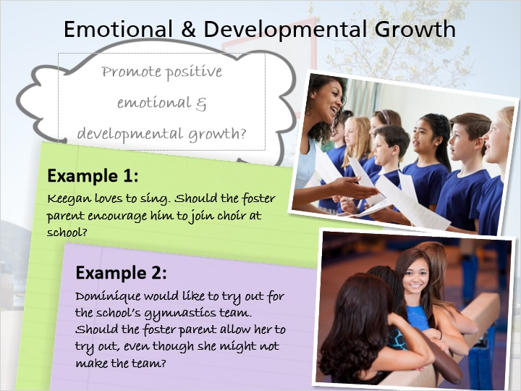
Notes:
As the youth just stated, having open communication, building trust and listening to individual needs and wants are part of making connections that contribute to children’s emotional and developmental growth.

The emotional and developmental growth of the child must also be considered when making reasonable and prudent parenting decisions. You must assess the activity and circumstance to determine if it will promote positive emotional and developmental growth. Interacting with peers and participating in team activities allows the child opportunities to develop social and emotional skills.

It is important to note that even when you know that the child in your care may not be successful at something, such as making a team, the child should still be encouraged to try out, as it could be an experience of personal growth.

The following examples illustrate the importance of encouraging and allowing a child to participate in athletic or extracurricular activities.

Keegan loves to sing. Should you encourage him to join choir at school, knowing that it could provide good social interaction and build his self‐esteem?

Dominique would like to try‐out for the school’s gymnastics team. Should you allow her to try out, even though she might not make the team?

You should keep in mind that the opportunity to participate in these types of activities will provide opportunities for emotional and developmental growth for the child, regardless of their success.

4.9 Voices of Foster Youth: Things to Teach
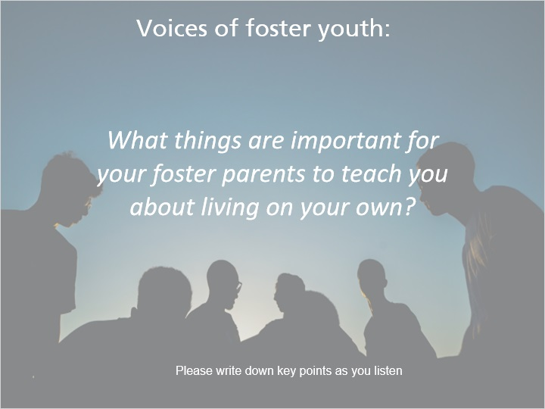
Notes:
Voices of foster youth:

“Learning how to do simple things such as laundry. Learning how to use a washer and dryer. You know washing your clothes. How to do laundry. Do laundry and know how to clean up after yourself. Making sure the fridge gets cleaned out, things that youth tend to forget about once they get on their own, making sure you know clean the toilets and...
Washing dishes like the basics, washing your clothes. How to clean a house the right way, do stuff the right way without making a fire hazard or something. Shopping, how to go grocery shopping. Cleaning, cooking. Cleaning, Cooking. How to cook. To make actual decent meals and not have to go out to eat and spend money every night. How to use a stove. Things that make a house home.

Learning how to manage money. How to do budgeting money. Budgeting. Budgeting. How to obtain a bank account and budgeting money and... How to budget my money so I'm that I'm not struggling when my rent needs to be paid. How to budget and how to take care of money and... Credit and money management. Taxes. How to pay my utilities.The basic things all people need to learn in life. Guidance, love, protection. How to keep yourself focused on what you're doing, focus on what you need to get done throughout your day. Preparing for your future, some type of assistance for my future. Finding job search. Knowing how to find a job, do a resume and interview. How to fill out job applications, saving money. Driving I think is an important one too. Basic daily living skills, knowing how to use a shower. Personal hygiene. How to take care of yourself.

Communication with my landlord, know what type of resources that I might need if I come into having problems with my landlord. They need to have some type of stability and stability is important when it comes to living on your own. Even if the foster parent doesn't have the correct training to teach us, it's their responsibility to help us find different avenues that we can learn those life skills.”

5. Daily Care Needs

5.1 Daily Care Needs
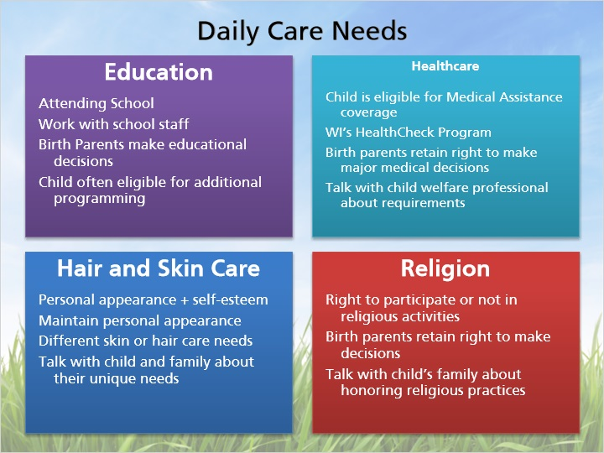
Notes:
Children in foster care have daily needs that are exactly like other children their age, including education, health care, hair and skin care, religion, recreation, life skills, and safety.

Education

You will be expected to make sure that the children in your home are attending school and keeping up with expectations. You will need to work with school staff to ensure that the children in your care are receiving the assistance they need, but birth parents retain the right to approve Individualized Education Plans and to make educational decisions. Children in foster care are often eligible for early education programming, such as Birth to 3 Programs and Head Start.

Healthcare

Every child in foster care in Wisconsin is eligible for Medical Assistance coverage, and some children have insurance through their parents as well. Children in foster care must receive medical and dental care according to Wisconsin’s HealthCheck program. Birth parents usually sign authorizations for medical care while their children are in foster care, but retain the right to make major medical decisions. Talk with your licensor or the child’s child welfare professional about the requirements for the HealthCheck program. More information about healthcare for children in foster care can be found in foster care licensing code.

Hair and Skin Care

For many children, personal appearance is important and is connected to their self-esteem. As foster parents, you will need to help children maintain their personal appearance. Due to cultural or ethnic differences, some of the children in your home may have different skin or hair care needs than you. Talk with the child or their family to learn about the unique skin and hair care needs of the child. Some agencies offer trainings on these topics as well.

Religion

As you may remember from previous modules, children in foster care have the right to participate, or to not participate, in religious activities. This is one of those areas where the child’s parents retain the right to make decisions. Talk with the child’s family about honoring their religious practices, and talk with your licensor about any concerns or conflicts that arise.

More information about these topics can be found in your Foster Parent Handbook.

5.2 Daily Care Needs Continued
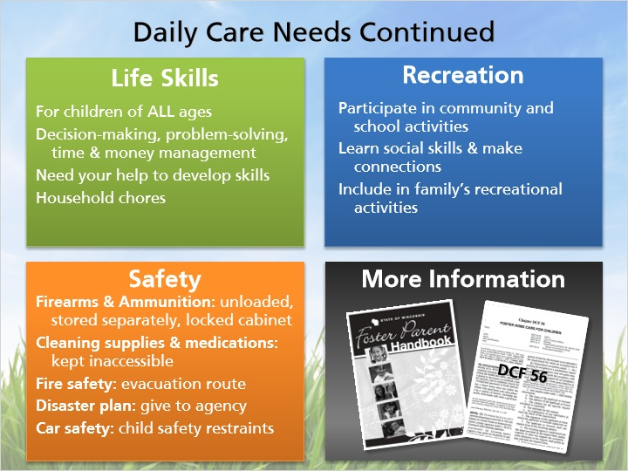
Notes:
Life Skills

Children in foster care must have an opportunity to develop life skills. This is true for children of all ages, not just teens. Life skills can include things like decision-making skills, problem-solving skills, and time and money management. These skills may not come as naturally to children in foster care due to their past experiences. These children will likely need your help in developing these skills. One way for children to learn life skills is by doing household chores. Foster care licensing code places restrictions on the types of chores children can do. You will learn more about life skills specific to teenagers later in this module.

Recreation

Children in foster care are able to participate in community and school activities of their choosing, and should be encouraged to participate in such activities in order to make friends with their peers. Recreation activities are an opportunity for children to learn social skills and to make connections with others. Foster children in your home should be included in your family’s recreational activities.

Safety

Foster care licensing code requires you to take specific precautions in order to keep children safe. It is important to explain these rules to children when they are first placed in your home. Your agency may also have additional safety policies. More detailed information can be found by reading Ch. DCF 56. Some important safety considerations are:
Firearms: must be unloaded and kept in a locked cabinet that is inaccessible to children. Ammunition must be locked and stored separately from firearms.
Cleaning supplies and medications must be kept in locations inaccessible to children
Fire safety: you must have an evacuation route in case of fire, and you must go over this route with the children in your home at the time of placement and every 3 months after placement.
Disaster Plan: must be given to your licensing agency and include where your family would evacuate to, a list of what you will take if evacuated, and, contact information for you, a friend or relative out of the area, and the licensor or other child welfare professional you will check in with.
Automobile safety: all laws regarding child safety restraints must be followed. Details on these requirements can be found in Ch. DCF 56.

More information about these topics can be found in your Foster Parent Handbook or in DCF 56.

5.3 Potential Risk Factors
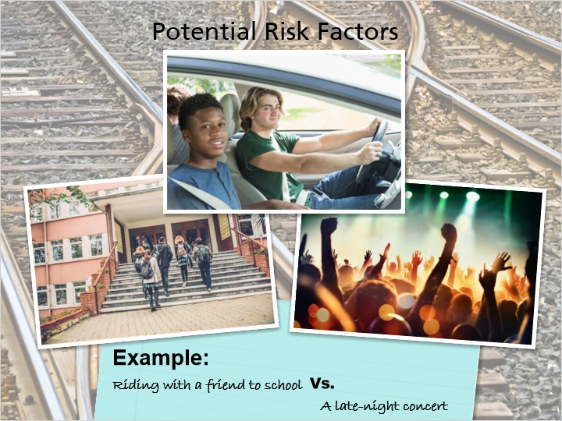
Notes:
There will times you will need to make a parenting decision while having to assess safety and risk. The Reasonable and Prudent Parenting Standard considerations includes assessing the potential risk factors of an activity a foster child may want to participate in.

Every situation has its own potential for risk, which varies based on the type of activity and the specific circumstances. Each situation should be considered individually. Risk factors may appear in many different ways, such as inadequate safety equipment, supervision levels, or a lack of information.

For example, a decision for 15-year-old Dakota to ride in a car with his seventeen-year-old friend Cory may change depending on the surrounding circumstances and level of risk. It may be reasonable and prudent to allow him to ride with the friend to and from school, but the same may not be true for a late-night concert.

You should discuss the assessment of risk with older youth. We want them to learn the skill of identifying how the same activity could be safe and appropriate in one situation, but would not be okay in other circumstances.

5.4 Potential Risk Factors Continued
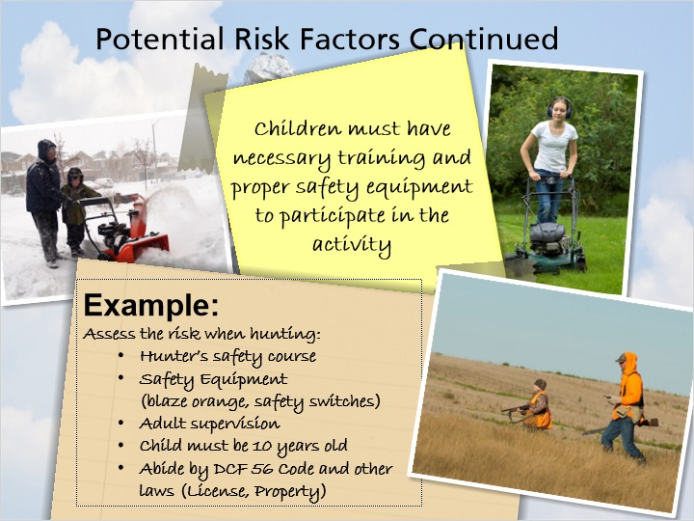
Notes:
Risk assessment includes whether the child is adequately prepared to safely participate in an activity. You must ensure that children have the necessary training and proper safety equipment in order to participate in certain activities.

Hunting is a good example of this consideration. If you are deciding whether to allow a child to go hunting, you must assess the risk of the situation. This includes whether the child has taken a hunter’s safety course and whether the child has the appropriate safety equipment, such as safety locks on guns and blaze orange gear. The child should also be supervised by an adult who is familiar with hunting at all times. The child must abide by other laws that dictate that they must have a license and may not trespass on private property.

5.5 Voices of Foster Youth: Independent Living
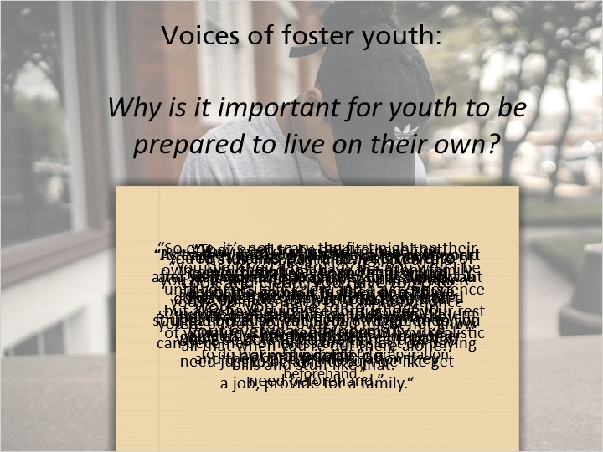
Notes:
Voices of foster youth:

“So one, it’s not scary the first night on their own. Two, they don't have the other family support to go back to, they don't have someone that can come and stay with them the first night.”

“As foster youth we don't get a lot of support after we're out of the system so it's important that we have as much of a base and foundation as we can before we go on to live our lives.”

“You're at home, you're being taken care of you're being fed everyday, you know where you're going to sleep that night but once you're out on your own you might not know all that when you're out there alone.”

“They need to be able to have that comfort, that safety and still having that little comfort blanket or a little stuffed animal, the only way they're going to get that is if they're prepared and they get the information they need beforehand.”

“You think you'll be ready but you won't be until you actually know and have experience but also have guidance throughout your rest of your life. They need to know how realistic it is in life.”

“It teaches you what it's like in the real world and so it won't be a culture shock when you do go into the real world and you won't struggle because when you struggle then you can become homeless or miss out on paying bills and stuff like that.”

“You have to pay bills, you have to cook and clean, you have to go to work, you have to do things in your everyday life normally, like normal people do.”

“It's just important that we know all the different things like how to write a check, like how to do different things that we need to in order to live our lives and be a productive member of society and in order to do that we need a lot or preparation beforehand.”

“You need driving skills; managing money definitely is one that I would classify as needed to learn. If they're not prepared to live on their own they won't be able to do the things that you need just to be able to survive like get a job, provide for a family.“

5.6 Voices of Foster Youth: Independent Living
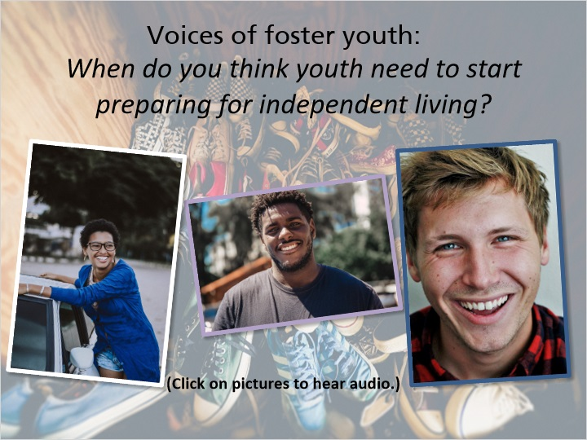
Notes:
Voices of foster youth:

“A youth should start preparing for independent living as soon as they know responsibilities the age varies, the child varies, everyone is different. This day and age youth are really maturing, really quickly and they can understand what they want and things that they want for their future.”

“Really there isn’t a number, I guess it just depends on the child. You know it's important to start informing them about college, about jobs or trades or just different options for the future as well as preparing them with those everyday life skills like cooking, cleaning, managing money and bill paying and just to get them on track so when they do age out of system they won't be just...their learning all of it now, they kind of a have foundation set up.”

“I think it depends on the youth themselves what age they need to start preparing, all youth are different. I think it's easier to start out at a younger age with the simpler things and then work your way up to the more complex.”

5.7 Voices of Foster Youth: Skills Learned
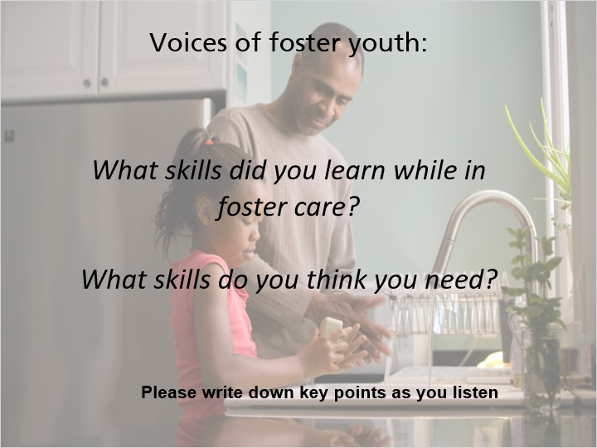
Notes:
Voices of foster youth:

“I learned how to pay bills, I learned how to clean, cook. How to use a washer and dryer, I got to learn daily living skills, making sure you take a shower every day, making sure your room is clean, making sure your bed's made decently. Make sure that I was dressed appropriately, I was clean. Cooking, baking, washing dishes, laundry, hygiene, how to do my hair, how to keep up with myself so you don't stink.

How to keep myself from doing stuff, buying stuff I don't need, doing stuff I'm not supposed to do. I learned how to do different... different cleaning, how to making sure that I know how to cook and clean and do my laundry, all that.

I learned how to manage my own money. How to manage my money and how to be a better saver and like prepare for the future because I didn't know was... what was going to happen next. Even the fun things too like going out and fishing or hunting and knowing how to do those things.

I learned how to drive in foster care; I learned how to cook in foster care, cleaning was definitely a skill that I built in foster care. And then just like simple things like social interactions as well, just being like having different people over and knowing what me and my foster brothers needed to do in that situation and... Skills that I still think I need, cooking, I still haven't really done much cooking, I don't like to cook because I'm not good at it and I still have my problems with picking up after myself.

How to take the bus, how to keep a job and stay focused on the job not focusing on other things. I think I really needed money management and credit management. Budgeting can be kind of a weak area some times. Money management, time management and just management in general. How to stay on budget, how to make sure you have enough of everything to the end of the month. I think that I needed those skills in foster care; I think that it would have helped me become a more aware adult now.”

5.8 Check Your Understanding - Health & Safety
(True/False, 10 points, 2 attempts permitted)
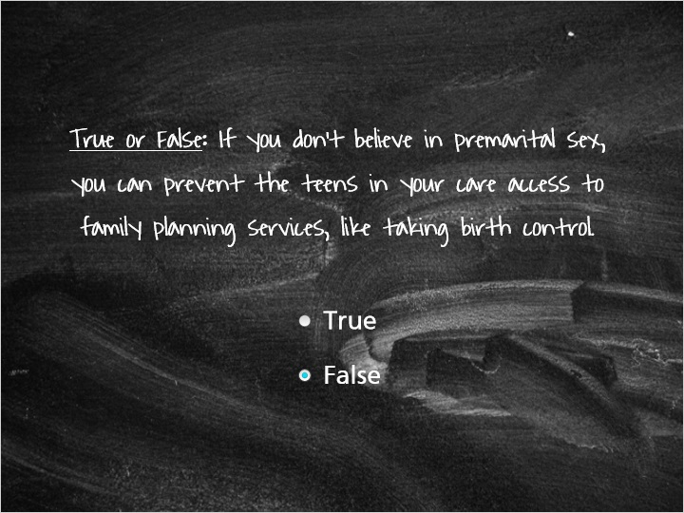
Correct | Choice
 | True
X | False

Feedback when correct:
You're right, this is false. Foster care licensing code states that you do not have the ability to deny access to confidential family planning services. If you feel that your beliefs or values will make it difficult for you to follow this rule, talk with your licensor.
Feedback when incorrect:
No! Foster care licensing code states that you do not have the ability to deny access to confidential family planning services. If you feel that your beliefs or values will make it difficult for you to follow this rule, talk with your licensor.

6. Fostering Teens

6.1 Fostering Teens
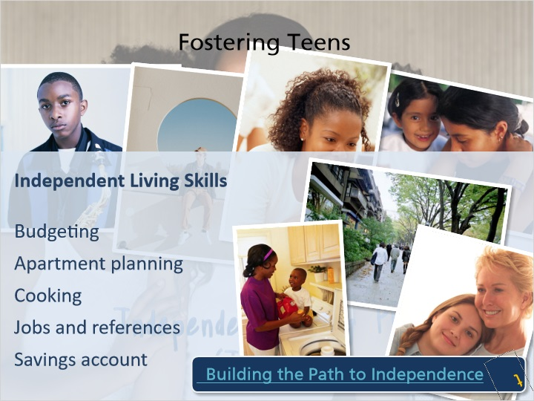
Notes:
Being a teenager is difficult enough, but it can be even more challenging to be a teenager in foster care. Teens have their own unique set of needs that must be addressed by foster parents. Teens desperately want to feel like they’re normal and fit in with others, and this is especially hard for those in foster care.

The most important developmental goal for adolescents is to work toward becoming independent. For teens in foster care, there are requirements put in place that are designed to help them reach this goal. Teens aged 14 or older who have been in care for 6 months or more are required to have an Independent Living Plan (sometimes called an “IL Plan”) that they create with their child welfare professional. This plan is meant to prepare the youth for transitioning into adulthood and includes topics like creating a budget and planning for what to do after high school. Older youth must have opportunities to practice life skills and become familiar with resources in their community.

In addition to the formal Independent Living Plan, there are lots of things that you can do with teens in your home to teach independent living skills Some ideas include:

Planning a budget
Looking at apartments, and talking about security, finances, and how to interact with a landlord
Teaching the youth how to cook and having them plan and cook meals for the family
Helping the teen complete job applications and finding people to act as references for them
Set up a savings account with the teen

Planning must begin early for this crucial transition toward self-sufficiency. In addition to learning life skills, healthy relationships with supportive individuals, including parents, extended family, foster parents, friends and other adults in the community are paramount in achieving permanence for older youth aging out of care.

If you would like additional information and training about fostering teens and building skills they need for a successful transition to adulthood, be sure to check out the online training, called "Building the Path to Independence".The training is available on the Wisconsin Child Welfare Professional Development System.

Website:
https://wcwpds.wisc.edu/independent-living/

6.2 Fostering Teens: Continued
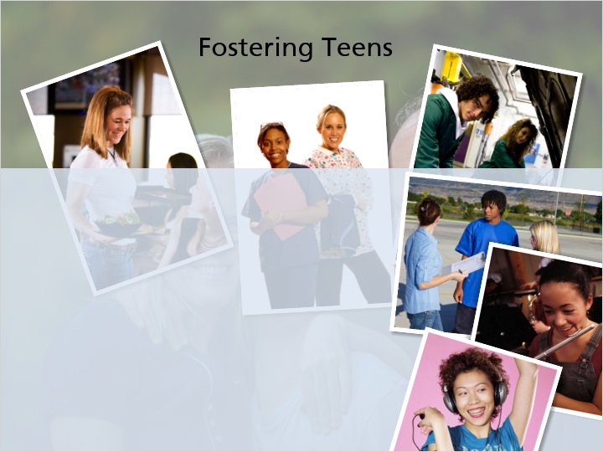
Notes:
Maintaining employment is a powerful independent living skill for any teen, as it gives them structure and the ability to earn money. Many youth in foster care have part-time or full-time jobs, and some are able to earn school credit for their employment. Teens must obtain a work permit, which requires a signature from a parent, guardian, or foster parent. Teens can work with their child welfare professional to obtain a work permit.

A common issue brought up by former foster youth is the ability to get a driver’s license while in foster care. In order for a teenager in foster care to obtain a driver's license, they must have consent from their parent, guardian, or foster parent. The decision for a youth to obtain a driver’s license should be discussed with the youth’s team members. You'll need to consider vehicle liability insurance and who will insure the teen driver.

Foster care licensing code requires that children in foster care are given opportunities to participate in community and school activities in order to develop relationships with peers. Children in foster care must be able to keep and wear their own clothing, as long as it is appropriate and suitable to wear, and must have access to music and books that are appropriate to their age and comprehension. Clothing and music are generally very important to teens and provide them with an opportunity to develop and express their own tastes and preferences.

6.3 Teens & Sexuality
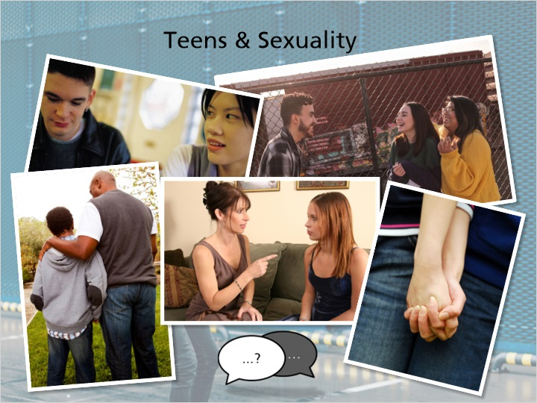
Notes:
If you foster teens, you will be faced with issues of sexuality. This is a challenging topic for any parent, and can be more so for foster parents, as teens in foster care may have past experiences that compound issues of sex and sexuality. You must be willing and able to discuss sex and sexuality with the teens in your care, and be willing to answer the many questions that teens may have related to dating, puberty, birth control, consent, among others. Teaching and modeling healthy physical boundaries around physical affection can be a good skill for pre-teens and teens to learn.

6.4 Check Your Understanding – Fostering Teens
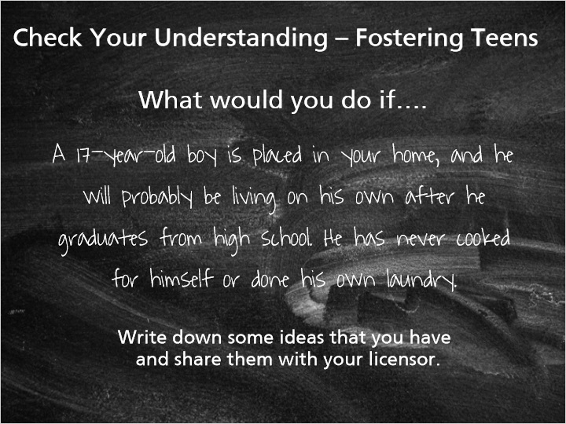
Notes:
What would you do if….

A 17-year-old boy is placed in your home, and he will probably be living on his own after he graduates from high school. He has never cooked for himself or done his own laundry.

Write down some ideas that you have and share them with your licensor.

6.5 Age, Maturity, & Developmental Level
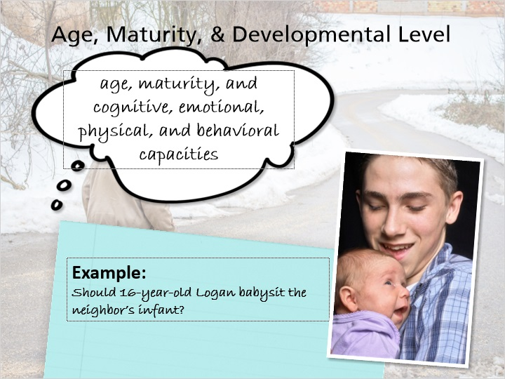
Notes:
The child’s age, maturity, and developmental level must be considered when making parenting decisions for children in foster care and a part of the Reasonable and Prudent Parenting Standard. The intention of this decision ‐ making factor is to match an activity with the child by considering their age, maturity, and cognitive, emotional, physical, and behavioral capacities.

Remember that many children in out‐of‐home care may not be functioning at their chronological age, so foster parent’s need to be sure to consider this for each individual child. It is also important to consider that children who have a physical, emotional, or learning disability should not be excluded from the Reasonable and Prudent Parent Standard. All children in out‐of‐home care must have equal opportunities to participate in activities and experience normalcy in all areas of their lives.

Here is an example of when to consider age, maturity, and the developmental level of a child.

As a foster parent, you are deciding whether 16‐year‐old Logan should babysit for your neighbor’s infant.

The opportunity to babysit may be a great way for him to gain independent living skills, demonstrate his responsibility, and earn money. Babysitting is appropriate for many teenagers, but a reasonable and prudent parenting decision depends on many factors for the individual child, not simply their chronological age.

As a foster parent, you must evaluate whether Logan is responsible enough to babysit just like any parent would. You must consider all areas of the child’s functioning, including behavioral history and caregiving skills, in combination with age & maturity. This includes any behavioral concerns that may put the infant he is caring for at risk, such as anger or frustration control.

7. Culture

7.1 Real Life Tips: Culture
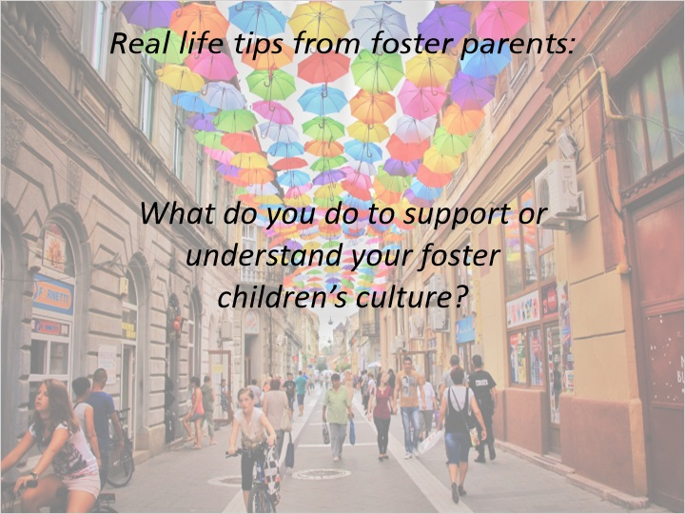
Notes:
Real life tips from foster parents:

“I think it would be helpful for foster parents to know that there is no expectation for you to be the expert when it comes to caring for kids that have different backgrounds. There are so many resources that are out there that are available. There are cultural consultants, you can connect with kids’ families to try to get information. When kids are old enough to be able to be verbal, they can tell you about pieces that are important to them; the ways they like to have food, music they like to listen to. I think that the part that’s really important for us to try to know is that representation matters. So, what we need to include in our home and make the effort to is to make sure that there are toys that look like these kids, there are books that have characters that look like these kids and movies and surround ourselves and try to bring those pieces into our home. Where we have done some of that effort without trying to put the burden for trying to have that representation within our home on everybody else and then connect up with other people so that we can go places where kids can be around positive role models that they feel connected to in different ways.”

“Around the holidays we talk about what kind of family holiday traditions they have and then we try and incorporate those into our family traditions. We take them to ethnic festivals, we make sure we experiment with food, we try and make sure that we're open to trying new foods in the house and we also try and make sure they're open to trying new foods and trying our food before they absolutely discount it as unfamiliar and yucky, we make sure everybody gets a big opportunity and multiple occasions to try everything that passes on our table and if they don't like it we get them something that they will eat.”

7.2 Identity / Culture
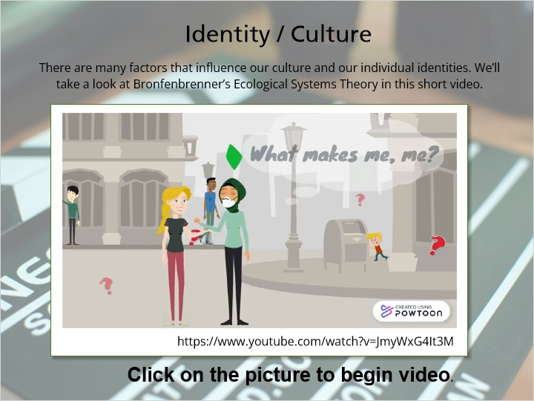
Notes:
There are many factors that influence our culture and our individual identities. Where we grow up, the values we are taught, the communities we live in, our experiences all shape how our individual identities are formed. We’ll take a look at Bronfenbrenner’s Ecological Systems Theory in this short video to get a better idea of how all of these factors influence us and each other.

Bronfenbrenner’s Ecological Systems Theory: <https://www.youtube.com/watch?v=JmyWxG4It3M>

7.3 Describe Yourself
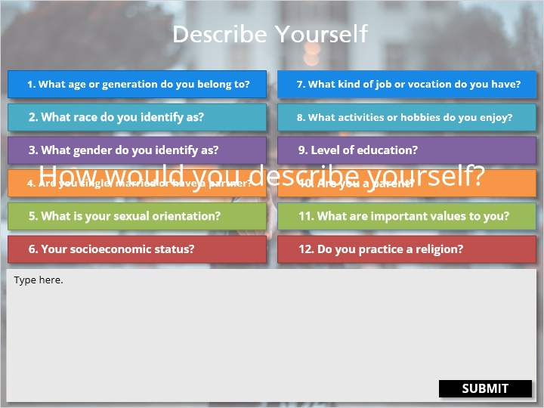
Notes:
How would you describe yourself?

Think about all the qualities and values that are important to you and all of the different ways you have been shaped in your life.

Take a few minutes here to type out 5-10 things about how you would describe yourself. Feel free to include as many as you'd like as well as others that may not be listed. Consider the qualities that are most important to you and your personal identity.

On the screen are questions to get you started, feel free to include as many as you’d like and other things that you come up with.

These are just some of the many ways we can define ourselves. These are the parts all of us that make up our identities and parts of our culture. Many people fit into multiple cultures or cultural groups which creates their own unique individual identity. Who we are as individuals, and how we define ourselves are often very important parts of our own identity and culture. They are what makes us who we are and influence how we interact with the people and world around us.

Identity and culture are also important to the children who come into foster care. All children have important parts of themselves; ways of communicating and experiences that have shaped who they are. How might a child in your care respond to the same questions you answered? Consider the qualities, values, beliefs they have about themselves and the world that may be important to THEM and how they might be different from your own. As foster parents, one of your roles is to help a child develop a strong sense of personal and cultural identity. You can do that by affirming all parts of how a child identifies themselves; all the parts that make them, them.

7.4 Race, Gender, Identity
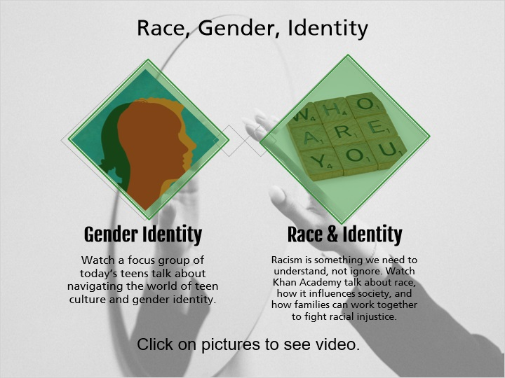
Notes:
Watch the following video clips as they talk a little bit about the importance of identity and the various ways people identify themselves. This identification could include religious identity, sexual or gender identity, and ethnic and racial identity. Some of the identities presented may be different from your own ideas and personal beliefs. As you watch we hope you keep an open mind as you explore these topics. Remember that foster parenting, as a part of the public child welfare system serves all children regardless of their background or identity. While children need caregivers who will be loving and nurturing, they also need caregivers to support and nurture their identity. If you are interested in learning more about identity and diversity or have any questions, talk to your licensor about additional learning opportunities.

7.5 Video Reflection
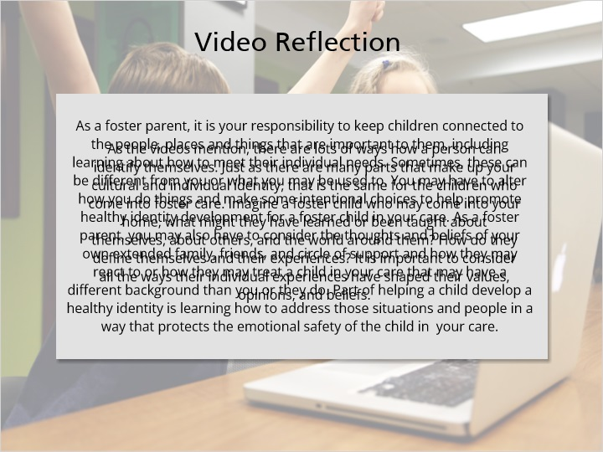
Notes:
As the videos mention, there are lots of ways how a person can identify themselves. Just as there are many parts that make up your cultural and individual identity, that is the same for the children who come into foster care. Imagine a foster child who may come into your home, what might they have learned or been taught about themselves, about others, and the world around them? How do they define themselves and their experiences? It is important to consider all the ways their individual experiences have shaped their values, opinions, and beliefs.

As a foster parent, it is your responsibility to keep children connected to the people, places and things that are important to them, including learning about how to meet their individual needs. Sometimes, these can be different from you or what you may be used to. You may have to alter how you do things and make some intentional choices to help promote healthy identity development for a foster child in your care. As a foster parent, you may also have to consider the thoughts and beliefs of your own extended family, friends, and circle of support and how they may react to or how they may treat a child in your care that may have a different background than you or they do. Part of helping a child develop a healthy identity is learning how to address those situations and people in a way that protects the emotional safety of the child in your care.

7.6 Positive Racial Identity - Real Life Tips
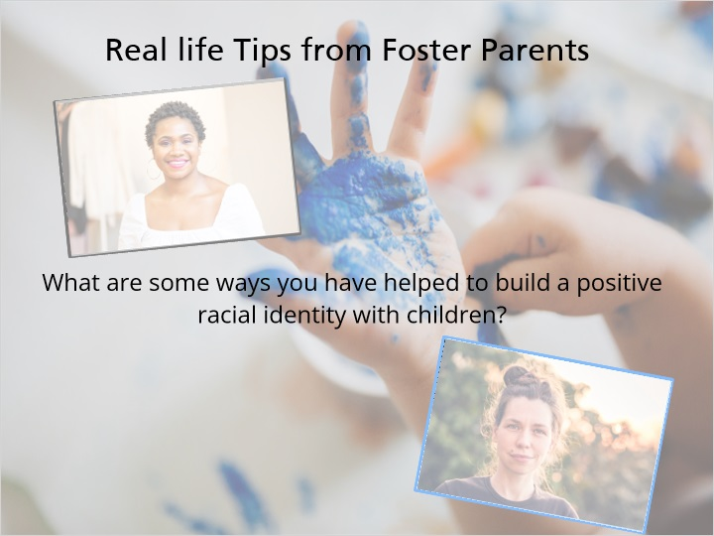
Notes:
“I’ve had to affirm my older two daughters’ racial identity just through candid conversation. A lot of things that they see on the news and a lot of discussions they have amongst themselves and their peers. There are questions that come up and things that need to be clarified. And, so we sit down as a family, and we talk about those things, and we talk about the unfortunate situations they see on TV, but we also talk about positive role models and how beautiful they are. And quite frequently, you know, I have to show them other young ladies that look like them or call out features that are similar and just how beautiful they are. And you know for African American girls especially, it’s difficult to deal with things like your hair and the difference in your hair and your texture of your hair and so just making sure that they know that those things are unique to them, to their culture, to their race and how beautiful they are and how beautiful they can be throughout their identity and how things can change, you know, and there just so much versatility in what they do and what they wear and the style that they have and so just affirming that through the conversation and the depths of a conversation that we have.”

“When it comes to kids’ racial identities, it’s really important that they see value in who they are, that they feel like as an individual that they are capable of doing anything that they want to do, that their life matters, that their dreams matter, that they can be anything they want to be and that, that comes to mind for them. And I think when it comes to developing their racial identity, being able to find those cultural mirrors, like I want this future for myself, and I will find somebody that you identify with, that looks like you, that is doing the thing that you want to do so that you can see that as a possibility, that you can see excellence in all different pieces of your life or, or dreams that you have for yourself represented in the world. So, when I think about affirming kids’ racial identities, what I think about is giving them the hope for the future that we want for them, that they are powerfully made exactly as they are, and they can do anything that they want to do because they see it as a real possibility for themselves.”

7.7 Caring for LGBTQ+
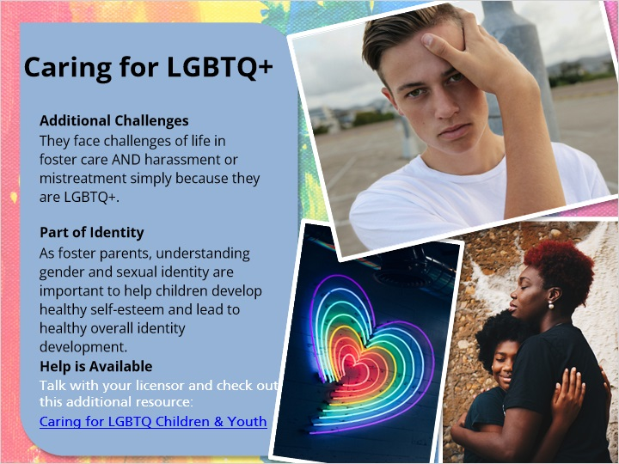
Notes:
Whether you are aware of it or not, children and youth in out-of-home care may be lesbian, gay, bisexual, transgender or in the process of questioning their sexual orientation or gender identity. These young people are dealing not only with the challenges of life in foster care but also with the risk of harassment or mistreatment simply because they identify as LGBTQ+. Unfortunately, we know LGBTQ+ youth are disproportionately represented in the child welfare system and often face discrimination and mistreatment in out-of-home care.

Children who identify as LGBTQ+ need love, support, and acceptance like any other foster child. Our sexuality, gender identity and gender expression are some of the parts that make up our identity. As foster parents, understanding gender and sexual identity are important to help children develop healthy self-esteem, self-worth, and confidence in themselves and lead to healthy overall identity development. The links here are good guides for caregivers to help learn ways to support and advocate for children and youth who identify as LGBTQ+ including terminology, inclusive and supportive language to use as well as additional resources. Talk with your licensor about how you can develop your skills as a caregiver when it comes to caring for children who identify as LGBTQ+.

Additional resource for foster parents:
Caring for LGBTQ Children & Youth: A Guide for Child Welfare Providers:
<https://assets2.hrc.org/files/assets/resources/HRC_Caring_For_LGBTQ_Children_Youth.pdf>

7.8 Gender Identity - Real Life Tips
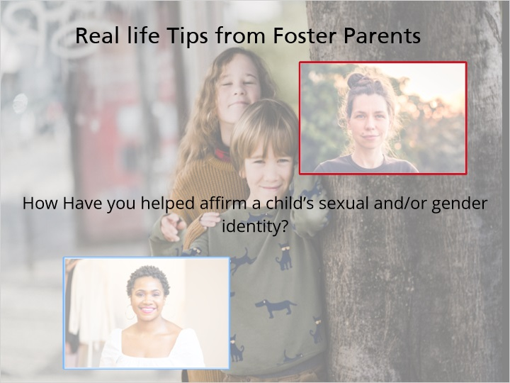
Notes:
“I learned early on that it is important for me to have conversations with my children about their sexual identity, their gender identity, and all of the things that they need to know. I think it’s better coming from me than their peers the things that we discuss. I make sure that we have open, honest and candid conversations; no question is off limits, no answer is fabricated. I am one of those people who’s going to give my children the truth and also let them explore the things that they’re interested in, the things that they want to learn about. I don’t want to overshadow their thoughts and belies with my own, so I do give them the opportunity to try new things or to think about and explore who it is that they want to be. Everybody has their own little personalities, so it’s important to the those shine and let them learn through their everyday lives the things that they want to do, and the people that they want to be.”

“I think it’s really important that we also really spend some time affirming that they get to decide who they are as just a human being. And that includes what pronouns they want to use, what name or nicknames they want to go by, who they might be interested in dating, what pronouns the person their interested in dating wants to go by, and that we spend our time letting them know that we will love them regardless of what decisions they make.”

7.9 Discrimination and Racism - Real Life Tips
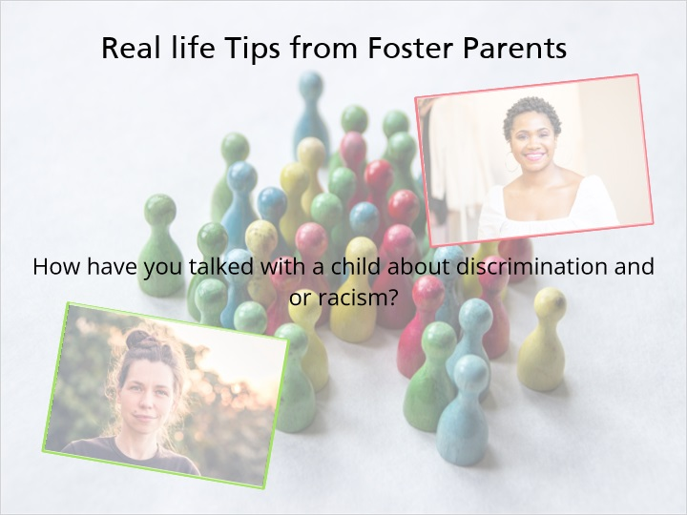
Notes:
“Talking with kids about discrimination and racism has been super hard for me. As a white woman, it’s not something I have experienced a lot of personally. So, I think back in the beginning when I first tried to have these conversations about how awkward I felt, how uneducated I felt, how worried I was that I might say the wrong thing or do the wrong thing. But what I’ve really learned over time as I’ve tried to have more and more of these conversations is that it’s being there for kids who are who are learning about discrimination in their own life, learning about racism in their own life, are learning about that it is happening in the world and they feel connected to other people that it’s happened to. To be able to be an emotional container for these kids so that they can feel safe and loved with me, knowing that things are happening in the world and that I am an OK person to talk to even if I don’t have all of the answers for those conversations. I think trying to talk about it with kids is hard because they don’t necessarily know what they are looking for with somebody else, but they’re really looking to be heard and to have their feelings validated. And trying to talk with those kids about racism and discrimination in terms of being a good listener for them isn’t that much different than talking to them about any hard thing in their life or that they might learn about in the world.”

“I’ve had to talk to each of my children about race and racial identity and racism. Unfortunately, in the world we live in, it’s a very important topic to bring up with your children for them to have clarity on what it looks like for them and for you to be able to instill in them those things that they need to carry with them. One of my children came home and he asked me what color he was, and he said the kids at school told him he was not the color he identified as, and so I thought it was important to him to have that conversation and I told him, you know I love you no matter what. You could be purple with one eye, and I would still love you. And so, since then we’ve made it our choice and we’ve made a point to go and find things of characters that look like him or the box of multicultural crayons that represent different skin tones and all of those things that he needed to support who he is and to be able to feel comfortable about who he is.”

7.10 Racism/Discrimination
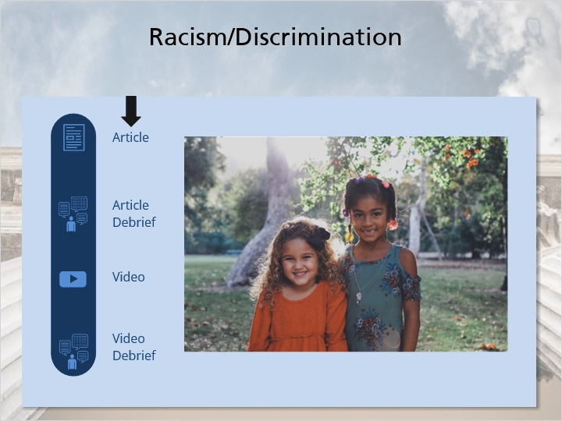
Notes:
Children of color are overrepresented in the child welfare system. That means more children of color are in out-of-home care compared to white children even though children of color make up less of the overall general population of children. What that means for foster parents is that the longer you foster, there is an increased likelihood that you may care for a child of another racial background than you. A child’s ethnicity and race are a part of their identity; a part of what makes them, them. Children with a healthy culture and racial identity have higher self-esteem, self-worth, and confidence. Racism and discrimination contradict healthy identity development. This slide contains two resources and a debrief of each. Please click through each of these for tools to learn more how to better care for children of another race.

Item 1
To be better prepared to care for children of another race, foster parents need to think about the different ways children of color face racism, prejudice, stereotyping, and discrimination in both big and small ways. As a foster parent, you will need to learn how to talk to your foster child about prejudice and discrimination. To help children learn to cope with these difficult incidents, listen to their experiences and feelings, and together, find ways you can help them develop strategies to deal with these situations. You can also begin to find ways that you can advocate for children of color in the foster care system.

Read this article and jot down any thoughts that come to you as you are reading. If you would like the article read to you, click the audio button.
· Dear White Parents of My Black Child’s Friends: I Need Your Help:
<http://fullcircleadoptions.org/wp-content/uploads/2017/08/Dear-White-Parents-Of-My-Black-Child%E2%80%99s-Friends-I-Need-Your-Help-%E2%80%93-Scary-Mommy.pdf>

Item 2
How did reading this article make you feel? What questions came up as you were reading/listening? What did you learn from this article? How would you handle some of the situations this mom described?

While we strive to see people as individuals, it is important that we are addressing the differences we have. Ignoring our differences will not help the children in your care learn how to process, manage, and combat the discrimination they may experience in the community or in school. Talk with your licensor about the ways you can develop your skills as a caregiver when it comes to caring for children of color in foster care.

Item 3
When children feel supported, they have better physical, mental, and social health outcomes. Considering all the ways that a person can identify themselves, it is important to ask yourself if there are any biases-conscious or unconscious-that may inhibit your ability to meet a child’s identity or cultural needs. So what are biases or blind spots? Let’s take a little time to explore this by first watching a helpful video. Click Play to start.

<https://www.youtube.com/watch?v=BFcjfqmVah8>

Item 4
As the video mentions, our brains have a lot to process every single day, not to mention throughout our lifetimes. Things we see, learn and hear all play a part in how we form thoughts and opinions. Due to all this information coming at us, our brains sometimes take shortcuts to identify patterns and draw on our past experiences to make quick conclusions. While it is often helpful for our brains to take these shortcuts, they can be harmful when they impact our interactions with other people. This is what is called implicit or unconscious bias.

7.11 Bias
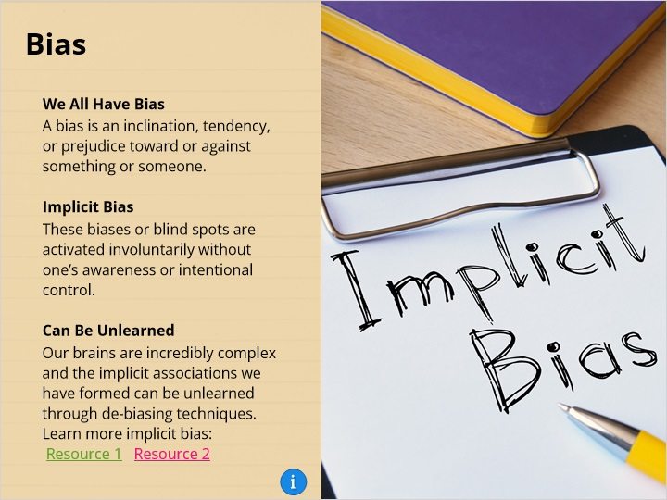
Notes:
We all have biases, no one is immune to them. A bias is an inclination, tendency, or prejudice toward or against something or someone. Biases include both positive and negative assessments. However, negative biases tend to be based more on stereotypes instead of actual knowledge of people or situations.

Implicit bias refers to the attitudes or stereotypes that affect our interactions, understanding, and our decisions in an unconscious or unthinking manner. These biases or blind spots are activated involuntarily without one’s awareness or intentional control. They reside deep in the subconscious and are different from our known biases. The development of implicit, also called unconscious, bias is influenced by our backgrounds, cultural environment, personal experiences, by biased media representations of groups, social experiences, and by repeated exposure to stereotypical associates and prejudices that become automatic in our long-term memory.

Our brains are incredibly complex and the implicit associations we have formed can be unlearned over time and through de-biasing techniques. Since everyone has implicit biases or blind spots we can begin to predict how we behave and judge others, it is important to find ways to work to address them to prevent interactions that are contrary to our values and beliefs.

To learn more about implicit bias:
· Harvard Implicit Bias Test, Project Implicit: <https://implicit.harvard.edu/implicit/takeatest.html>
· Kirwan Institute For The Study Of Race And Ethnicity: https://kirwaninstitute.osu.edu/

Adapted from Jamie Cimpl-Wiemer, Director of Equity and Diversity Services, Module 4: The Power of Implicit Bias UWM Racial Justice and Equity Program

7.12 Bias and Identity
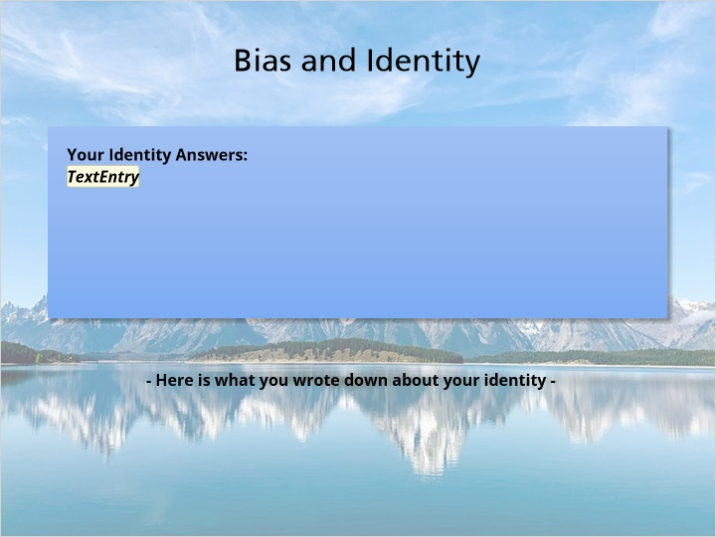
Notes:
Here is what you wrote down about your identity - did you have a reaction to any of those questions? Have you ever thought about why? This could be a clue to an implicit or unconscious bias that you have developed.

Think of a time when you became aware of a bias you hold about a particular group. How did you become aware of this? How did it make you feel?
Think about how your biases or blind spots could impact your actions, language, interactions, beliefs, and relationships with the foster children and families you may work with.

So how can implicit /unconscious biases our blind spots be unlearned?

7.13 Overcome Unconscious Bias
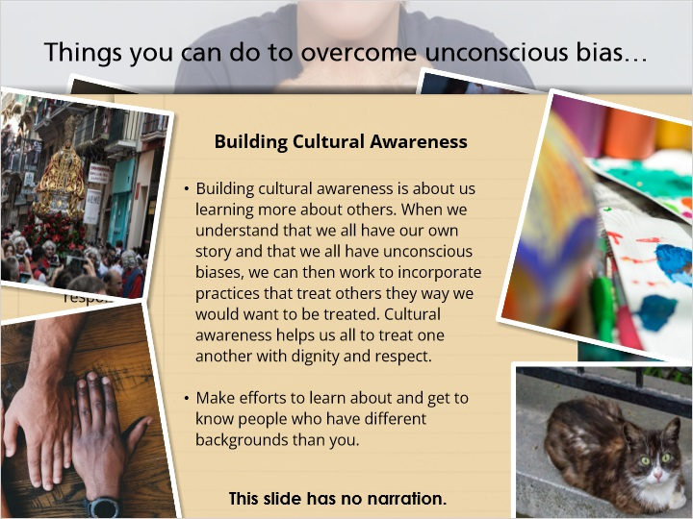

7.14 Multi-Cultural Families
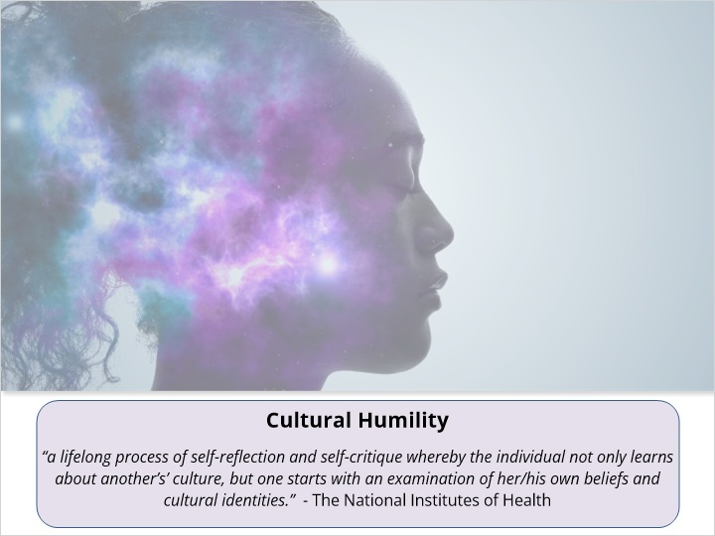
Notes:
Becoming a multi-cultural family takes some intention and some practice. Something to consider is learning to become culturally humble. The National Institutes of Health (NIH) defines cultural humility as “a lifelong process of self-reflection and self-critique whereby the individual not only learns about another’s culture, but one starts with an examination of her/his own beliefs and cultural identities.

As the definition states becoming culturally humble is a life-long process; something we continue to strive towards and learn throughout our lives. It also suggests that it takes practice and intentionality on the part of the individual. Start to think of the ways that this shift in mindset toward Cultural Humility could benefit you in your role as a foster parent. Begin to think of ways that you can start on your journey of becoming a more culturally humble and multi-cultural individual and family.

7.15 Connecting with Different Cultures
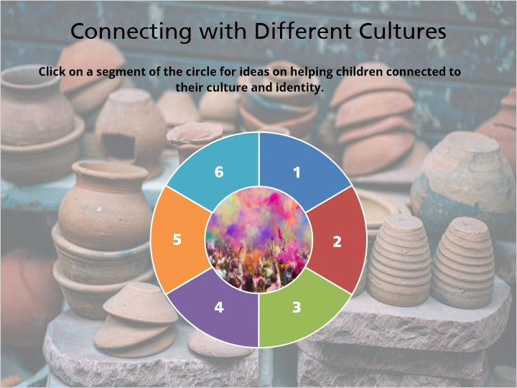
Notes:
As foster parents, we will need to make deliberate choices to become a multi-cultural, identity affirming family. Keeping children connected to people, places, and things that are important to them, to their culture and individual identity will take some extra effort on the part of foster parents. It probably will require you to step out of your comfort zone and experience things that are unfamiliar to you. What multi-cultural connections do you have in your community? Begin to think of what is available in your community, outside of your community-this may take some research on your part. If you are stuck or need additional ideas, be sure to talk with your licensor.

Click on a segment of the circle for suggestions on helping children connect to their culture and identity.

7.16 Advocating for Children and Families
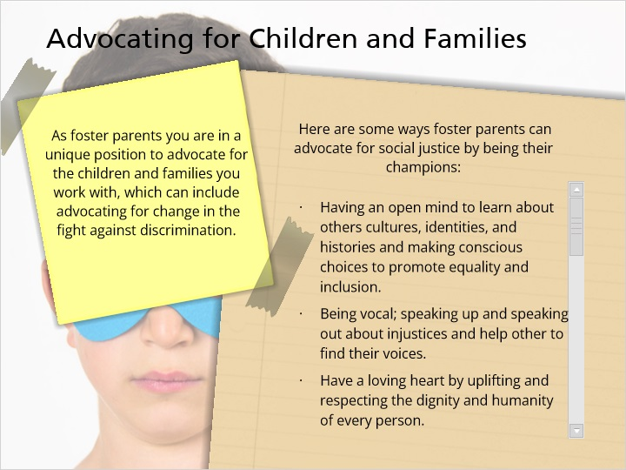
Notes:
As foster parents you are in a unique position to advocate for the children and families you work with, which can include advocating for change in the fight against discrimination. Here are some ways foster parents can advocate for social justice by being their champions:

· Having an open mind to learn about others cultures, identities, and histories and making conscious choices to promote equality and inclusion.
· Being vocal; speaking up and speaking out about injustices and help other to find their voices.
· Have a loving heart by uplifting and respecting the dignity and humanity of every person.
· Joining hands with others like and unlike yourself to build power for change.
· Use your smart phone to inform and activate your networks, share, Tweet, comment, and post about issues of discrimination and how to take action against.
· Use your legs to show up vote, support public actions, marches, and rallies.
· Alert your eyes by envisioning solutions to the realities of racism, discrimination, and prejudice through and equity conscious lens.
· Use your ears to listen to and learn from other people with different backgrounds than you.
· Strong backbone; keep being courageous, taking risks, and even making mistakes.
· Pay attention to coded discrimination, stereotypes, and prejudices.
· Use your pocketbook to donate to social causes and organizations advocating for social change, and support businesses that align with your social values and boycott those that do not.
· Keep your feet grounded; continue to hold onto your values, allies, and your spirit for the long haul as you continue the journey down the road to social justice.

7.17 Multi-Cultural Action Plan
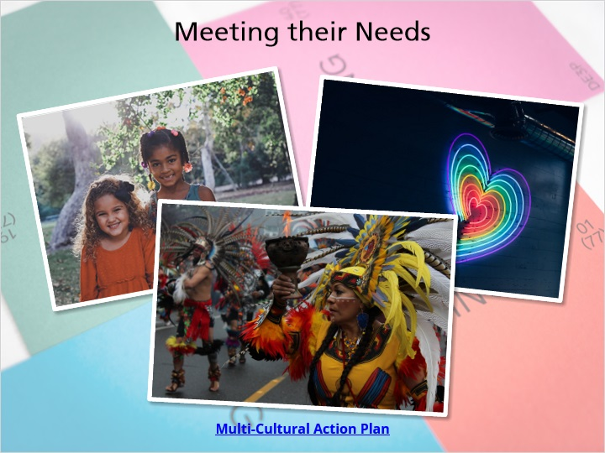
Notes:
There are lots of ways we can be advocates for children in foster care. All of these things are important as a foster parent to better understand how to support a foster child to help meet their cultural and identity needs. If this is something you don’t feel you can do, you need to talk with your licensor to have a frank conversation on whether fostering is a good fit for you and your family.

Next, let’s begin to create our Multi-Cultural Action Plan. We have covered a lot of things about affirming identity for foster children. Now let’s work on developing a plan to work towards becoming a multi-cultural foster family. Take as much time as you need to jot down some ideas to share with your licensor.

7.18 Multi-Cultural Background - Real Life Tips
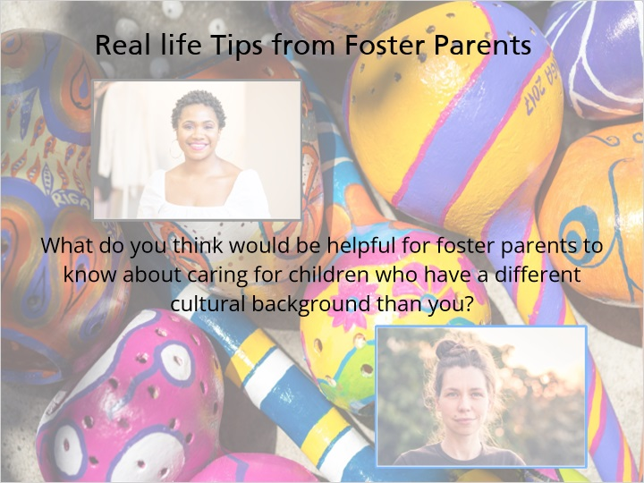
Notes:
“I think that it’s helpful for future foster parents to know that when your child doesn’t look like you, the world is going to stare. Sometimes they’ll have questions, sometimes they’ll ask questions, and a lot of the questions are coming from a place that’s curious and just wanting to know information. Sometimes people are being nosy. But it’s important to know that it’s better to respond and plan a response than to just go off the top of your head. Sometimes the way you react is how your kids are going to react, so if it seems awkward and odd to you, it’ll seem the same way for them. But if you plan and prepare for it and you know what to say and you know how you’re going to say it, then that makes all the difference for how your kids are going to respond to it. So, it’s important to sit down as a family and discuss some of those things that you could say, tell the child that it’s OK for them to share their story and make sure you know when you’re sharing information, you’re sharing your own story.”

“Becoming a multicultural family has really changed the trajectory for how we spend our free time as a family. So, we’ve fostered kids from all different cultural backgrounds. We’ve adopted kids from different backgrounds too, so it’s become really important to us that we spend our time being out in the community doing life with people who are cultural mirrors for kids that we care for. So, we go to different churches. We spend time at different festivals. We go to different restaurants. We listen to different music. We as a whole family go and spend time experiencing culture in a lot of different ways for different kids, and I think that it was maybe a little bit awkward at the beginning because I was very used to what I already knew, but it’s become a really fun and important part for our family that helps us feel connected to our community in a way that we just weren’t before. And I think for the kids that we’re caring for, when they see that our whole family finds value in going to experience their culture and that we do that for other cultures as well, it helps them to feel loved and valued in a way that they wouldn’t if everybody just looked and did things exactly like me.”

7.19 Cultural & Religious Considerations
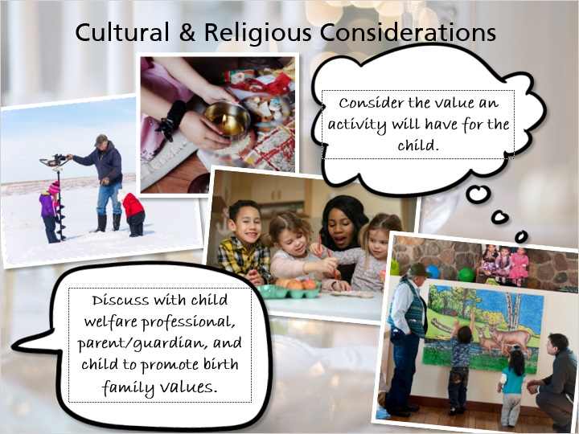
Notes:
As a foster parent, you must consider a child’s cultural, religious, and tribal values when making a prudent parenting decision. This may be difficult depending on the situation, as the child and the parent or guardian may have different ideas and opinions about their values. You must carefully weigh these factors when making decisions. A child may not want to participate in a cultural or tribal activity that the parent or guardian feels is an important part of their culture and identity. This does not mean that you should automatically allow the child to miss this activity, and you should consider the value that activity will have for the child.

Discussions with the child welfare professional, parent or guardian, and the child should take place as soon as possible when there are conflicting opinions to ensure that the child’s and family’s culture, religion, and tribal values are promoted in both day-to-day and big decisions impacting the child. You may not force your own cultural or religious values on a child placed in your home, and must give heavy consideration to the values of the child and the parent or guardian when making reasonable and prudent parenting decisions.

Ho-Chunk Daycare Image source: ©UW-Madison University Communications. Photo by: Jeff Miller

7.20 Cultural & Religious Considerations Example
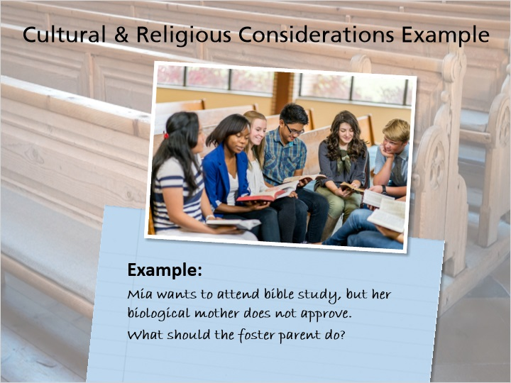
Notes:
Here’s an example:

Mia, a 13-year-old in out-of-home care, would like to attend bible study at a friend’s church. You believe that the activity is age and developmentally appropriate for her, as well as an opportunity for positive social interaction and personal growth. However, Mia’s biological mother does not approve of Mia attending any activity related to religion.

What next steps should you take? You should collaborate with Mia’s mom to gather more background on why she disapproves, and share thoughts with one another. Is the parent disapproving because of strongly held cultural beliefs? Or is she disapproving to exercise control? Can a compromise be found that respects the parents’ values while allowing Mia to explore her own cultural beliefs?

Every situation, case, and child is different. A parent or guardian’s opinion on decisions regarding cultural, religious, and tribal values should be taken into account. You can also consult your licensor and the child’s child welfare professional on how to apply the Reasonable and Prudent Parent Standard.

8. Thinking Back on the Module

8.1 True or False: If you have the same ethnicity or race as the children in your care, you don't have to worry about culture because their culture and values will be the same as yours.
(True/False, 10 points, 2 attempts permitted)
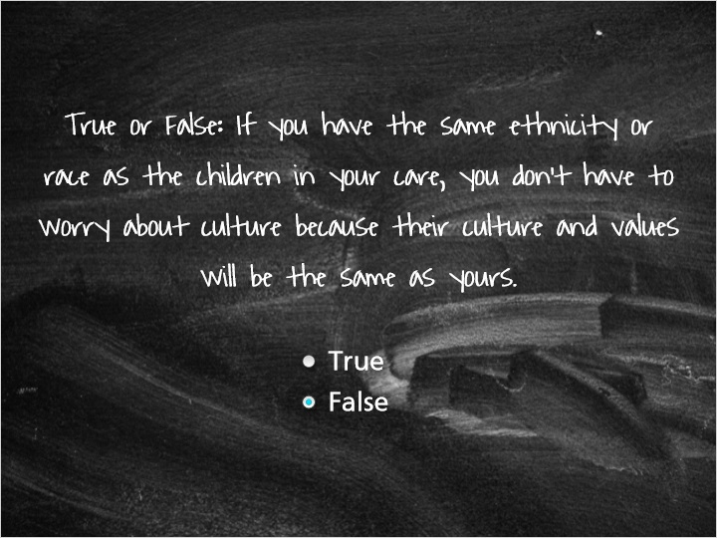
Correct | Choice
 | True
X | False

Feedback when correct:
You're right! Sharing race or ethnicity doesn't mean that you share values or traditions with the children in your care and their families.
Feedback when incorrect:
No, just because you share race or ethnicity, this doesn't mean that you have the same values or traditions as the children in your care and their families.

8.2 Please check which of the following things you can do to discipline children in your home:
(Multiple Response, 10 points, 2 attempts permitted)
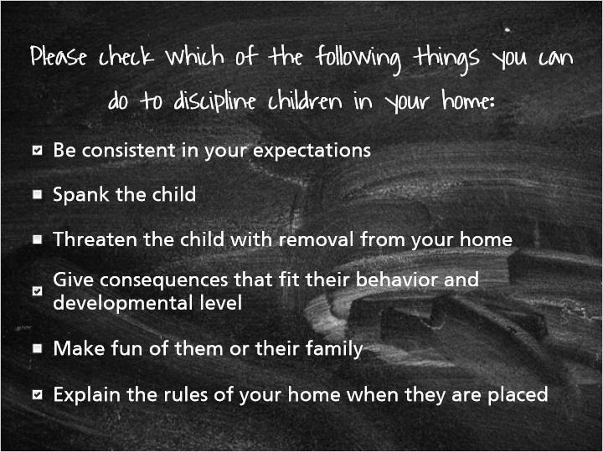
Correct | Choice
X | Be consistent in your expectations
 | Spank the child
 | Threaten the child with removal from your home
X | Give consequences that fit their behavior and developmental level
 | Make fun of them or their family
X | Explain the rules of your home when they are placed

Feedback when correct:
That's right! These are all things to try when managing children's behaviors.
Feedback when incorrect:
You chose items that are not options for you to use when managing children's behaviors.

8.3 Thinking Back on the Module…
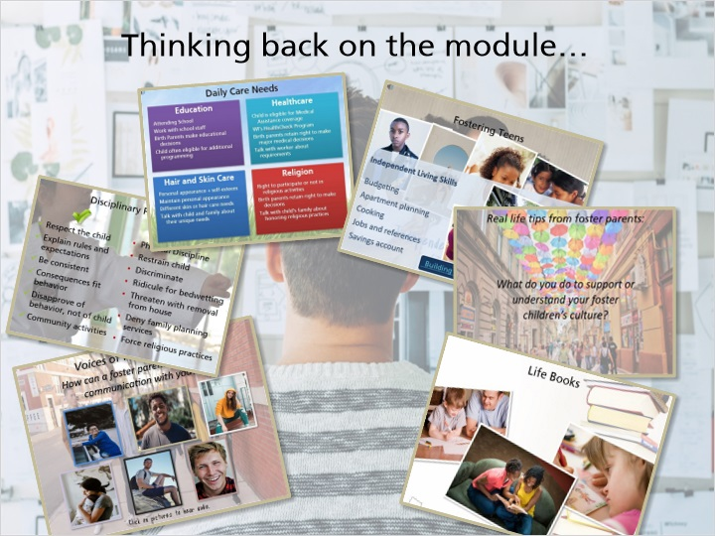
Notes:
Think back on the information that you learned in the second part of this module. You’ve heard from youth and foster parents, and learned about nurturing care and discipline, the daily needs of children in foster care, fostering teens, culture, identity and about transitions that children in care face at different times in their lives. Remember to write down questions that you have to discuss with your licensor about any of these topics.

8.4 Results Slide
(Results Slide, 0 points, 1 attempt permitted)


Results for
8.2 Please check which of the following things you can do to discipline children in your home:

Result slide properties | Passing Score
100%

Notes:

