Module 3a

1. Module 3 Caring for Children in Foster Care, Part 1

1.1 Foster Care Overview
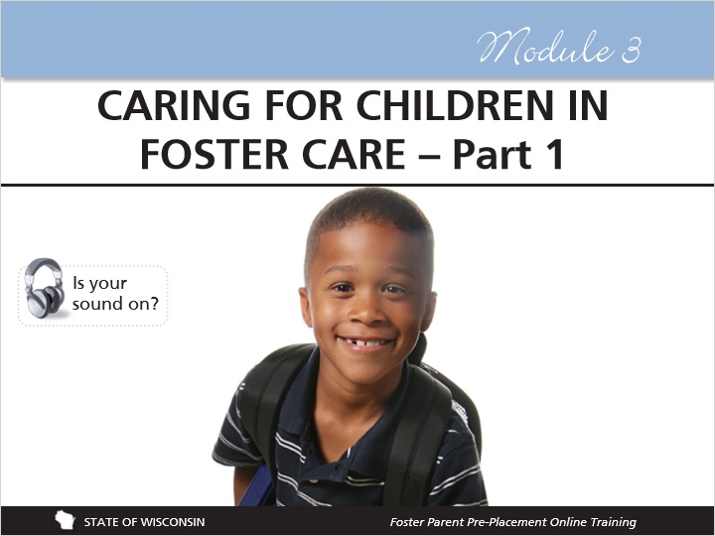
Notes:
This module, called Caring for Children in Foster Care, is broken into two parts. In this module you will hear from former foster youth about their experiences in foster care, and you will learn about different aspects of caring for the children in your home. Some of what you will learn about in this module is really just about parenting, but with considerations for the unique background and experiences of children in foster care.

In the first part of this module, you’ll learn about things to think about before a child is placed in your home, how being in placement affects children, how to help children adjust to being in a foster home, stages of grief and loss, and about red flags to watch for in children's development.

Remember that you have the notepad document to keep notes as you go!

2. Voices of Foster Youth

2.1 Voices of Foster Youth
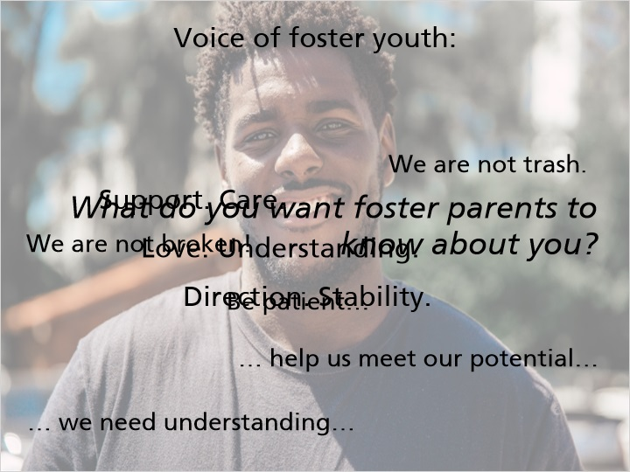
Notes:
Voice of Foster Youth:

“WE ARE NOT BROKEN! Don’t think that we need fixing. We just need understanding of the situation that we are in. We need for someone to understand that we are going through a lot and needed a little extra empathy, understanding. Be PATIENT and don’t prove us right and abandon us like our biological families or other foster parents have. We are not trash! Treat us as though we are kids/teenagers who have been through a lot and help us meet our potential and have a sense of ‘normalcy.’”

3. Birth Parents Perspective: Being Separated

3.1 Birth Parent Perspective: Being Separated
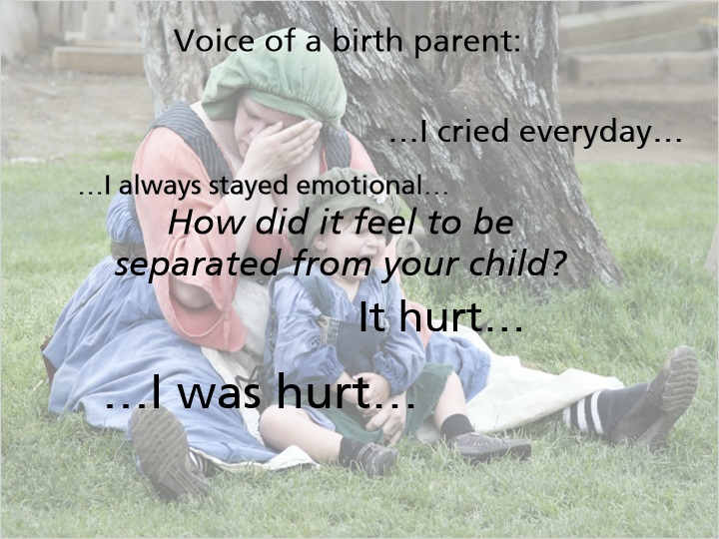
Notes:
Voice of a birth parent:

“It hurts, I was always crying everyday that my child wasn't there with me and it's like when I was seeing my friends with their kids and my child wasn't there with me I always stayed emotional all of the time just wanting her to be there and being separated from your child is like you lost your best, best friend and that's a hurting feeling, you know to see your child separate from you, that hurts, I cried every day, I was hurt.”

4. Part 1 Topics

4.1 Part 1 Topics
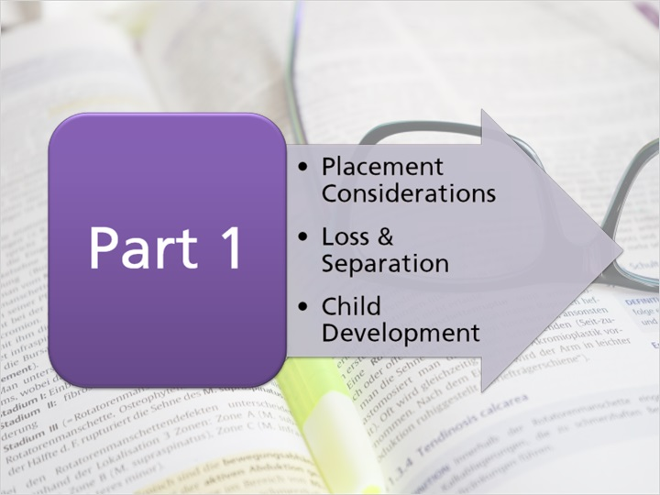
Notes:
The first part of this module will include information about:

• Placement Considerations, or things to think about before and after a child is placed in your home;
• Grief, Loss, and Separation, including how children and foster parents process grief; and
• Child Development and how trauma affects development.

5. When a Child Enters Foster Care: Placement Considerations

5.1 Why Children Enter Foster Care
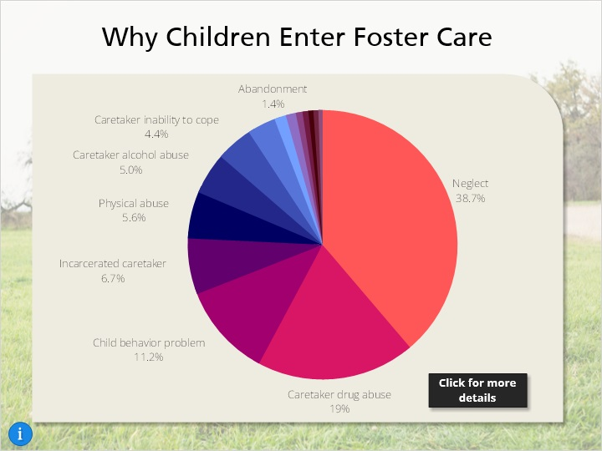
Notes:
In Module 1 you learned about some of the reasons that children enter foster care, including neglect, abuse, and delinquency, but as you can see, there are lots of other reasons that children are placed in foster care.

Understanding the reason that the children in your home were placed into foster care will help to find the most appropriate placement for the child. Having this information will help you best care for the child. Children placed into foster care may not always know why they were removed from their homes, and if they ask you these questions, you must be able and willing to answer their questions honestly and appropriate to their age and understanding. Talk with the child’s child welfare professional if you struggle with how to respond to these questions.

5.2 Declining a Placement
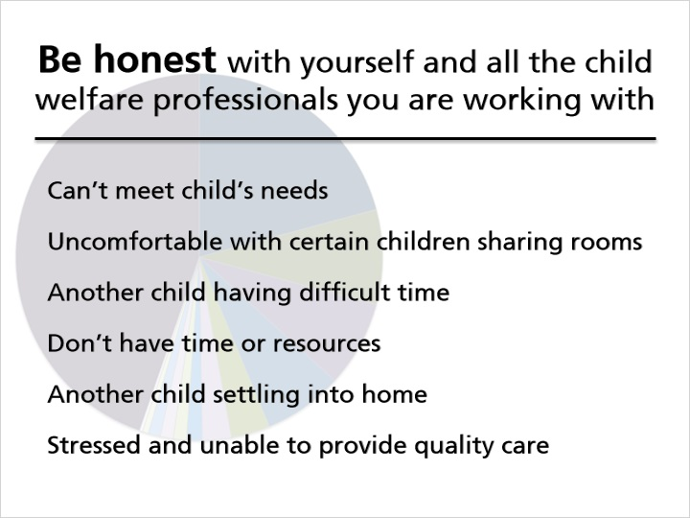
Notes:
The reality when considering if and when to accept children into your home is that you won’t be a perfect match to every child that is placed with you. In Module 2, you learned about questions to ask before a child is placed with you so that you can make an informed decision on whether or not this would be an appropriate placement for that child and your family.

It is important for you to be honest with yourself and with all the child welfare professionals you are working with about the types of children that you will feel comfortable accepting for placement. Remember that the child welfare professional will give you as much information as they have about a child before placing a child with you, but that this information will likely be incomplete initially.

You will have the final say on whether or not you will accept a child for placement. It is perfectly okay to decline a placement! It is better to decline than to accept a child that you do not feel comfortable caring for or if you feel unprepared to meet that child’s needs Accepting a placement you are not prepared for may lead to you asking for that child’s removal which is another loss for that child.

Foster parents who are relatives most often feel pressure to take placement of a child with short notice because child welfare professionals will turn to relatives as the first choice for a child who needs placement outside of the home. It is important for foster parents who care for relatives to be honest about their capacity to provide a safe and nurturing environment and to know it is okay to say “no”. Even if the relative is not able to take primary placement of a child, relatives can play many other important roles in helping children when out‐of‐home placement is required. This may feel or be similar if you are a like-kin caregiver.

Child welfare professionals will do their best to provide you with information on the child at the time of placement. However depending on the situation and circumstances, information may be limited. This is another important thing to consider when deciding whether or not to accept placement of a child.

Some reasons to decline a placement would be:
If you do not feel you could meet the child’s identified needs.
If your own children or other foster children would then have to share a bedroom and you are uncomfortable with certain children sharing rooms.
If another child in your home is having a difficult time and you do not have the time or resources to care for another child.
You have just gotten placement of another child who needs time and attention while settling in to your home. Your family is going through a stressful time and would be unable to provide quality care to a child.
The child welfare professional may not know everything about a child at the time of placement but do provide all information they do have.

If you have concerns about accepting a child, talk with the child’s child welfare professional or your licensor. While it may be difficult to decline a placement, if you do not feel that you can adequately care for a child, you should not accept the child for placement. It is okay for you to say no!

5.3 Fostering Children Impacted by Sexual Abuse
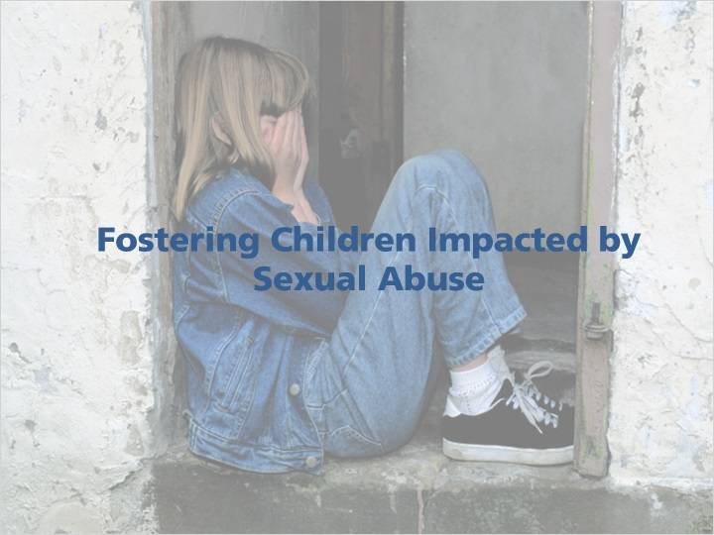
Notes:
One of the considerations to keep in mind when deciding to accept a child into your home for placement is your ability to care for a child that may have been impacted by sexual abuse. It is important to recognize that any child coming into foster care may have been sexually abused, and that some of these children have not yet disclosed this abuse. Children who have been sexually abused will need patience, flexibility, support, additional supervision, and may disclose information about their abuse to you. You will need to be comfortable discussing sex and sexual abuse without becoming upset, judgmental or insecure.

5.4 Precautions When Fostering Children Impacted by Sexual Abuse
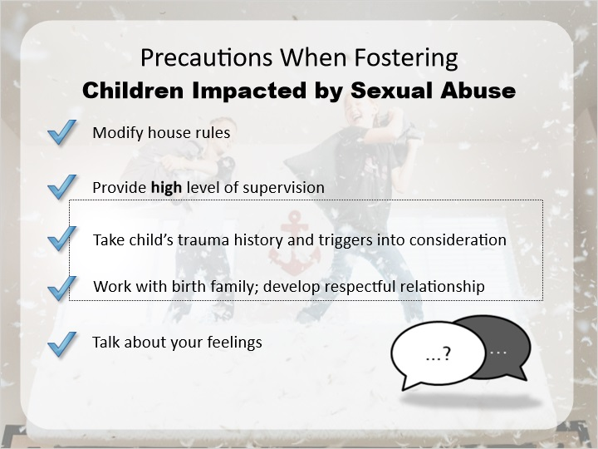
Notes:
Possible precautions to take when fostering children who have been impacted by sexual abuse can include:

Modifying house rules to provide a safe and comfortable environment, including always being clothed in common areas of your home and restricting the parents’ bedroom to parents only.

Providing a high level of supervision, as some children who have been sexually abused develop sexualized behaviors. Know what the safety plan is and what the supervision expectations are.

Take into consideration the child’s trauma history and possible trauma triggers when seeking alternative temporary care such as respite providers and babysitters. This could include specific genders of caregivers, smells, sounds, presence of alcohol, to name a few possible triggers.

Working with the birth family and maintaining a respectful and empathetic relationship. This can be difficult if members of the birth family contributed to the abuse. Talk with your licensor or the child’s child welfare professional if you have concerns about maintaining a positive relationship with the child’s family.

Talk about your feelings with your licensor or the child’s child welfare professional so that your feelings do not interfere with your interactions with the child.

5.5 Pre-Placement Information
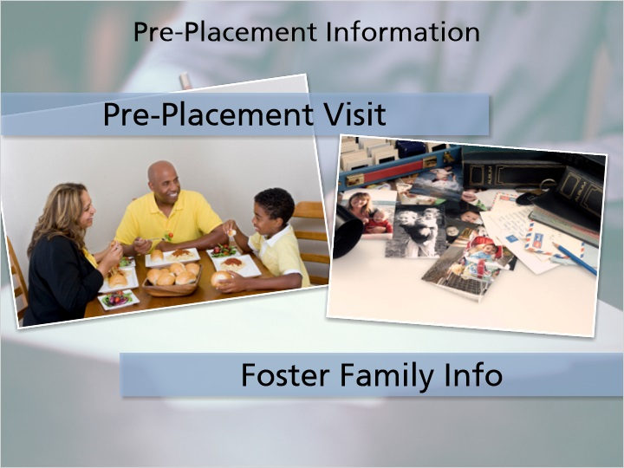
Notes:
In the previous module, you learned about questions to ask a child welfare professional before accepting a child for placement in your home. Sometimes it is also possible to have the child come for a pre-placement visit to see if your family a good match for the child and to help address the concerns the child may have about the transition. Pre-placement visits are not always possible, but when they do occur, they can range from a couple of hours to a full weekend. Involving a child’s parents in these visits will assist you in building positive relationships with them.

Some foster parents create a foster family book or info sheet to share with children who may be placed in their home. These books usually include pictures of your family, your home, your pets, and your neighborhood, and gives information about things your family likes to do together. This helps children become more familiar with your home and family before they are placed with you. You can find a Resource Family Profile in the Appendix of your Foster Parent Handbook, which answers questions that a child or their family may have about you or your home.

Be creative! Just like you want to know about the child, they want to know about you, your family, your home, and the community.

6. How Placement Affects Children

6.1 How Placement Affects Children
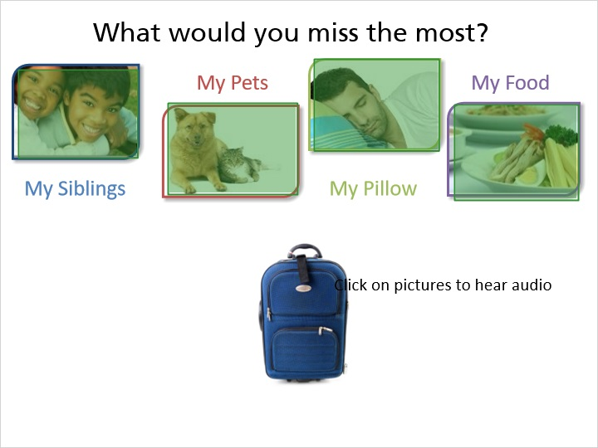
Notes:
Imagine that starting tonight, you have to go live at someone else’s house. What would you miss the most?

My Siblings: No Problem! We have kids at our house who are your brothers’ and sisters’ ages. You’ll love them!

My Pets: Oh, perfect! We have a dog too, so you can play with our dog now!

My Pillow: Awesome! You’ll have your own bed at our house, and we have cool new sheets for you that don’t smell like smoke, so that’s even better than at your house!

My Food: Well, I’m a great cook, so this isn’t a problem! You’ll love the food I make for you!

7. Attachment

7.1 Attachment

Notes:
You’re probably thinking that all of those things might sound nice, but you’re also probably thinking, “But I want my stuff!” This is exactly how children feel when they enter foster care or move to a new placement. While the things that you are offering them might be newer or nicer than their things, they can’t replace what these children are missing. For many of these children, the items that they bring along with them are all of the things that they have in this world. It is understandable that you want to provide them with nice things, but you must also respect the attachment they have to their belongings, even if you don’t understand it.

These children have little control over their lives when placed, but the objects they bring with them are tangible things they can control.

Children also have attachments to their family members, and these connections must be honored and promoted (as long as they are safe and appropriate). Interaction with family members is the best way for children to maintain the connections they have with these family members, especially siblings. A common concern voiced by former foster youth is that they wish they had been able to spend more time with their siblings. Family interaction is required for children in foster care and cannot be taken away as a consequence. If you have concerns about family interaction for children in your care, talk with the child’s child welfare professional. Family interaction will be discussed in more detail in Module 5.

7.2 True or False: If a child brings toys and clothes with them that are old or smell funny, you can throw them away and replace them.
(True/False, 10 points, 2 attempts permitted)
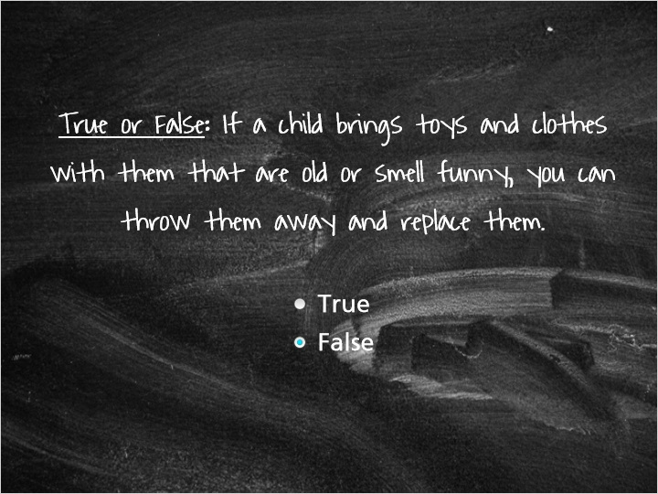
Correct | Choice
 | True
X | False

Feedback when correct:
You're right! You do not have the right to dispose of a child's belongings because they are old or smell bad. If a child's clothes are unsuitable for wear (such as being infested with lice), then they can be thrown away. Children have attachments to their belongings, and that attachment must be honored.
Feedback when incorrect:
No! You cannot throw a child's belongings away. If a child's clothes are unsuitable for wear (such as being infested with lice), then they can be thrown away. Otherwise, you are not able to simply dispose of the child's belongings because they are old or smell. Children have attachments to their belongings, and that attachment must be honored.

7.3 Invisible Suitcase

Notes:
Children come into foster care and move to each new placement with their personal belongings, but they also bring along an “invisible suitcase” full of their feelings about themselves, about their caregivers, and about the world based on their unique histories. Given that many children in foster care have trauma in their histories, these suitcases are usually full of negative beliefs about themselves and about their caregivers.

The invisible suitcase is full of thoughts about themselves like: I’m worthless, I am always going to get hurt, and I have no power or control; and thoughts about you like: you don’t care about me, you won’t be there for me, and you will reject me.

You did not create this invisible suitcase and you are not responsible for what is in it. What you are responsible for is being able to understand that it is there and that the contents of each child’s suitcase will shape their behavior. When a child is acting out, consider that their behavior is a response to their past experiences and that there is a reason for it.

If you think back to the video that you saw in the Introduction Module, you’ll remember that the child in the video talked about things he might do to act out in your home (like fighting with your children or breaking things), but that he also said that if you stick with him, one day he will thank you (in his own way). Even if children are not completely aware of their own invisible suitcase, they will (either consciously or unconsciously) try to push you away in order to confirm that they’re right about you (that you’ll reject them and won’t care about them).

As you build a relationship with the children in your care, they will be more willing to discuss their histories with you. This will help both of you to see what is in their invisible suitcase and will help to dispel their negative beliefs and expectations.

7.4 Invisible Suitcase Vignette

Notes:
Please listen to the following case scenario that illustrates the idea of the invisible suitcase.

Foster parent, Ann (calling child welfare professional, Chris): I just don’t know what to do! Every time Jamie comes back from a home visit, he punches the walls and yells and screams for hours!
Chris: Well, is he telling you what’s wrong? Did his parents say if anything went wrong during the visit?
Ann: No! He won’t say a thing and his parents said the visit was fine!

Jamie (in background): You want to know why? I look forward to my visits with my family all week, and then they go so fast and then I have to come back here. I don't like having to come back here and leave my family. I like you, Ann, but I love my family and wish I could go home.

7.5 Your 7-year-old foster son is having regular interaction with his parents and older brother. You are concerned that his family members are negative influences on him. What can you do?
(Multiple Choice, 10 points, 2 attempts permitted)
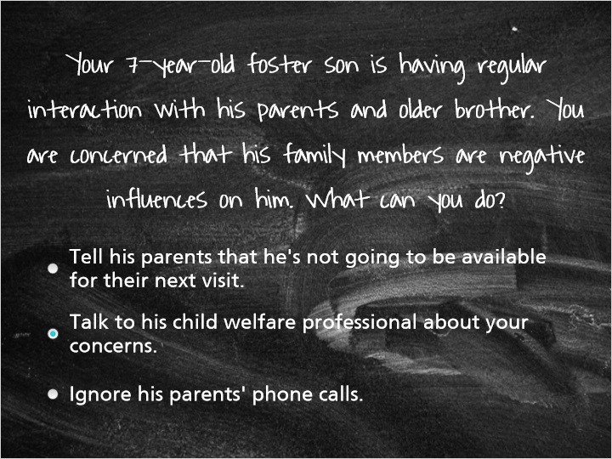
Correct | Choice | Feedback
 | Tell his parents that he's not going to be available for their next visit. | No! You are not able to make the decision to prevent a child from interacting with his or her family members. If you have concerns about family interaction, talk with the child's child welfare professional.
X | Talk to his child welfare professional about your concerns. | Yes! If you have concerns, discuss them with the child's child welfare professional. You do not have the ability to prevent family interaction.
 | Ignore his parents' phone calls. | No! You do not have the ability to prevent family interaction or ignore his parents' attempts to schedule interaction.

8. Helping Children Adjust to Placement

8.1 Helping Children Adjust to Placement
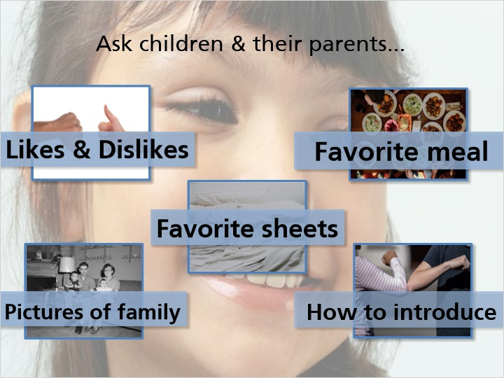
Notes:
When a child is first placed in your home, it is very important to do what you can to help them feel comfortable. You can ask the child and their parents what will help them to settle in. Some ideas for helping a child feel comfortable are:

Talk to the child about their likes and dislikes
Use favorite sheets or a blanket from home when making their bed
Put up pictures of their family in their bedroom and around the house
Make a child’s favorite meal for their first dinner at your home
Talk with the child about how they would like to be introduced. As you’ve heard from former foster youth, this is a sensitive issue for children in foster care.
Ask other foster parents about ideas of things they do when children are placed in their home.

Having a child placed in your home will require a period of adjustment for everyone in the home. The most important thing that you can do during this period is to provide a stable, consistent environment - and be patient! During this adjustment time, keep an eye on all of the children in the home to ensure that all of them are receiving attention from you and adjusting well.

It is critical for foster parents to understand that children will experience many complex emotions that they will not understand. They will not typically welcome the idea of being placed in a new home with strange people, noises, rules, and smells. The home of foster parents who are relatives or like-kin caregivers may have some advantage of being familiar to children who are placed with them, however, in these circumstances the changes in roles is what children will need time to adjust to. The changes in roles such as grandma, grandpa, aunt, uncle or cousin now takes on the role of “mom” and/or “dad”. This change in roles can be very confusing. The more patient and understanding foster families can be, the more likely it will be that the child will slowly adjust to his or her placement in the foster home.

Every new placement is an adjustment for everyone.

8.2 Family-Like Living Experience
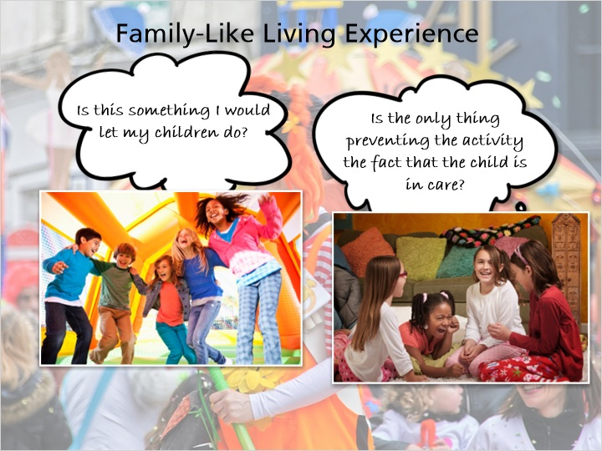
Notes:
Providing a Family-Like Living Experience is a Reasonable and Prudent Parenting standard consideration. The previous slide helps give foster parents some ideas about how to get to know, care for, and help a child feel welcomed into their home. Let’s take a look at some other ways we can think about how to use this Standard.

When you are faced with a decision, you should consider whether the activity will promote a “family‐like” living experience. You should consider whether the activity is something that other members of the family can do. A child’s status of being in out‐of‐home care should not be the only thing preventing the child from doing the activity. You should allow the child to experience living like a member of the family, not just a child placed in your home.

Decisions could range from simple to more complex.

A decision to allow a child to participate in an activity that you would allow your birth child to participate in could be reasonable and prudent. A child’s status of being in out‐of‐home care should not be a barrier to taking part in a normal activity that other household members participate in.

8.3 Real Life Tips from a Foster Parent
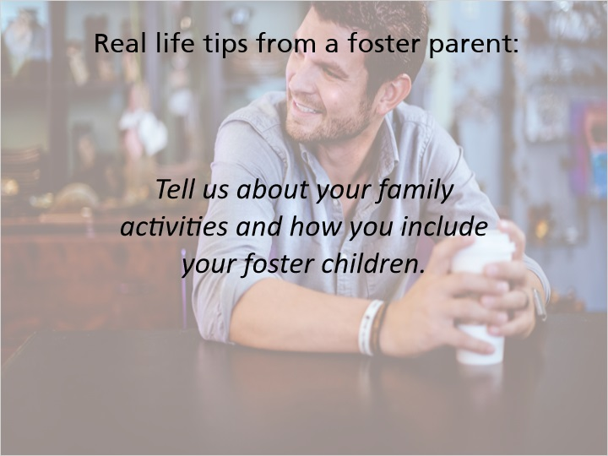
Notes:
“I know some foster families put their kids in respite and take their holiday vacations, but our kids are our kids and we take them with us everywhere we go. Our families have been super supportive, so when we travel we travel as a family of five with a dog; that’s 3 foster kids, and both my and my wife’s parents treat them as grandchildren; there’s no differentiation between their birth grandchildren and our kids.

“We make sure that we include them. I mean, we’re a family, and we explain that we don’t know what the future holds, but right now this is our family and this is what our family looks like and we do things as a family. We need to get along as a family, and we just keep trying to build that successful family bond with people from three types of families living in the same home.” trying to build that successful family bond with people from three types of families living in the same home.”

Every child and family situation is different. Respite is a great resource and can be a great support for the foster family as well as for the child in care. Family needs vary at different times and every family needs to make their own determination about what works for your family and the child in your care. Be sure to talk about respite options or ask questions with your licensor.

8.4 Check Your Understanding - Placements
(Multiple Choice, 10 points, 2 attempts permitted)
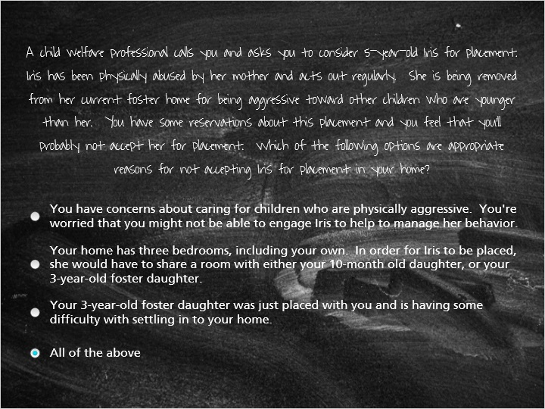
Correct | Choice | Feedback
 | You have concerns about caring for children who are physically aggressive. You're worried that you might not be able to engage Iris to help to manage her behavior. | If you do not feel that you can meet a child's needs, declining the placement is the most appropriate choice.
 | Your home has three bedrooms, including your own. In order for Iris to be placed, she would have to share a room with either your 10-month old daughter, or your 3-year-old foster daughter. | You might not be comfortable with Iris sharing a room with younger children due to the aggression she has shown to children who are younger than she is.
 | Your 3-year-old foster daughter was just placed with you and is having some difficulty with settling in to your home. | If you have just taken placement of another child who needs time to adjust, taking another placement right away is likely not the best choice.
X | All of the above | Yes, all of the answers would be considered appropriate reasons for declining Iris' placement.

8.5 Voice of Caregivers
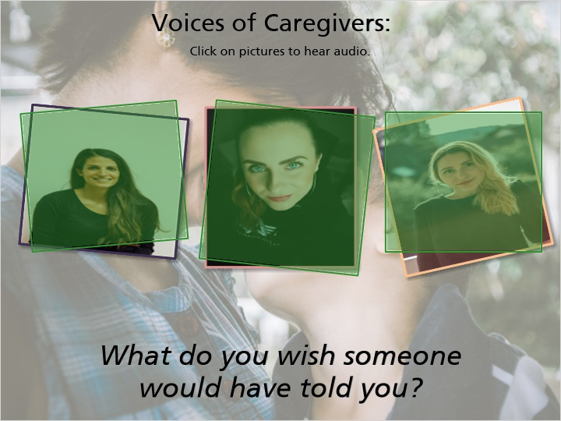
Notes:
Voices of caregivers:

“So I guess I would have told people, that look you really need to have a strong support system and you need to be able to ask for help and you need to be able to ask for all kinds of help, I mean just logistics even with transportation or baby sitting or you know whatever.”

“One of the questions that I wish somebody would have shared with me when we started to foster were how connected you get with the children and how painful it is when they do return but that it is important that they return home if they can because that's where their links are and if they don't return home they're going to have a loss it's just part of what’s going to happen, they have a loss coming to us and they'll have a loss if they don't go home so I would really have wished somebody would have been honest with me about how much I was going to care about the children and how painful that process would be.”

“What would have been helpful for me to know before I became a relative caregiver would have been just how emotionally complicated it would have been. You know, this is my family and I love my son and, you know, the divided loyalties that I’ve had to deal with since I’ve become a relative caregiver are complex and getting even more complex the longer the case goes on. So, I think that would have been helpful to me as a relative caregiver. I think other relative caregivers would benefit from knowing just how complicated the child welfare system can make things. You know, being a grandma can be fun and easy. Caring for a child can feel wonderful and be exhausting. But when the child welfare system becomes involved, it’s just an entirely new set of emotions. Requirements from you as a caregiver; I don’t know how you can prepare somebody for that if you have no idea that it’s coming. I think another thing that is really important for relative caregivers to know is that no matter the outcome of the case there’s going to be a certain amount of grief. And it might be grief for that relationship of your son or daughter, or sister or brother, who is incarcerated, or has drug or alcohol issues, or is just no longer speaking to you because you became involved to protect this child. You have a huge set of emotions going on and I don’t think we recognize that they are grief. And there is grief in the loss of that relationship, and it complicates all of the emotion and energy and love that you’re pouring out to care for this child. So, it’s helpful if we recognize it as grief and not that you’re ill, or you don’t have energy or there’s something wrong with you.”

9. Grief, Loss, and Separation

9.1 Grief, Loss, and Separation
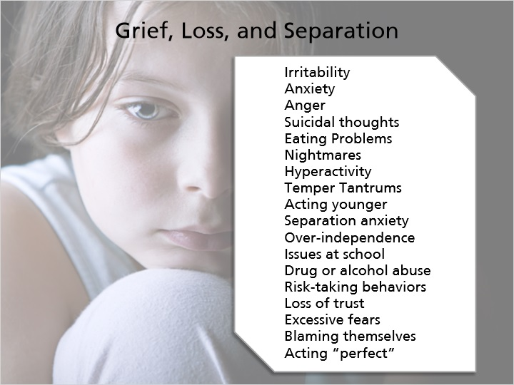
Notes:
When children enter foster care or move to new placements, they experience a sense of loss, and must grieve that loss each time. As a foster parent, you and your family will also probably experience grief and loss when children leave your home.

Everyone handles grief and loss differently. A child’s developmental level will affect how they handle their grief and separations from loved ones. Depending on developmental level, children dealing with grief can display depressive symptoms and other reactions such as:

- Irritability
- Anxiety
- Anger
- Suicidal thoughts
- Eating problems
- Nightmares, sleep problems, or fatigue
- Hyperactivity

…among the others listed here.

As they deal with grief, children in foster care experience many emotional conflicts. Many children struggle with divided loyalty, as they care for both their birth family and their foster family. Children often feel that caring about their foster family diminishes their love for their birth family. Each time a child experiences a new loss, there is potential for a reactivation of a previous loss. It is not uncommon for a new placement to trigger feelings of a loss in the past, such as the death of a grandparent or losing friends when they started at a new school.

9.2 Stages of Grief and Loss
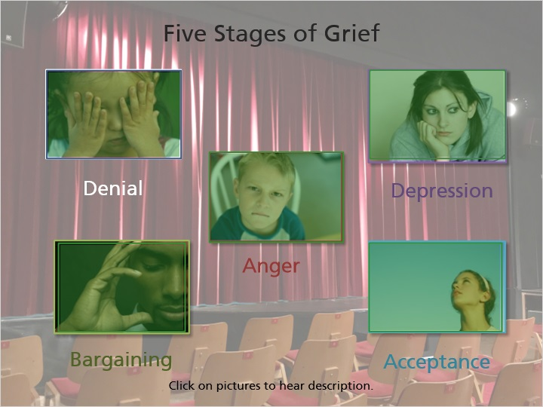
Notes:
When we have a loss in our lives, we all go through the grieving process, which contains five stages. We don’t all go through these stages in the same way or the same order, and there is no set time period for each stage. It will be helpful for you to recognize the different stages and understand the purpose of each stage of grief both to help the children in your care but also to help yourself process your own grief as children leave your home.

Denial: The Denial Stage helps us to survive a loss and puts us in a state of shock and denial. When we’re in this stage, we feel numb and overwhelmed and try to find ways to simply get through the day. While in the Denial Stage, we begin to process the loss and begin to heal. As we process, all of those feelings that we’ve been denying start to bubble up.

Anger: This stage is necessary to continue processing the pain and continuing to heal. Feeling angry can sometimes be scary or make us feel out of control, but feeling anger can also be productive to help us process our grief. The anger that we feel about our loss can end up being directed at various people in our lives and can give us some structure at a time where we feel lost.

Bargaining: In this stage, we try to change the past to prevent the loss. We say things like, “What if I never get mad again” or “What if I help someone everyday” to try to change the fact that we experienced a loss. We get consumed with questions like “What If” & “If only” to try to return to how things used to be. With this bargaining, we feel guilty and stuck in the past.

Depression: The Depression Stage is not necessarily about being diagnosed with depression and isn’t about mental illness. This stage is about feeling empty after a loss, which is a normal and appropriate response. Often in this stage, we withdraw from others and feel very isolated.

Acceptance: The Acceptance Stage isn’t about feeling like everything is okay after a loss, it is about accepting the fact that the loss happened and learning to live with it. This stage is about adjusting to life after a loss and paying attention to our feelings instead of denying them. In this stage, we begin to get involved in our own lives and the lives of our loved ones again.

9.3 Voices of Foster Youth: Being Separated
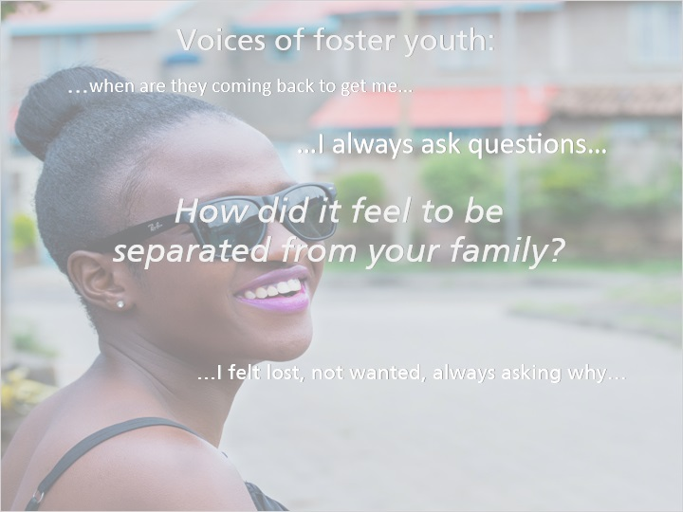
Notes:
Voice of foster youth:

“I felt lost, not wanted, always asking why I needed some answers, I always ask questions, where's my mom, where's my dad, where's my grandma, when are they coming back to get me. Why are people treating me this way, I always asked questions with parents, my foster parents, my social workers, my therapists, my judges and whoever else and that's why I acted a certain way.”

9.4 Emotional Disturbance
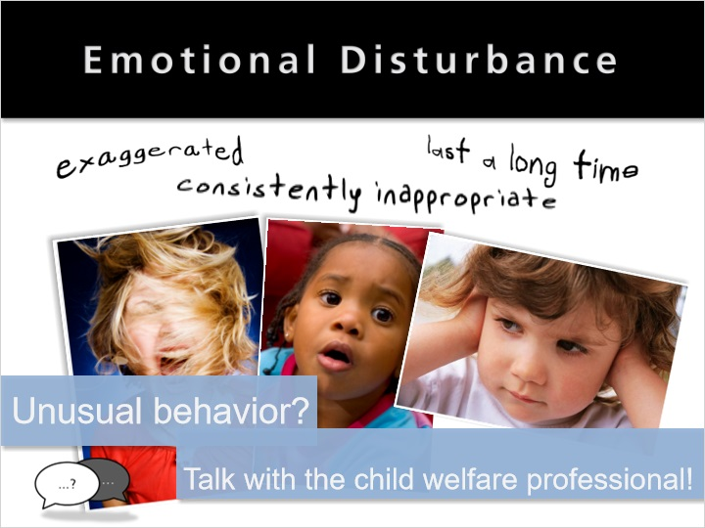
Notes:
You’ve now seen that grief and loss will often trigger negative reactions or behaviors, and that these can be normal in the grieving process. Sometimes, however, these behaviors are signs of more significant mental health or emotional disturbance. Signs of emotional disturbance can include behaviors that are exaggerated, last for a long period of time, or are consistently inappropriate with the child’s developmental level or the situation. Some examples include a teenager having a temper tantrum; a child panicking and running away from an otherwise normal situation; or a child reporting hearing voices.

If a child in your care displays unusual behavior or behaviors that you have not seen before, talk with the child’s child welfare professional.

9.5 Suicidal Thoughts
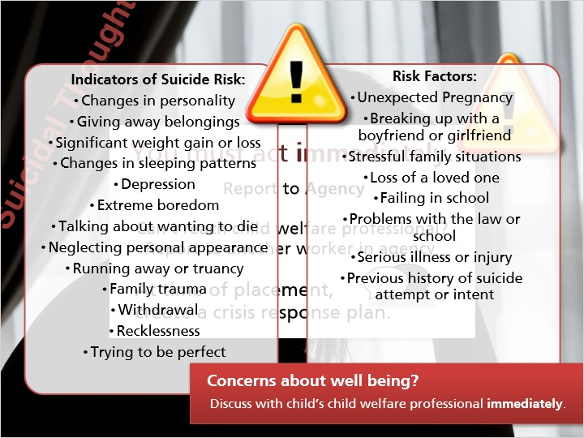
Notes:
Suicidal thoughts, also called suicidal ideation, must be taken very seriously. If a child in your care tells you that they have had thoughts about hurting or killing themselves, you must act on this information immediately. You must report this information to the child’s child welfare professional’s agency immediately. This means that if you cannot reach the child’s child welfare professional , you must report this information to another child welfare professional in the agency. Talk with your child’s child welfare professional at the time of placement to create a crisis response plan and to identify who to contact in the event that you cannot reach the child welfare professional or if it's after hours.

It is important that you are able to discuss these thoughts with the children in your care. These are difficult conversations to have and can be scary for both you and the child. Talk to your licensor about how you might handle these conversations, and about attending additional training on suicide.

Sometimes children who are having suicidal thoughts are not able to discuss them, so you’ll need to be aware of any changes in mood or behavior of children in your home, as these may be indicators of suicide risk. Things to look for include:

- Sudden changes in personality
- Giving away their belongings
- Significant weight gain or loss
- Changes in sleeping patterns
- Depression
- Extreme boredom
- Talking about wanting to die or be dead
- Neglecting personal appearance
- Running away from home or truancy
- Family trauma
- Withdrawal
- Recklessness
- Trying to be perfect

In addition to these warning signs, other risk factors to look for include:

- Unexpected pregnancy
- Breaking up with a boyfriend or girlfriend
- Stressful family situations or a loss of a loved one
- Failing in school
- Problems with the law or in school
- Serious illness or injury
- Previous history of suicide attempt or intent

If you see the behaviors or risk factors on these lists, this does not necessarily mean that the child or youth is suicidal, but these are things to watch for. If you have concerns about the safety or well-being of a child or youth in your home, discuss them with the child’s child welfare professional immediately.

9.6 True or False: Your 16-year-old foster son comes home from school very upset because he found out that the girl he likes is dating someone else. He tells you that he's so upset and he wants to die. You figure he's just being dramatic and you can ignore the comment, right?
(True/False, 10 points, 2 attempts permitted)
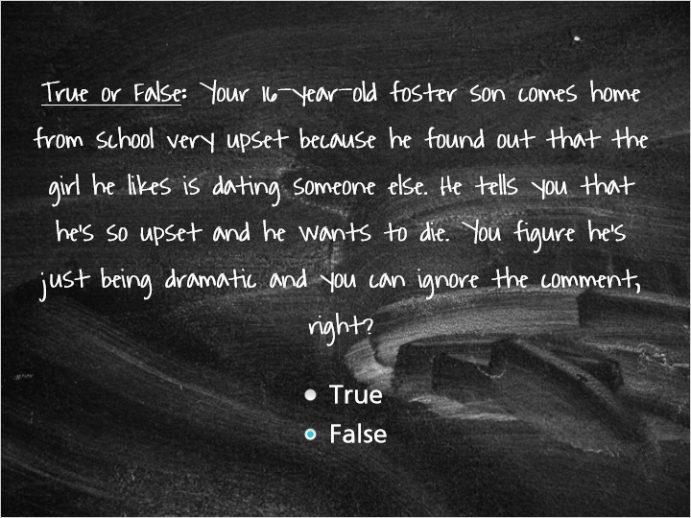
Correct | Choice
 | True
X | False

Feedback when correct:
You're right! You cannot ignore suicidal statements by a child. If a child makes statements about suicidal thoughts or feelings, you need to discuss this with the child and you must report this to the child's child welfare professional’s agency immediately. Look at the crisis plan that you created with the child's child welfare professional for direction on what you must do. Suicidal thoughts must be taken very seriously.
Feedback when incorrect:
No!! If a child makes statements about suicidal thoughts or feelings, you need to discuss this with the child and you must report this to the child's child welfare professional’s agency immediately. Look at the crisis plan that you created with the child's child welfare professional for direction on what you must do. Suicidal thoughts must be taken very seriously.

9.7 Transitions Faced by
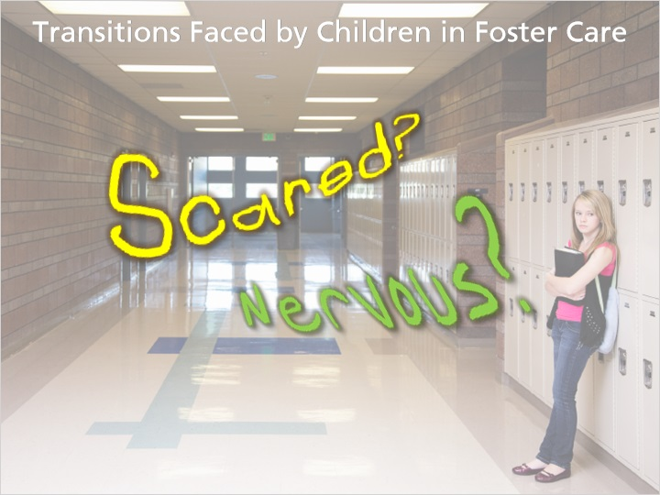
Notes:
As stated in previous slides, each new placement is a loss for children in foster care, and requires them to start over in a new place with new faces, new environments, new routines, and new expectations. Imagine what it feels like to start at a new school: you don’t know many people, you’re not sure where to go, you don’t know the routines, and you feel like everyone else knows each other and you’re all alone. How would you feel? Scared? Nervous? Did you feel afraid of how people would treat you? Now imagine going through that experience over and over, as children in foster care sometimes do.

If you had to move to a new placement often, do you think you would face each new transition with a positive attitude? Would you be excited to meet the new foster parents and other children in the home? Or would you get more and more frustrated each time and feel pretty hopeless?

Children in foster care may transition to a new home for many reasons, such as returning home to their parents or guardian, transitioning to an adoptive home, or aging out of foster care. It is important to limit the amount of trauma the child experiences. Regardless of the reason for the move, each move is a loss of relationships and connections for the child. The child and their foster family need time to say goodbye. You may want to do something to honor the child’s time with your family (for example, to add something to the child’s life book or have a special meal together with the child’s favorite foods). Not every child in foster care moves multiple times, but for those that do, each transition has a negative impact on their development. There is more on that impact in the upcoming slides.

9.8 Check Your Understanding - Grief Loss, & Separation
(Matching Drop-down, 10 points, 2 attempts permitted)
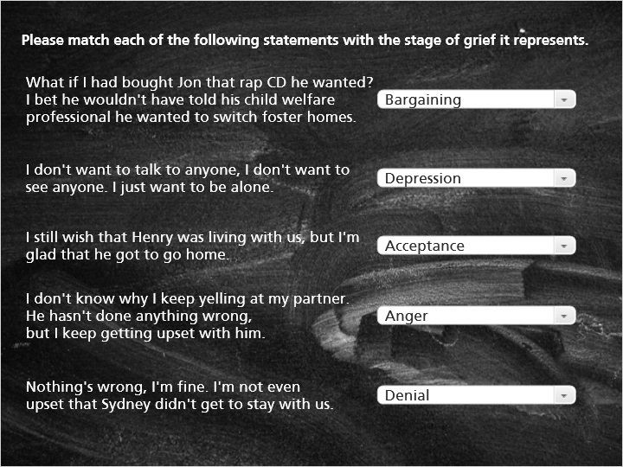
Correct | Choice
What if I had bought Jon that rap CD he wanted? I bet he wouldn't have told his child welfare professional he wanted to switch foster homes. | Bargaining
I don't want to talk to anyone, I don't want to see anyone. I just want to be alone. | Depression
I still wish that Henry was living with us, but I'm glad that he got to go home. | Acceptance
I don't know why I keep yelling at my partner. He hasn't done anything wrong, but I keep getting upset with him. | Anger
Nothing's wrong, I'm fine. I'm not even upset that Sydney didn't get to stay with us. | Denial

Feedback when correct:
That's right! You matched the correct stages to the statements.
Feedback when incorrect:
You did not select the correct responses.

10. Real Life Tips: Adjusting to Change

10.1 Real Life Tips: Adjusting to Change
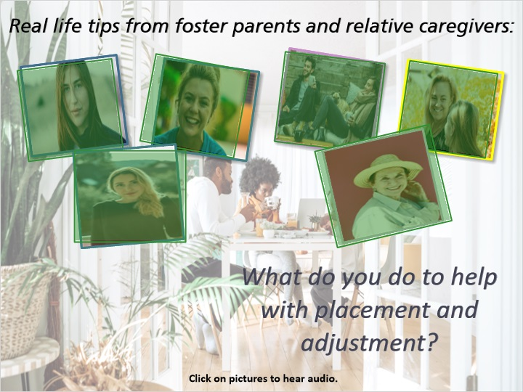
Notes:
Voices of foster parents:

“When we are accepting a new placement and a new child is coming into our home, I usually try to have the home real quiet when they first come – not everybody there so they have some time to get used to their surroundings and check things out. We do a tour of the house so they can see where everything is, where their room is going to be, we talk about whether they’re going to school or not and how they’ll address us when they go to school – whether it’s ‘mom’ and ‘dad’ or ‘foster mom and dad’ or by our names; then we take time to introduce them to the other children in our home so everybody gets to know each other and often times what we do is go out to McDonald’s for dinner because everyone likes McDonald’s and it breaks the ice, so to find something fun to do to take a little bit of the stress away.”

“The kids come into your house and they’re scared, and they don’t know you and what is going to be expected of them in this house, so I think it’s important to surround them with stuff that’s familiar to them (their smells and their clothes), and I think it’s really important to take them grocery shopping the first day so you can get them some food that they’ll going to find comfortable. Even if it’s not necessarily food that your family eats or what you try to feed your kid – there’s a big safety/security hump that you need to get over right away and it can really ease the transition. Kids love it when you talk about things they like and food, it’s so much more than food – it’s more than sustenance, it’s love and it’s family connection and it’s a connection to their family, a connection to your family, it’s a way we show love to each other in preparing and sharing food together. A lot of these kids come from a really different social background than I come from, so approaches to food are going to be different but the love of shared food and the shared family time of family meals is still very present.”

“The last time my older daughter who is also in care, we made a big welcome sign and, you know, had a special meal, I think I asked what she liked, and that kind of thing, just trying to ease them in gently and not bombard them with rules and our culture and our family too much, just kind of the basics.”

“Talking to birth parents to be able to find out what does that child like, where do they like to sleep, what do they like to eat, what are their favorite clothes; they can be a great resource. And if I can’t talk with birth parents I’ll talk with the worker or with the children and try to have some of that for the child, whether its videos or music or laundry soap, fabric softener are huge for a couple of reasons, one is it makes the child feel like they’re at home, and also when they go to visit their birth family they smell like their birth family so a very important thing that we do without even doing it so much, it’s not like a big activity, it’s just changing their laundry soap or fabric softener.”

Voices of relative care givers:

“Hopefully as a relative you know that you can provide that joy and that love and that stable, continuous caregiving and, also think about that emotional safety; you know what it is that’s gonna help them feel safe. They might be having regular phone calls; it might be making sure all their favorite stuff is there. Helping children to adjust to being with you all the time rather than just a little bit of time. I hope that’s the easiest parts for you a relative caregiver, because a lot of it’s not easy, but loving them and being with the kids hopefully is the easy part.”

“She herself went to the case manager and the DA in a session asked if she could call us Mama and Papa, she didn’t want to call us mom or dad, but she chose an in between terminology, and I think that’s important for any caretaker to understand. The child has to take a role or feed into the family dynamics to figure out where they want to be calling who. The agencies each hosted events and we took the kids to those hoping that they would see that were a lot of other children in the same environment as them, living with a grandparent, living with an aunt or an uncle, maybe even living with an older adult sister or something, and that does seem to help. They see that they’re not alone. They see that they’re not unique in what their living environment is.”

11. Thinking Back on the Module

11.1 Thinking Back on the Module…

Notes:
Think back on the information that you learned in the first part of this module. You’ve heard from youth and foster parents, and learned about how placement affects children, grief and loss, the “invisible suitcase,” adjusting to placement, emotional disturbance, and about transitions faced by children in foster care. Remember to write down questions that you have to discuss with your licensor about any of these topics.

11.2 Results Slide
(Results Slide, 0 points, 1 attempt permitted)


Results for
9.6 True or False: Your 16-year-old foster son comes home from school very upset because he found out that the girl he likes is dating someone else. He tells you that he's so upset and he wants to die. You figure he's just being dramatic and you can ignore the comment, right?

Result slide properties | Passing Score
100%

Notes:

