Module 2 Expectations of Foster Parents

1. Introduction

1.1 Foster Care Overview
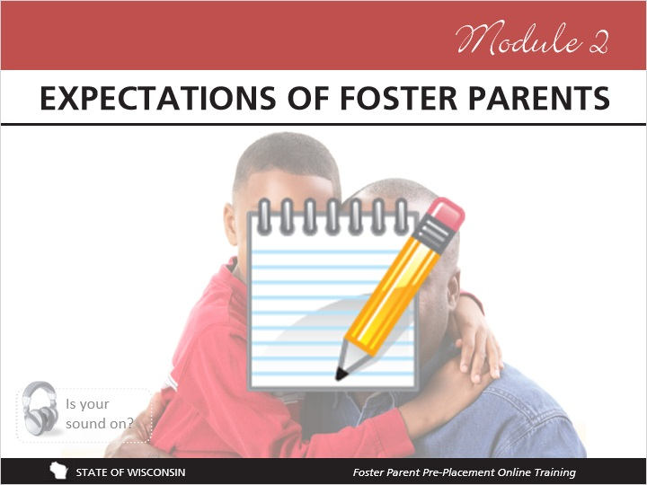
Notes:
This module explains the expectations of you as a foster parent. You will learn about confidentiality, communicating with your agency, reimbursement, the rights of people involved in foster care, maintaining records for foster children, and responding to allegations of abuse and neglect.

Before you continue, please remember that you have the notepad document to jot notes in as you go!

1.2 A Letter to Foster Parents
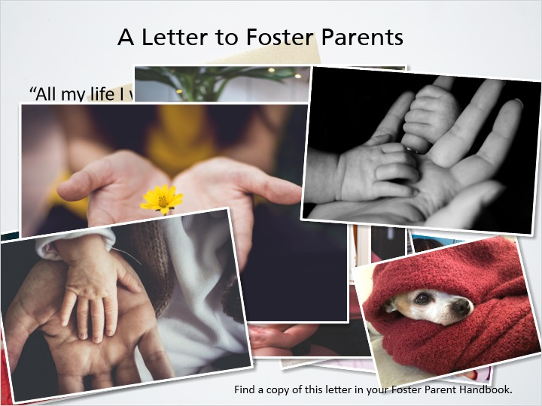

1.3 Information to be Communicated to Foster Parents
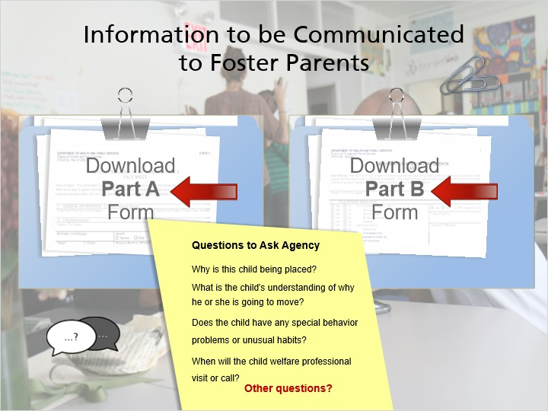
Notes:
What would you want to know about a child who was going to be placed in your care?

In Wisconsin, agencies are required to give specific forms to you when a child is placed in your home. These forms may be incomplete when the child is placed, but the agency will pass on the information they have and will update you as new information is learned. Click on the “Part A” and “Part B” links to see examples of the paperwork that should be given to you when a child is placed in your home.

You will probably have lots of questions about a child before they are placed in your home. It’s a good idea to keep a list of questions handy for when your agency calls to ask if you’ll accept a child for placement. Some examples of questions to ask might be:
Why is this child being placed?
What is the child's understanding of why they are going to move?
Does the child have any special behavior problems or unusual habits?
When will the child welfare professional visit or call?
What is the family interaction plan?
What will my role be in family interactions?

What other questions come to mind that you might want to ask?
Be sure to write them down and share them with your licensor. Some agencies have lists of questions already prepared for foster parents; check with your licensor to see if this is the case for your agency.

2. Things to Communicate

2.1 Things Foster Parents Need to Communicate to the Agency
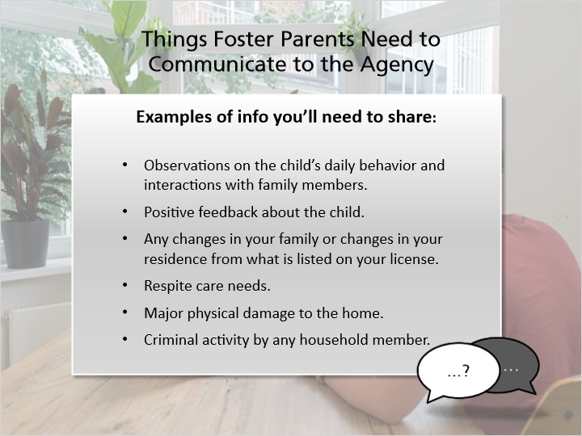
Notes:
As a foster parent, you have the responsibility to share certain things about the children in your care with the child’s child welfare professional and with your licensing agency. This may include things that are shared with you by the child or their families, or that you discover in your interactions with the child or other people involved in the child’s life.

The child’s child welfare professional and your licensor will all need updated information. Sometimes they will want the same information and sometimes each will need different information. It’s important to ask your licensor how this will work for you, and about when you need to communicate certain information.

Some examples of information you’ll need to share are:

Your observations on the child’s daily behavior and interactions with family members.
Positive feedback about the child.
Any changes in your family or changes in your residence from what is listed on your license.
Your need for a break, often called respite care.
Major physical damage to your home.
Criminal activity by any household member.

This is not a complete list, so if you have information about the child in your home and you’re not sure who to share it with or when you need to share it, talk with your licensor. Please refer to DCF 56 for specific requirements about sharing information.

2.2 Emergencies and Special Circumstances
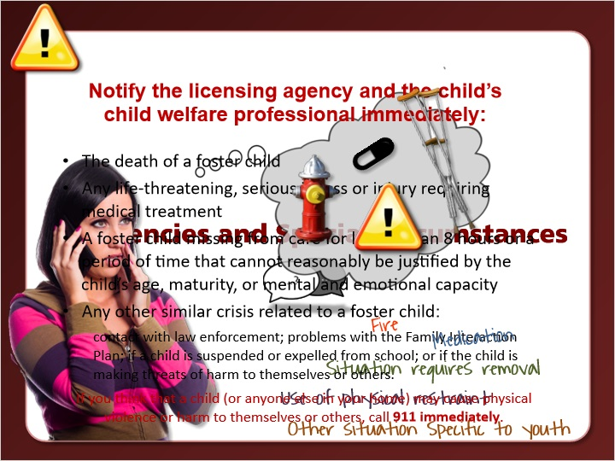
Notes:
As a foster parent, you will likely experience some emergencies or other crisis situations with your foster children. When a child is placed in your home, you should discuss with your licensor and the child’s child welfare professional how emergencies should be handled in order to create a plan for crises during and after business hours.

DCF 56 explains requirements for reporting such emergencies.

There may be unique and complicated situations that require you to notify the agency immediately. Some of these situations include: A fire in the foster home or its property, which requires the assistance of the fire department; an error in administering medication to a foster child.; a condition or situation which requires the removal of a child from the foster home; the use of physical restraint as required under s. 56.09 (1g) (e), Adm. Code; and any other situation specific to the child or identified by the agency that qualifies as an emergency or special circumstance. Remember, if you have concerns about any situation, you should consult the agency as soon as possible.

If a child in your care has a serious illness or injury that requires medical treatment, you must notify the child’s child welfare professional as soon as possible.

The following situations require you to notify the licensing agency and the child’s child welfare professional immediately:

The death of a foster child
Any life-threatening, serious illness or injury requiring medical treatment
A foster child missing from care for longer than 8 hours or a period of time that cannot reasonably be justified by the child’s age, maturity, or mental and emotional capacity
Any other similar crisis related to a foster child, which can include but is not limited to: contact with law enforcement; problems with the Family Interaction Plan; if a child is suspended or expelled from school; or if the child is making threats of harm to themselves or others.

It is important to remember that if at any time you think that a child in your home (or anyone else in your home) may cause physical violence or harm to themselves or others, call 911 immediately.

2.3 Staying in Touch
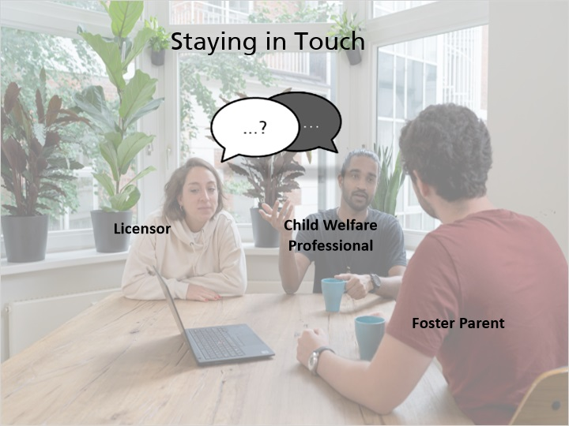
Notes:
Foster care licensing code lays out requirements for the amount and type of contact that must occur between agency child welfare professionals and foster parents. Each agency may have additional expectations in terms of the type of information to share and the frequency of communication. Check with your licensor to see what you can expect from your agency professionals as well as what the agency’s expectations are of you.

You may find it difficult to get in touch with a child welfare professionals because of their schedules, which is often frustrating for foster parents. It may be helpful to ask the child’s child welfare professional for the best time and way to contact them.

Remember to keep any notes, emails, or other written information about the child in the child’s case record. Always remember that all communication about the child and the child’s family must be kept confidential and could be included in a court record. More information about case records and confidentiality will be shared later in this module.

2.4 Voice of a Birth Parent: Being Included
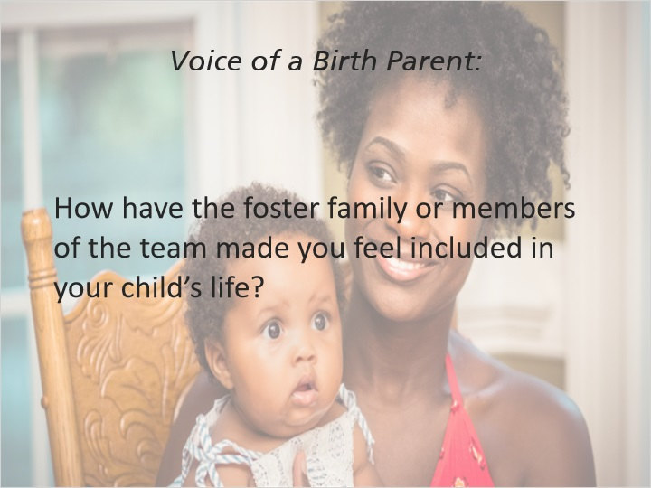
Notes:
Voice of a birth parent:

“The second foster parent, they was very nice, we stayed in contact like if I'm going to be late dropping her off, late picking her up I call and let them know. One of the foster parent I had little issues with her, I tried to work around those things because I feel that they is helped taking care of my child, I used to always was emotional every time me and one of the foster parents had a few words back to back, I learned how to go to my social worker and let her know what's going on and how I feel about the situation, everything started moving forward, we start getting to work with one another for my child, staying in contact and I still stay in tune with them right now till today, whenever something is going on I would like to be a part of that, doctor's appointments, dentist, whatever has something to do with my child I wanted to know about it.”

2.5 Check Understanding: Information Sharing
(True/False, 10 points, 2 attempts permitted)
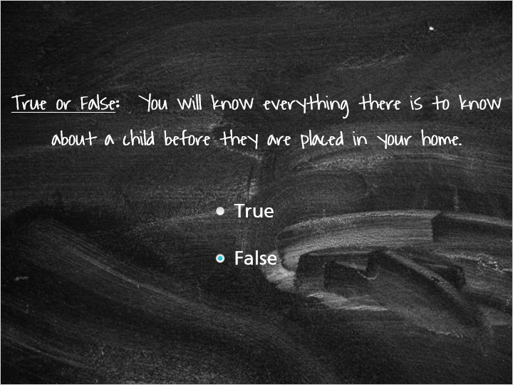
Correct | Choice
 | True
X | False

Feedback when correct:
You're correct, you won't know everything about a child before they are placed. The child welfare professional may not have been given complete information about a child or their family, but that information will be shared with you as it becomes known to the agency objectives.
Feedback when incorrect:
Unfortunately this is not true. The child welfare professional will give you the information that they have about a child, but this may be incomplete at the time that a child is placed because the information has not been shared with the agency. As the child welfare professional learns more about a child, they should share this information with you.

3. Confidentiality

3.1 Confidentiality
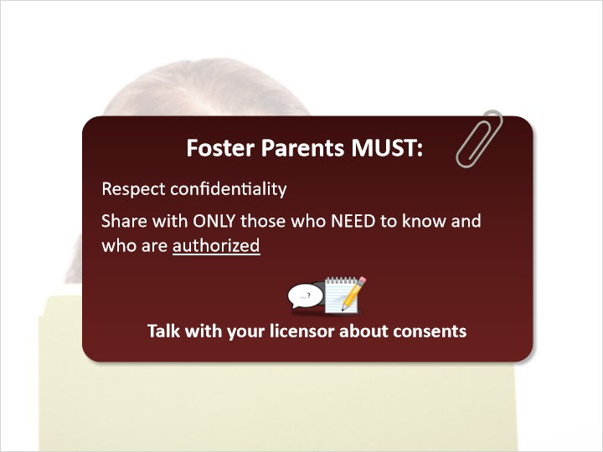
Notes:
Think for a moment of a secret that you would only share with certain people. Now imagine that this secret is suddenly shared with multiple people that you have not chosen to tell. You would probably feel betrayed, scared, and angry, and that is exactly how children and birth parents in foster care feel when their confidentiality is violated.

Foster parents must respect the confidentiality of foster children and their families, which means sharing details about a child or their family with only those who need to know the information and who have been authorized to receive it. In order for someone to be authorized, the child’s parent must have a signed consent form giving that person authorization to communicate about their child. This means that foster parents including relative and like-kin caregivers cannot share information about the child or their family with friends, neighbors, or even relatives without authorization.

The agency who placed the child should obtain consent forms for medical care, and school. Talk with your licensor about how to get these consents signed for the children in your home.

Laws require all licensed out of home caregivers to respect the confidentiality of children in foster care and their families.

Please listen to some examples given by former foster youth about how their confidentiality was violated.

“My foster mom told me one day, ‘Your bio-mother sent you a letter, so I opened it and this is what she had to say.’”

“I was at the store with my foster dad. A friend of my foster dad’s came up and asked who I was, and my foster dad said, ‘This is my foster kid, Johnny.’” The friend said, ‘Ohhhh you’re Johnny, I’ve heard all about you.’”

“My foster mom told me, ‘I read your diary. I didn’t know you hate this place; you shouldn’t leave it in the open for me to read.’”

Think for a moment about how these children must have felt. Think about how you would feel if you were the one in these situations. Write down what you’re thinking now as a reminder to yourself when these situations come up in the future. Also consider how your relationship with the children in your home (and their families) could benefit from respecting their confidentiality.

3.2 Confidentiality Scenarios
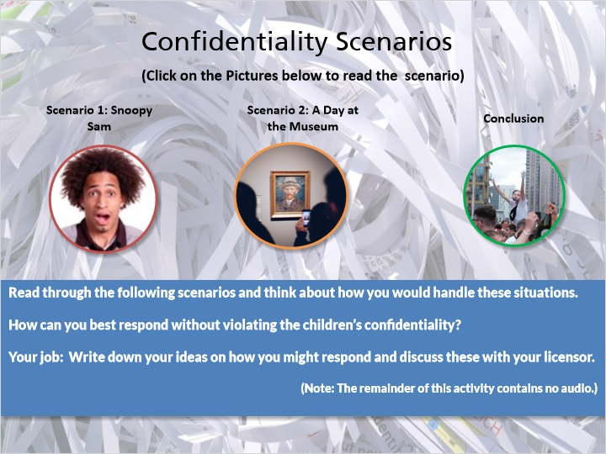
Notes:
Your friends and family will likely know that you are a foster parent, and will be curious about the children in your care. You will also probably be approached by others in the community wanting to know about the children in your home. It is important to plan how you’ll respond to these situations ahead of time to avoid awkward or embarrassing situations.

When someone says things to you such as, “Oh, who is this?” or “Are these all your foster children!?” How will you respond?

Read through the following scenarios and think about how you would handle these situations. How can you best respond without violating confidentiality? Write down your ideas on how you might respond and discuss these with your licensor.

Scenario 1:

You take your foster children to register for school. One of the staff at the school looks up to see you walking in with multiple children and in a shocked voice says, “Are these all foster kids!?”

Scenario 2:

You take your birth children, your foster children, and some of the children’s friends to a local museum. Admission to this museum is expensive, and you’re aware that this museum offers free admission for children in foster care.

What were some of your ideas?

Saying, “These children all live in my home and need to be registered for school”
Getting a family pass to the museum to avoid breaching confidentiality – or asking for the state issued FP ID card. Telling the neighbor that you can’t discuss the incident.
Telling people “it’s not my story to tell” when they ask specifics about the children.

3.3 Real Life Tips: Confidentiality
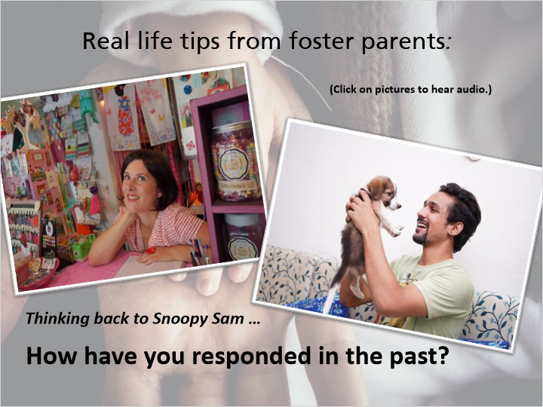
Notes:
Real life tips from foster parents:

“My answer to that question took me a little bit of time to think of, I just paused for a moment and I responded that yes all these children live at my home; and it's very difficult when people ask you those kinds of questions and sometimes it's just take a breath and think about what's the correct way to answer and they do all live at my house.”

“I usually just answer by saying that they're my kids and if they keep pushing at me I just say that they're my kids and that's all I can really say about that.”

3.4 Confidentiality: Key Points
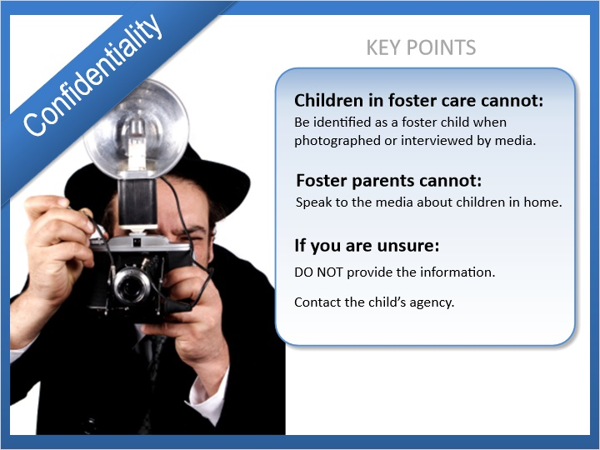
Notes:
As a foster parent, you will be asked to share information about the children in your home. When this happens, remember the following things:

Children in foster care cannot be identified as a foster child when photographed or interviewed by media.
Foster parents cannot speak to the media about the children in their home.
If you are asked for information about a child in your home and you are unsure if the person has authorization to receive it, do not provide the information.
Instead have that person contact the child’s agency.

Media requests can occur for various reasons; for example, to feature a child’s achievements or if the child or their family is involved in legal action.

3.5 Check Understanding - Confidentiality
(Multiple Choice, 10 points, 2 attempts permitted)
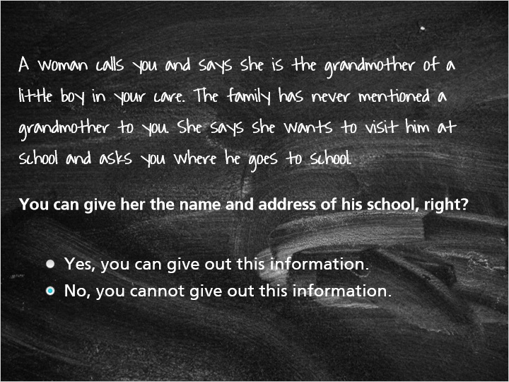
Correct | Choice
 | Yes, you can give out this information.
X | No, you cannot give out this information.

Feedback when correct:
Correct! You can only share this type of information with individuals who have been authorized to access it. The agency would need to verify that this woman has permission to have access to information about this boy before you can even tell her that he is in your home.
Feedback when incorrect:
No! You cannot share information with anyone who has not been authorized to receive it. The agency would need to verify that this woman has permission to access information about this boy before you even tell her that he is in your home.

4. RPPS

4.1 Reasonable and Prudent Parent Standard - What is it?
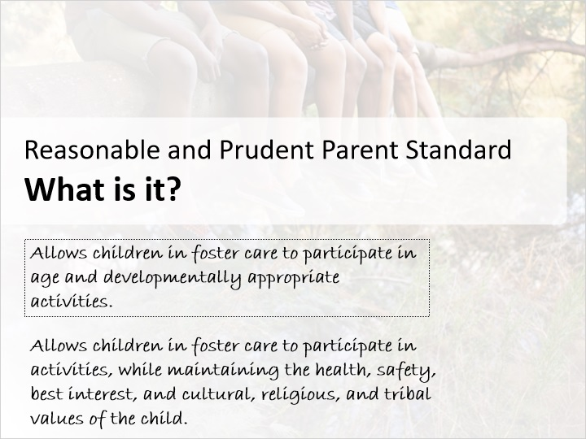
Notes:
Legislators heard from current and former foster youth that they weren’t able to “be a kid” while in out-of-home care. Being in care prevented them from building relationships with peers or experiencing normal personal growth which negatively affected their well-being. The federal government responded with the requirement for Reasonable and Prudent Parenting Standards to increase normalcy for children in out-of-home care. The Federal “Preventing Sex Trafficking and Strengthening Families Act” of 2014 requires that all states implement a Reasonable and Prudent Parent Standard to increase normalcy for children placed in foster care. Normalcy is the ability to easily have opportunities for normal growth and development that promotes well‐being. Every child has a right to normalcy, and personal growth should not be prevented by a child’s placement in foster care.

This law requires all foster parents to apply the Reasonable and Prudent Parent Standard when making decisions about children in foster care to allow them to participate in age and developmentally appropriate activities. This standard is not used for children who are with a foster parent for respite.

As a foster parent, you will use this standard on a child specific basis to allow foster children to participate in activities that encourage normalcy and emotional and developmental growth, while still maintaining the health, safety, best interest, and cultural, religious, and tribal values of the child.

If you have questions about decisions you can and cannot make, you should talk with your licensor.

4.2 Voices of Foster Care: Normalcy for Youth
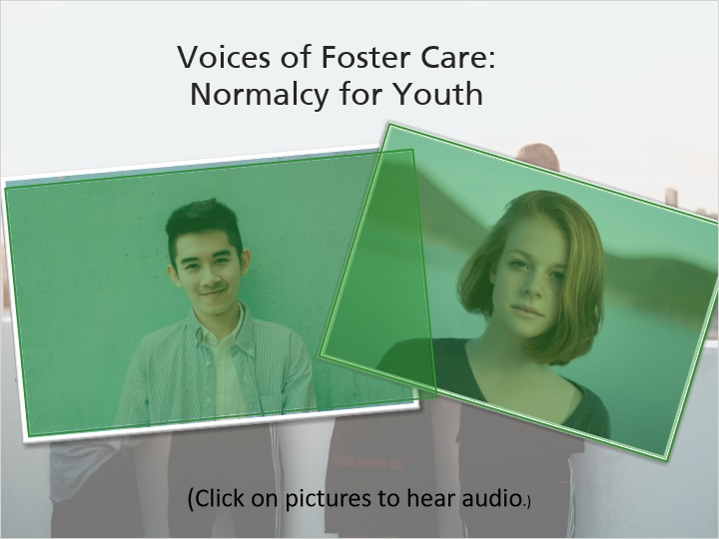
Notes:
When asked about their experiences in out-of-home care, the following responses about normalcy were submitted by young adults from the Youth Advisory Council.

“When I was in foster care I felt like nothing in my life was ‘normal.’ I think promoting normalcy for youth in care might help a little bit with that feeling - if at least some aspects of your life look like the lives of your friends and peers, maybe you feel a little less out of place and a little less different than everybody else.”

“Being able to do things at the same time as friends and peers such as get a learner’s permit or driver’s license, attend school dances or activities, go to sleepovers, etc. Sometimes it’s not a matter of not being able to do the activity, it’s about how long it takes to get permission and figure out who is going to pay for it or run the background checks. If those things could be negotiated and figured out ahead of time, it might draw less attention to kids in care by allowing them to participate in those experiences at the same time as their peers rather than having to wait for all the “red tape” to clear.

4.3 Voices of Foster Care: Two Different Experiences
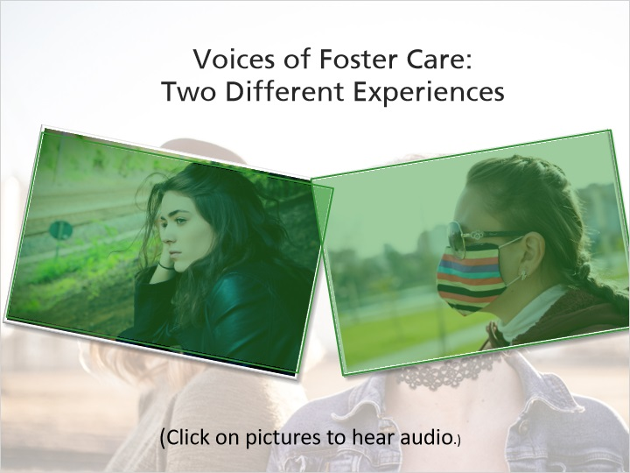
Notes:
Listen to two former foster youth share their contrasting experiences of normalcy.

“My foster parents were really great at letting me participate in sports and activities at school. It made a huge difference for me as far as making me feel like a regular teenager and allowing me to have those normal experiences with my peers.”

“I have lots of examples of times I was prevented from participating in activities due to being in out of home care, unfortunately. I didn't have the chance to go to football games, school dances, or participate in extracurricular activities because my foster parents felt that providing me rides to anything outside of school (I took the bus) was above and beyond what they were expected to do…”

In reality, this second experience is not above and beyond what out-of-home caregivers are expected to do. In fact, as part of the law, it is required that out-of-home care providers use the Reasonable and Prudent Parenting Standard to promote normalcy.

4.4 The Reasonable and Prudent Parent Standard Defined
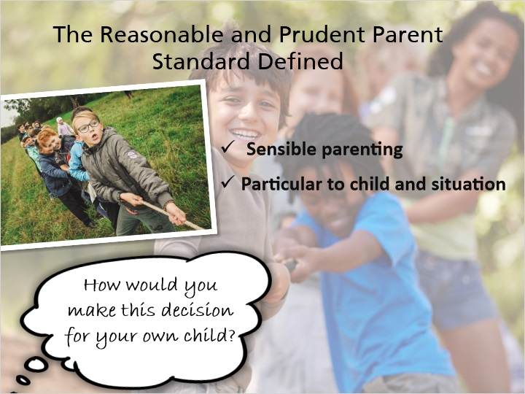
Notes:
Simply put, reasonable and prudent parenting is sensible parenting. It allows foster parents to make decisions on a day-to-day basis that will not delay a child from having normal experiences. Every decision is particular to the child and the situation.

Another way to frame prudent parenting is to ask, “How would you make this decision for your own child?”

4.5 Purpose of the Standard
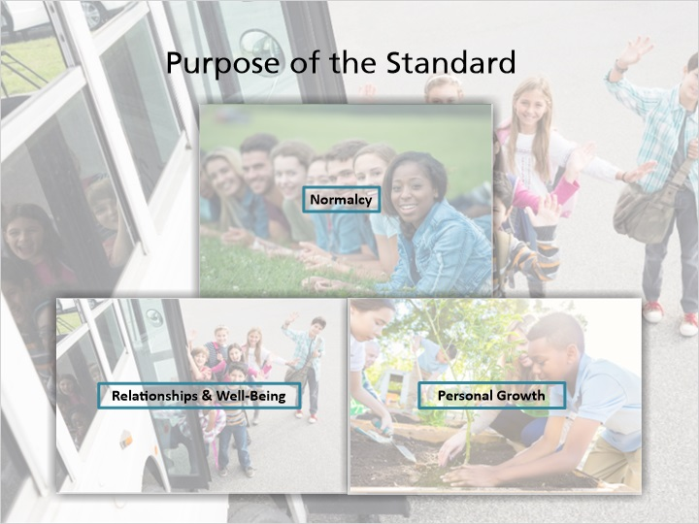
Notes:
Over the next few modules, we'll begin to explore the purpose of the Reasonalbe and Prudent Parent Standard, which includes creating and promoting normalcy, building relationships and improving well-being and personal growth.

4.6 Create and Promote Normalcy
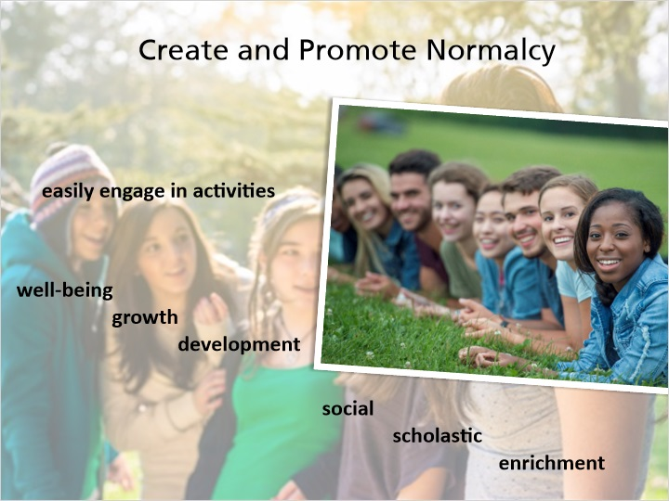
Notes:
Normalcy is the ability to easily engage in healthy and developmentally appropriate activities that promote well-being and personal growth and development, such as social, scholastic, and enrichment activities. The standard promotes normalcy for children in out-of-home care by allowing them to pursue their interests, engage in the same activities as their peers, build skills for their future, and promote a trusting, caring relationship with their foster parents. This takes place while still keeping the health, safety, and best interest of the child as the priority.

Normalcy needs to be promoted for all children in out-of-home care, no matter their permanence status. Their childhood should not be stunted because they are placed in out-of-home care.

4.7 Improve Well-Being & Build Relationships
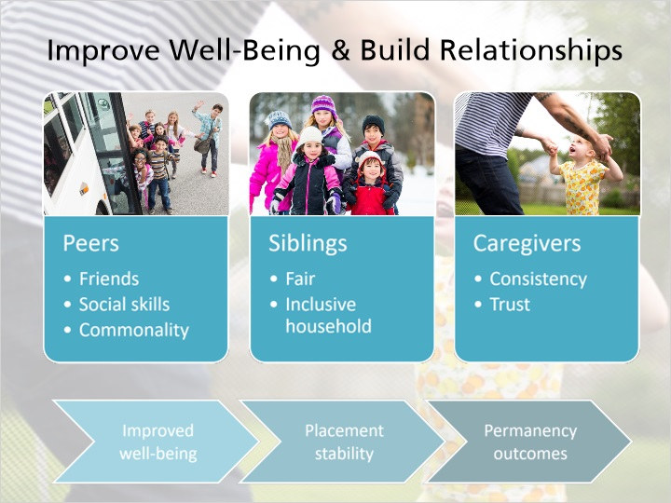
Notes:
Another goal of reasonable and prudent parenting is to improve the overall well-being of children by creating opportunities to build and normalize relationships. Improved well-being may contribute to greater placement stability and better permanency outcomes.

Ultimately, the standard will improve a child’s social and emotional development by building their peer relationships. Many children in out-of-home care have experienced some form of trauma and need additional support with emotional development, well-being, and understanding social cues. Some children may need more support and guidance from foster parents to engage in activities similar to their peers. When children experience normalcy, they can participate in common activities that give them opportunities to make and maintain friends, and develop relationship problem-solving skills.

Relationships between foster children and other children in the home benefit from prudent parenting. These decisions promote a fair & inclusive household by creating shared experiences among all children.

Lastly, the standard promotes more consistency and trust between the foster parent and the child. All children test boundaries and break rules. As a foster parent, you should provide supportive and consistent guidance to help children think through life circumstances. This teaches them natural consequences and how to make positive choices. And, all the while, builds a trusting parent-child relationship.

4.8 Personal Growth

Notes:
Out-of-home care placements need to be a safe place for children to grow and make mistakes.

Through reasonable and prudent parenting, foster parents make decisions that are child-specific and encompass a child’s development and personal growth. Youth develop life skills, such as obtaining employment, and social skills, through increased opportunities of peer interaction. They can pursue interests by exploring different activities.

All children should be allowed to try new things, make decisions, and fail at times, while still under the guidance of caring adults. All children make mistakes and these should be seen as opportunities for growth.

4.9 How to Make RPPS Decisions
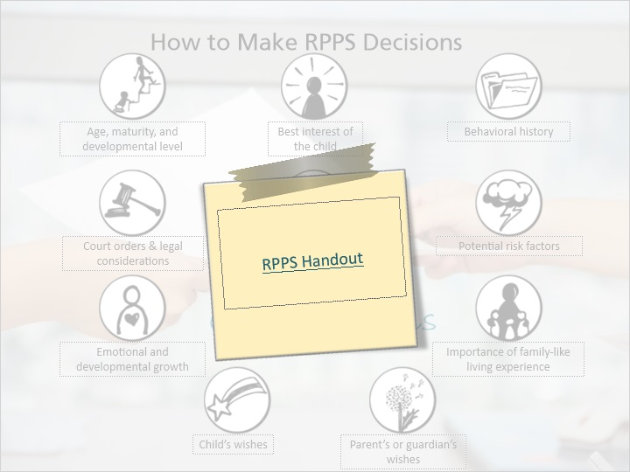
Notes:
When determining if a decision is reasonable and prudent, you must consider the following:

The child’s age, maturity, and developmental level
The best interest of the child
The child’s behavioral history
Court Orders & Legal Considerations
Cultural, Religious, & Tribal Values of the child and the child’s family
Potential risk factors
The child’s emotional and developmental growth
The importance of family-like living experience
The child’s wishes, and
The child’s Parent’s or Guardian’s Wishes

You also need to make sure the child has taken any necessary training for participation in an activity, and any necessary safety equipment is provided to the child.

These considerations should be made for each specific child, situation, and activity. You should recognize that these considerations are flexible and can change from day to day.

In addition to the list of considerations, you should use as much information as you can to make prudent parenting decisions.

We will take a closer look at each of the considerations along with examples of common situations over the next few modules of this training.

4.10 RPPS Success Is Everyone’s Responsibility!
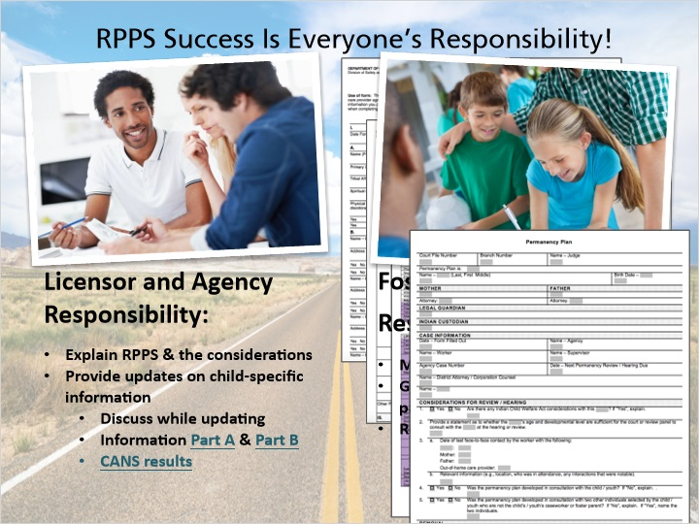
Notes:
When a child is placed in your home, the child’s child welfare professional must provide you with specific information about the child to consider when making normalcy decisions for the child. The child’s child welfare professional will also share updates thereafter that may impact reasonable and prudent parenting decisions.

You will receive this information through the Information for Out-of-Home Care Providers Part A and B forms, through the Child and Adolescent Needs and Strengths (CANS) tool, and through updates throughout the life of the child’s case, including updated permanency plans. As you learn more about the child and the best ways to promote normalcy in their life, you should communicate this to the child’s child welfare professional.

If you do not have enough information about the child in order to make a reasonable and prudent parenting decision, you should contact the child’s child welfare professional and/or your licensor for more information about the child. Remember, the child’s child welfare professional and/or licensor can help you understand how to apply the Reasonable and Prudent Parent Standard, but they cannot make the decisions for you.

Remember to keep a record of big decisions you make for a child placed in your home, especially if it impacts key information. For example, you should note if a child joins a sports team or starts a part-time job.

4.11 Child’s Wishes
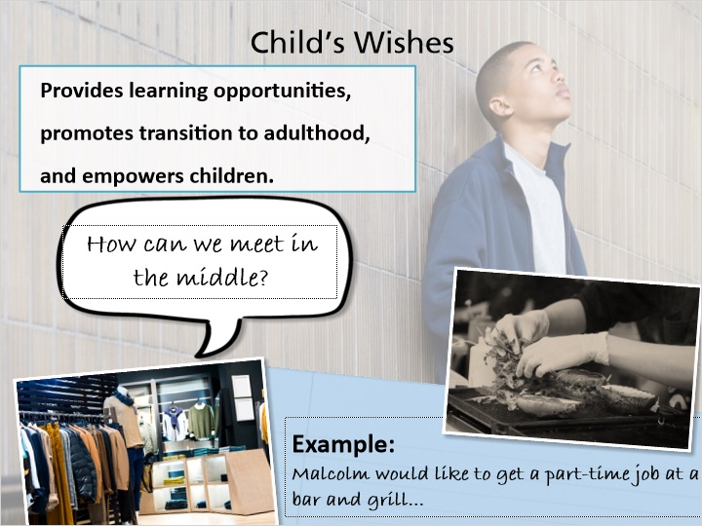
Notes:
Alongside the multiple considerations that you must take into account when making decisions, a child’s wishes are also a factor. A child has their own ideas about what makes them feel normal and similar to their peers. This involvement provides learning opportunities, promotes a successful transition to adulthood, and empowers children to be part of their own planning.

This does not mean that every time a child asks to do something you are required to say yes. You have to make decisions based on the individual child and the current situation. The intent is to encourage normalcy. The “no” should not be because the child is in out-of-home care. The “no” should be based on a reasonable and prudent parenting decision.

You and the child may have different ideas about what is normal and what is reasonable. You should get creative and ask, “How can we meet in the middle?”

For instance, Malcolm would like to get a part-time job at a bar and grill to earn extra money. This promotes life skills and is age and developmentally appropriate for him. However, the foster parent says ‘no’ due to concerns about the hours and the environment of the workplace.

You need to talk through the concerns and the decision to not allow this type of employment. You may not feel comfortable with Malcom working past 9 pm or perhaps he has a history of alcohol use. Then, you and the child need to decide on a creative alternative. Perhaps a job at a local department store is a better option.

We want to give older children the opportunity to develop skills to successfully transition to adulthood. The use of the Reasonable and Prudent Parent Standard may be different for a child in out-of-home care who is over the age of 18. Their age will impact whether or not you allow them to participate in an activity. Even though the child is legally an adult, there are still “house rules” the child will need to a follow, such as curfew.

4.12 Parent/Guardian Wishes & Input
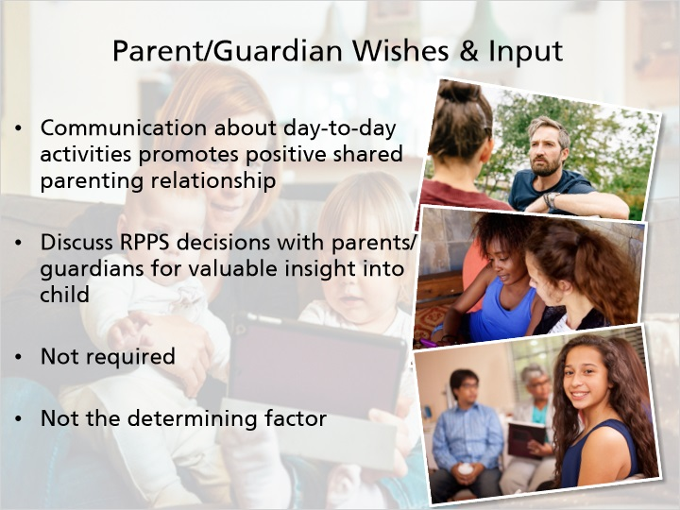
Notes:
As we touched on earlier, parent and guardian input should be taken into account when you make decisions about whether a child can or should participate in an activity.

Communication between you and a child’s parent or guardian about day-to-day activities is essential to a positive shared parenting relationship. Whenever feasible, you should discuss reasonable and prudent parenting decisions with parents or guardians, as they have valuable insight regarding their child.

However, parent or guardian wishes are not required for each decision and should not be the determining factor. You may apply the Reasonable and Prudent Parent Standard without parental consultation on each decision.

4.13 Court-ordered / Legal Considerations
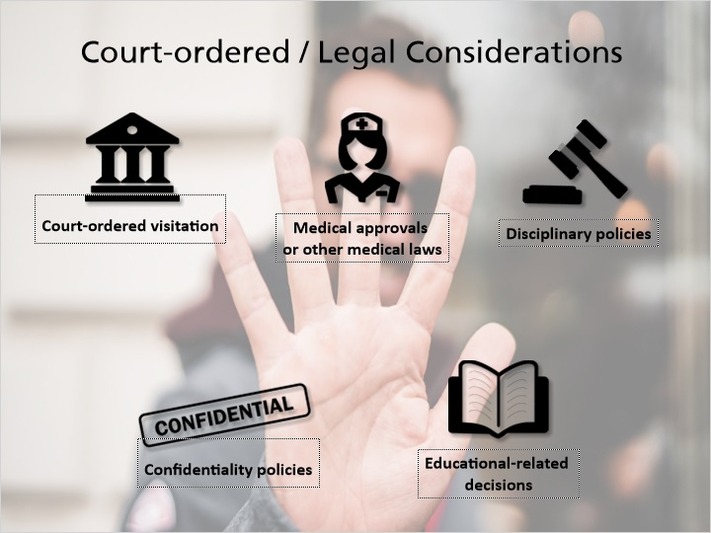
Notes:
Reasonable and Prudent Parent Standard decisions cannot conflict with any court order, other laws, or other services that are part of the child’s treatment plan. If you are uncertain if a decision conflicts with any of the following, you should contact the child’s child welfare professional or your licensor for more information.
Remember, that the Reasonable and Prudent Parent Standard only covers extracurricular, enrichment, cultural, and social activities, not just any decisions made for the child.
Considerations that prevent the use of the Reasonable and Prudent Parent Standard are:
Any court‐ordered visitation,
Medical approvals and other medical laws,
Disciplinary policies,
Confidentiality policies, and Educational‐related decisions.
Any type of medical consents, medication changes, doctor’s examinations, and therapy instruction still require parent or guardian consent. You may not use reasonable and prudent parenting authority to make any type of medical decisions for the child in your care.
You also cannot consent to a child’s marriage or authorize a child’s enlistment in the US Armed Forces.
Another area that the Reasonable and Prudent Parent Standard does not apply to is Education. IEP decisions and other educational‐related topics that are dictated by statute cannot be made, as they still require parent or guardian consent. It is important to note that extra‐curricular activities or field trip permission slips are areas you can apply the Reasonable and Prudent Parent Standard to promote normalcy.”

4.14 Creative Planning Around Court Orders
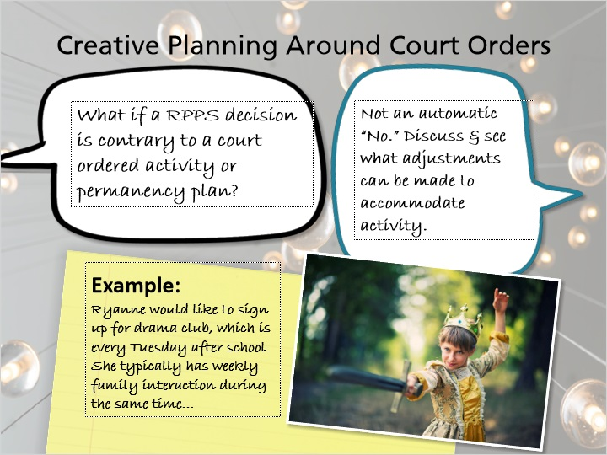
Notes:
If a prudent parenting decision is contrary to a court ordered activity, it might not be an automatic “no.” You should discuss the activity with the child’s child welfare professional to determine what, if any, adjustments can or should be made to accommodate the activity and promote normalcy.

For example, Ryanne would like to sign up for drama club, which is every Tuesday after school. She typically has weekly family interaction during the same time. Instead of saying “no” right away, you should work together with the agency to accommodate a different family interaction plan, or brainstorm other creative solutions to get Ryanne involved in an activity she enjoys.

Once again, reasonable and prudent parenting decisions cannot supersede any court order or other legal considerations, but you should engage in and advocate for creative planning that allows for normalcy activities.

4.15 Disagreements
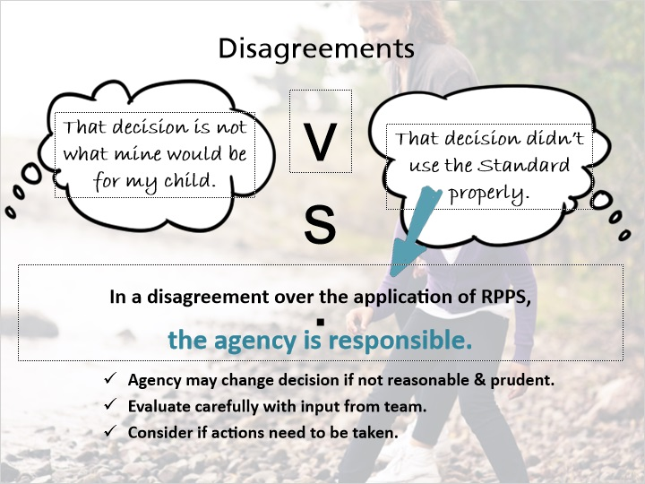
Notes:
You should be empowered to make decisions without relying on the agency. Only serious disputes should lead you to rely on agency intervention and mediation. Typically, the agency does not get involved with the actual decision.

For example, if the parent or guardian does not like a decision that you made because it is different than what their decision would be, this is not a disagreement with the application of the Standard.

On the other hand, if the parent or guardian feels that a decision was made without proper use of the Standard, such as a disregard for cultural considerations, this may be a disagreement in which the agency is involved.

In any disagreement over the application of the Reasonable and Prudent Parenting Standard, the agency is ultimately responsible for the decisions concerning the care of the child. Agencies may change the decision if it is not reasonable and prudent, but should evaluate the situation carefully and with input from the parent or guardian, foster parents, and other members of the team.

In situations where a decision was made and it is later determined not to be reasonable and prudent, the agency may need to consider whether actions need to be taken, such as additional training, or formal or informal licensing actions.

4.16 Liability
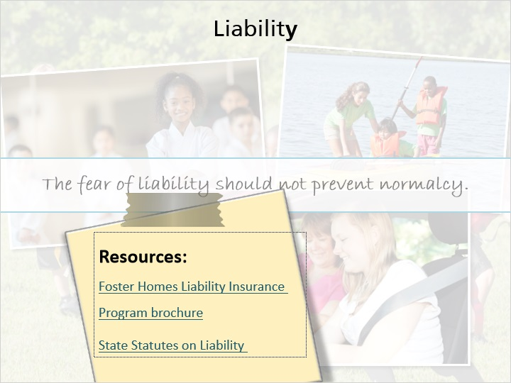
Notes:
Next, let’s address a common concern - liability.

The fear of liability should not prevent a child in out-of-home care from experiencing normalcy.

If you have acted in accordance with the Reasonable and Prudent Parent Standard, you will not be liable for harm to the child or others as a result of the approved activity.

The Foster Homes Liability Insurance Program references the Reasonable and Prudent Parent Standard. A claim may be filed if an incident in need of reimbursement occurs under a prudent parenting decision. The claim must meet the other requirements of the Foster Homes Liability Insurance Program, as well. Those requirements can be found on the Foster Homes Liability Insurance Program Brochure: https://dcf.wisconsin.gov/files/publications/pdf/2010.pdf

The State Statutes that address liability for out-of-home care providers can be found at this link: https://docs.legis.wisconsin.gov/statutes/statutes/895/II/485

4.17 RPPS Review
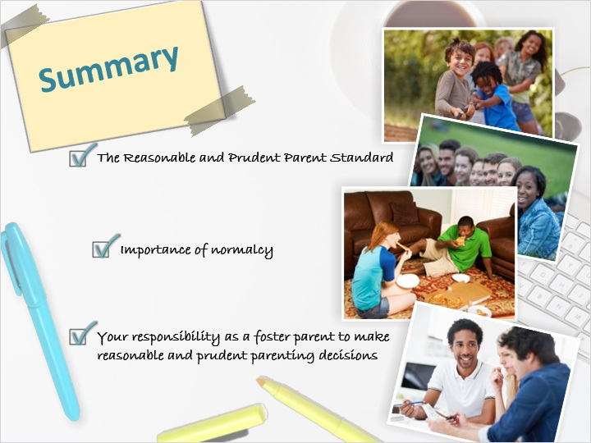
Notes:
In the prudent parenting slides, you have started to learn about:

· The Reasonable and Prudent Parent Standard, and
· The importance of normalcy,
· Your responsibility as a foster parent to make reasonable and prudent parenting decisions.

4.18 Check Understanding - RPPS
(Multiple Choice, 10 points, 2 attempts permitted)
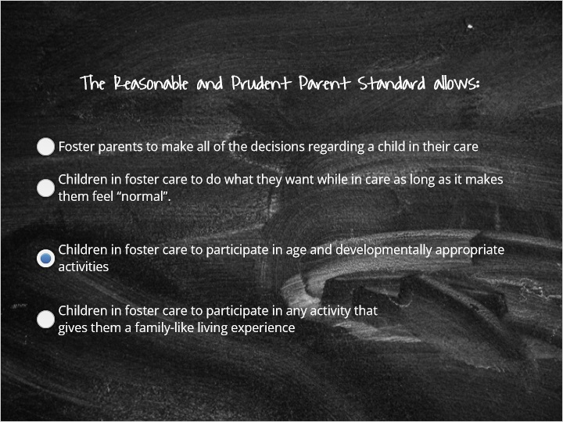
Correct | Choice | Feedback
 | Foster parents to make all of the decisions regarding a child in their care | False. Birth parents maintain the ability to make major decisions regarding the child and the child’s best interest and should be consulted by the foster parent when making a reasonable and prudent parent decision.
 | Children in foster care to do what they want while in care as long as it makes them feel “normal”. | False. Children/youth wishes should be considered when foster parents are making a decision but the foster parent maintains the ability to say "yes" or “no”
X | Children in foster care to participate in age and developmentally appropriate activities | True. The Reasonable and Prudent Parent Standard allows children in foster care to participate in activities, while maintaining the health, safety, best interest, and cultural, religious, and tribal values of the child.
 | Children in foster care to participate in any activity that gives them a family-like living experience | False. Children/youth can be allowed to participate in family-like experiences; however, there are several other factors to take into consideration when making a decision for a child/youth to participate in an activity.

4.19 When making a reasonable and prudent parenting decision when appropriate you should consult:
(Multiple Choice, 10 points, 2 attempts permitted)
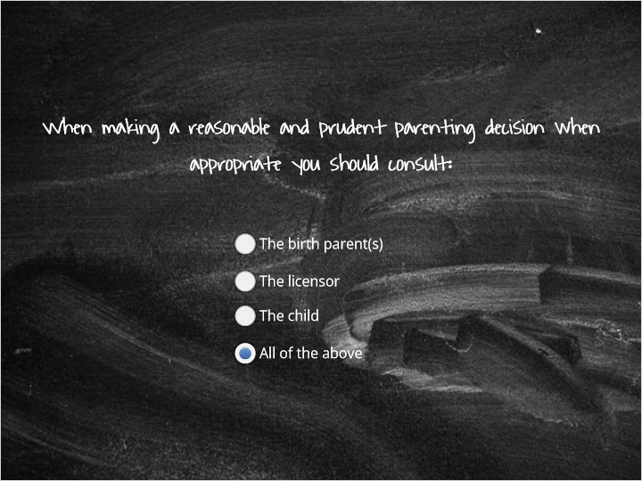
Correct | Choice | Feedback
 | The birth parent(s) | Incorrect. Make sure to consult with all of the above parties when making a reasonable and prudent parenting decision when appropriate and feasible. Remember, you do not need approval or permission, but it is best practice to consult and discuss the normalcy decisions that impact the child placed in your home when possible. Talk to your licensor to utilize time during team meetings to discuss any upcoming reasonable and prudent parenting decisions and the promotion of normalcy for the child placed in your care.
 | The licensor | Incorrect. Make sure to consult with all of the above parties when making a reasonable and prudent parenting decision when appropriate and feasible. Remember, you do not need approval or permission, but it is best practice to consult and discuss the normalcy decisions that impact the child placed in your home when possible. Talk to your licensor to utilize time during team meetings to discuss any upcoming reasonable and prudent parenting decisions and the promotion of normalcy for the child placed in your care.
 | The child | Incorrect. Make sure to consult with all of the above parties when making a reasonable and prudent parenting decision when appropriate and feasible. Remember, you do not need approval or permission, but it is best practice to consult and discuss the normalcy decisions that impact the child placed in your home when possible. Talk to your licensor to utilize time during team meetings to discuss any upcoming reasonable and prudent parenting decisions and the promotion of normalcy for the child placed in your care.
X | All of the above | Correct! Make sure to consult with all of the above parties when making a reasonable and prudent parenting decision when appropriate and feasible. Remember, you do not need approval or permission, but it is best practice to consult and discuss the normalcy decisions that impact the child placed in your home when possible. Talk to your licensor to utilize time during team meetings to discuss any upcoming reasonable and prudent parenting decisions and the promotion of normalcy for the child placed in your care.

5. Uniform Foster Care Rate

5.1 Uniform Foster Care Rate
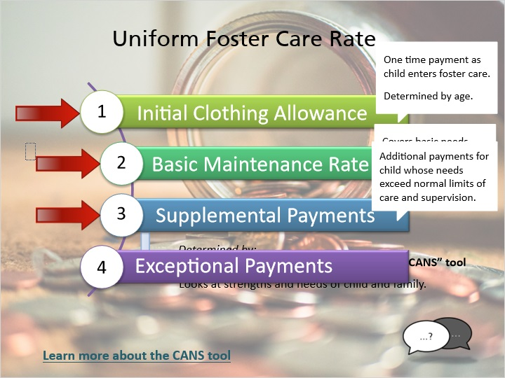
Notes:
The Uniform Foster Care Rate is designed to offset costs of caring for additional children in your home. The Uniform Foster Care Rate is broken down into four components: The Initial Clothing Allowance, the Basic Maintenance Rate, the Supplemental Payments, and Exceptional Payments. Only foster parents certified as a level 2 or higher are eligible for the supplemental or exceptional payments.

The Initial Clothing allowance is a one-time payment for a child as they enter foster care and is determined by the child’s age when placed with a foster parent certified at or above level 2. When a child is placed into your home, this payment may have already been made to previous foster parents.

The Basic Maintenance Rate is meant to cover the basic needs for the children in your care, including food, clothing, housing, and other personal care.

Supplemental Payments are additional payments meant to cover costs for a child whose needs exceed normal limits of care and supervision for what is developmentally and age appropriate for that child. The supplemental payment will be determined on a case-by-case basis by completing an assessment, called the Child Adolescent Needs and Strengths tool (usually just called “the CANS”) for each child. The CANS looks at the strengths of a child and their family, as well as at the needs for the child in lots of different areas of their lives, like school, development, behavior, and trauma.The CANS will be done by a child’s team on a regular basis. More information about the CANS tool can be found here: (link ref: http://praedfoundation.org/tools/the-child-and-adolescent-needs-and-strengths-cans). You can also talk with your licensor or the child’s child welfare professional about the CANS.

5.2 Uniform Foster Care Rate Cont.
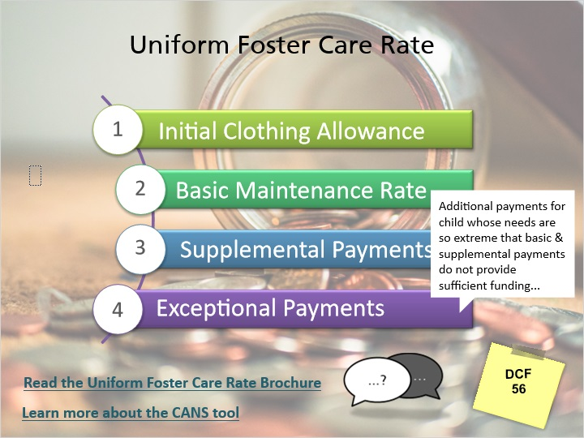
Notes:
Exceptional Payments are additional payments for a child whose needs are so extreme that basic maintenance and supplemental payments do not provide sufficient funding to ensure the child’s placement in a foster home and to prevent placement in a more restrictive setting. The eligibility for these payments is determined on a case-by-case basis, and the criteria can be found in DCF 56.

Foster care payments are made on a retrospective basis, which means that payments are made to foster parents after the end of the month that a child was in care.

Children in foster care may be eligible for fee waivers as well as free and reduced lunch at school. In addition, many children’s museums and other activities throughout the state are free or available at a reduced cost for children in foster care. Talk with your licensor about how to explore these options in a way that does not breach the child’s confidentiality.

Foster parents may also qualify for childcare assistance to support the cost of foster children in your home attending childcare, as long as the foster parent is in an activity that qualifies under the Wisconsin Shares Program, including employment or education courses. Wisconsin Shares will review the foster child's birth parent's income to determine eligibility for childcare assistance. If the child's birth parent's income is too high and does not meet the income eligibility requirements, then Wisconsin Shares will review the foster parent's income and eligibility will be determined based on your income. Foster parents should contact their foster care licensor or the child’s child welfare professional to find out specific information about how to enroll in the Wisconsin Shares program.

Read the Uniform Foster Care Rate Brochure:
https://dcf.wisconsin.gov/files/publications/pdf/0142.pdf

Learn more about the CANS tool:
http://praedfoundation.org/tools/the-child-and-adolescent-needs-and-strengths-cans/

5.3 A rate meant to cover the basic needs for the children in your care, including food, clothing, housing, and other personal care.
(Multiple Choice, 10 points, 2 attempts permitted)
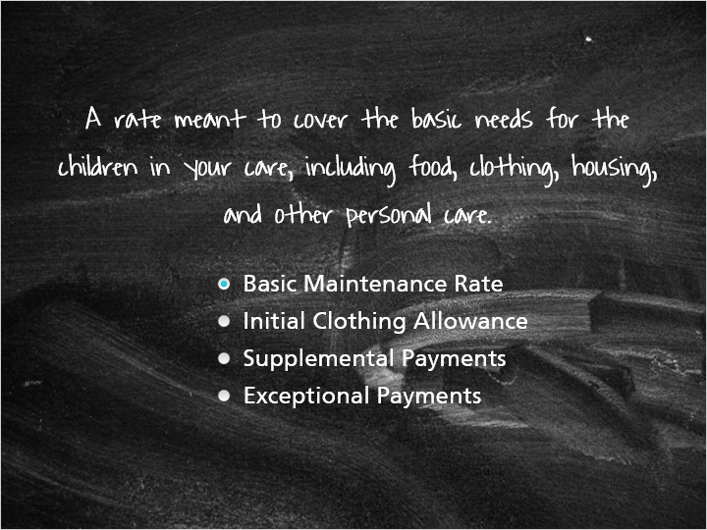
Correct | Choice
X | Basic Maintenance Rate
 | Initial Clothing Allowance
 | Supplemental Payments
 | Exceptional Payments

Feedback when correct:
That's right! This is the description of the Basic Maintenance Rate.
Feedback when incorrect:
You did not select the correct response.

5.4 A one-time payment for a child as they enter foster care that is determined by the child's age.
(Multiple Choice, 10 points, 2 attempts permitted)
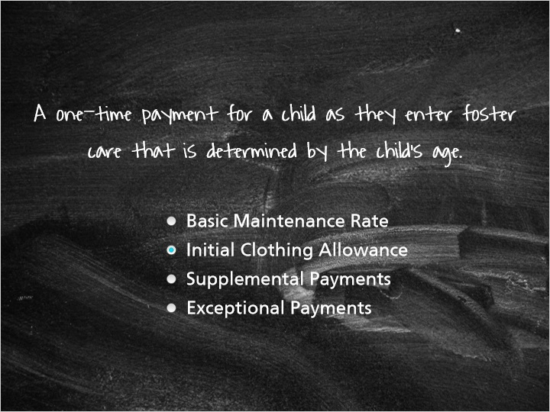
Correct | Choice
 | Basic Maintenance Rate
X | Initial Clothing Allowance
 | Supplemental Payments
 | Exceptional Payments

Feedback when correct:
You are correct. This is the Initial Clothing Allowance.
Feedback when incorrect:
You did not select the correct response. Please review the reimbursement information.

5.5 Additional payments meant to cover costs for a child whose needs exceed normal limits of care and supervision for that child's age.
(Multiple Choice, 10 points, 2 attempts permitted)
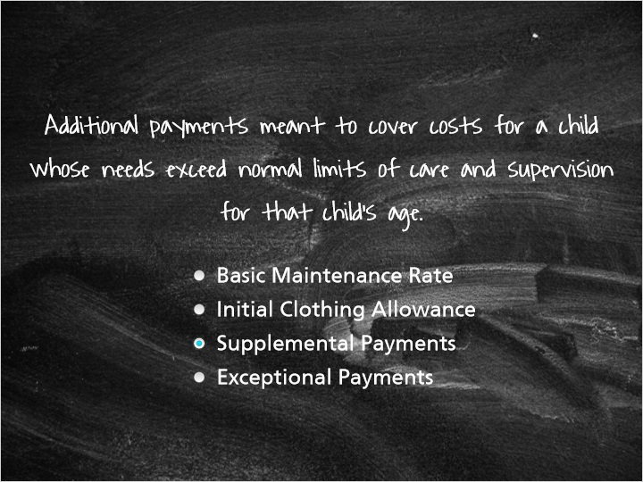
Correct | Choice
 | Basic Maintenance Rate
 | Initial Clothing Allowance
X | Supplemental Payments
 | Exceptional Payments

Feedback when correct:
Exactly. This is the description of supplemental payments.
Feedback when incorrect:
You did not select the correct response. Please review the reimbursement information.

5.6 Additional payments for a child whose needs are so extreme that basic maintenance and supplemental payments do not provide sufficient funding to ensure the child's placement in a foster home and to prevent placement in a more restrictive setting.
(Multiple Choice, 10 points, 2 attempts permitted)
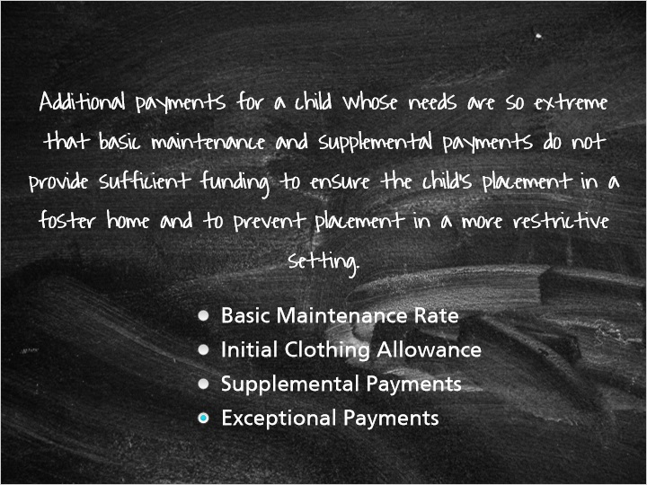
Correct | Choice
 | Basic Maintenance Rate
 | Initial Clothing Allowance
 | Supplemental Payments
X | Exceptional Payments

Feedback when correct:
Exceptional! This is the description of exceptional payments.
Feedback when incorrect:
You did not select the correct response. Please review the reimbursement information.

5.7 Real Life Tip: Financial Impacts
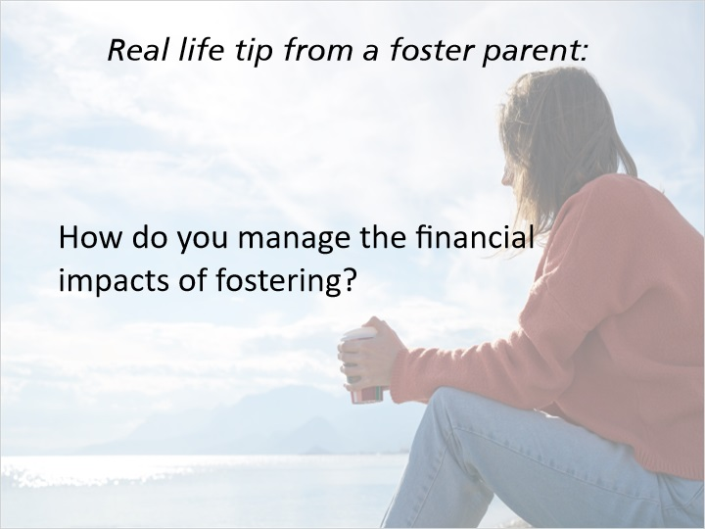
Notes:
Real life tip from a foster parent:

“The financial aspect of fostering, sometimes can be a little challenging but we've learned to do things a little bit differently, I like to go garage saleing and we buy things that way and kind of keep tubs of different things that are there so if we get a child of different size we have clothing for them. We do things as a family, we do a lot of outings, you know we have a campfire in the back yard and we go to the parks together so there are inexpensive ways to enjoy each other.”

6. Maltreatment

6.1 Concerns about Child Maltreatment
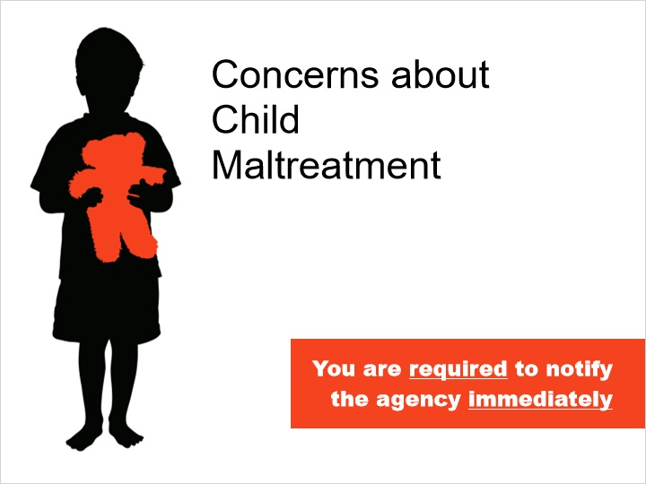
Notes:
You may notice suspicious marks, injuries, or bruises on the children in your care, or they may indicate to you that they have been harmed in some way. As a foster parent, you are required to notify the agency immediately if you believe that a child in foster care has been abused or neglected, has been threatened with abuse or neglect, or you have reason to believe that the child will be abused or neglected. This applies to any child in foster care, not just those in your home.

The children in your care may disclose past or current abuse. The next slide will give you some ideas on how to have these difficult conversations.

6.2 What to Do When a Child
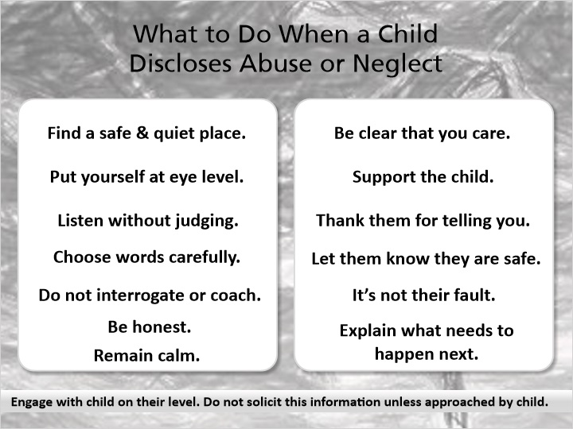
Notes:
If a child has been abused or neglected or is currently being maltreated, it will take a great deal of courage for them to tell you. It will also probably be a difficult conversation for you to have. You must be able and willing to engage with the child on their level. Please listen to these ideas to help this conversation be more comfortable for you and the child. Do not solicit this information from a child unless they approach you about it.

Find a safe and quiet place to talk and put yourself at eye level with the child (but also understand that they may not be able to make eye contact with you during this conversation).
Listen without judging and choose your words carefully.
Do not interrogate or coach the child!
You are not investigating the situation, so just listen.
The child will probably feel some shame or embarrassment, and will need to feel safe and be able to tell you their story in their own words.
Be honest about the responsibility that you have to share this information with someone who can help.
Do not tell the child that you won’t tell anyone.
You are required to share this information.
You will probably have strong reactions to their story.
Try to remain calm and not show the child your reactions, especially disgust, fear, or anger, as the child may interpret this to mean that you are disgusted or angry with them.
Be clear with the child that you care for them.
Support the child in telling you their story, thank them for telling you, and let them know that they are safe.
Let the child know that this was not their fault.
Children will often blame themselves.
Outline what steps you’ll need to take to share this information, and explain that you’ll be sharing with someone who can help.

7. Allegations

7.1 Allegations Intro
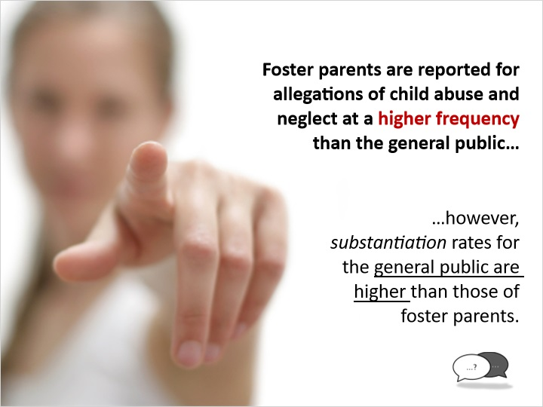
Notes:
Did you know? Foster parents are reported for allegations of child abuse and neglect at a higher frequency than the general public, however, the substantiation rates for the general public are higher than those for foster parents.

Licensing agencies and tribes have a responsibility to ensure that foster parents are providing a safe environment, and they must assess any allegations of abuse and neglect of the children in foster care.

You are encouraged to talk with your licensor to learn what the agency will do if an allegation is made against someone in your home. The agency assessing the allegation should give you information about appeal rights if you are substantiated for abuse or neglect.

There is no guaranteed method for avoiding allegations, but there are ways to minimize your risk. The next slide will explain some of these preventative strategies.

7.2 Minimizing the Risk of an Allegation
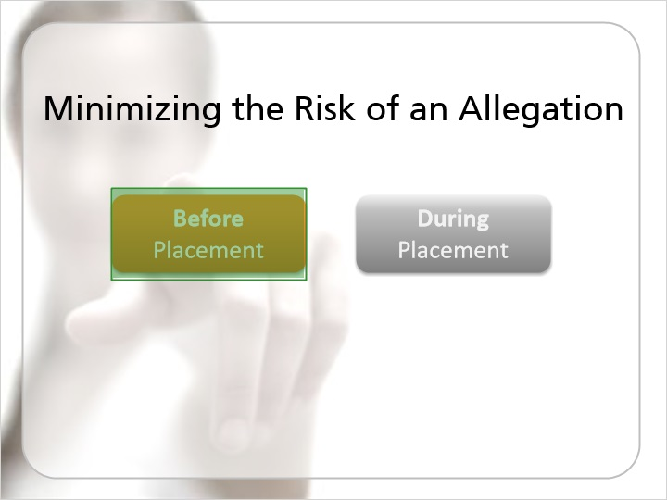
Notes:
Suggestions for Minimizing the Risk of an Allegation

To minimize the risk of an allegation, there are things that you can do prior to accepting a child for placement and once the child is placed in your home.

Click the first button to learn about strategies to use before placement.

7.3 Minimizing the Risk of an Allegation Before Placement
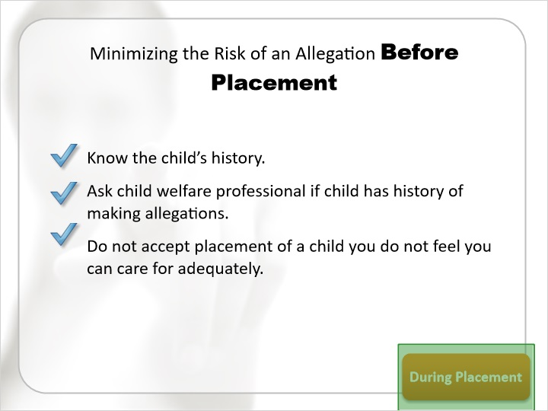
Notes:
Suggestions for Minimizing Allegation Risk Before Placement

Before placement you can:

Find out as much as you can about the child’s history of abuse or neglect (both at home and in previous placements).
Ask the child welfare professional if the child has a history of making allegations against caregivers.
Do not accept placement of a child that you do not feel you can care for adequately.

7.4 Minimizing the Risk of an Allegation During Placement
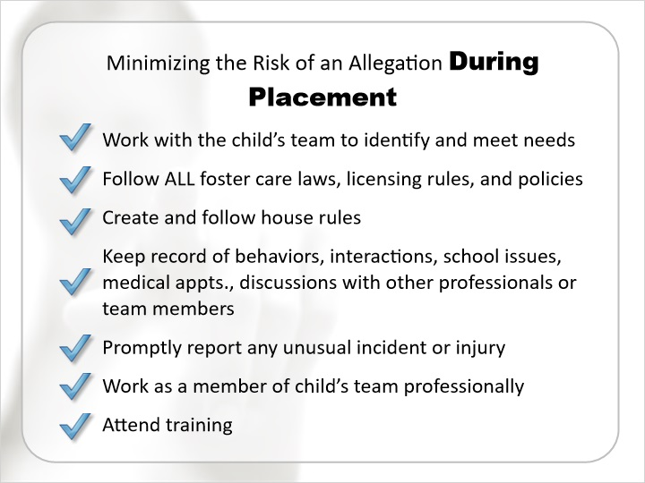
Notes:
During a child’s placement you can:

Work with the child’s team to ensure that the child’s needs are identified and sufficiently met.
Follow all foster care laws, licensing rules, and policies.
Create house rules and ensure that all household members follow them.
Keep a record of the child’s behaviors, interactions, school issues, medical appointments, discussions with other professionals or team members, especially behaviors, comments, or interactions that seem unusual or out of the ordinary for that child.
As stated earlier, promptly report any unusual incident or injury.
Work as a member of the child’s team in a professional manner, and
Attend training to learn about caring for children who have been abused or neglected.

7.5 Coping with Maltreatment Allegations
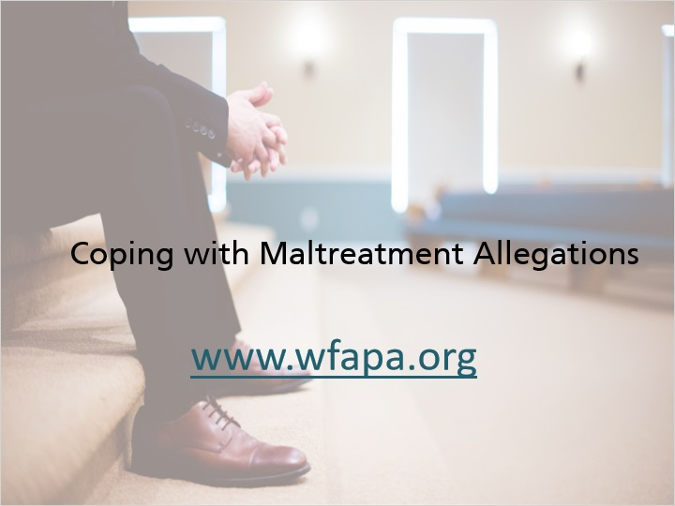
Notes:
Undergoing an allegation of abuse and neglect is an emotional and challenging process. When allegations are made, the case is turned over to another county to determine if an initial assessment is necessary. If an initial assessment is warranted, the other county will conduct an independent investigation. If you are the subject of an initial assessment, having support from other foster parents who have experienced allegations will be incredibly beneficial.

The Wisconsin Foster and Adoptive Parents Association, Inc. (called “WFAPA”), is a statewide support association for foster and adoptive parents. WFAPA has a program called Foster and Adoptive Support and Preservation Program (called “FASPP”), which is a collection of phone numbers for foster and adoptive parents to call when they are experiencing allegations of abuse and neglect. Please visit WFAPA’s website (www.wfapa.org) for more information on accessing the support of other foster parents.

7.6 Coping with Maltreatment Allegations
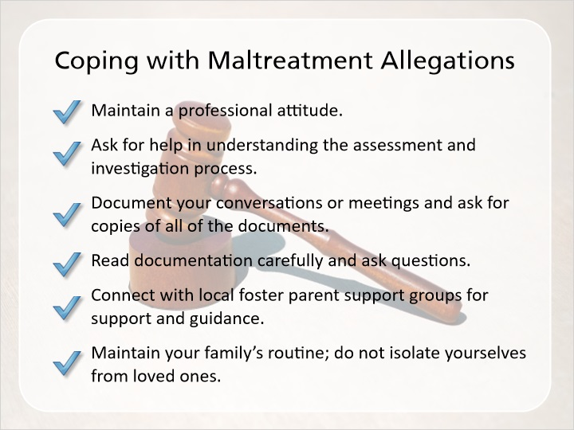
Notes:
Consider the following suggestions for getting through the initial assessment process. There are additional tips in your Foster Parent Handbook:

Maintain a professional attitude.
Ask for help in understanding the assessment and investigation process.
Document your conversations or meetings and ask for copies of all of the documents.
Read through the documentation that is provided to you carefully and ask questions about anything that is confusing or inaccurate.
Connect with local foster parent support groups for support and guidance.
Maintain your family’s routine; do not isolate yourselves from loved ones.

7.7 Check Your Understanding - Allegations
(Multiple Choice, 10 points, 2 attempts permitted)
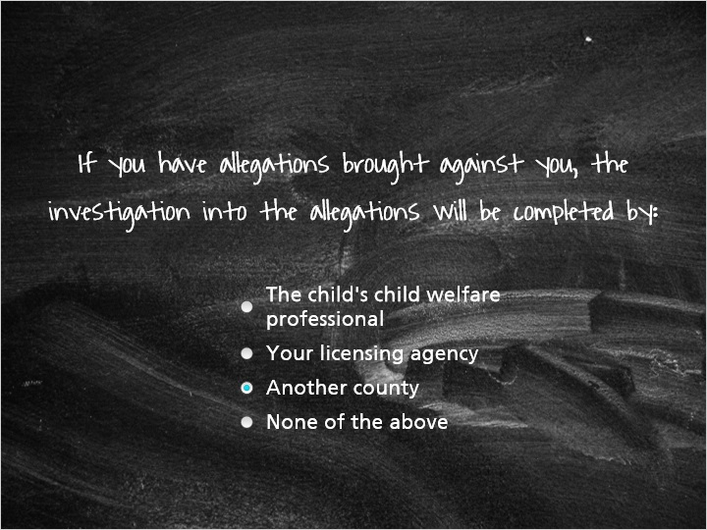
Correct | Choice | Feedback
 | The child's child welfare professional | No, the child's child welfare professional will not be involved in an investigation into allegations. Another county will conduct the investigation into allegations made against your home.
 | Your licensing agency | No, your licensing agency cannot investigate allegations into foster homes that they license. Another county will conduct the investigation into allegations made against your home.
X | Another county | You're right! Another county will conduct the investigation into allegations against your home as your licensing agency cannot investigate allegations against homes that it licenses.
 | None of the above | Nope, the correct answer is another county will conduct the investigation into allegations made against your home.

Notes:

8. Additional Information

8.1 Other Concerns That May Be Raised
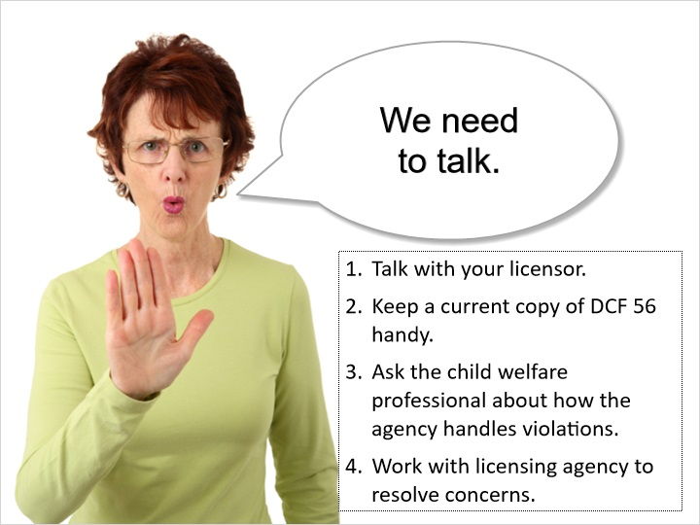
Notes:
During your time as a foster parent, there may be occasions when individuals either within or separate from your licensing agency have concerns about situations, behaviors, or decisions made in your home. These concerns will need to be addressed even if they do not rise to the level of allegations of abuse or neglect or licensing violations. When general concerns exist, child welfare professionals will usually contact you to discuss the concern and will assist you in addressing and resolving the concern. The process of resolving these issues is an opportunity for you and the child welfare professional to build trust and respect, and will result in better, more positive outcomes for the children in your care.

Licensing concerns or violations may be communicated to licensing agencies through complaints or concerns raised about the foster home. These concerns may relate to the physical environment of the home, general care of the children, disciplinary procedures, or other concerns that would violate licensing code. Your licensor will generally handle alleged licensing violations by coming to your home to address the violation.

The most effective way to avoid licensing violations is to review foster care licensing code, DCF 56, and to talk with your licensor if you feel you cannot meet the code.

To understand licensing requirements:

Keep a current copy of DCF 56 handy so that you can read through it and be familiar with its expectations.
Ask your licensor for documentation about how your agency handles licensing violations.
If violations arise, work with your licensing agency to resolve the concerns and immediately comply with the plan to resolve any issues.

8.2 If Violations are Found
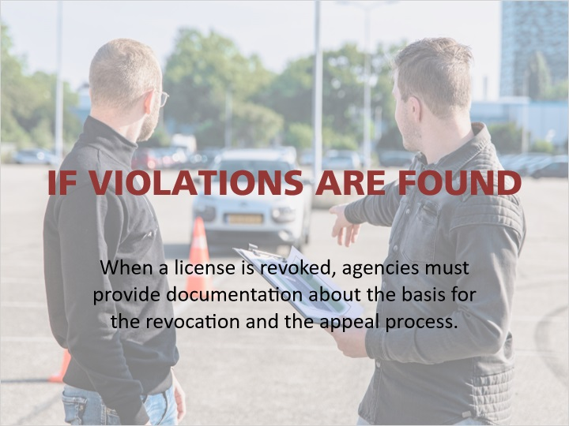
Notes:
If licensing violations are found, there are several possible consequences:

Your agency may decide that you can maintain your license as long as you correct the licensing violation.
The licensor will provide instructions (either verbally or in writing) on how to correct the violation, sometimes this is an agreement called a “corrective action plan.”

Agencies can decide to revoke a license if the violation is severe enough, if there are a number of violations, or if there is an inability or unwillingness to correct the violation. When a license is revoked, agencies must provide documentation about the basis for the revocation and the appeal process in writing. The next slide will explain the process of grievances and appeals.

8.3 Grievances and Appeals
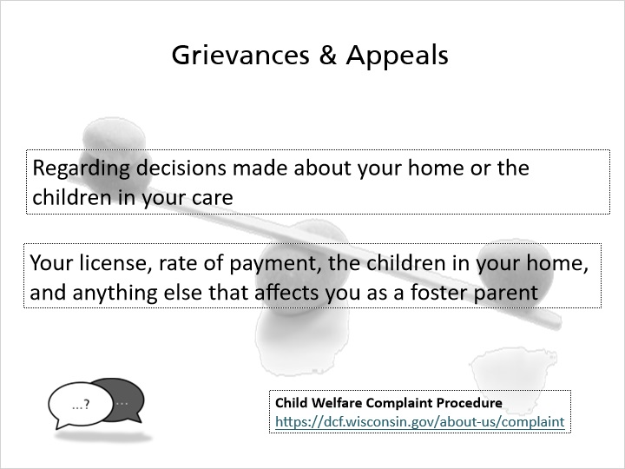
Notes:
As a foster parent, you have the ability to file grievances and appeals regarding decisions made about your home or the children in your care.

Your licensing agency and the child’s child welfare professional’s agency will have a policy about how individuals can communicate concerns, complaints, or file grievances. Ask your licensor or the child welfare professional for a copy of their agency’s child welfare complaint procedure.

When communicating a concern or filing a grievance, be specific about your concerns so that the agency has accurate, detailed information, and consider what outcome or resolution you are hoping for.

Every public agency has a Child Welfare Complaint Procedure, and has a staff member identified for individuals to contact. This information can be found at this link: https://dcf.wisconsin.gov/about-us/complaint.

You also have the power to appeal decisions made about your license, your rate of reimbursement, the children in your home, and anything else that affects you as a foster parent. When an agency notifies you of a decision made about your home or the children in your care, they should also supply you with the information about your ability to appeal the decision. This will include time limits and who you can appeal the decision to. Pay close attention to these time limits and who to appeal to. Some appeals are handled by the Division of Hearings and Appeals in Madison, and others are handled by the Circuit Court with jurisdiction over the child.

This information about appeals is for decisions about your license and the children in your care, not about substantiations of child abuse and neglect. If you have allegations substantiated for child abuse or neglect, you will receive specific instructions on how to appeal those decisions.

You can find additional information about what decisions you can appeal and the procedures to request an appeal in DCF 56.10.

8.4 Requests for Removal
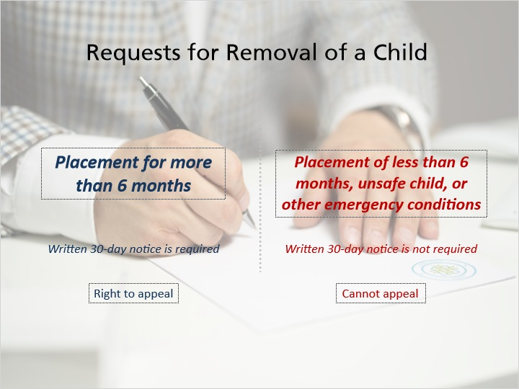
Notes:
In certain situations, foster parents, agencies, or tribes may decide that a child needs to be moved from a foster home, which is called a change of placement.

Foster parents are required to give agencies 30 days notice when requesting that a child be removed from their home. In particularly challenging situations, you may request that the child be moved sooner than 30 days, but your agency may not be able to locate an appropriate placement option in a shorter time period, unless an emergency situation exists.

If the agency decides to remove a child in your home, they are required to provide you with a written 30-day notice if that child has been in your home for more than six months. If the child has been in your home for less than six months, if the agency determines that the child is not safe, or if other emergency conditions exist, the agency is not required to give you a written 30-day notice.

You can appeal an agency’s decision to remove a child from your home if that child has been in your home for more than six months. When the agency notifies you that they intend to remove the child, they should provide you with information about how to appeal the decision. You only have the right to appeal when the agency decides to remove a child from your home; you cannot appeal a court’s decision to remove a child without a 30-day notice.

8.5 Foster Parent Insurance Program
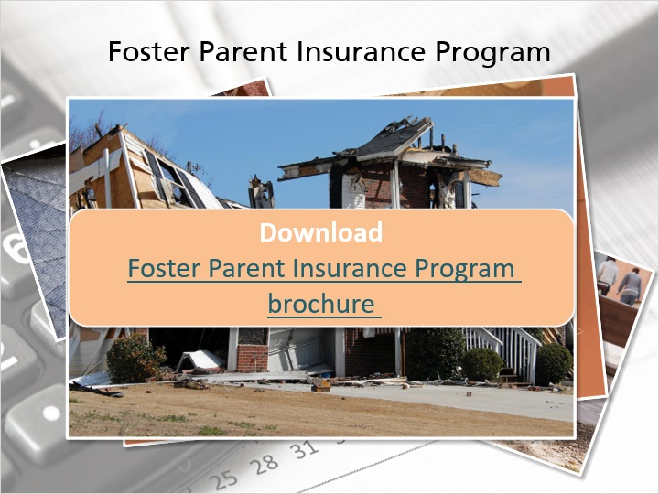
Notes:
Link to Foster Parent Insurance Program Brochure: https://dcf.wisconsin.gov/files/publications/pdf/2010.pdf

The Foster Parent Insurance Program is designed to assure that foster parents are reimbursed for damages or loss that are caused by children placed in their homes and are not covered by insurance policies. This program is also meant to cover injury or damage caused by foster parents to the foster child or for acts done by foster parents for which they are sued by the child’s parent, if not caused by negligence of the foster parent. This program is an “insurer of last resort,” which means that it can only be used once a private insurance company denies coverage for damage or loss. Claims to the Foster Parent Insurance Program must be submitted to the department within 90 days after the loss or damage occurs or is discovered. The forms required to complete a claim can be provided to you by your licensor.

Click on the link for the Foster Parent Insurance Program brochure to learn more about what must be included in a claim. https://dcf.wisconsin.gov/files/publications/pdf/2010.pdf

The department cannot pay claims if there is not sufficient documentation of the loss or damage. There are no appeals to a decision on a claim to the Foster Parent Insurance Program.

8.6 If you have concerns about decisions that are made about your home or the children in your care, there's nothing you can do?
(True/False, 10 points, 2 attempts permitted)
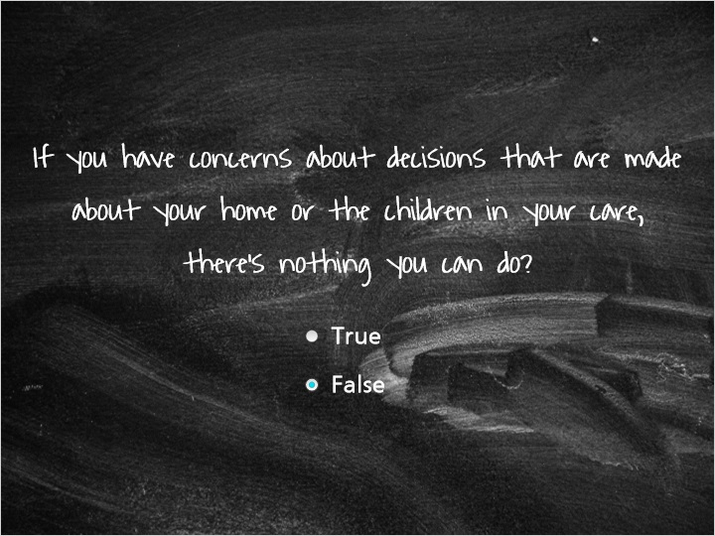
Correct | Choice
 | True
X | False

Feedback when correct:
You're right, this is not true! You have several options to respond to decisions made about your home or the children in your care. You can discuss concerns with those directly involved. If you are still unable to resolve the situation, you may file complaints or grievances with the agencies involved through the agency's complaint procedure. You can also appeal decisions about your license, your rates, decisions about the child in your home, and anything else that affects you as a foster parent.
Feedback when incorrect:
No! You have several options to respond to decisions made about your home or the children in your care. You can discuss concerns with those directly involved. If you are still unable to resolve the situation, you may file complaints or grievances with the agencies involved through the agency's complaint procedure. You can also appeal decisions about your license, your rates, decisions about the child in your home, and anything else that affects you as a foster parent.

8.7 If your licensing agency finds that you have violated foster care licensing code, they can:
(Multiple Choice, 10 points, 2 attempts permitted)
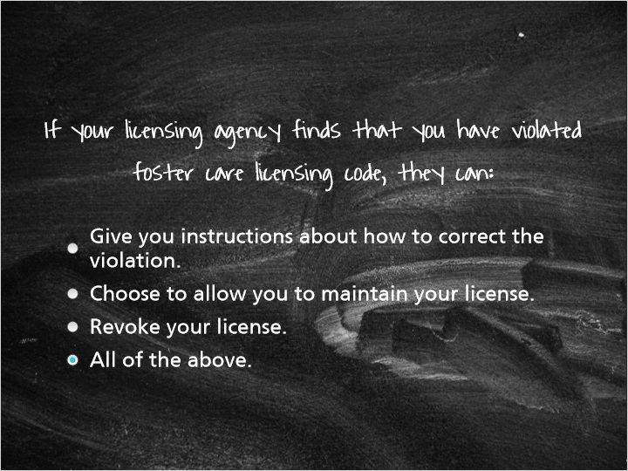
Correct | Choice | Feedback
 | Give you instructions about how to correct the violation. | Yes, your licensor or foster care coordinator can provide you with either verbal or written instructions about how to correct the violation. The other options are also correct.
 | Choose to allow you to maintain your license. | Yes, if you are able and willing to correct the violation, your licensing agency can choose to allow you to maintain your license. The other options are also correct.
 | Revoke your license. | Yes, your licensing agency can revoke your license if the violation was severe enough, if there were a number of violations, a frequency of violations, or if you are unwilling or unable to correct the violation. The other options are also correct.
X | All of the above. | Yes, all of the above are options for your licensing agency to take in the event of a licensing violation.

8.8 If you feel that you can no longer care for a child in your home, what can you do?
(Multiple Choice, 10 points, 2 attempts permitted)
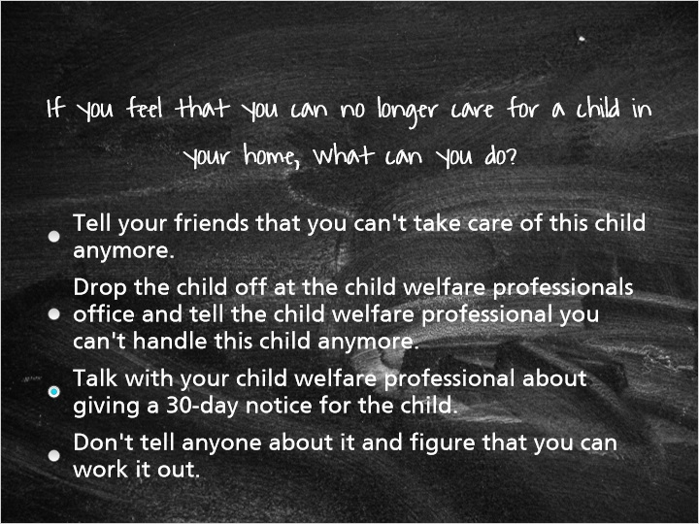
Correct | Choice | Feedback
 | Tell your friends that you can't take care of this child anymore. | No, as this would violate that child's confidentiality. If you need to process your feelings and concerns about caring for a child, you are encouraged to talk with that child's child welfare professional.
 | Drop the child off at the child welfare professionals office and tell the child welfare professional you can't handle this child anymore. | No!!! This answer was included because unfortunately, this has happened! Please talk with your child's child welfare professional about your concerns before you get to this point of frustration. Consider how the child would feel if this were to happen.
X | Talk with your child welfare professional about giving a 30-day notice for the child. | Exactly! If you feel that you can no longer adequately care for a child in your home, talk with the child's child welfare professional about giving your 30-day notice. The child welfare professional will then begin working on finding an appropriate place for the child within that 30-day timeframe.
 | Don't tell anyone about it and figure that you can work it out. | No… If you are feeling that you cannot adequately care for a child in your care, talk with the child's child welfare professional about it. This does not make you a bad foster parent; sometimes foster parents and foster children just don't make a good match. If you feel that your home is not the most appropriate placement for this child, talk with your child welfare professional in order to allow the worker to find a more suitable place for that child.

9. Thinking Back

9.1 Thinking Back on the Module…

Notes:
You now have an overview of the expectations placed on you as a foster parent and the rationale behind those expectations.

You have learned about the importance of communication and confidentiality, and how communicating openly and respecting confidentiality can improve your relationships with the children in your care, their families, and the other members of the child’s team.

You heard a lot about disclosing abuse and neglect and allegations of abuse and neglect. You now have the tools to talk with children about abuse and neglect as well as to deal with allegations that may be brought against you.

You also learned about options that you have to respond to decisions made about your home and the children in your care, and that you can and should advocate for yourself and the children in your care.

You’ve been given information about the foster care rates that you are reimbursed and the ability to be reimbursed for loss or damage in your home.

There are a lot of expectations placed on you as a foster parent because you have the responsibility to keep these children safe in your home. If you have additional questions or concerns about the material in this module, talk with your licensor!

9.2 Results Slide
(Results Slide, 0 points, 1 attempt permitted)


Results for
8.8 If you feel that you can no longer care for a child in your home, what can you do?

Result slide properties | Passing Score
100%

Notes:

