Module 1 Foster Care Overview

1. Introduction

1.1 Foster Care Overview
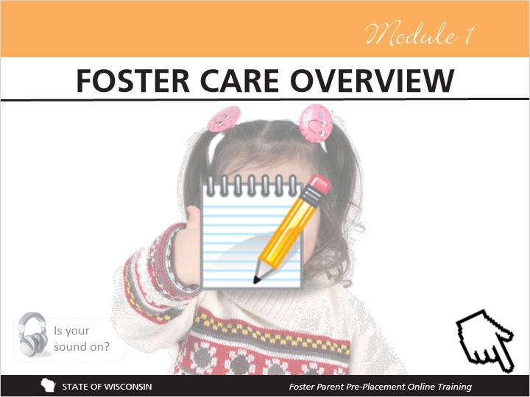
Notes:
Module 1 of this training explains basic information about the foster care program in Wisconsin. It has been designed to help you understand how children come into foster care, why they are there, and the rules that have been created to protect children in foster care. It also explains permanency planning and describes the different people connected to the child welfare and court systems who may work with a child, their family, and the foster family.

As a reminder, be sure to download the Notepad document from the Table of Contents to track your thoughts and questions and to complete activities throughout the training.

Please click the forward arrow in the lower right once you’re ready to continue.

2. Notes for the Module

2.1 Notes for the Module
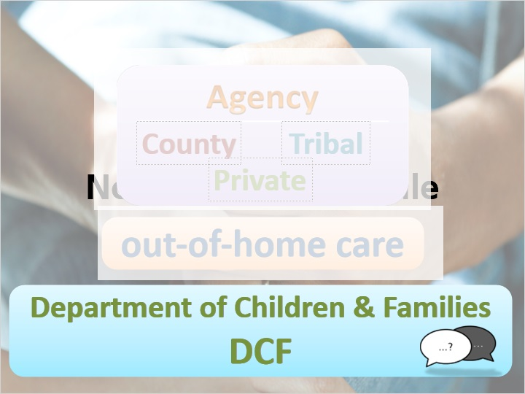
Notes:
It’s important to note that this module covers general information about foster care in Wisconsin. Since local agencies have some flexibility in operating their foster care programs, there may be differences from agency to agency or county to county. If you have any questions about policies or procedures for your agency, county, or tribe, you should ask your licensor. When you hear the term “agency” throughout this training, it means the county licensing agency, a private licensing agency, or a tribal licensing agency. Also, you might hear the term “out-of-home care,” which includes foster care as well as other types of placements. You’ll also hear about the Department of Children and Families (called DCF or “the department”), which is the state government department that oversees the foster care program in Wisconsin.

You will hear the term foster parent throughout the training as well. For the purpose of this training, this includes all out of home care providers, including relatives and like-kin caregivers. We will help define these roles and others for you later in this module.

There is a lot of information and some of it is complicated, so stick with it and remember that you don’t have to memorize this! You can always come back to this training for a refresher and to use it as a resource.

2.2 Voices of Foster Youth
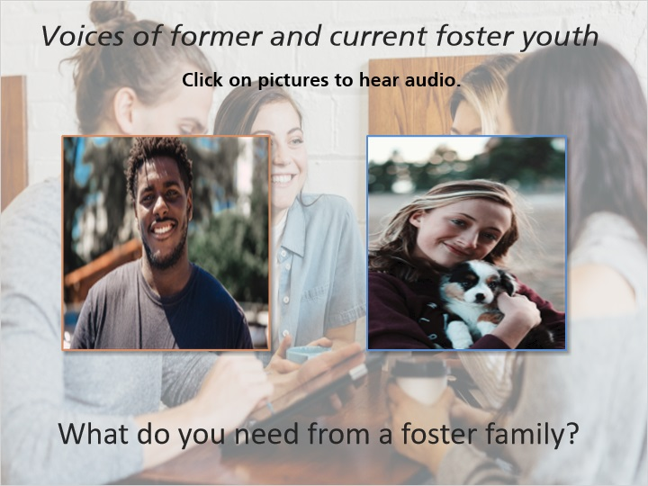
Notes:
Voices of foster youth:

“Well, the thing I feel that you need from a foster family is support, guidance, love, respect and I think the number one over all thing is just trust. Trust that they’ll prepare you just like they will prepare their own child to be able to do whatever it is that you want to do or need to do in life and to become a better person.”

“What I needed from a foster family was love, care, respect. To know that they trust me and that I can trust them and just for them to make me feel part of their family.”

2.3 Voices of Foster Youth
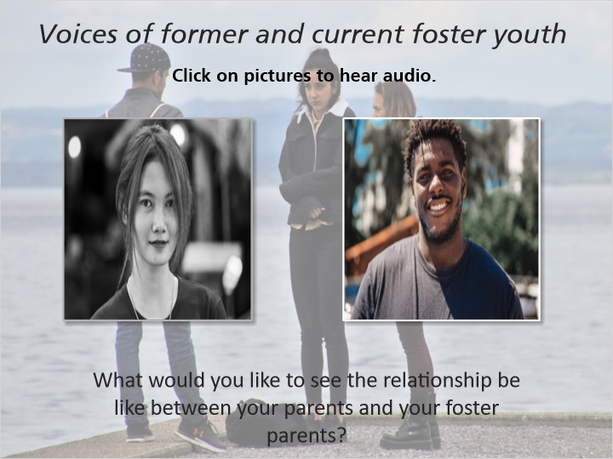
Notes:
Voices of foster youth:

“I would like to see the relationship between my foster parents and my parents to be good and communicative, talk to each other if the need to know stuff about me, know stuff about me, get to know me through my parents for my foster parents to know me.”

“Well I would like to see the relationship between the birth parent and the foster parent be simply both should have what's the best... the best interest of the child, to be stable when leaving the foster care system, be able to stand on its own two feet, it can be a friendship there too, like there's nothing wrong with the birth and foster parents coming together because I think the whole point of foster care is you know reunification so I think the better the foster parent and the birth parents communicate then reunification becomes more... it can be more realistic because it's like the foster parent is you know kind of looking at the birth parent like well if you could have your kids you could have them now I wouldn't have them so it's always that grudge there, at least that's what it seems like so I think the more communication that it is things could get better you know future wise.”

3. Your Questions

3.1 Your Questions
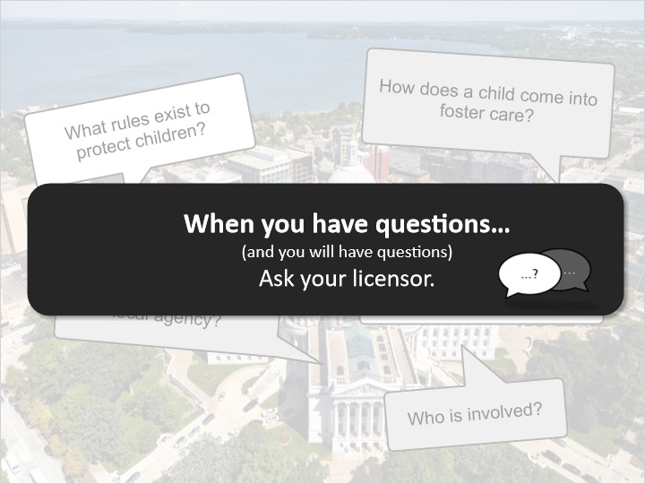
Notes:
You are about to explore how children come into foster care, why they are there, and the rules that have been created to protect children in out-of-home care.

You’re going to learn about the idea of permanency planning and the different people connected to the child welfare and court systems who may work with a child, the child’s birth family, and the foster family. Permanence means safe and nurturing relationships that can be expected to last for the child’s lifetime. Permanency planning includes identifying the permanence goal for the child, and this planning begins at the time that a child is removed from their home.

Wisconsin is what’s called a state-run, county-administered system. This means that the state has specific laws and policies about foster care, but each licensing agency may have additional policies that differ between agencies or counties.

If you have any questions about policies or procedures for your agency, county, or tribe, ask your licensor. You’ll hear this a lot throughout the training because it’s important to remember: when in doubt - about any of this information - ask your licensor!

4. What is Foster Care

4.1 What is Foster Care?
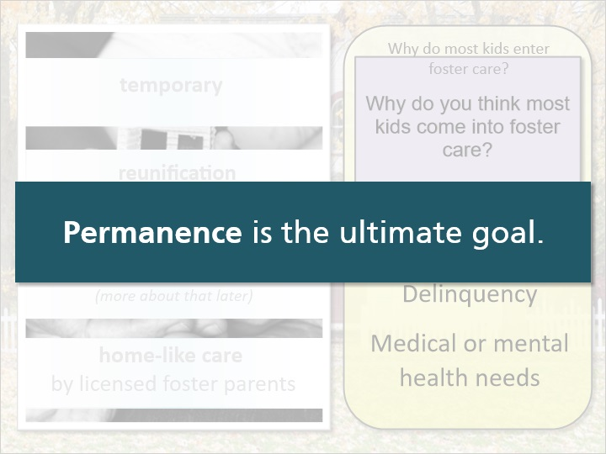
Notes:
So… What is foster care?

Generally, placement in foster care is temporary and intended to give families time to make necessary changes so that the child can live safely in his or her home and community. Most children in foster care return home to their families, which is called reunification. When children can't return home, they find permanence through placement with relatives, adoption, or other options.

Foster care is home-like care provided by the licensed foster parents for children who cannot live with their parents because the children are unsafe, have special care or treatment needs that the parent is unable to manage, or other circumstances resulting in their parents or family being unable to care for them.

Why do you think children come into foster care?

4.2 Rules that Govern Foster Care
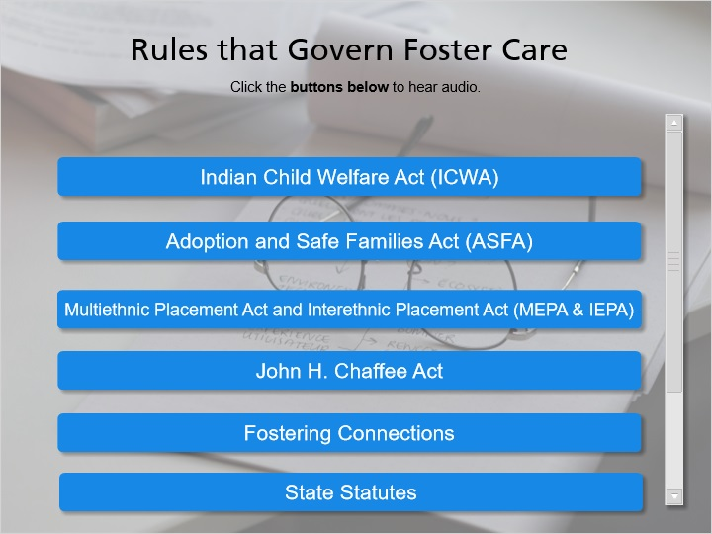
Notes:
As a foster parent, sometimes you might wonder why agencies or child welfare professionals have to make certain decisions. Let’s take a look now at some of the regulations that agencies and foster parents have to follow and the meaning behind those regulations. Click the buttons below to read through some of the regulations.

Indian Child Welfare Act (ICWA):

• Established minimum Federal standards for the removal of Indian children to promote the stability and security of Indian tribes and families.
• Created specific rules for foster and adoptive placements that are intended to preserve Indian heritage and culture, including an order of preference for placement of Indian children.
Adoption and Safe Families Act (ASFA):

• Created to prevent children from staying in foster care for extended periods of time without achieving permanence.
• Gives the foster parents the right to be heard in court after having a child in placement for 6 months.
• Requires Permanency Planning to begin at the time of placement.
Multiethnic Placement Act and Interethnic Placement Act (MEPA & IEPA):
• Placement of a child into a foster home may not be delayed or denied on the basis of race, color, or national origin of the foster parent or child.
• Placements must be consistent with the best interests of the child and not solely based on the race, color, or national origin of the child or potential foster family.
• Requires states to actively recruit potential foster and adoptive families that reflect the ethnic and racial diversity of children in the state for whom placements are needed.
John H. Chafee Act:
• Outlines requirements and provides funding to meet the needs of youth aged 14-21 who are in or who have aged out of court-ordered foster care, specific to preparing them to transition from care and to be successful young adults.
• Dedicated funding and services to children and young adults up to age 21 who are leaving the foster care system.
• Wisconsin law states that youth aged 14 and older who have been in court-ordered care for 6 months or longer must have an Independent Living Assessment and Independent Living Plan during their time in care, which identifies the knowledge and skills the youth will need to make a successful transition to living on their own.
Fostering Connections:
• Emphasizes the importance of involving relatives throughout a case for familial connections as well as for placement options.
• Notice to relatives: Adult relatives will be notified within 30 days of the removal of a relative child from the child’s parental home. The notice will inform relatives that the child has been removed and will provide information regarding the benefits of becoming a foster parent.
• Sibling connections and interaction: agencies will place siblings together when possible, and if this is not possible, agencies will provide for frequent interaction between the siblings.
Preventing Sex Trafficking and Strengthening Families Act:
The federal Preventing Sex Trafficking and Strengthening Families Act of 2014 amends the Title IV-E foster care program to address a number of different issues including: introducing a requirement for “Reasonable and Prudent Parent Standard” for out-of-home care providers, limiting the permanency goal of Other Planned Permanent Living Arrangements for youth 16 years or older, reducing the age for independent living services for youth in out-of-home care from 15 to 14 years old, allowing for a successor guardian in Subsidized Guardianship agreements, expanding the relative notification requirements to include custodial parents of a sibling when a child has been placed in out-of-home care, and updating the reporting requirements to include the National Missing and Exploited Children when a child is missing from foster care and how to respond when a child is no longer missing.
State Statutes:
• These statutes, or laws, were created by the Wisconsin State Legislature and must be followed by all agencies. There are no exceptions to either of these statutes.
• Chapter 48, the Children’s Code
• Chapter 938, the Juvenile Justice Code
State Administrative Rules:
• These rules, also called administrative code, explain licensing requirements and standards for foster care.
• Ch. DCF 56, Foster Home Care for Children.
State Policies:
• These are published by the Department of Children and Families as numbered and informational memos for agencies to follow.

4.3 True or False: Foster care is governed only by the State of Wisconsin Administrative Code, Ch. DCF 56.
(True/False, 10 points, 2 attempts permitted)
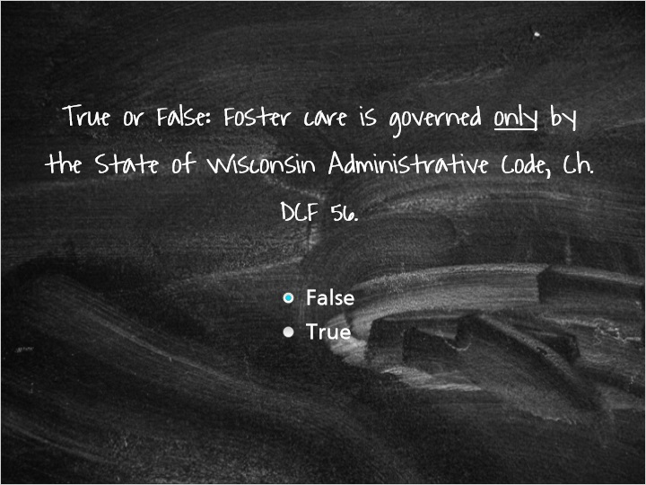
Correct | Choice
X | False
 | True

Feedback when correct:
You're right, this is false. While Ch. DCF 56 is the state administrative code for licensing foster homes and foster parents, the foster care system is governed by federal laws, state laws, state administrative codes, state policies, and licensing agency policies. DCF 56 is one part of the umbrella that oversees the foster care program in Wisconsin.
Feedback when incorrect:
Nope, foster care in Wisconsin has to follow rules at many levels. There are federal laws, state laws, state administrative codes, state policies, and licensing agency policies. Please refer back for more information on DCF 56.

Notes:

4.4 Voices of Foster Care: Rules
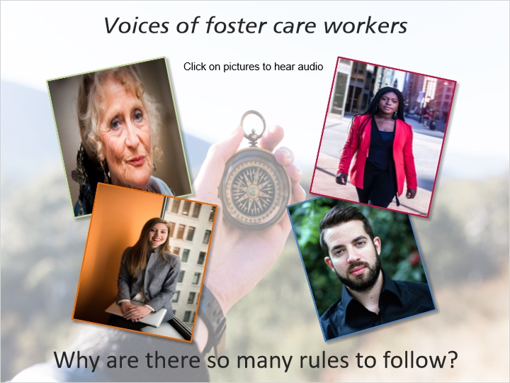
Notes:
“In our everyday life we follow rules in a million different settings and in foster care probably more than most of the places, it's critical that we have rules to follow, this assures that children get the best possible care, are provided safety, nurturing, all of the things that they need for their development. It helps guide us in our work and keeps us focused on what's important.”

“There's a lot of rules in foster care really to basically protect the health, safety and welfare of the foster children but it also protects the foster family and the agency from liability, the rules provide some clarity and guidance and fairness for the care of the children and fostering really the rules help the foster parents just really understand how to properly take care of children and it helps foster and balance that relationship between the agency and the foster family and importantly as well the biological family.”

“So there's so many rules to follow to protect not only the children in foster care but as well as the foster parents.”

“Biological parents know that when we're putting their children in somebody else's care that we make sure that they're going to be safe.”

5. Focus on DCF Ch. 56

5.1 Focus on DCF Ch. 56
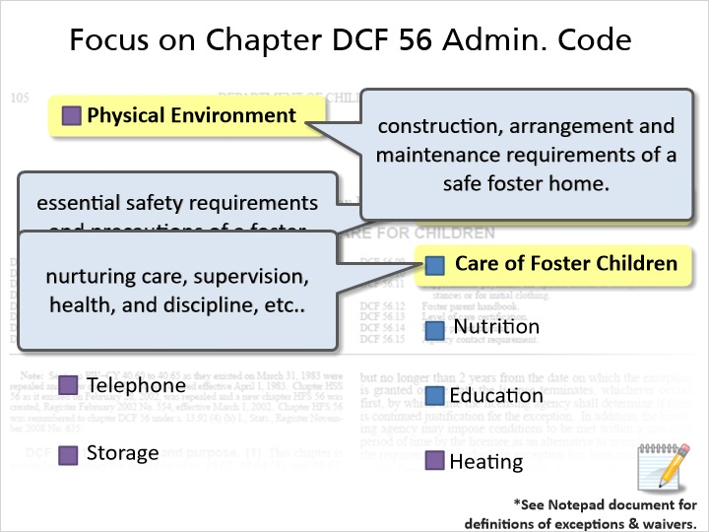
Notes:
The requirements for foster care are laid out in the administrative code for foster care, Ch. DCF 56. Your licensor will provide you with a copy of the administrative code, and the code will answer questions that you have about your licensing requirements. This code is not always easy to read, so always ask your licensor when you have questions.

If you find a requirement in the code that you cannot meet and you feel that this might not allow you to become a foster parent, talk with your licensor as this may be something that an exception or a waiver can be granted for.

Exceptions can be granted to parts of the administrative code; some by your licensing agency and some only by DCF. There are parts of the administrative code that no one can grant exceptions or waivers to, which come from building code and other laws outside of the child welfare system.
When in doubt, ask your licensor!

5.2 Real Life Tips: DCF 56
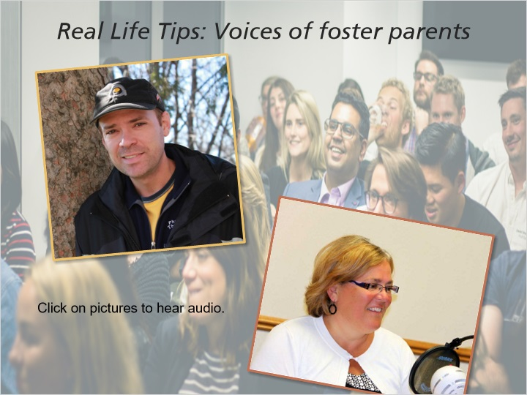
Notes:
“It's not really that complicated it's all based on safety aspects for the kids so you make sure that your house is safe, follow your licensing worker's recommendations, after they walk through the house they'll usually find one or two things that you need to take care of but it's all pretty straight forward, logical stuff.”

“As far as staying on top of the rules and regulations I try to remind myself occasionally of what's in there and look at the overview of it and any time something is going to change in my house whether we're going to get a trampoline or go on vacation I check with the worker to make sure we're doing things how we're suppose to be.”

5.3 Voices of Foster Parents: Surprises
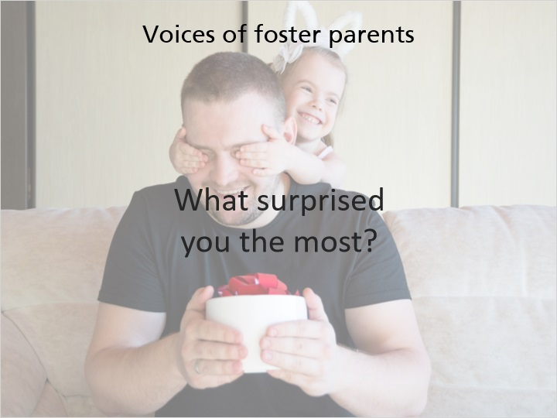
Notes:
“Believe it or not because I'm a single parent what was hardest for me to adjust to was like the regular cooking three meals a day or not three meals a day but cooking dinner everyday and just getting into the daily routine.”

“The surprises of being a foster parent, boy there were a lot of them because we've been licensed for a long time and there weren't real good courses to help us out, there wasn't the internet back in those days so there were a lot of surprises. I think the biggest surprise is that birth parents are more like us than not like us.”

5.4 Check Your Understanding - DCF 56
(Multiple Choice, 10 points, 2 attempts permitted)
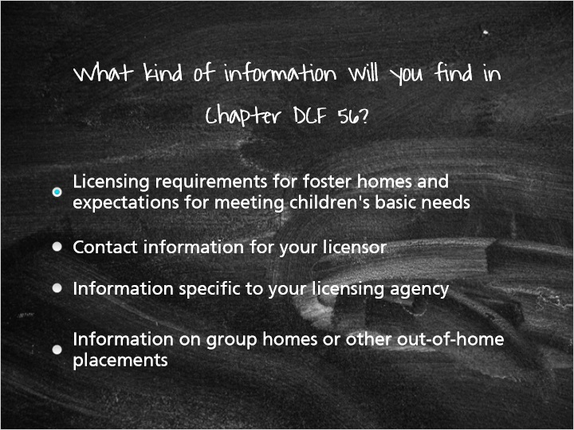
Correct | Choice | Feedback
X | Licensing requirements for foster homes and expectations for meeting children's basic needs | Yes! DCF 56 lays out licensing requirements for foster parents and foster homes, and it is designed to ensure that the basic needs of children in foster care are being met by their foster parents and foster homes.
 | Contact information for your licensor | Contact information for your licensor cannot be found in DCF 56. This information should be provided by your licensor at the beginning of your licensing process.
 | Information specific to your licensing agency | DCF 56 addresses the foster care system as a whole, and while all licensing agencies have to follow DCF 56 when licensing foster homes, DCF 56 cannot account for all of the differences between licensing agencies across the state. Your licensor will provide you with information specific to your agency.
 | Information on group homes or other out-of-home placements | DCF 56 is specific to foster homes. Group homes and other out-of-home placements have their own licensing codes similar to DCF 56.

5.5 True or False: There are no exceptions to any expectations in DCF 56. If you can't meet all of these requirements, you can't be a foster parent.
(True/False, 10 points, 2 attempts permitted)
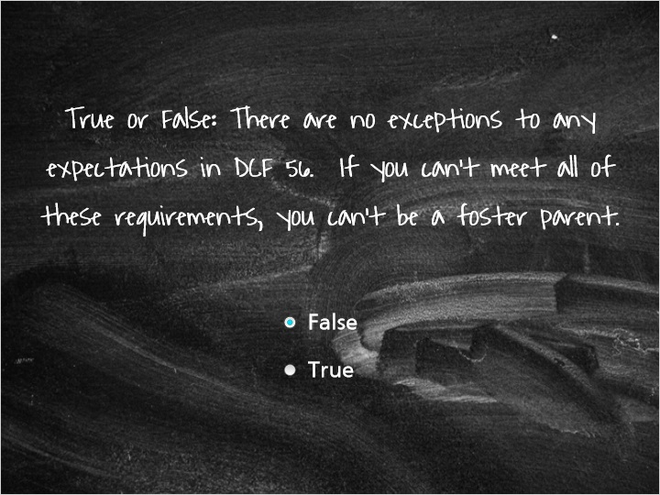
Correct | Choice
X | False
 | True

Feedback when correct:
You're right, this is not true! There are some parts of DCF 56 that exceptions or waivers can be made for. Some of these can be granted by your licensing agency and some have to be granted by the DCF Exceptions Panel. If you feel that you cannot meet a requirement of DCF 56, talk with your licensor because an exception or waiver may be able to be granted for that requirement.
Feedback when incorrect:
Nope, this is false. Certain exceptions can be made to DCF 56, and if you (or your home) cannot meet certain requirements, you may be able to have an exception or a waiver granted and be licensed as a foster parent.

5.6 True or False: There are additional expectations and requirements to follow when an Indian child is placed in foster care.
(True/False, 10 points, 3 attempts permitted)
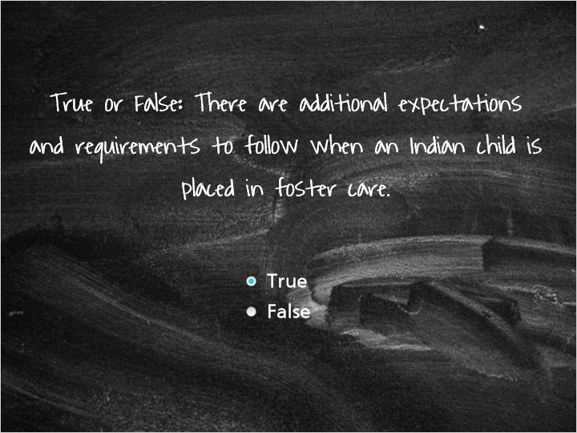
Correct | Choice
X | True
 | False

Feedback when correct:
You're right, when an Indian child is placed in foster care, agencies must follow the Indian Child Welfare Act (called "ICWA") in order to preserve Indian heritage and culture.
Feedback when incorrect:
Nope, this is true; agencies must follow the Indian Child Welfare Act when placing Indian children into foster care.

6. Roles

6.1 Roles of People in Foster Care
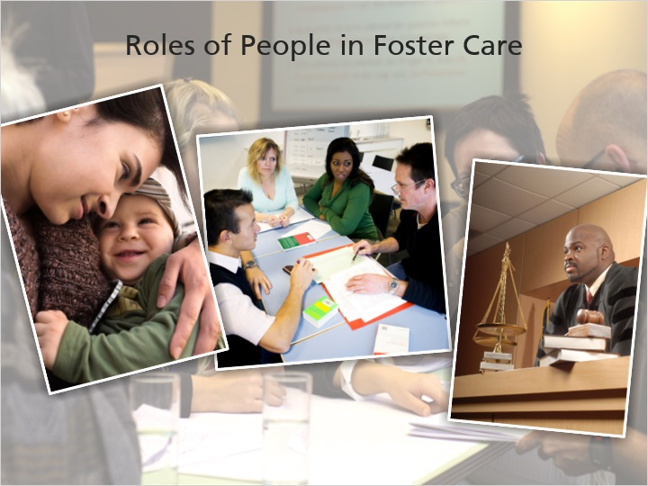
Notes:
Next, we’re going to look at the different roles and responsibilities of people involved with foster care. On the following slides you can click the buttons to learn more about the people closely involved with a child in foster care, including people in the court and mental health systems.

This is a broad overview, so please read through your Foster Parent Handbook for additional information on people who may be involved with a child in foster care.

6.2 Out of Home Care Providers (with various roles)
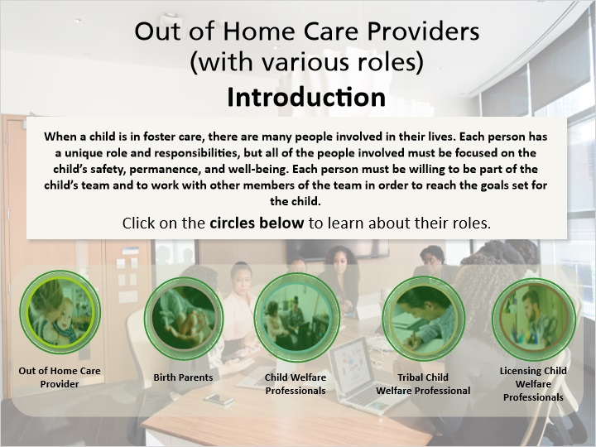
Notes:
When a child is in foster care, there are many people involved in their lives. Each person has a unique role and responsibilities, but all of the people involved must be focused on the child’s safety, permanence, and well-being. Each person must be willing to be part of the child’s team and to work with other members of the team in order to reach the goals set for the child.

Click on the circles below to learn about their roles.

Out of Home Care Providers:

Out of Home Care Providers include foster parents, relative caregivers, and like-kin caregivers (or simply referred to as caregivers) who temporarily care for a child until the child’s permanence goal is achieved. In the State of Wisconsin, all out of home care providers or caregivers are licensed under Wisconsin Chapter 56 as licensed foster parents. The terms “foster parent” and “caregiver” encompass all caregiver roles for the purpose of this training and are used interchangeably.

Relative caregivers or kinship caregivers are out of home care providers who are related to the child as outlined in Wisconsin Chapter 48 Children’s Code.
Like-kin caregivers are caregivers who have a pre-existing relationship with a child and/or parent connected to the child welfare system.

General foster parents are out of home care providers who are not typically known to the child or parent prior to a child coming into out of home care.
All caregivers, provide care, support, and nurturance to a child who has been placed into out-of-home care to ensure that the child’s basic needs are being met. All caregivers must help prepare the child to meet their permanence goal. Caregivers are expected to work together with the child’s birth family, the licensing agency, child welfare professionals, and if applicable, the child’s tribe. Out of home care providers must comply with agency requirements and foster care licensing code (Chapter 56).

Birth Parents:

Birth parents have responsibilities to enhance their parenting capacities in order to demonstrate to the Court that they can care for their child in a safe and acceptable manner. Birth parents must also work together with the agency, out of home care providers, and the tribe, if applicable. While children are in foster care, birth parents still have the right to make major decisions for and about their children, including health care, school services, and religious and cultural involvement.

Child Welfare Professionals:
Child welfare professionals include all the people connected to a child welfare case. This includes both child protective services and youth justice. Child welfare professionals have a number of different roles. Child welfare professionals are also referred to as social workers and sometimes simply as “workers” in this training.
The Child Protection Services professionals are the child welfare professionals who investigate allegations of maltreatment or safety concerns and makes recommendations on behalf of a county agency.
Youth Justice professionals are child welfare professionals who specialize in cases connected to the Youth Justice branch of the child welfare system. Youth Justice professionals gather information, help make decisions with the child and family for services, coordinate with the child’s team, assess ongoing progress and needs, and present information to the court regarding the child and their family. They work on behalf of a county agency.
Ongoing Child Protection professionals are child welfare professionals specializing in the child protective services branch of the child welfare system. Child welfare professionals gather information, make decisions with the child and family, connect the birth family to needed services, coordinate the child’s team, assess ongoing progress and needs, and present information to the court regarding the child and their family.

Tribal Child Welfare Professionals:
Tribal child welfare professionals have a similar role to county or private agency child welfare professionals but they work within the tribal social service agencies for child welfare cases that are under tribal court jurisdiction. In some cases, tribal child welfare professionals may assist a county agency in providing services that reflect the tribe's customs, beliefs, and traditions, as well as making sure the child stays connected to their tribe. The Indian Child Welfare Act (ICWA) and the Wisconsin Indian Child Welfare Act (WICWA) stipulates the tribe’s involvement in child custody proceedings and placement of children who are members of the tribe or eligible for membership in the tribe. Tribes may license, certify, or approve their own out of home care providers or work with a caregiver licensed by the county or a private agency, and most tribal child welfare professionals work with the licensing agency. Tribal child welfare professionals roles may change from case to case depending on the role that the tribe has chosen to take in each case.
Licensing Child Welfare Professionals:
Licensing Child Welfare Professionals (also called licensors, or Foster Care Coordinators) work directly with out of home care providers licensed to provide foster care by their agency, and are generally responsible for recruiting new foster parents, licensing foster, relative, and like-kin homes, matching children to their placements, training foster parents and supporting caregivers and other child welfare professionals connected to an out of home care placement. Licensing professionals make sure that caregiving families follow the rules and policies of foster care in order to provide a safe place for the children in their homes.
If you have any questions about child welfare professionals’ or caregiver roles, be sure to check with your licensor.

6.3 Relationships with Birth Parents
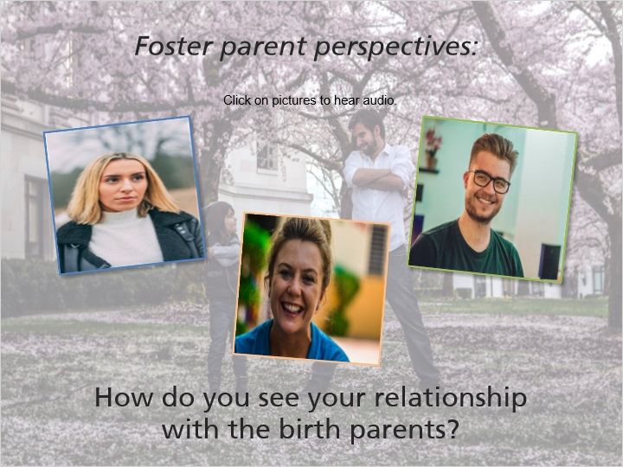
Notes:
“I believe my relationship with the biological parents is very, very important relationship, I think that for the children to be successful in my home they have to see that I can respect their parents and that their parents and I can get along. There are a lot fewer problems usually if we're able to get along and have a good relationship if the parents can see that I care about their children as much as they do.”

“You need to make sure that you're viewing the parents in as positive a light as possible while maintaining the safety of the children. For instance in my home I have some children who are allowed to have at home visits and other children who can only have supervised visits and the discussion between the kids talking about well that's not fair how come you get to see your mom every week for two days and I get to see my mom every week for one hour, that can be really complicated to and you have to negotiate that without putting it on the birth parents any more than factually can be complicated and emotional.”

“My relationship with the birth parents pretty much in all cases has been very good; some of them haven't been involved. I like working with the birth parents, I like the kids background and I think to help them grow they need to see where they came from and they need to know their parents are part of their history. Some of my kids aren't comfortable with that at all, that they haven't wanted to talk about their parents or go there and you just kind of take them at their speed but most of the time the parents, I mean they're human like me so.”

6.4 Birth Parent Perspective
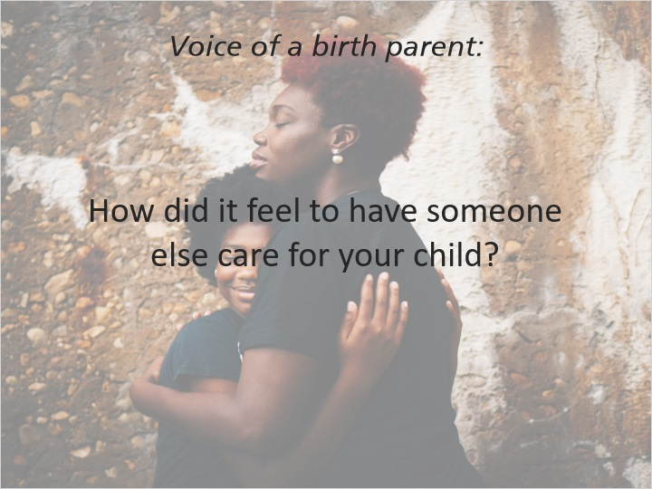
Notes:
“Well at the time I couldn't care for her then but now I can. At that time I was feeling like emotional when my daughter was in foster care, I went and got help and I always say to myself I know you can do this, can't nobody do it but you. If you want this you have to go and get this. So what I did was I went and got help, I feel good about myself you know, being a full time mom over again and learning how to reach out for help when I need it, not being afraid to ask for anything and if I need anything or like if my child wants to go somewhere I have to be there with her to be there to you know keep her safe and everything. It was stressful because I was seeing my child coming home on a home visits and over nights to see her being looking real mad because she have to go and it made me mad, it made me sad and everything like I have to get this child home because there's no way that I can keep letting my child see me look sad and for me to see my child look sad.”

7. How Children Enter Foster Care

7.1 How Children Enter Foster Care in Wisconsin
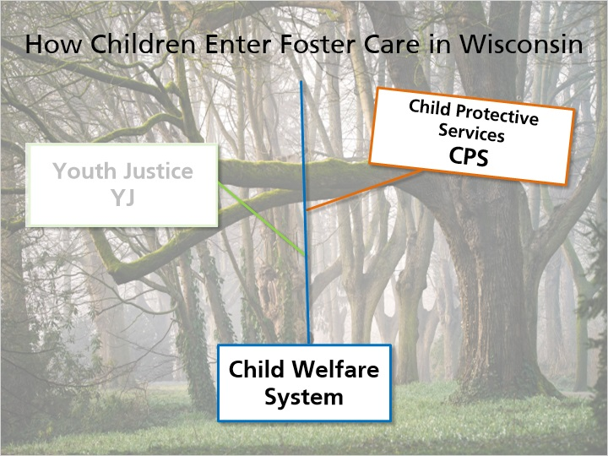
Notes:
The child welfare system in Wisconsin is like a tree that splits into two main branches: child protective services (called “CPS”) and youth justice (sometimes called “YJ”). Just like a tree’s branches will intertwine or may stand alone, sometimes children or families are involved in both, and sometimes they are involved with just one. Each “branch” has its own laws, guidelines, resources, and services.

We’ll begin with the CPS branch to see how a child or family might move through that branch of the child welfare system. Continue to the next slide.

7.2 Overview of the CPS Process
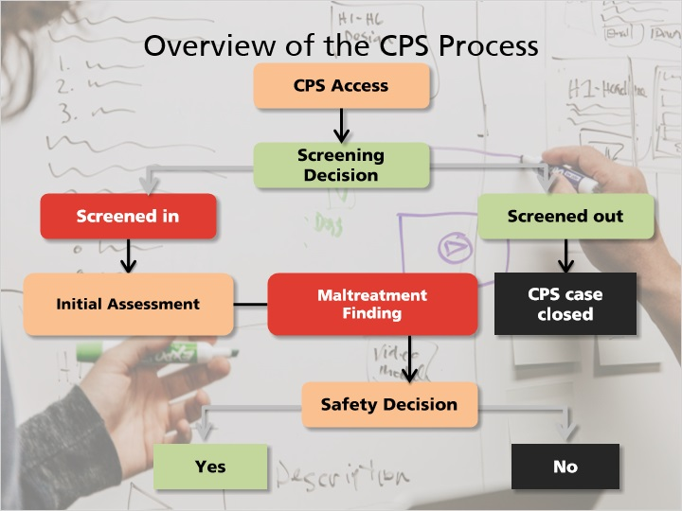
Notes:
Now let’s take a look at how a child enters foster care through child protective services. Don’t worry if this seems complicated. On the next slide, we’ll walk through a case scenario of how a child might move through the CPS process.

First, a report concerning a child who may have been maltreated (abused or neglected) is made to CPS Access or law enforcement. This report can be made by anyone who has reason to believe that a child has been maltreated or threatened with abuse or neglect.
After this report is received, the agency will make a decision whether to screen in or screen out the report based on state statutes and state standards.
If this report is screened out, the case would be considered closed with the agency, but the family could be referred to services in the community.
If the report is screened in, the agency conducts what’s called an initial assessment. Then the CPS professional meets with family members and others to collect information needed to understand individual and family conditions, functioning and dynamics, as well as to assess and analyze threats to child safety.
If this assessment finds that a child is unsafe, CPS must take action to control the threats to the child’s safety and create a safety plan. This plan may be done in-home with services put in place, but if these services cannot be put in place in the home to control the safety threat, a child may be removed from the home and placed in out of home care.
This assessment will determine whether or not maltreatment occurred, who the maltreater is, and whether the child is in need of protection or services. If the child is found to be in need of protection or services, the case is opened with the CPS agency.
When children are placed in out-of-home care, the agency will provide services to the parents and child that will allow the child to return home with a safety plan. At the same time, the agency will work with the family to make needed changes so the child can remain safely in the home.
Some agencies also provide services to families on a voluntary basis or may work with them to identify available services in the community.

7.3 How Children Enter Foster Care in Wisconsin
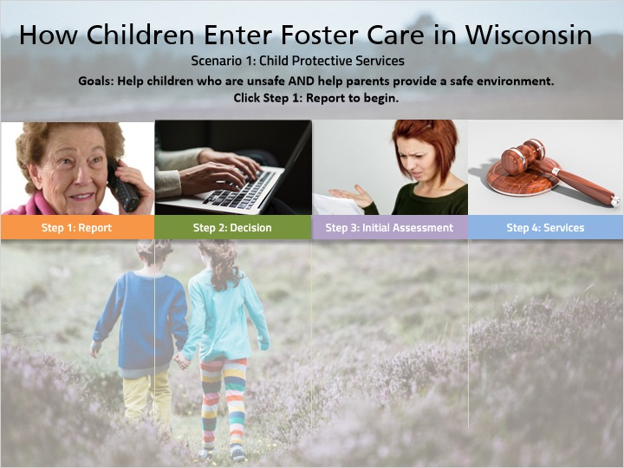
Notes:
INTRO: Let’s walk through a case example to see how a child could enter foster care through the child protective services. Click on Step 1 below to begin.

Step 1: REPORT

On Monday morning, CPS receives a call from an elderly woman who believes the two children, age 2 and 4, who live in the apartment next door to her are home alone. She said she saw both parents leave this morning without the children and can now hear them running, banging things, and crying.

Step 2: DECISION

The report is screened in and assigned to the CPS professional the same day because there may be vulnerable children being left without appropriate care or supervision.

Step 3: INITIAL ASSESSMENT

The CPS professional contacts law enforcement who accompanies the worker to the family home. CPS and law enforcement find the 2 year old and 4 year old home alone. Neither has any idea where their parents are, when they will be back or how to get a hold of them.

CPS is not able to immediately locate the parents or any other family members. The decision is made to take the children into custody and place them in foster care. A note is left at the family's apartment to contact CPS.

The parents contact CPS later that day, upset that their children have been taken and not understanding what the issue is. The CPS professional meets with the family to explain their involvement and gather information related to the parents’ individual functioning, parenting capacity and family functioning. Despite the young age and capacity of the children, the parents continue to deny that they did anything wrong by leaving the children home alone to care for themselves. Both parents share that they have done this numerous times in the past and nothing bad has ever happened. The children know what is expected of them and will do it. The parents report that they will often leave the two children home if they need to run errands; it is more work and a hassle to take them with them.

The CPS professional determines that the children are unsafe. The CPS professional is not able to implement an in-home safety plan as the parents refuse to allow services in the home and continue to believe that they did nothing wrong. A substantiated finding of neglect, and parents are named the maltreater.

Step 4: SERVICES PROVIDED

The CPS agency files a CHIPS or Child in Need of Protection or Services petition in court. The parents do not agree to the petition (contest it), but the judge grants it and the children are found to be in need of protection and services. CPS identifies conditions that must be met in order for the children to safely return to the parents’ home and continue to work with them to determine what changes need to be made in order for the children to live safely in the home without CPS agency intervention.

8. Overview of the Youth Justice Process

8.1 Overview of the Youth Justice Process
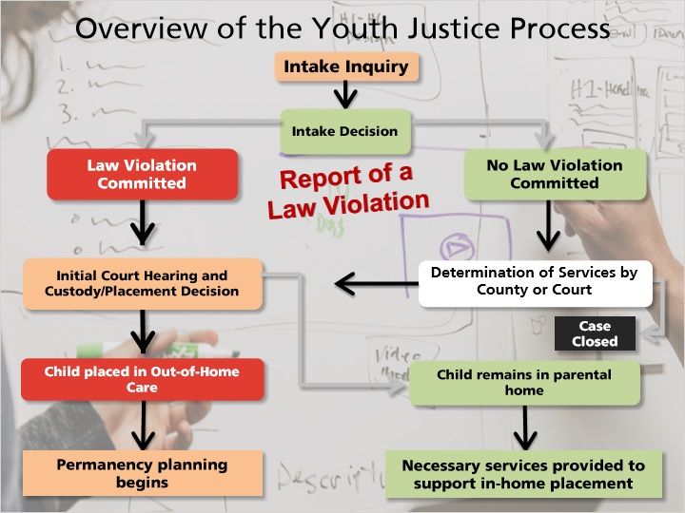
Notes:
Now let’s take a look at how a youth could enter foster care through Youth Justice. The next slide will walk you through a case example of this process.

First, a report of a law violation or other uncontrollable behavior is made to law enforcement or to the county agency. An Intake Inquiry is then completed to determine the youth’s needs as well as to assess community safety. A decision will be made about whether or not a law violation was committed. This is then where the process splits into two branches; If a law violation was committed, the youth will attend an initial court hearing, and the judge will make a decision regarding custody and placement of the youth. If the judge determines that an out-of-home placement is necessary in order to meet the youth’s needs or to ensure community safety, the youth will be placed in out-of-home care and permanency planning begins immediately. However, if a law violation was not committed, the county will determine the level of services needed. At this point, there are two different decisions that can be made. One, if the county feels that an out-of-home placement is necessary in order to meet the youth’s needs or to ensure community safety, the county will bring a petition before the court. A judge will then decide either to place the youth in out-of-home care, or decide that the youth’s needs and community safety can be managed while allowing the youth to stay in their home. If the youth remains at home, the county will provide the necessary services to the family to support the youth at home. The county or judge could also decide that no services are necessary for this youth or family and the case will be closed.

8.2 How Children Enter Foster Care in Wisconsin
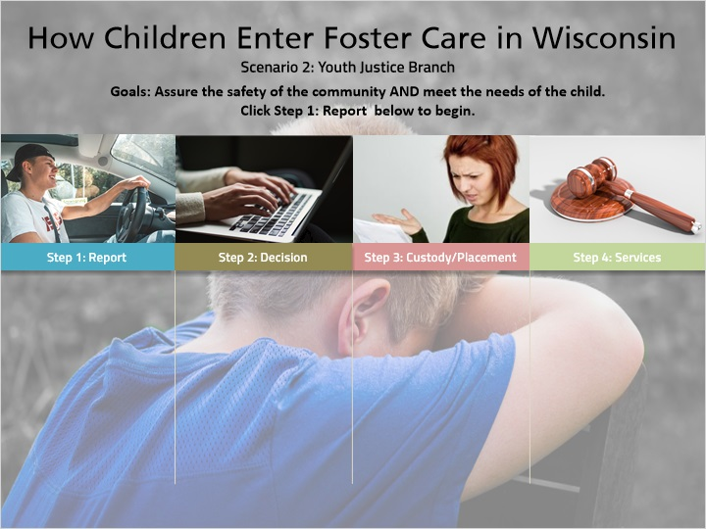
Notes:
Let’s walk through a case example to see how a youth could enter foster care through the youth justice branch.
Step 1: REPORT
On Tuesday night, 15‐year‐old Bobby steals his parents’ car and is pulled over by the police after his parents report the car as stolen. Police take Bobby into custody, and take him to the local Detention Center where he is charged with Operating a Motor Vehicle Without the Owner’s Consent. Based on this charge, he is held in Detention until he can appear in court for a Temporary Physical Custody Hearing, which is scheduled for the following day, Wednesday, at 11:00am.
Step 2: DECISION
On Wednesday morning, Bobby appears in court for his Custody Review Hearing. This hearing is also set to be a Plea Hearing, and Bobby pleads No Contest to the charge of Operating a Motor Vehicle Without the Owner’s Consent. The Judge orders Bobby to remain in Detention until his next hearing, which is scheduled for the following Monday at 9:00am.
Step 3: CUSTODY / PLACEMENT
Before the next hearing, a child welfare professional specializing in youth justice approaches foster parents Mr. and Mrs. Morgan to see if they would consider Bobby for placement in their home if the Judge orders Bobby to be placed in a foster home. On Monday morning, Bobby appears at his next hearing before the Judge. Based on Bobby’s behaviors and the reports that he is not attending school regularly, the Judge orders Bobby to be placed in a foster home that day.
Step 4: SERVICES PROVIDED
Mr. and Mrs. Morgan have agreed to take placement of Bobby, and he is placed with them that day. At that point, Bobby’s child welfare professional begins the permanency planning by discussing with Bobby and his family all the changes that will need to occur for Bobby to return to and remain at home successfully. The services that are put in place for Bobby include meeting with his teachers to create a plan to increase his school attendance and connecting Bobby with an individual therapist. Bobby’s family is referred for family therapy to work through their conflicts together.

8.3 Want More Details?

Notes:
If you want more details on the CPS process, just follow the link to download the CPS Standards.

8.4 Check Your Understanding - CWS
(True/False, 10 points, 2 attempts permitted)
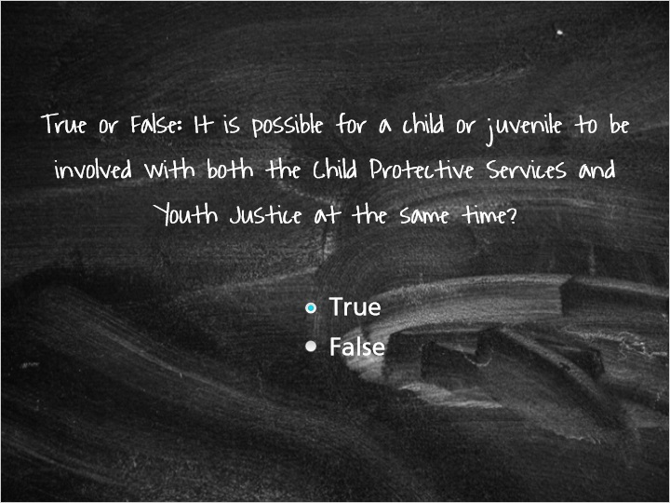
Correct | Choice
X | True
 | False

Feedback when correct:
Yes! It is possible for a child or family to be involved with both parts of the child welfare system and have court orders and expectations for both.
Feedback when incorrect:
It is actually possible for a child or youth to be involved in both parts of the child welfare system, as there may be both family safety issues and delinquency issues.

9. What is Permanence?

9.1 What is Permanence?
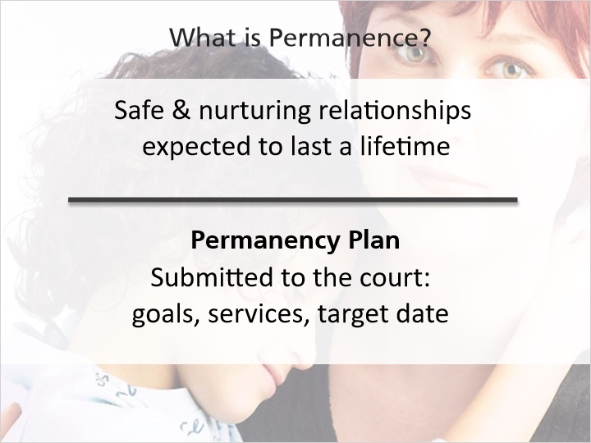
Notes:
What is permanence and why is it important?

Permanence is the word used to describe safe and nurturing relationships that can be expected to last for a lifetime. For children in foster care, permanence also means developing and sustaining connections to important people in their lives.

The process of achieving permanence begins with long-term planning for the child. There is a plan that is developed, called a permanency plan that states goals to achieve, with timelines. The permanency plan also includes services and supports to put into place that the child’s team will be using to achieve the permanence goals. This plan is given to the court and is reviewed every six months while the child is in foster care.

You’ve heard what the legal definition of permanence is, but for the children in care, permanence has an emotional definition as well. On the next slide, you’ll hear how the children in care define permanence and what it means for them.

9.2 Permanence: The Child's Perspective
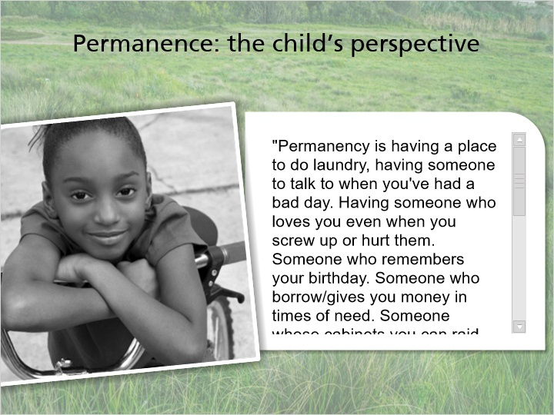
Notes:
Voices of foster youth:

"Permanency is having a place to do laundry, having someone to talk to when you've had a bad day. Having someone who loves you even when you screw up or hurt them. Someone who remembers your birthday. Someone who borrow/gives you money in times of need. Someone whose cabinets you can raid when food is low. Someone who will be at your high school graduation when you graduate. Someone who helps you find your potential. A place to go for the holidays. Someone who I would put down when they ask for my emergency contact. Someone who treats me like their own child even if I am not. Someone who helps you when times are hard. Someone who encourages you to be better! Someone who LOVES you NO MATTER WHAT!"

9.3 Importance of Permanency
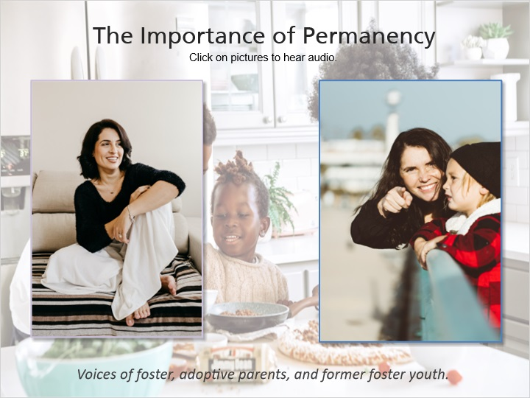
Notes:

“A child who doesn’t have permanency is always just feeling like they’re wandering and a little bit unsafe, so permanency for a foster child is knowing that they don’t ever have to move, they don’t have to go somewhere, they don’t have to live with a new family, they don’t have to make new friends and new siblings and new teachers and new schools. It could be through adoption, it could be through reunification, it could be through a variety of options, but for that child permanency has to mean they don’t need to pack their bags anymore.”

“Permanency is having a permanent home forever, that you have one home (also as a former foster child and an adoptive parent) it is just something that I want to give both my birth child and my adopted child that we’re going to be there forever for them no matter what happens, no matter what happens. I think that is the key to having people understanding that – whether it’s foster, working for birth homes, or foster to adopt, is that permanency is really, in one home, where someone’s going to stick with you through thick or thin.”

9.4 Permanency Options
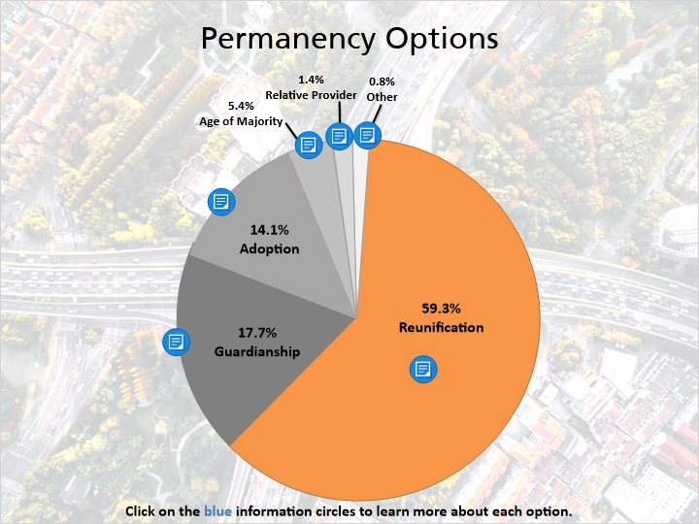
Notes:
There are several options for a child to find permanency, including reunification, adoption, guardianship, placement with a fit and willing relative, or other planned permanent living arrangement. This chart shows the most frequent reasons for leaving foster care for the 5,196 children who left foster care in 2019. As you can see, reunification is the most common outcome. Click on the blue information circles to learn more about each option.

9.5 True or False: Everyone has the same definition of permanence.
(True/False, 10 points, 2 attempts permitted)
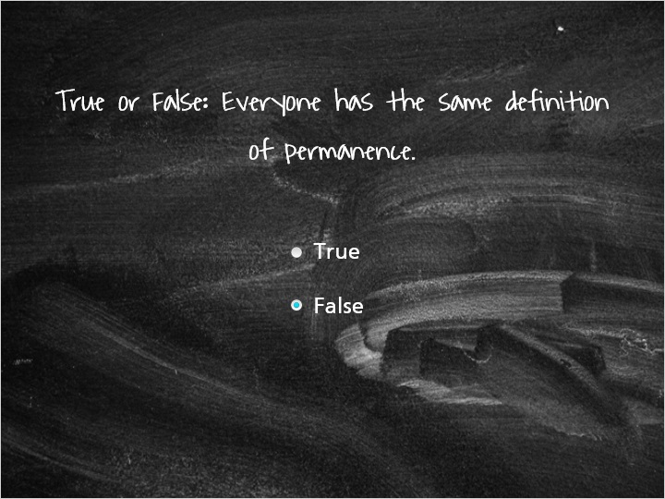
Correct | Choice
 | True
X | False

Feedback when correct:
Correct! The child welfare system generally uses the legal definition of permanence "safe and nurturing relationships that can be expected to last for the child's lifetime," but the children of the child welfare system define permanence in a more emotional way in terms of connections to important people.
Feedback when incorrect:
While there is a legal definition of permanence that is widely used in the child welfare system, there is also an emotional definition that is used by children in the child welfare system that may be different from the legal definition. Please refer back to the slide on the child's perspective on permanence to hear the children's definitions in their own words.

9.6 Check Your Understanding - Permanency
(Multiple Choice, 10 points, 2 attempts permitted)
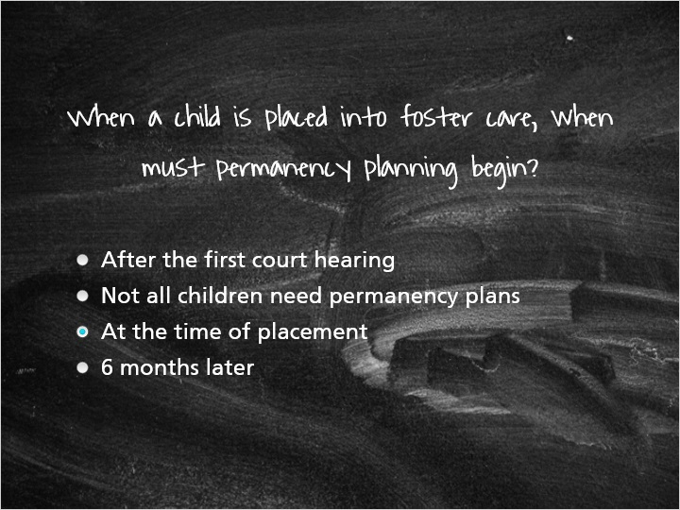
Correct | Choice | Feedback
 | After the first court hearing | Nope, permanency planning begins immediately at the time of the child's placement into foster care and does not wait until the first court hearing. Sometimes the child's date of placement into foster care is the same as the initial court date, but regardless of the date of the first court hearing, permanency planning begins when the child is placed into foster care.
 | Not all children need permanency plans | All children in foster care are required to have a permanency plan and to have it reviewed every 6 months.
X | At the time of placement | Correct! Permanency planning must begin immediately at the time of the child's placement into foster care. The 6-month timeline for reviewing the permanency plan will be based from the date of the child's removal from their home.
 | 6 months later | Permanency plans are reviewed every 6 months, and alternate between hearings before the judge and reviews with an administrative panel, but permanency planning must begin immediately at the time of the child's placement in foster care.

10. Concurrent Planning

10.1 Concurrent Planning
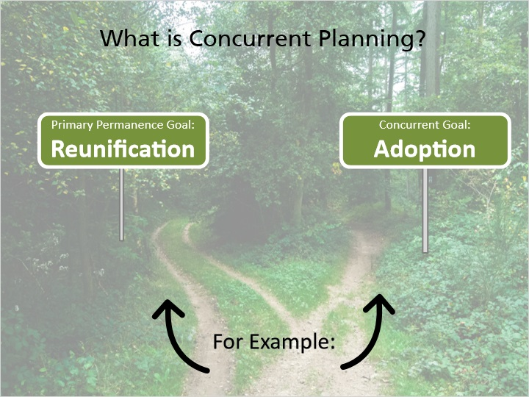
Notes:
Concurrent planning involves identifying two permanence goals (called concurrent goals) for every child in care, and working toward both goals at the same time. Concurrent planning is done so that in case the permanence goal is not able to be reached, the child will still have another permanent living arrangement option. A common example of concurrent goals would be to have reunification as the permanence goal and have adoption as the concurrent permanence goal if the child is unable to return home.

If this sounds challenging, you’re right. It is challenging, and it can be emotional and confusing.

Concurrent planning may be a difficult and emotional process for foster parents, because you are being asked to plan for the child to return home, but you also may be asked to consider being the permanent placement for the child if they cannot return home safely.

10.2 Real Life Tips: Concurrent Planning
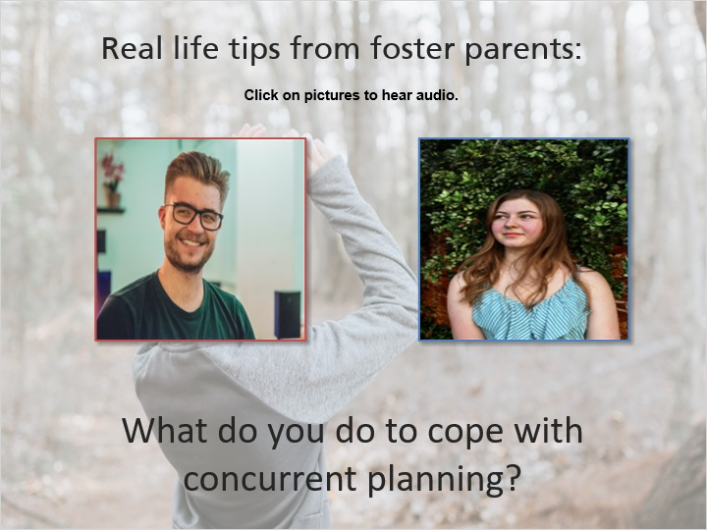
Notes:
“It's complicated dealing with...being a concurrent placement because on the one hand you're supposed to be helping the kids get adjusted and ready to go back home once the parents take care of their end of it and on the other end you're also kind of planning for the kids to be with you forever so you have to negotiate the waters of raising the kid like they're going to be with you forever but not making any long term promises because you just don’t know, it's all up to a judge and it's all up to the birth parents.”

“Concurrent planning is one of the hardest ones to be in because as much as you want the child to go home you may want that child to stay with you as well and that's a really difficult spot to be even when you know it's best for them to return home if they can. I try to always think of the child that's it's...the child is not my child, that I'm there to help and I have to remind myself through the concurrent process that this child doesn't belong to me and that my goal is reunification, so if I stay in that way of thinking then it's much easier if it goes the other way, it's harder to start thinking of them as your own and then have them leave. So I really try to stay in that spot of my job is to get them home.”

11. People in Mental Health

11.1 People in Mental Health System and Other Supportive Professionals
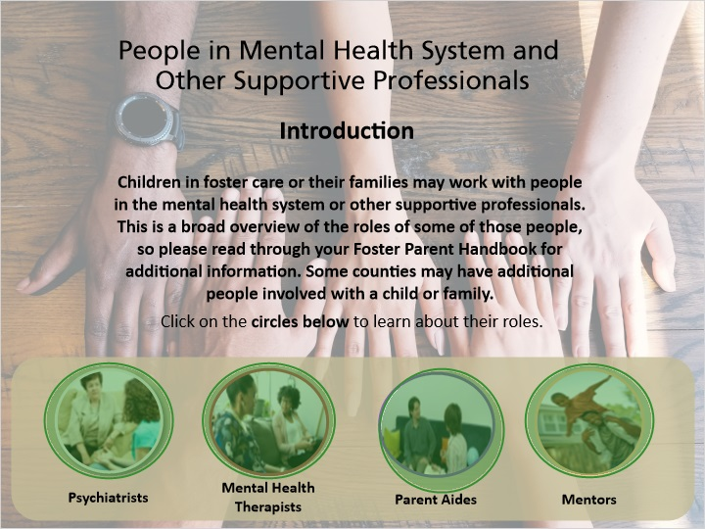
Notes:
Children in foster care or their families may work with people in the mental health system or other supportive professionals. This is a broad overview of the roles of some of those people, so please read through your Foster Parent Handbook for additional information. Some counties may have additional people involved with a child or family.

Click on the circles below to learn about their roles.
Psychiatrists:

Psychiatrists are doctors who have special training in mental health issues. They are responsible for evaluating children when an assessment is required to determine if a child has a mental health diagnosis and if that child needs medication to manage their behaviors. Psychiatrists prescribe those medications and will monitor the child while they are taking those medications.

Mental Health Therapists:

Mental health therapists (also called counselors or psychotherapists) work with the child, their siblings, the birth parents, and foster parents to address the mental and emotional health needs of the child. They can also work with a child to aid them in their healing from trauma, grief, and loss.

Parent Aides:

Parent aides (also called home consultants) work with birth parents on the issues that led to the child being removed from the home. This role may be called something different in your agency, so check with your licensor if you have questions about the role of a parent aide.
Mentors:
Mentors help children learn about positive activities and teach them how to build positive relationships with adults, can be positive role models, and help children build positive self-esteem.

11.2 Check Your Understanding - Teaming
(True/False, 10 points, 2 attempts permitted)
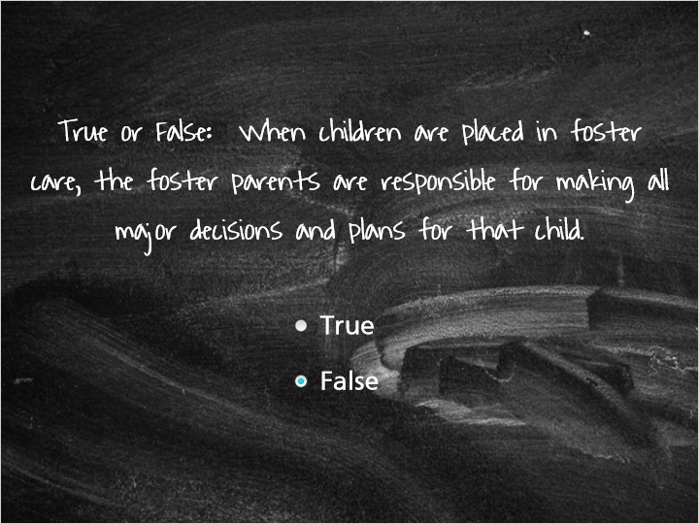
Correct | Choice
 | True
X | False

Feedback when correct:
You are correct! You are not alone in this process and are not solely responsible for the plan for your foster child. You are also limited in the major decisions you can make for your foster child. Please refer to your Foster Parent Handbook and talk with your licensor to learn more about the decisions you are able to make for your foster child.
Feedback when incorrect:
Nope, you are not alone in this! As a foster parent, you will be part of a team of people, all working in the best interests of the child placed in your care. Together you will plan for the child and the family and will help that child to be safe and successful. As a foster parent, you are limited in the decisions you can make for your foster child. Please refer to your Foster Parent Handbook and talk with your licensor to learn more about the decisions you are able to make for your foster child..

Notes:

12. Professionals in Legal System

12.1 Professionals in the Legal System or at Court Hearings
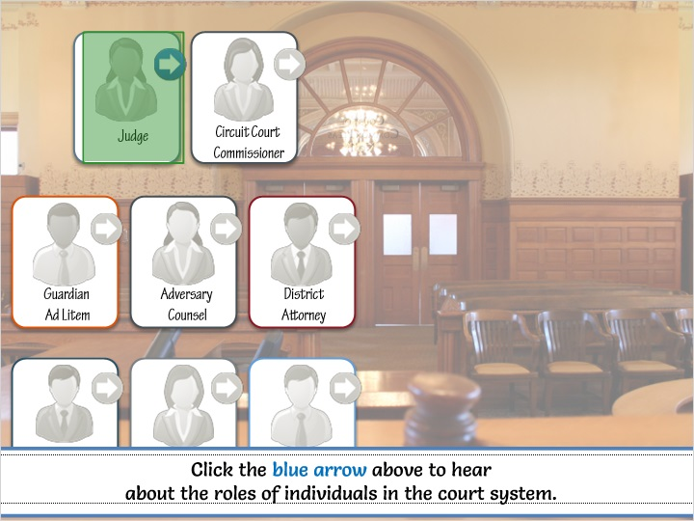
Notes:
There are a lot of people involved in the court system, and, again, this is a broad overview of these roles. Click the arrow to hear about the roles of individuals in the court system.

Please read through your Foster Parent Handbook for additional information.

12.2 Judge
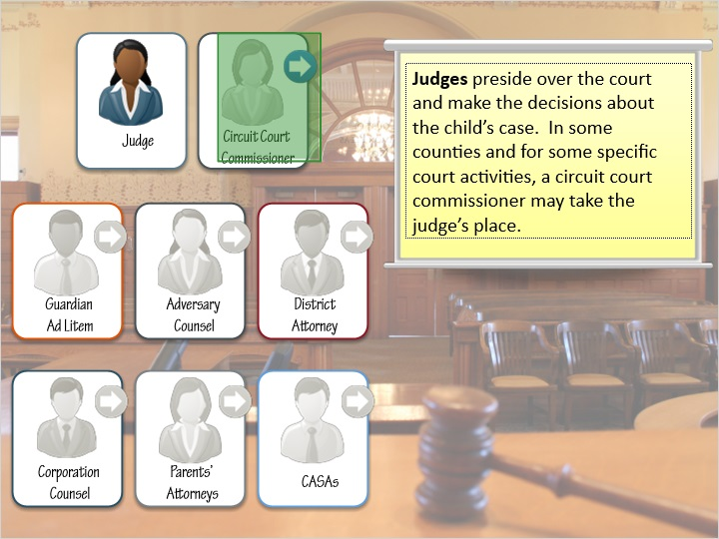
Notes:
Judges preside over the court and make the decisions about the child’s case. In some counties and for some specific court activities, a circuit court commissioner may take the judge’s place.

12.3 Circuit Court Commissioner
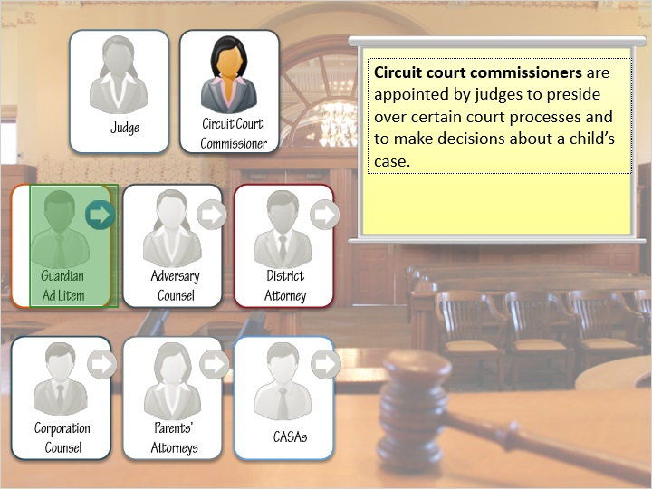
Notes:
Circuit court commissioners are appointed by judges to preside over certain court processes and to make decisions about a child’s case.

12.4 Guardian Ad Litem
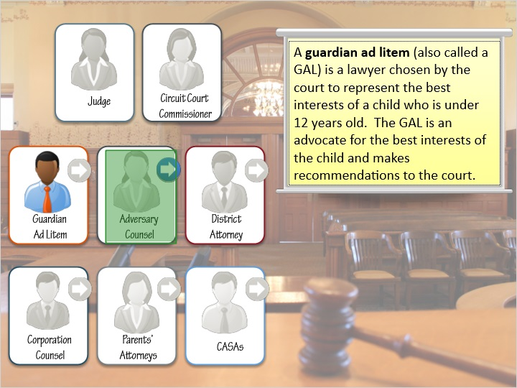
Notes:
A guardian ad litem (also called a GAL) is a lawyer chosen by the court to represent the best interests of a child who is under 12 years old. The GAL is an advocate for the best interests of the child and makes recommendations to the court.

12.5 Adversary Counsel
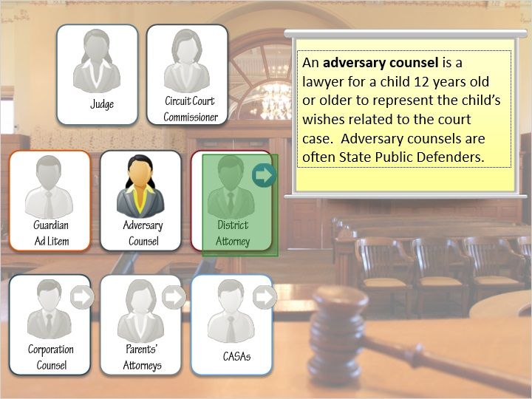
Notes:
An adversary counsel is a lawyer for a child 12 years old or older to represent the child’s wishes related to the court case. Adversary counsels are often State Public Defenders.

12.6 District Attorney
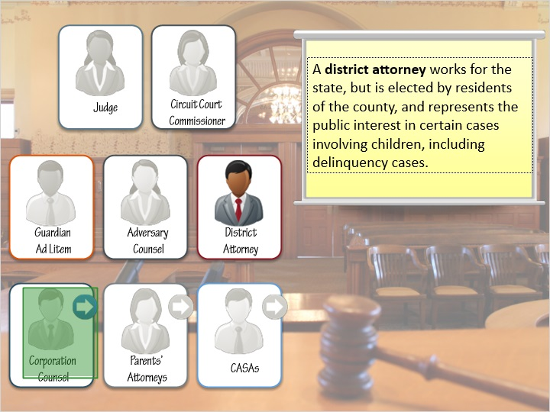
Notes:
A district attorney works for the state, but is elected by residents of the county, and represents the public interest in certain cases involving children, including delinquency cases.

12.7 Corporation Counsel
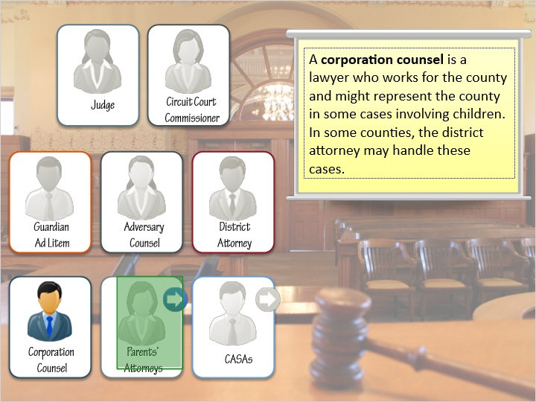
Notes:
A corporation counsel is a lawyer who works for the county and might represent the county in some cases involving children. In some counties, the district attorney may handle these cases.

12.8 Parents’ Attorneys
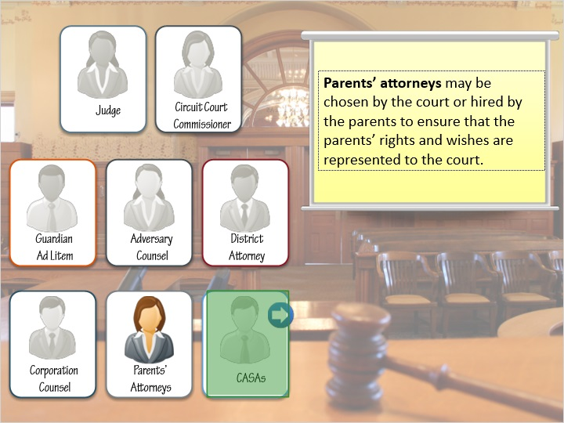
Notes:
Parents’ attorneys may be chosen by the court or hired by the parents to ensure that the parents’ rights and wishes are represented to the court.

12.9 Court-appointed special advocates
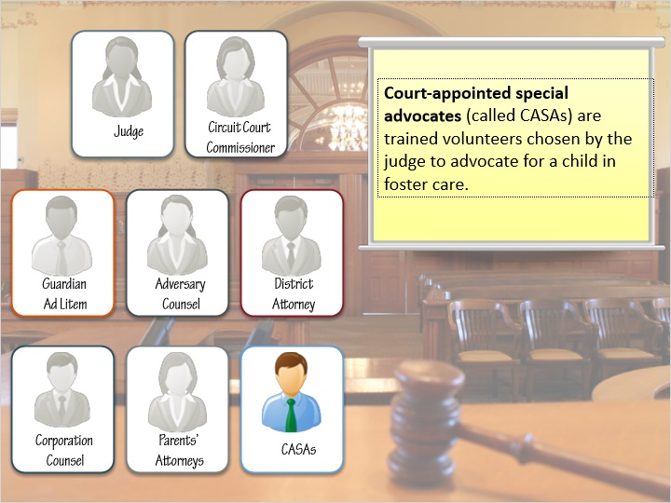
Notes:
Court-appointed special advocates (called CASAs) are trained volunteers chosen by the judge to advocate for a child in foster care.

12.10 Interacting with the Courts
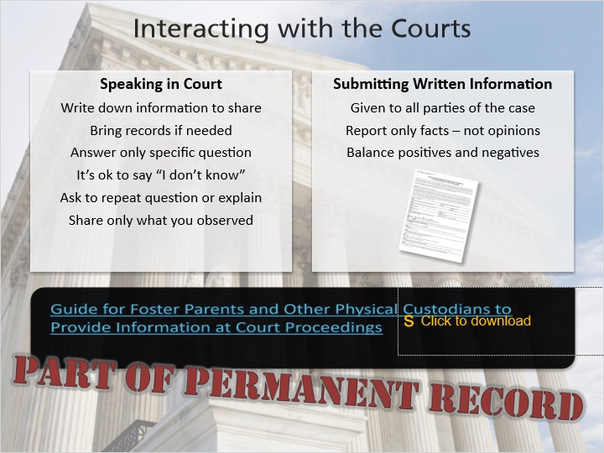
Notes:
Foster parents have the right to be heard in court proceedings. This means that you can either submit written comments to the court or participate in the court hearing, but this right does not guarantee that you will have a chance to speak in court.

It’s natural to be nervous when you go to court. Here are some things to remember:

Write down the information that you want to share ahead of time.
Bring records or other paperwork with you to refer to, if necessary.

If you are asked a question, answer only that specific question. If the judge wants additional information, they will ask for it.
If you’re not sure of the answer, it’s okay to say that you’re not sure or don’t know. Don’t guess!
Feel free to ask to have a question repeated or explained more.
Use description and facts to help clearly explain the information.
Talk only about things that you have observed, not secondhand information or assumptions.

If you are submitting written information to the court before the hearing, these are important things to remember:
Anything you submit to the court will be given to all of the parties of the case, including the child and the birth family, and will become a part of the child’s permanent record and the court record.
Report only facts – this is not a time to share your opinions.
Balance the positives and negatives – even if something has improved just a little bit, mention it.

There is a new form for foster parents to fill out to give to the court before hearings. It is called “Guide for Foster Parents and Other Physical Custodians to Provide Information at Court Proceedings” and can be found here: [ https://dcf.wisconsin.gov/files/forms/doc/2474.docx ]

Again, please remember that anything you write on this form will be shown to all of the parties of the child’s case and will be a part of their permanent record.

12.11 Voices of Foster Youth
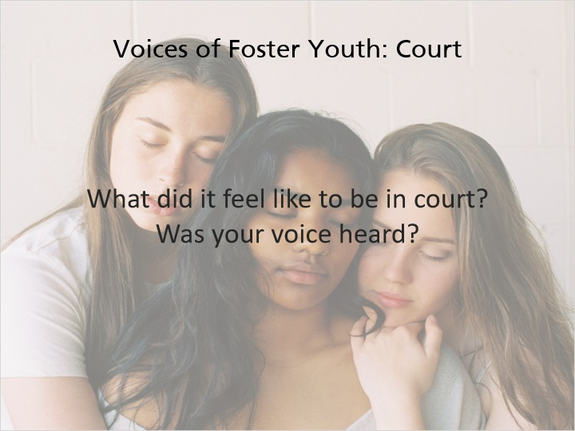
Notes:
Voices of foster youth:

“The first time I was in court was scary, even though I was only 16 it was it was... would have been nice to be able to talk to someone beforehand to be able to see the court room, to know what was going to go on, um, I did get my point across the judge did come over and say hey what do you want to say, what do you want, you are considered an adult at what your age is, you get to put your voice in here but it would have been more comforting to be able to see it and to know what was going to go on.”

“Yes, I felt my voice was heard, I was very outspoken.”

“I felt weird, I don't really like speaking in front of people and sometimes I felt like my voice was heard but others I didn't because things that I said they didn't really stick with the plan.”

12.12 Introduction
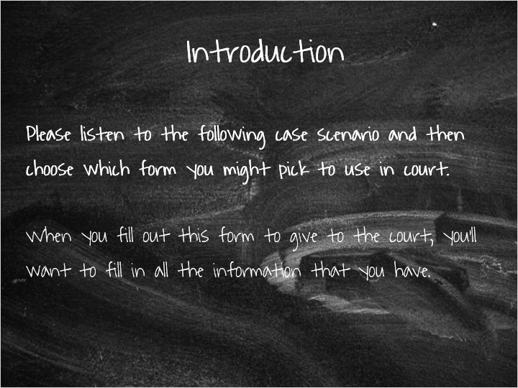

12.13 Case Scenario - Interacting with the Courts
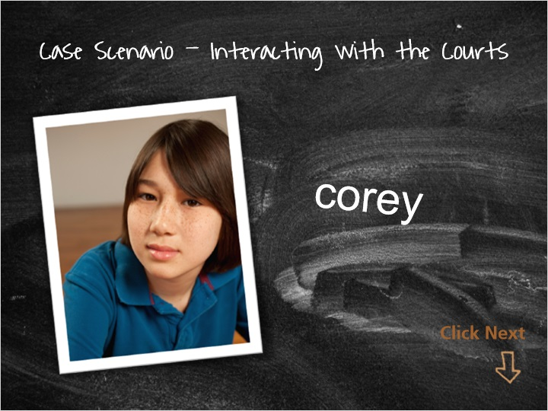
Notes:
Please listen to (or read) the following case scenario and then choose which form you might use in court. When you fill this form out to give to the court, you’ll want to fill in all the information that you have. Talk with your licensor before court if you have questions about what you want to say during the hearing or what you should write on the form.

Scenario:

Your 10-year-old foster child, Corey, has been living with you for 4 months. A month ago, he started having visits with his parents every weekend, for the full weekend. Recently, he has been fighting with other students at school and in the last 4 weeks has been sent to the principal’s office 5 times. Prior to this last month, Corey had not gotten into any physical confrontations at school. When you’ve talked with Corey about this, he shrugs and says it’s not a big deal and that nothing is wrong. When he is at your home, he seems to be upset a lot of the time recently and doesn’t respond when you try to talk with him about why he seems angry or sad. In the last month, you’ve observed Corey becoming more withdrawn and less willing to open up to you, as he used to talk with you more about how he was feeling.

Click the next button on the slide to continue.

12.14 Interacting with the Courts - Case Scenario
(True/False, 10 points, unlimited attempts permitted)
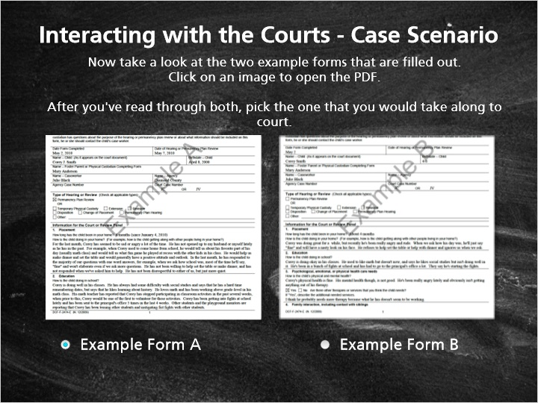
Correct | Choice
X | Example Form A
 | Example Form B

Feedback when correct:
Yes! This form is filled out with a lot of detail and factual information about your observations of Corey in the last month. It is not judgmental and is simply giving the court your observations. You've used specific examples instead of assuming to know that he's sad or angry (or both), and pointed out the differences you've noticed in the last month. There is also some positive information; you mentioned that Corey reports liking social studies and that he's working above grade-level in math.
Feedback when incorrect:
Unfortunately, no, this is not a form you would want to give to the court. The information on this form is judgmental and gives opinions rather than facts. You're assuming to know what Corey is feeling even though he's not sharing that information with you. For example, writing that Corey has a "nasty look on his face," when in reality he might have that look because he's sad. This form is reporting judgments and opinions, and not your observations and the facts. This form also has a pretty negative tone!

12.15 What is the most common goal for children in foster care?
(Multiple Choice, 10 points, 2 attempts permitted)
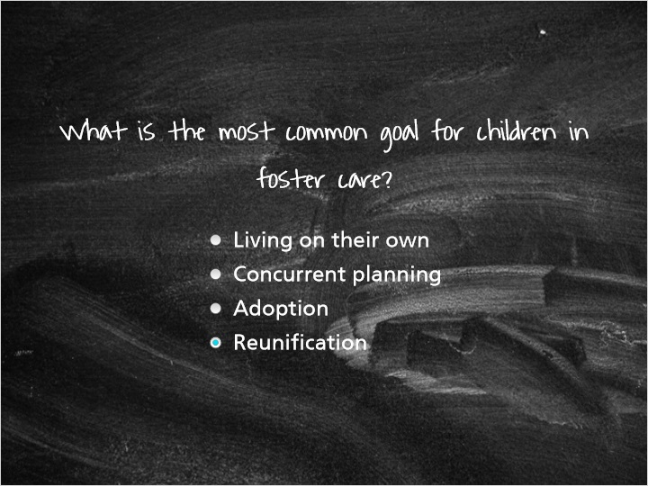
Correct | Choice | Feedback
 | Living on their own | Living on their own, which is also called Alternative Planned Permanent Living Arrangements (or Independent Living), is generally a concurrent goal for children when another permanency option cannot be identified.
 | Concurrent planning | Concurrent planning is not a goal for children, but is a required part of the permanency planning process for all children in foster care. The process of concurrent planning includes identifying a primary goal for children, which is usually reunification, but also choosing a concurrent goal in case the child cannot return home safely.
 | Adoption | Adoption is used when children cannot return safely to their family homes (and another permanent family is being sought).
X | Reunification | You're right! Reunification is the most common goal for children in foster care and is usually the primary goal for children. Reunification is the goal when children can return safely to their homes, and children have concurrent goals in case they are not able to return home safely.

13. Thinking Back

13.1 Thinking Back on the Module…
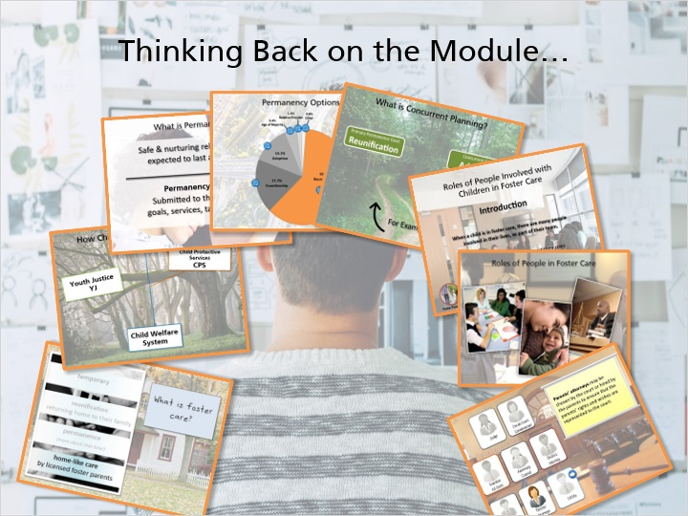
Notes:
Please think back over the information you have learned in this module and make some notes about what you feel are the most important points.

Foster care is meant to be temporary

The 2 branches of the child welfare system

Permanency planning

Permanence options

Concurrent planning

Roles of people in foster care

Working as part of the child’s team, and

Interacting with the courts

13.2 Results Slide
(Results Slide, 0 points, 1 attempt permitted)


Notes:

