Course Introduction

1. Course Introduction

1.1 Foster Care Overview
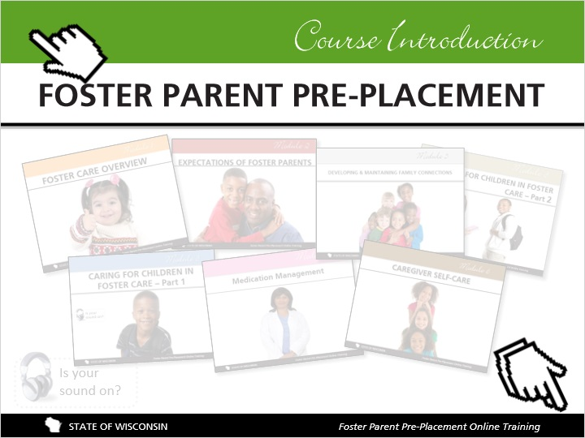
Notes:
Hi, and welcome to the foster parent pre-placement training. Over the past 10 years, my husband and I have provided a safe and nurturing home for 14 different foster children. While the job has never been easy, I can honestly say that the decision to become a foster parent was the most important, life changing decision I’ve ever made.

10 years ago, I was in the same situation that you are in today, and if you’re anything like me you are experiencing a lot of emotions and questions. Can I handle this? Is this the right decision for me? What is expected of me? How will becoming a foster parent affect my relationships with my family, friends, and biological children? Do any of these questions sound familiar? If so, don’t worry. This training is meant to help you find some answers.

On the next few slides, we are going to give you a quick tour of how this training is put together. We’ll share some tips that will allow you to get the most out of your time. You’ll also be asked to watch a video that will get you thinking about what it means to be a foster parent.

While this training is meant for new foster parents, it is also a valuable learning tool for experienced foster parents who want a refresher.

To find your way around this course, here are a few tips. You can use the controls along the bottom of the window to play, pause, rewind, and move to the next or previous page. On the left side of the window, the Menu bar lists all the course pages. You can also view the Notes tab to read the script and the Resources tab for all the documents and links covered in the course. If you close the course and return to it later, you’ll have the option to continue where you left off or start again. There are several quiz questions along the way to help check your understanding. After the final quiz be sure to print your results to document that you completed the course.
When you're ready, click the forward arrow to go to the next slide.

1.2 Organization of the Course
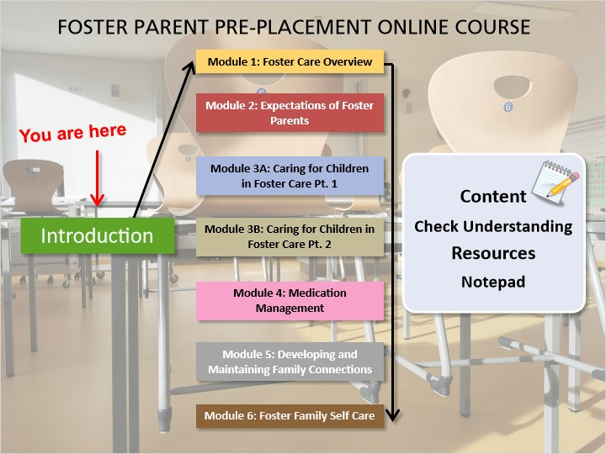
Notes:
I am going to give you a quick preview of how this training works. Each module has been designed to walk you through the information that is required for becoming licensed as a foster parent. Some modules are longer than others, but each has important information that you’ll want and need to know. The training includes a mixture of stories, statistics, legal requirements, interactive activities, questions, and more. You’ll be asked to answer some questions along the way to see how you’re doing (these questions are not tests; they’re intended to help you learn). You will be prompted to download some extra resources and you can find these links on the main course page too. Be sure to download the notepad document before starting module 1 so you can write down your questions and thoughts to share with your licensor. You’ll find a link to the notepad on the table of contents page.

Now, let’s take a look at how you’ll move around in these modules.

1.3 Tips for Success
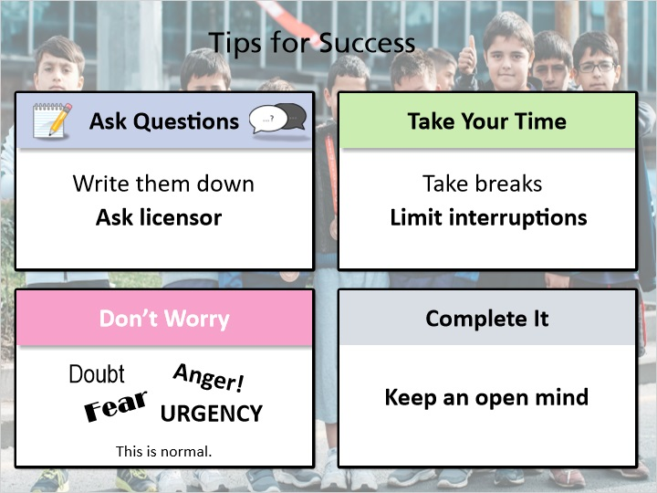
Notes:
This training is going to cover a lot of information. Here are 4 things you can do to get the most out of it:

Number 1: Write down thoughts or questions as they come up. Write them ALL down. Sometimes the answer to a question is, “It depends.” Your licensor is there to answer these questions and to discuss any concerns you have. To help with this, each module includes a notepad document for you to download and use to write down your thoughts. You can type in your questions and save it to your computer, or just print it and write down questions as you go through the module. You’ll be glad you took the time to write down these questions as you thought of them.

Number 2: Take your time. Trying to understand too much information in a short amount of time will only put you to sleep and try your patience. Pace yourself as you work through the modules. Take breaks when you feel your mind wandering. Come back to where you left off when you can focus on the information.

Number 3: Don’t worry, you will probably feel a lot of different emotions as you go through this training. You might doubt your ability to be a foster parent. This is normal. Talk with your licensor about these feelings. You’re not alone and help is available to you.

And number 4: Complete the whole training and keep an open mind until you have all of the information; this will help you take the next steps and make decisions about becoming a foster parent.

So remember: ask questions, take your time, don’t worry, and please complete all of the modules.

1.4 Review
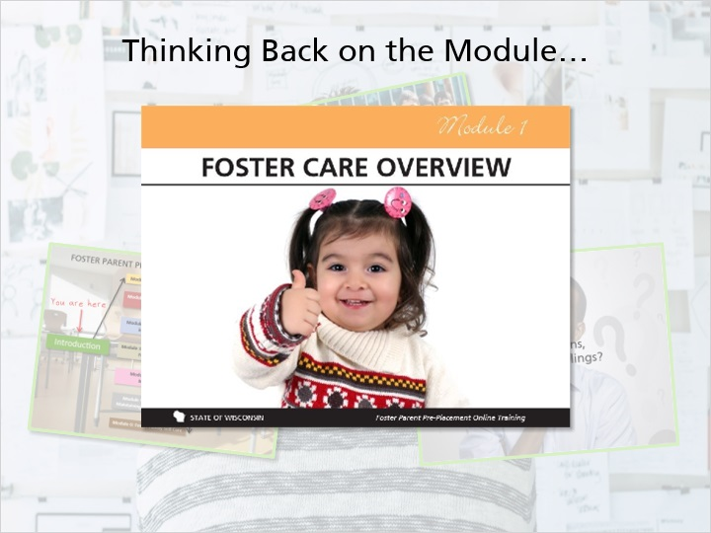
Notes:
That brings us close to the end of this introduction module. We covered an overview of the course, and shared a few strategies for getting the most out of the training.

Lastly, we started the process of asking what it would really mean to become a foster parent and positively impact the life of a child. You are now ready to move into Module:1 Foster Care Overview.

